John Hancock Tower, 27th Floor

200 Clarendon Street

Boston, Massachusetts 02116

Tel: +1.617.948.6000 Fax: +1.617.948.6001

www.lw.com

 |  |  | FIRM / AFFILIATE OFFICES
 |  |  | Barcelona | Moscow
 |  |  | Beijing | Munich
 |  |  | Boston | New Jersey
 |  |  | Brussels | New York
Via EDGAR Correspondence |  |  | Century City | Orange County
 |  |  | Chicago | Paris
 |  |  | Dubai | Riyadh
June 3, 2016 |  |  | Düsseldorf | Rome
 |  |  | Frankfurt | San Diego
United States Securities and Exchange Commission |  |  | Hamburg | San Francisco
Division of Corporation Finance |  |  | Hong Kong | Shanghai
100 F Street, N.E. |  |  | Houston | Silicon Valley
Washington, D.C. 20549 |  |  | London | Singapore
 |  |  | Los Angeles | Tokyo
 |  |  | Madrid | Washington, D.C.
 |  |  | Milan
Attention: | Suzanne Hayes, Assistant Director
 | Michael Gershon
Re: | Selecta Biosciences, Inc.
 | Registration Statement on Form S-1
 | File No. 333-211555

Dear Ms. Hayes:

As discussed with Mr. Michael Gershon, Selecta Biosciences, Inc., a Delaware corporation (the “Company”), is submitting as correspondence marked pages showing proposed changes to be made in an Amendment (the “Amendment”) to its Registration Statement on Form S-1 filed with the Securities and Exchange Commission (the “Commission”) on May 24, 2016 (the “Registration Statement”). Attached hereto as Exhibit A are proposed changed pages to the Amendment that reflect the Company’s anticipated updates to certain clinical and other disclosures in the Registration Statement, including additional data points in Figures 18 and 19 and a new Figure 20 (the “Supplemental Disclosure”).

The Company respectfully requests that the Staff of the Commission (the “Staff”) review the filed correspondence in advance of the Company filing the Amendment. The Company appreciates the Staff’s willingness to accommodate the Company’s request to review and not make public the Supplemental Disclosure before it launches the offering.

Please do not hesitate to contact me at (202) 637-2117 or my colleague, Peter N. Handrinos, at (617) 948-6060 with any questions or further comments you may have regarding this correspondence or if you wish to discuss any of the Company’s proposed changes to the Amendment.

Sincerely,

/s/ Brandon J. Bortner

Brandon J. Bortner

of LATHAM & WATKINS LLP

Enclosures

- Werner Cautreels, Ph.D., Selecta Biosciences, Inc. David Abraham, Selecta Biosciences, Inc.
Peter N. Handrinos, Latham & Watkins LLP

2

EXHIBIT A

Phase 1b clinical trial

In December 2015, we initiated our Phase 1b clinical trial. We anticipate that this clinical trial will have approximately 53 subjects with serum uric acid levels greater than 6 mg/dl separated into nine cohorts. We plan to co-administer a single intravenous infusion of SVP-Rapamycin at ascending dose levels with a fixed dose of pegsiticase of 0.4 mg/kg for four of the cohorts, which will be Cohort #2, Cohort #4, Cohort #6 and Cohort #8 of the Phase 1b clinical trial, or collectively the SEL-212 Cohorts. In addition to a fixed 0.4 mg/kg dose of pegsiticase, subjects in the SEL-212 Cohorts will receive SVP-Rapamycin in the

following dose levels: Cohort #2 (0.03 mg/kg), Cohort #4 (0.1 mg/kg), Cohort #6 (0.3 mg/kg) and Cohort #8 (0.5 mg/kg). We also plan to administer to Cohort #9 a fixed amount of pegsiticase alone at a dose level of 0.4 mg/kg, which we refer to as the Pegsiticase Cohort. Additionally, we intend to administer a single intravenous infusion of SVP-Rapamycin alone at the following ascending dose levels to the remaining cohorts, which will be Cohort #1 (0.03 mg/kg), Cohort #3 (0.1 mg/kg), Cohort #5 (0.3 mg/kg) and Cohort #7 (0.5 mg/kg) of the Phase 1b clinical trial, or collectively the SVP-Rapamycin Cohorts. All subjects will be followed for 30 days after their initial dose. The primary objective of the Phase 1b clinical trial is to evaluate the safety and tolerability of SVP-Rapamycin alone and in combination with a fixed dose of pegsiticase. A secondary clinical objective is to evaluate the ability of SVP-Rapamycin co-administered with pegsiticase to reduce serum uric acid levels and mitigate the formation of uricase-specific ADAs when compared to administration of pegsiticase alone. We expect that complete data from the Phase 1b clinical trial will be available in the second half of 2016.

Although the Phase 1b clinical trial is currently ongoing, as of May 20June 3, 2016, we had completed the dosing of:

- all four SVP-Rapamycin Cohorts;

- the three SEL-212 Cohorts, Cohort #2, Cohort #4 and Cohort #6, receiving the lowest three (out of the four projected) SVP-Rapamycin ascending dose levels; and

- the Pegsiticase Cohort, Cohort #9.

We have received 30-day observation period data for Cohort #1 (SVP-Rapamycin Cohort), Cohort #2 (SEL-212 Cohort), Cohort #3 (SVP-Rapamycin Cohort), Cohort #4 (SEL-212 Cohort), Cohort #5 (SVP-Rapamycin Cohort), Cohort #6 (SEL-212 Cohort) and Cohort #9 (Pegsiticase Cohort) of the Phase 1b clinical trial. As of May 20, 2016, for Cohort #6 (SEL-212 Cohort), we have received data for 21 days of the 30-day observation period for four (out of the projected five) subjects and 30-day observation period data for three (out of the projected five) subjects.

Figure 18 below indicates the serum uric acid levels of Cohort #3 from the Phase 1a clinical trial, in which subjects received a fixed amount of pegsiticase alone (at the same 0.4 mg/kg pegsiticase dose level as Cohort #9, the Pegsiticase Cohort, of the Phase 1b clinical trial). Figure 18 below also indicates the serum uric acid levels of Cohort #9 (Pegsiticase Cohort), Cohort #1 (SVP-Rapamycin Cohort), Cohort #2 (SEL-212 Cohort), Cohort #3 (SVP-Rapamycin Cohort), Cohort #4 (SEL-212 Cohort), Cohort #5 (SVP-Rapamycin Cohort) and, with respect to available data as of May 20, 2016, Cohort #6 (SEL-212 Cohort) from the Phase 1b clinical trial. The In Figure 18 below, observational data is presented for all cohorts in which subjects have reached the end of the 30-day observation period. In these subjects, serum uric acid levels were measured at baseline and days seven, 14, 21 and 30 in all subjects from the Phase 1b clinical trial who have reached the end of the 30-day observation period. In those subjects who have not reached the end of the 30-day observation period, interim data is presented. As expected, SVP-Rapamycin alone had no relevant effect on reducing serum uric acid levels across the SVP-Rapamycin Cohorts, as such levels remained relatively constant during the 30-day period. In Cohort #2 from the Phase 1b clinical trial, which received the lowest dose of SVP-Rapamycin co-administered with pegsiticase, we observed that four out of five subjects tested maintained serum uric acid levels below 6 mg/dl through day 21 of the trial. We also observed that four out of five subjects in Cohort #4 from the Phase 1b clinical trial, which received the second lowest dose of SVP-Rapamycin co-administered with pegsiticase, maintained levels of serum uric acid of less than 0.1 mg/dl through day 30. For Cohort #6 (SEL-212 Cohort), as of May 20, 2016, we have observed that four (outeach of the projected five) subjects maintained levels of serum uric acid of less than 0.1 mg/dl through day 21 and three (out of the projected five) subjects maintained levels of serum uric acid of less than 0.1 mg/dl

through day 30. By comparison, for Cohort #9 (Pegsiticase Cohort), four of the five subjects returned to baseline serum uric acid levels by day 30.
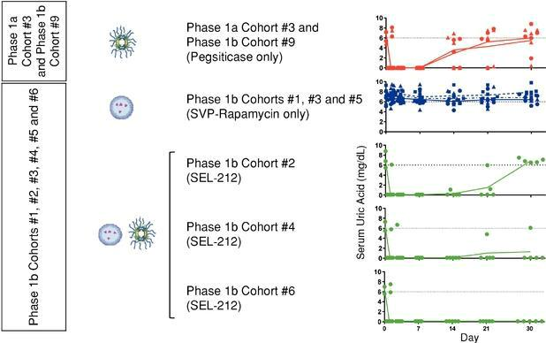

Figure 18. Phase 1b Clinical Trial: Uric Acid Levels Across Seven Phase 1b Cohorts (and Cohort #3 from the Phase 1a Clinical Trial)

Figure 19 below shows the serum uric acid levels and uricase-specific ADA levels for each subject in Cohort #3 of the Phase 1a clinical trial and Cohort #9 (Pegsiticase Cohort) of the Phase 1b clinical trial for comparison to the serum uric acid levels and uricase-specific ADA levels for each subject in Cohort # 4 (SEL-212 Cohort) and Cohort #6 (SEL-212 Cohort) in the Phase 1b clinical trial. Cohort #3 from the Phase 1a clinical trial is depicted in Figure 19 along with Cohort #9 from the Phase 1b clinical trial for purposes of comparison against Cohort #4 and Cohort #6 from the Phase 1b clinical trial because the subjects in these cohorts received the same fixed dose of pegsiticase. In addition, Cohort #4 from the Phase 1b clinical trial is depicted below in Figure 19 because the subjects in Cohort #4 from the Phase 1b clinical trial received a higher dose of SVP-Rapamycin than did the subjects in Cohort #2 in the Phase 1b

clinical trial, the other SEL-212 Cohort for which 30-day observation period data. We have also included Cohort #6 from the Phase 1b clinical trial was available as of May 20, 2016because these subjects received the highest dose of SVP-Rapamycin tested to date—higher than both Cohorts #2 and #4.

As depicted in Figure 19 below, in Cohort #3 from the Phase 1a clinical trial and Cohort #9 from the Phase 1b clinical trial, we observed uricase-specific ADA formation at day 14 resulting in a return to baseline levels of serum uric acid. In comparison, for Cohort #4 from the Phase 1b clinical trial, we observed minimal uricase-specific ADA formation in four of the five subjects tested with corresponding maintenance of control of serum uric acid levels through day 30. In Cohort #6 of the Phase 1b clinical trial, we observed minimal to no uricase-specific ADA formation in each of the five subjects, with corresponding maintenance of control of serum uric acid levels through day 30. In the Phase 1a clinical trial, we did not measure uricase-specific ADA levels at day 21. However, in the course of conducting the Phase 1a clinical trial, we learned that it would be useful to measure uricase-specific ADA levels at day 21 to more fully understand any variations in such levels between day 14 and day 30. As a result, for the Phase 1b clinical trial, we monitor uricase-specific ADA levels at day 21.
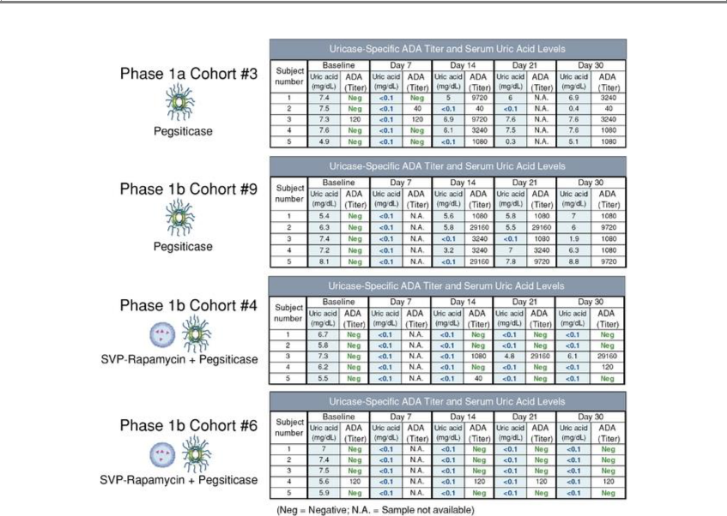

Figure 19. Comparison of Phase 1a Cohort #3, Phase 1b Cohort #9 and, Phase 1b Cohort #4 and Phase 1b Cohort #6: Uric Acid and Uricase-Specific ADA Levels

Figure 20 below compares the efficacy of SEL-212 in Cohort #6 of the Phase 1b clinical trial with published data from the Krystexxa clinical trials. The Krystexxa data shows the mean plasma uric acid levels over the first four weeks after the initial administration of Krystexxa in the cohorts of subjects that received monthly dosing of Krystexxa. The placebo control subjects, indicated in open circles in Figure 20 below, had uric acid levels above 6 mg/dl for the entire four weeks. The Krystexxa-treated subjects that went on to become responders, as defined by maintenance of uric acid levels below 6 mg/dl for 80% of the time at months three and six, are indicated in black circles. The Krystexxa-treated subjects that went on to become non-responders, as defined by the inability to maintain uric acid levels below 6 mg/dl for 80% of the time at months three and six, are indicated in black triangles. Only 35% of Krystexxa-treated subjects in the monthly dosing cohorts were classified as responders. It is notable that, even at four weeks, the mean uric acid levels were above 6 mg/dl in the non-responders, representing 65% of subjects, and were above 4 mg/dl in the responders. While not depicted in Figure 20 below, 89% of all Krystexxa-treated subjects developed ADAs. In contrast, all subjects in Cohort #6 of the Phase 1b clinical trial, treated with SEL-212 and indicated in green in Figure 20 below, maintained levels of serum uric acid of less than 0.1 mg/dl through day 30. Subjects in Cohort #5 of the Phase 1b clinical trial, treated with SVP-Rapamycin alone and indicated in blue,

experienced no significant reduction in uric acid levels, as such levels remained relatively constant over the 30-day period.

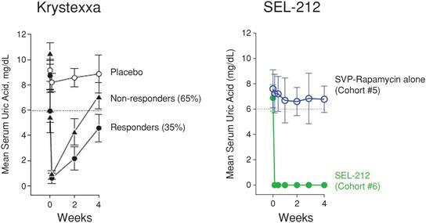

Figure 20. Comparison of the Efficacy of Krystexxa and SEL-212 After a Single Dose

We collected additional serum uric acid and uricase-specific ADA data after day 30 for three of the subjects in Cohort #4 (SEL-212 Cohort) that had no or very low serum uric acid and uricase-specific ADA levels at day 30. We collected data on day 37 for all three of these subjects and again on day 42 or day 44 for two of the three subjects. Each of these three subjects had no or very low uricase-specific ADA levels on day 37, day 42 or day 44, as applicable. Serum uric acid levels remained below baseline on day 37 in all three subjects. With respect to the two subjects for which day 42 or day 44 data was available, serum uric acid levels approached or exceeded baseline by the last time point measured. We anticipated these results as we did not expect a single dose of the enzyme to be capable of clearing all of the uric acid deposits in the body. Based on our observations from the Phase 1b clinical trial data that SEL-212 was capable of controlling uric acid levels for at least 30 days in the majorityall of the subjects in Cohort # 46, we believe SEL-212 has the potential to maintain low uric acid levels with monthly dosing, which we plan to test in the Phase 2 clinical trial.

As of May 20June 3, 2016, on a combined basis, we had dosed a total of 70 subjects with either SEL-212 (SVP-Rapamycin and pegsiticase), SVP-Rapamycin alone or pegsiticase alone in connection with the Phase 1a and Phase 1b clinical trials. We have generally observed that SEL-212 and its components, SVP-Rapamycin and pegsiticase, have been well tolerated. As of May 20June 3, 2016, there have been a total of two serious adverse events, or SAEs, in both Phase 1 clinical trials. One SAE occurred in a subject from Cohort #9 (Pegsiticase Cohort) of the Phase 1b clinical trial, a 62 year-old male, who received a dose level of pegsiticase alone of 0.4 mg/kg. This subject developed atrial fibrillation 13 days after administration of pegsiticase. The subject has been treated. The medical records from the principal investigator indicate that this subject has recovered. The principal investigator has deemed this SAE to not have been related to the study drug, pegsiticase. The second SAE occurred in a 59 year-old male from Cohort #4 (SEL-212 Cohort) of the Phase 1b clinical trial who developed a pruritic rash on his lower extremities and joint pain approximately 12 days after being dosed with SEL-212, consisting of a dose level of SVP-Rapamycin of 0.1 mg/kg and a dose level of pegsiticase of 0.4 mg/kg. This subject was treated with steroids, analgesics, anti-nausea medications and topical antihistamine cream. As a result of such treatment, the medical records from the principal investigator indicate that the rash and joint pain experienced by the subject have been resolved. This subject was the only subject in Cohort #4 (SEL-212 Cohort) that developed significant uricase-specific ADAs and whose serum uric acid levels returned to baseline by day 30. This adverse event was classified as an SAE because the subject was admitted to the emergency room instead of going directly to the investigational site for treatment. The principal investigator classified this second SAE as having been possibly related to the study drug, SEL-212.

