SEC Form 4

FORM 4

Check this box if no longer subject to Section
- Form 4 or Form 5 obligations may continue. See Instruction 1(b).

UNITED STATES SECURITIES AND EXCHANGE COMMISSION
Washington, D.C. 20549
Washington, D.C. 20549 |  | OMB APPROVAL
STATEMENT OF CHANGES IN BENEFICIAL OWNERSHIP
STATEMENT OF CHANGES IN BENEFICIAL OWNERSHIP |  | OMB Number: | 3235-0287
 |  | Estimated average burden
Filed pursuant to Section 16(a) of the Securities Exchange Act of 1934 |  | hours per response: | 0.5
or Section 30(h) of the Investment Company Act of 1940
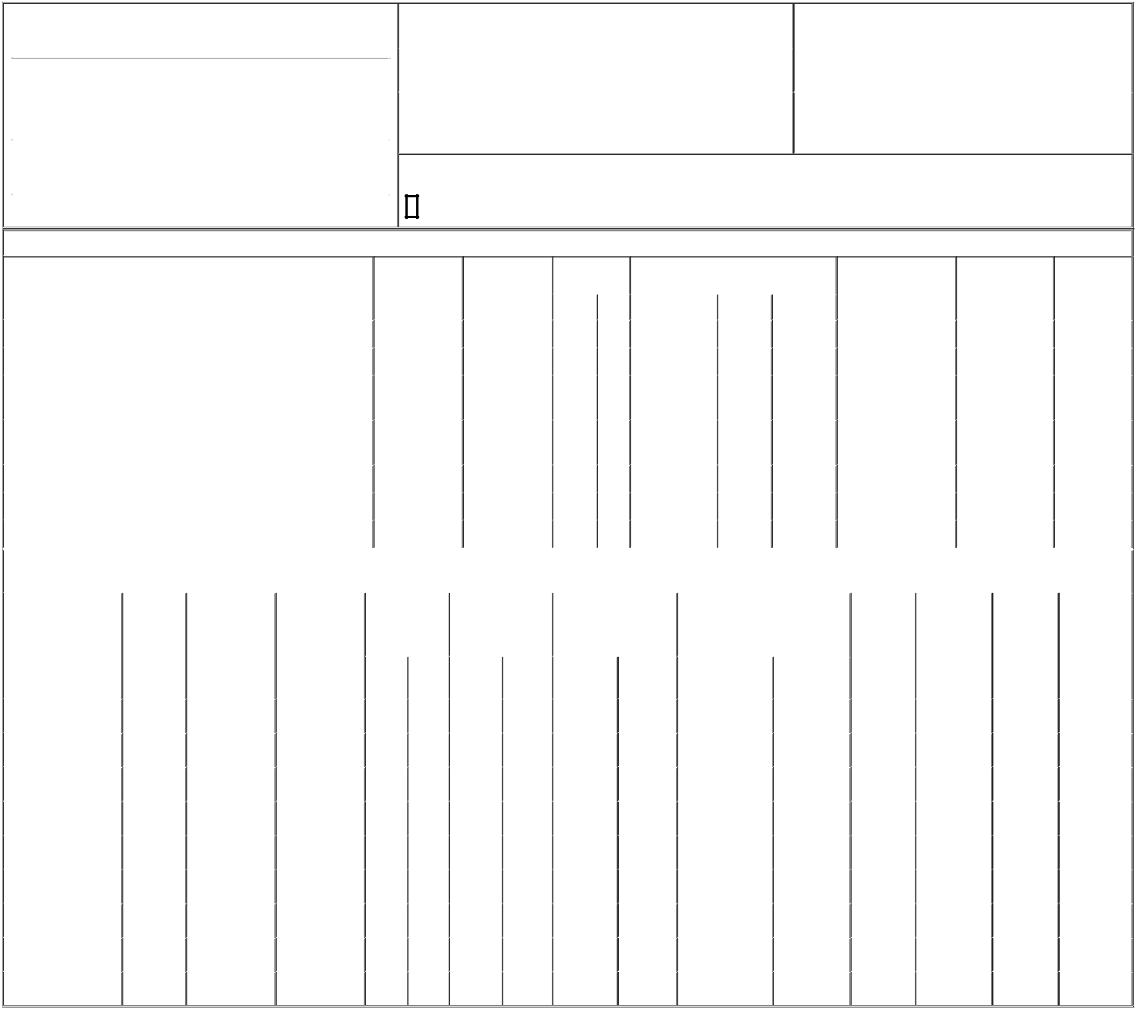

1. Name and Address of Reporting Person*
Singer Michael

 | (Last) | (First) | (Middle)
 | C/O CARTESIAN THERAPEUTICS, INC.
 | 704 QUINCE ORCHARD ROAD
(Street)
 | GAITHERSBURG | MD | 20878
 | (City) | (State) | (Zip)

2. |  | Issuer Name and Ticker or Trading Symbol |  | 5. Relationship of Reporting Person(s) to Issuer
 | Cartesian Therapeutics, Inc. [ RNAC ] |  |  | (Check all applicable)
 |  |  |  | X | Director | X | 10% Owner
3. |  | Date of Earliest Transaction (Month/Day/Year) |  |  | Officer (give title |  | Other (specify below)
12/22/2023 |  |  |  |  | below) |  | Other (specify below)
4. |  | If Amendment, Date of Original Filed (Month/Day/Year) |  | 6. Individual or Joint/Group Filing (Check Applicable Line)
 |  |  |  | X | Form filed by One Reporting Person
 |  |  |  |  | Form filed by More than One Reporting Person

Rule 10b5-1(c) Transaction Indication

Check this box to indicate that a transaction was made pursuant to a contract, instruction or written plan that is intended to satisfy the affirmative defense conditions of Rule 10b5-1(c). See Instruction 10.

Table I - Non-Derivative Securities Acquired, Disposed of, or Beneficially Owned

 | 1. Title of Security (Instr. 3) |  |  |  | 2. Transaction |  | 2A. Deemed | 3. Transaction |  | 4. Securities Acquired (A) or Disposed Of |  |  |  |  | 5. Amount of Securities |  |  | 6. Ownership |  | 7. Nature of
 |  |  |  |  | Date |  | Execution Date, | Code (Instr. 8) |  | (D) (Instr. 3, 4 and 5) |  |  |  |  | Beneficially Owned |  |  | Form: Direct (D) or |  | Indirect
 |  |  |  |  | (Month/Day/Year) |  | if any |  |  |  |  |  |  |  | Following Reported |  |  | Indirect (I) (Instr. 4) |  | Beneficial
 |  |  |  |  |  |  | (Month/Day/Year) | Code | V | Amount |  | (A) or (D) | Price |  | Transaction(s) (Instr. 3 |  |  |  |  | Ownership
 |  |  |  |  |  |  |  | Code | V | Amount |  | (A) or (D) |  |  | and 4) |  |  |  |  | (Instr. 4)
 | Common Stock |  |  |  | 01/02/2024 |  |  | _{A}(1) |  | 178,000 |  | A | $0 |  | 288,123 |  |  |  | D
 | Common Stock |  |  |  |  |  |  |  |  |  |  |  |  |  | 197,663 |  |  |  | I | by trust⁽²⁾
 | Common Stock |  |  |  |  |  |  |  |  |  |  |  |  |  | 49,555 |  |  |  | I | as
 | Common Stock |  |  |  |  |  |  |  |  |  |  |  |  |  |  |  |  |  | I | custodian⁽³⁾
 | Common Stock |  |  |  |  |  |  |  |  |  |  |  |  |  | 49,555 |  |  |  | I | as
 | Common Stock |  |  |  |  |  |  |  |  |  |  |  |  |  |  |  |  |  | I | custodian⁽⁴⁾
 | Common Stock |  |  |  |  |  |  |  |  |  |  |  |  |  | 3,670 |  |  |  | I | by trust⁽⁵⁾
 | Common Stock |  |  |  |  |  |  |  |  |  |  |  |  |  | 29,212 |  |  |  | I | by trust⁽⁶⁾
 | Common Stock |  |  |  |  |  |  |  |  |  |  |  |  |  | 7,616 |  |  |  | I | by spouse⁽⁷⁾
 |  |  |  | Table II - Derivative Securities Acquired, Disposed of, or Beneficially Owned
 |  |  |  |  | (e.g., puts, calls, warrants, options, convertible securities)
 | 1. Title of Derivative | 2. | 3. Transaction | 3A. Deemed | 4. Transaction | 5. Number of |  | 6. Date Exercisable and |  |  | 7. Title and Amount of Securities |  |  |  |  | 8. Price of | 9. Number of |  | 10. | 11. Nature of
 | Security (Instr. 3) | Conversion | Date | Execution Date, | Code (Instr. 8) | Derivative |  | Expiration Date |  |  | Underlying Derivative Security |  |  |  |  | Derivative | derivative |  | Ownership | Indirect
 |  | or Exercise | (Month/Day/Year) | if any |  | Securities Acquired |  | (Month/Day/Year) |  |  | (Instr. 3 and 4) |  |  |  |  | Security | Securities |  | Form: | Beneficial
 |  | Price of |  | (Month/Day/Year) |  | (A) or Disposed of |  |  |  |  |  |  |  |  |  | (Instr. 5) | Beneficially |  | Direct (D) or | Ownership
 |  | Derivative |  |  |  | (D) (Instr. 3, 4 and 5) |  |  |  |  |  |  |  |  |  |  | Owned |  | Indirect (I) | (Instr. 4)
 |  | Security |  |  |  |  |  |  |  |  |  |  |  |  |  |  | Following |  | (Instr. 4)
 |  |  |  |  |  |  |  |  |  |  |  |  | Amount or |  |  |  | Reported
 |  |  |  |  |  |  |  | Date |  | Expiration |  |  | Number of |  |  |  | Transaction(s)
 |  |  |  |  | Code V | (A) | (D) | Exercisable |  | Date | Title |  | Shares |  |  |  | (Instr. 4)
 | Stock Option (Right to | $0.6552 | 01/02/2024 |  | A | 228,000 |  | (8) |  | 01/01/2034 | Common Stock |  | 228,000 |  | $0 |  | 228,000 |  | D
 | Buy) | $0.6552 | 01/02/2024 |  | A |  |  | (8) |  | 01/01/2034 |  |  | 228,000 |  |  |  |  |  | D
 | Series A Convertible | (9) | 12/22/2023 |  | _{G}(10) |  | 3,000 | (9) |  | (9) | Common Stock |  | 3,000,000 |  | $0 |  | 3,304.559 |  | D
 | Preferred Stock | (9) | 12/22/2023 |  | _{G}(10) |  | 3,000 | (9)
 | Series A Convertible | (9) |  |  |  |  |  | (9) |  | (9) | Common Stock |  | 6,304,559 |  |  |  | 6,304.559 |  | I | by trust⁽²⁾
 | Preferred Stock | (9) |  |  |  |  |  | (9) |  | (9) |  |  |  |  |  |  |  |  | I
 | Series A Convertible | (9) |  |  |  |  |  | (9) |  | (9) | Common Stock |  | 11,316,263 |  |  |  | 11,316.263 |  | I | by trust⁽⁶⁾
 | Preferred Stock | (9) |  |  |  |  |  | (9) |  | (9) |  |  |  |  |  |  |  |  | I
 | Series A Convertible | (9) |  |  |  |  |  | (9) |  | (9) | Common Stock |  | 1,672,389 |  |  |  | 1,672.389 |  | I | by trust⁽⁶⁾
 | Preferred Stock | (9) |  |  |  |  |  | (9) |  | (9) |  |  |  |  |  |  |  |  | I
 | Series A Convertible | (9) |  |  |  |  |  | (9) |  | (9) | Common Stock |  | 210,152 |  |  |  | 210.152 |  | I | by trust⁽⁵⁾
 | Preferred Stock | (9) |  |  |  |  |  | (9) |  | (9) |  |  | 210,152 |  |  |  |  |  | I
 | Series A Convertible | (9) |  |  |  |  |  | (9) |  | (9) | Common Stock |  | 2,837,052 |  |  |  | 2,837.052 |  | I | as custodian⁽³⁾
 | Preferred Stock | (9) |  |  |  |  |  | (9) |  | (9) |  |  |  |  |  |  |  |  | I
 | Series A Convertible | (9) |  |  |  |  |  | (9) |  | (9) | Common Stock |  | 2,837,052 |  |  |  | 2,837.052 |  | I | as custodian⁽⁴⁾
 | Preferred Stock | (9) |  |  |  |  |  | (9) |  | (9) |  |  |  |  |  |  |  |  | I
 | Series A Convertible | (9) |  |  |  |  |  | (9) |  | (9) | Common Stock |  | 436,066 |  |  |  | 436.066 |  | I | by spouse⁽⁷⁾
 | Preferred Stock | (9) |  |  |  |  |  | (9) |  | (9) |  |  | 436,066 |  |  |  |  |  | I

Explanation of Responses:

- Each Restricted Stock Unit represents a contingent right to receive one share of common stock, which will vest in three equal annual installments so that the underlying shares will be fully vested on January 2, 2027.

- Shares are held in a trust for the benefit of the reporting person's spouse and children. The reporting person's spouse is a trustee of the trust.

- The shares are held for LS, the child of the reporting person, through a custodial account established pursuant to the Uniform Transfer to Minors Act ("UTMA") for which the reporting person serves as custodian.

- The shares are held for SS, the child of the reporting person, through a custodial account established pursuant to the UTMA for which the reporting person serves as custodian.

- Shares are held in a trust for which the reporting person is a beneficiary. The reporting person's spouse is a trustee of the trust.

- Shares are held in a trust for which the reporting person is a beneficiary. The reporting person is a trustee of the trust.

- Shares are held by the reporting person's spouse.

- This award will vest in 36 equal monthly installments, so that it shall be fully vested on the third anniversary of the date of grant.

- Following the approval by the Stockholders of the conversion of the Series A Non-Voting Convertible Preferred Stock of the Company ("Series A Preferred Stock") into shares of common stock of the Company ("Common Stock"), each share of Series A Preferred Stock will be convertible into 1,000 shares of Common Stock, subject to certain limitations, including that a holder of Series A Preferred Stock is prohibited from converting shares of Series A Preferred Stock into shares of Common Stock if, as a result of such conversion, such holder, together with its affiliates, would beneficially own more than 19.9% of the total number of shares of Common Stock issued and outstanding immediately after giving effect to such conversion.

- Bona fide gift to Yale University.

Remarks:

Exhibit 24 - Power of Attorney

/s/ Matthew Bartholomae, Attorney-in- _{01/04/2024}
Fact for Michael Singer

** Signature of Reporting Person Date

Reminder: Report on a separate line for each class of securities beneficially owned directly or indirectly.

* If the form is filed by more than one reporting person, see Instruction 4 (b)(v).

- Intentional misstatements or omissions of facts constitute Federal Criminal Violations See 18 U.S.C. 1001 and 15 U.S.C. 78ff(a). Note: File three copies of this Form, one of which must be manually signed. If space is insufficient, see Instruction 6 for procedure.
Persons who respond to the collection of information contained in this form are not required to respond unless the form displays a currently valid OMB Number.





