SEC Form 3
 | FORM 3 |  |  | UNITED STATES SECURITIES AND EXCHANGE COMMISSION
 |  |  |  |  |  | Washington, D.C. 20549 |  |  |  |  |  |  | OMB APPROVAL
 |  |  |  | INITIAL STATEMENT OF BENEFICIAL OWNERSHIP OF SECURITIES |  |  |  |  |  |  |  |  | OMB Number: | 3235-0104
 |  |  |  |  |  |  |  |  |  |  |  |  | Estimated average burden
 |  |  |  |  | Filed pursuant to Section 16(a) of the Securities Exchange Act of 1934 |  |  |  |  |  |  |  | hours per response: | 0.5
 |  |  |  |  | or Section 30(h) of the Investment Company Act of 1940
1. Name and Address of Reporting Person * |  |  |  |  | 2. Date of Event Requiring |  | 3. Issuer Name and Ticker or Trading Symbol
 | Seymour June Ann |  |  | 10/27/2025 |  |  | Cartesian Therapeutics, Inc. [ RNAC ]
 |  |  |  |  | Statement (Month/Day/Year)
 |  |  |  |  |  |  | 4. Relationship of Reporting Person(s) to Issuer |  |  |  | 5. If Amendment, Date of Original Filed (Month/Day/Year)
 | (Last) | (First) |  | (Middle) |  |  | (Check all applicable)
 | (Last) |  |  |  |  |  |  |  |  |  | 6. Individual or Joint/Group Filing (Check Applicable Line)
 | (Last) |  |  |  |  |  |  | Director | 10% Owner
 | C/O CARTESIAN THERAPEUTICS, INC. |  |  |  |  |  |  | Director | 10% Owner |  | Form filed by One Reporting Person
 |  |  |  |  |  |  |  | Officer (give title | Other (specify below)
 | 7495 NEW HORIZON WAY |  |  |  |  |  |  | Officer (give title | Other (specify below) |  | Form filed by More than One Reporting Person
 |  |  |  |  |  |  |  | below) | Other (specify below)
 |  |  |  |  |  |  |  | Chief Accounting Officer
(Street)
 | FREDERICK | MD |  | 21703
 | (City) | (State) |  | (Zip)
 |  |  |  |  | Table I - Non-Derivative Securities Beneficially Owned
1. Title of Security (Instr. 4) |  |  |  |  |  | 2. Amount of Securities Beneficially |  |  | 3. Ownership Form: | 4. Nature of Indirect Beneficial Ownership (Instr. 5)
 |  |  |  |  |  | Owned (Instr. 4) |  |  | Direct (D) or Indirect
 |  |  |  |  |  |  |  |  | (I) (Instr. 5)
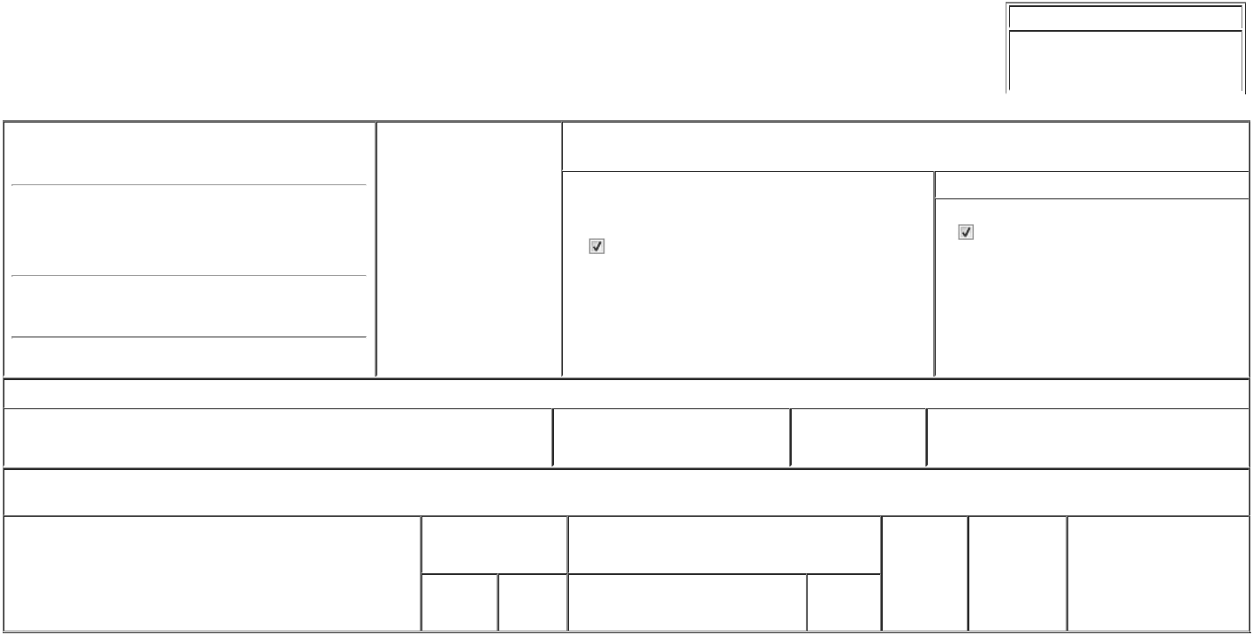

Table II - Derivative Securities Beneficially Owned

(e.g., puts, calls, warrants, options, convertible securities)

1. Title of Derivative Security (Instr. 4) | 2. Date Exercisable and |  | 3. Title and Amount of Securities Underlying |  | 4. | 5. Ownership | 6. Nature of Indirect Beneficial
 | Expiration Date |  | Derivative Security (Instr. 4) |  | Conversion | Form: Direct | Ownership (Instr. 5)
 | (Month/Day/Year) |  |  |  | or Exercise | (D) or Indirect
 |  |  |  |  | Price of | (I) (Instr. 5)
 |  |  |  | Amount or | Price of | (I) (Instr. 5)
 |  |  |  | Amount or | Derivative
 | Date | Expiration | Title | Number of | Security
 | Exercisable | Date | Title | Shares

Explanation of Responses:

Remarks:

Exhibit 24 - Power of Attorney

No securities are beneficially owned.

/s/ Matthew Bartholomae, Attorney-in-
Fact for June Ann Seymour

** Signature of Reporting Person

Reminder: Report on a separate line for each class of securities beneficially owned directly or indirectly.

* If the form is filed by more than one reporting person, see Instruction 5 (b)(v).

- Intentional misstatements or omissions of facts constitute Federal Criminal Violations See 18 U.S.C. 1001 and 15 U.S.C. 78ff(a). Note: File three copies of this Form, one of which must be manually signed. If space is insufficient, see Instruction 6 for procedure.
Persons who respond to the collection of information contained in this form are not required to respond unless the form displays a currently valid OMB Number.

10/28/2025

Date



