UNITED STATES

SECURITIES AND EXCHANGE COMMISSION

Washington, D.C. 20549

FORM 8-K

CURRENT REPORT

Pursuant to Section 13 or 15(d) of

the Securities Exchange Act of 1934

Date of Report (Date of earliest event reported): January 8, 2024

CARTESIAN THERAPEUTICS, INC.

(Exact name of registrant as specified in its charter)

Delaware

(State or other jurisdiction

of incorporation)

001-37798

(Commission

File Number)

26-1622110

(IRS Employer

Identification No.)

704 Quince Orchard Road, Gaithersburg, MD 20878

(Address of principal executive offices)(Zip Code)

(617) 923-1400

Registrant’s telephone number, including area code

N/A

(Former name or former address, if changed since last report)

Check the appropriate box below if the Form 8-K filing is intended to simultaneously satisfy the filing obligation of the registrant under any of the following provisions:

- Written communications pursuant to Rule 425 under the Securities Act (17 CFR 230.425)

- Soliciting material pursuant to Rule 14a-12 under the Exchange Act (17 CFR 240.14a-12)

- Pre-commencement communications pursuant to Rule 14d-2(b) under the Exchange Act (17 CFR 240.14d-2(b))

- Pre-commencement communications pursuant to Rule 13e-4(c) under the Exchange Act (17 CFR 240.13e-4(c))

Securities registered pursuant to Section 12(b) of the Act:

Title of each class | Trading Symbol(s) | Name of each exchange on which registered
Common Stock (Par Value $0.0001) | RNAC | The Nasdaq Stock Market LLC

Indicate by check mark whether the registrant is an emerging growth company as defined in Rule 405 of the Securities Act of 1933 (§230.405 of this chapter) or Rule 12b-2 of the Securities Exchange Act of 1934 (§240.12b-2 of this chapter).

Emerging growth company ☐

If an emerging growth company, indicate by check mark if the registrant has elected not to use the extended transition period for complying with any new or revised financial accounting standards provided pursuant to Section 13(a) of the Exchange Act. ☐

Item 7.01. Regulation FD Disclosure.

Cartesian Therapeutics, Inc. (the “Company”) from time to time presents and/or distributes to the investment community at various industry and other conferences slide presentations to provide updates and summaries of its business. A copy of its current corporate slide presentation is attached to this Current Report on Form 8-K as Exhibit 99.1.

Additionally, on January 8, 2024, the Company issued press releases announcing long-term follow-up data from its Phase 2a study of Descartes-08 in patients with myasthenia gravis and announcing its 2024 strategic priorities, respectively. These press releases are attached to this Current Report on Form 8-K as Exhibits 99.2 and 99.3, respectively.

The information in Item 7.01 of this Form 8-K, including Exhibits 99.1, 99.2, and 99.3 attached hereto, shall not be deemed “filed” for purposes of Section 18 of the Securities Exchange Act of 1934, as amended (the “Exchange Act”), or otherwise subject to the liabilities of that section, nor shall it be deemed incorporated by reference in any filing under the Securities Act of 1933, as amended, or the Exchange Act, except as expressly set forth by specific reference in such a filing. The Company undertakes no obligation to update, supplement or amend the materials attached hereto as Exhibits 99.1, 99.2, or 99.3, except as required by law.

Item 9.01 Financial Statements and Exhibits.

(d) Exhibits

Exhibit |  |  |  | Exhibit Description
 | No. |  |  | Exhibit Description
99.1 |  |  |  | Corporate slide presentation of Cartesian Therapeutics, Inc. dated January 2024
99.2 |  |  |  | Press release announcing long-term follow-up data from Phase 2a study of Descartes-08 in myasthenia gravis issued on January 8,
 |  |  |  | 2024
99.3 |  |  |  | Press release announcing the Company’s 2024 strategic priorities issued on January 8, 2024
 | 104 |  |  | Cover Page Interactive Data File (embedded within the Inline XBRL document)

SIGNATURES

Pursuant to the requirements of the Securities Exchange Act of 1934, the registrant has duly caused this report to be signed on its behalf by the undersigned hereunto duly authorized.

CARTESIAN THERAPEUTICS, INC.

Date: January 8, 2024 By: /s/ Carsten Brunn, Ph.D.

Carsten Brunn, Ph.D.

President and Chief Executive Officer

Exhibit 99.1


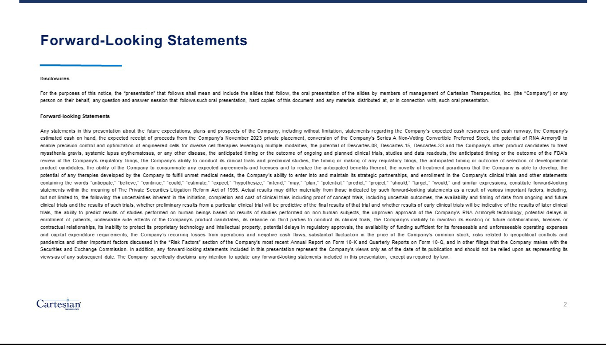

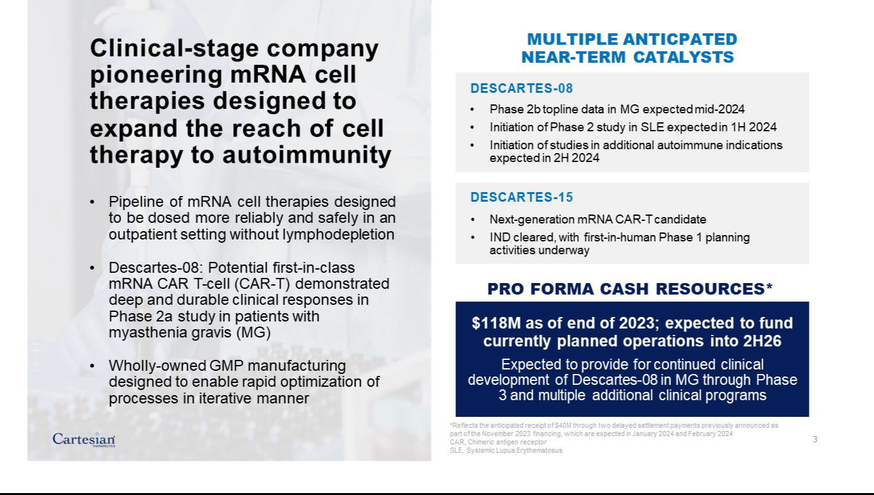

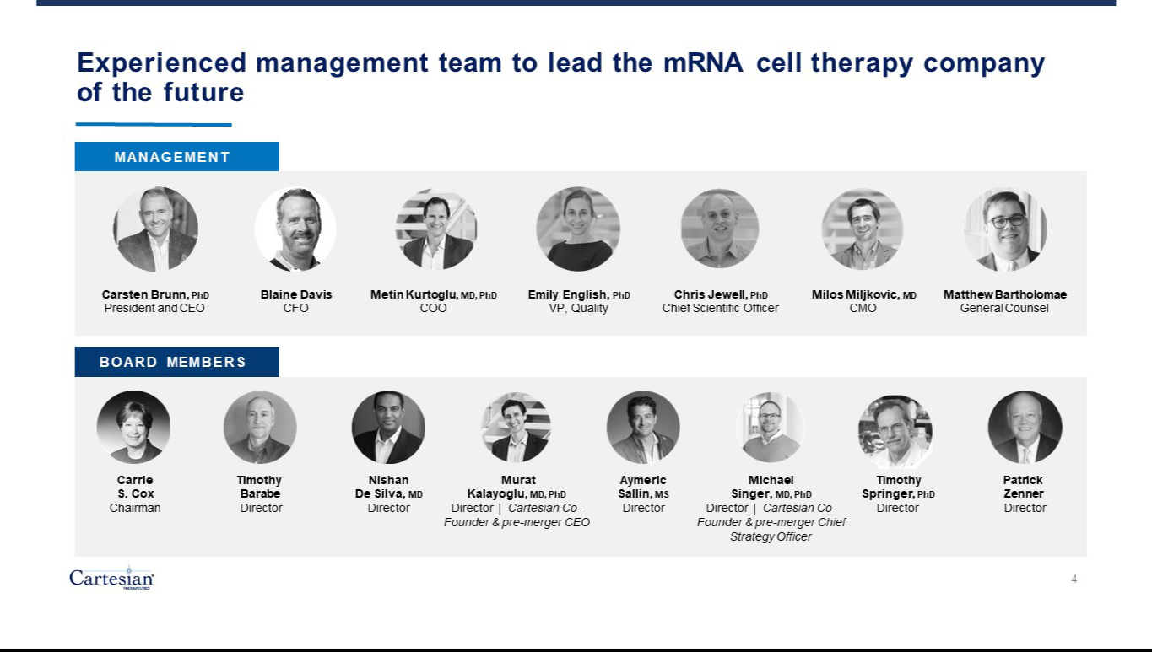

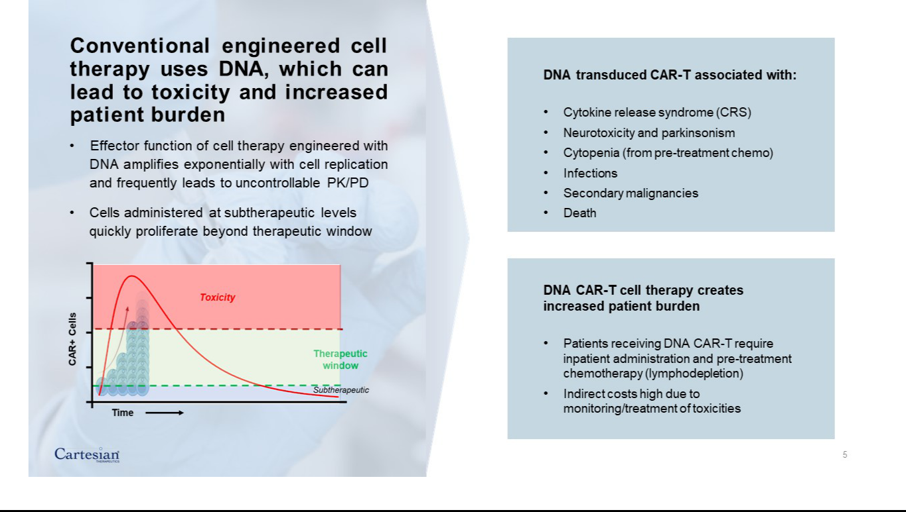

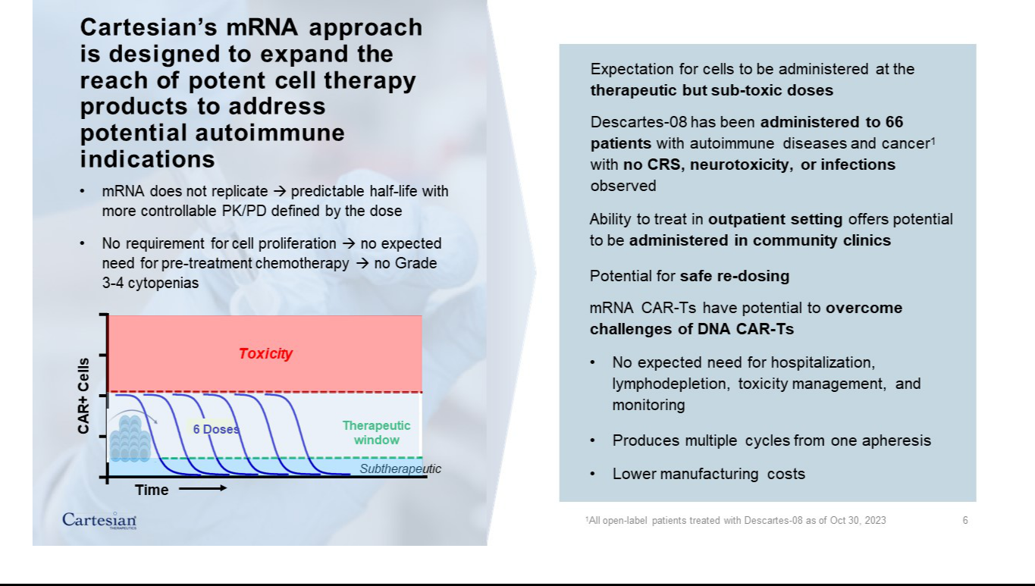

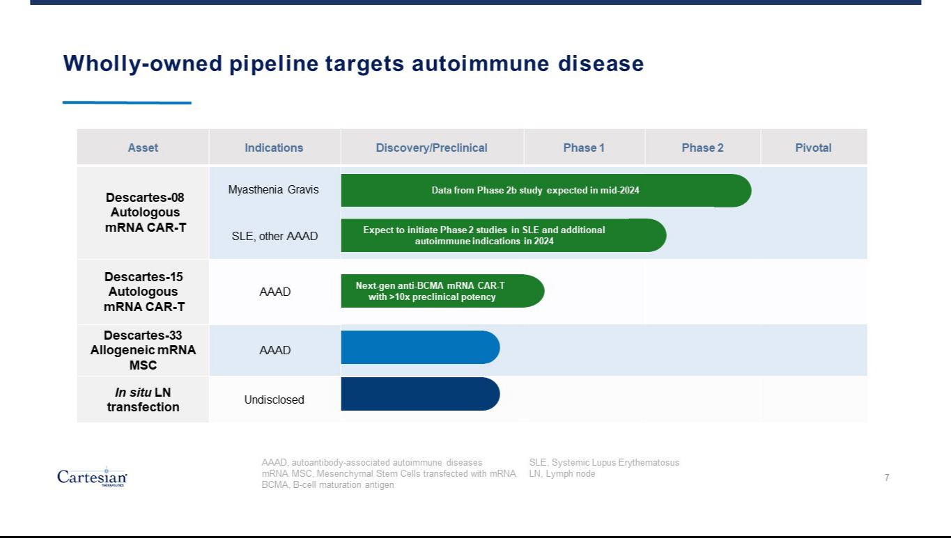

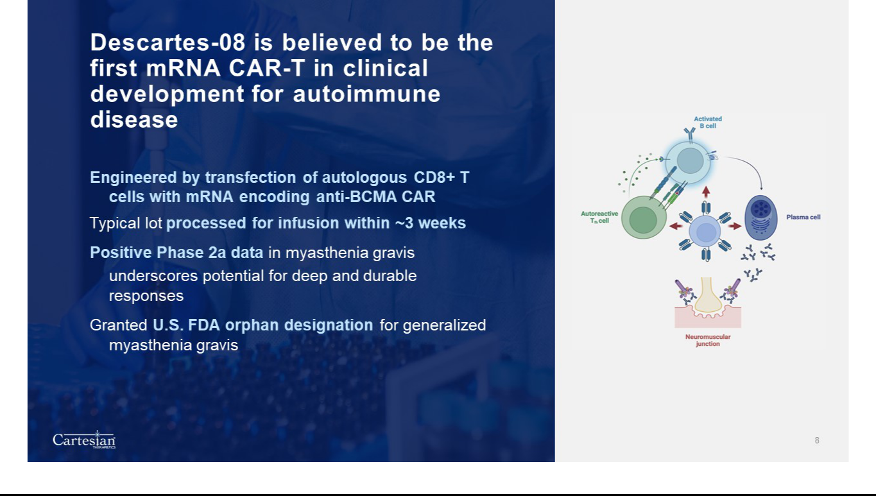

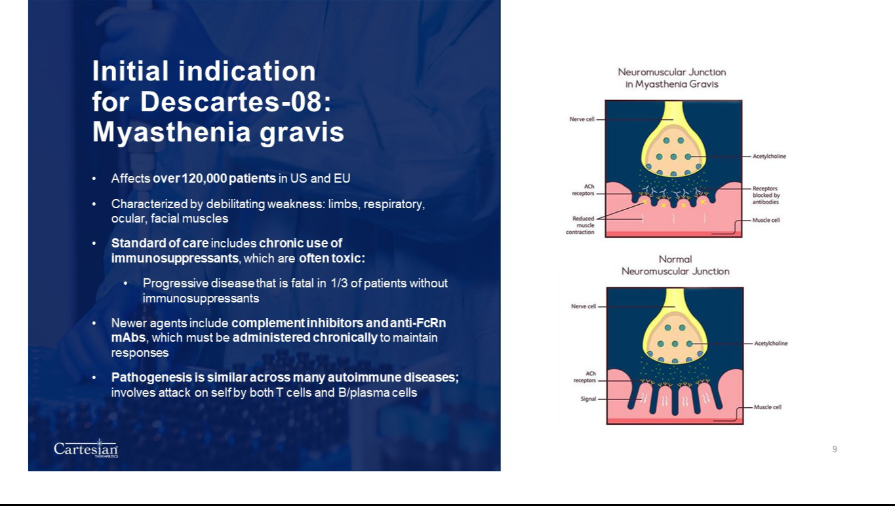

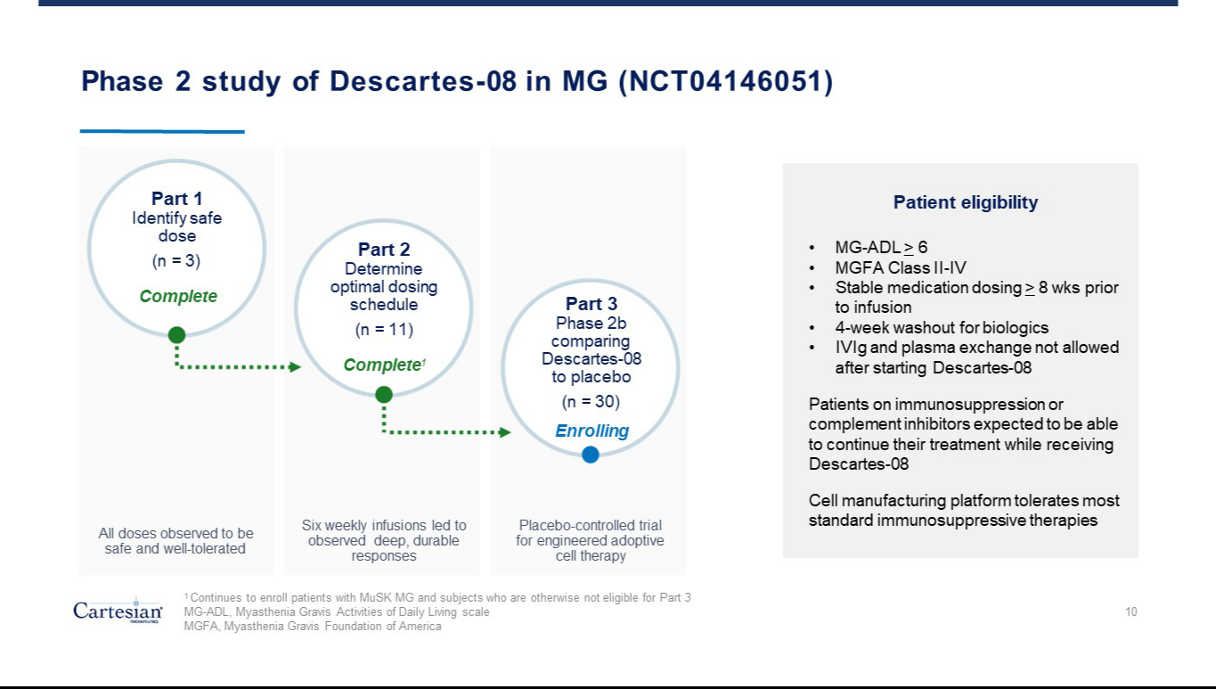

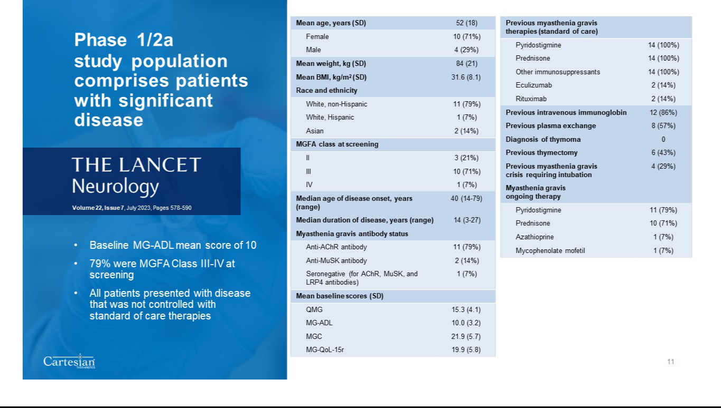

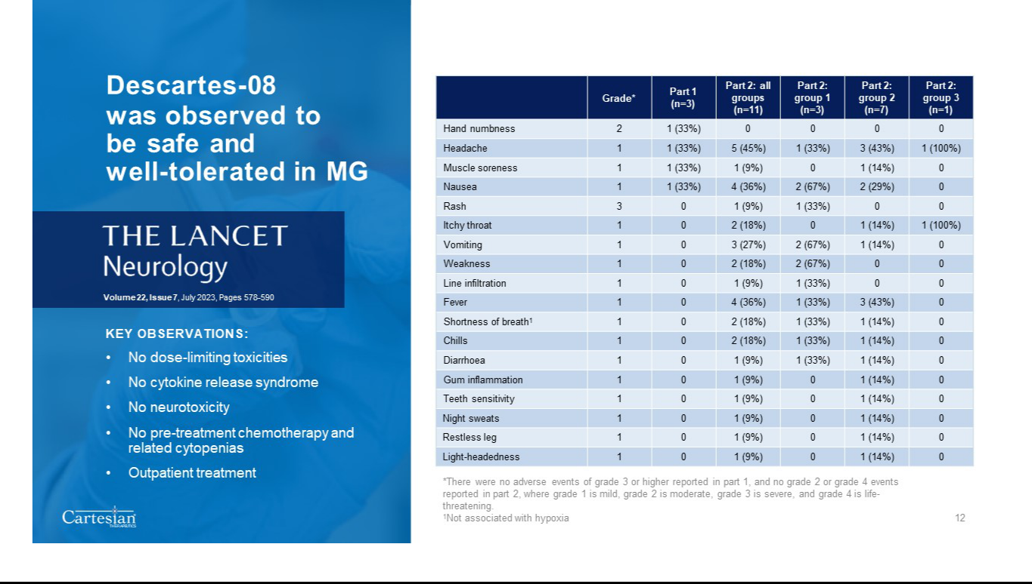

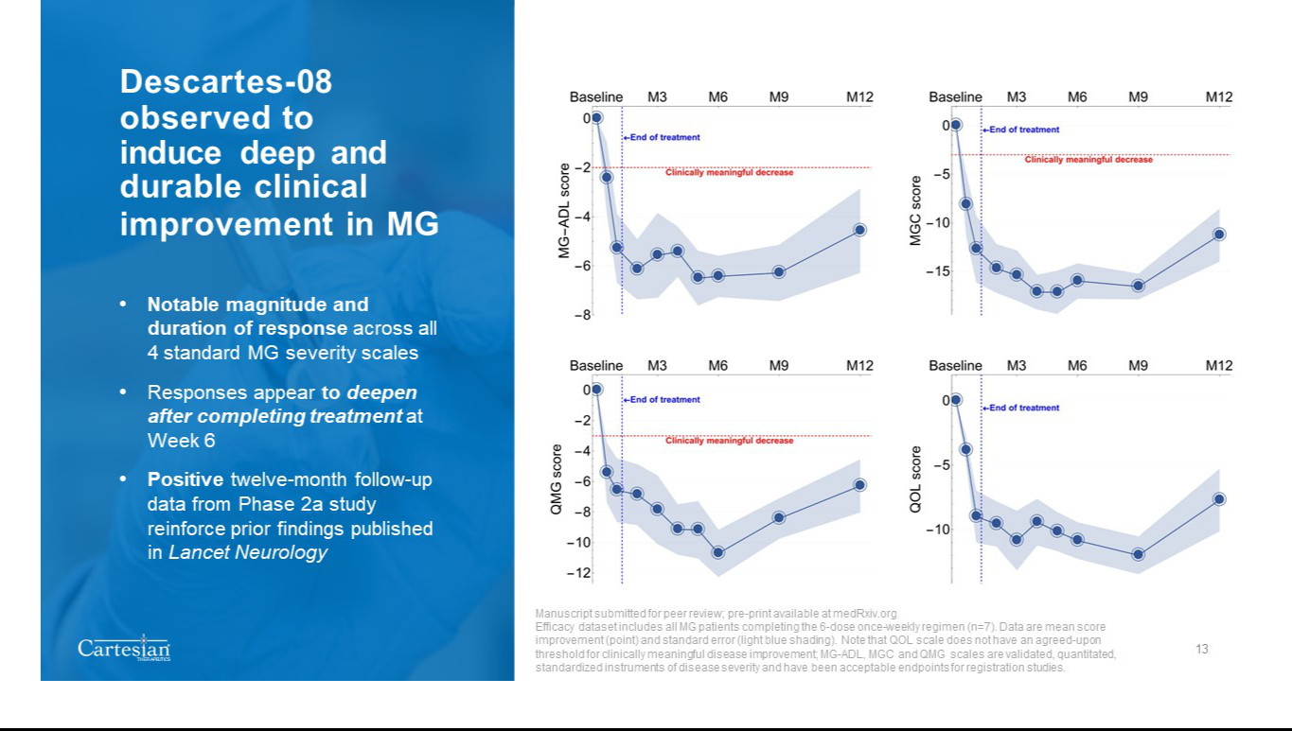

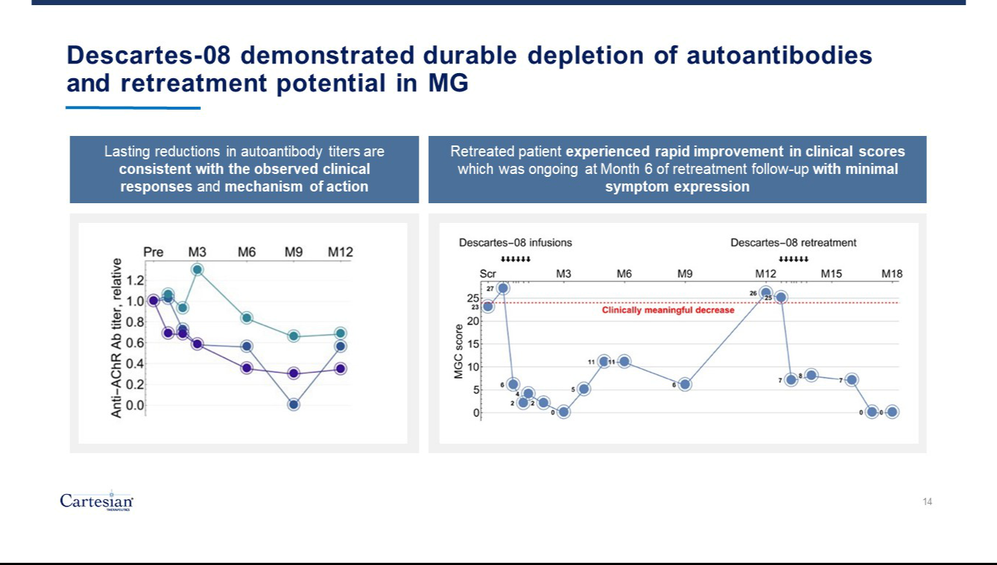

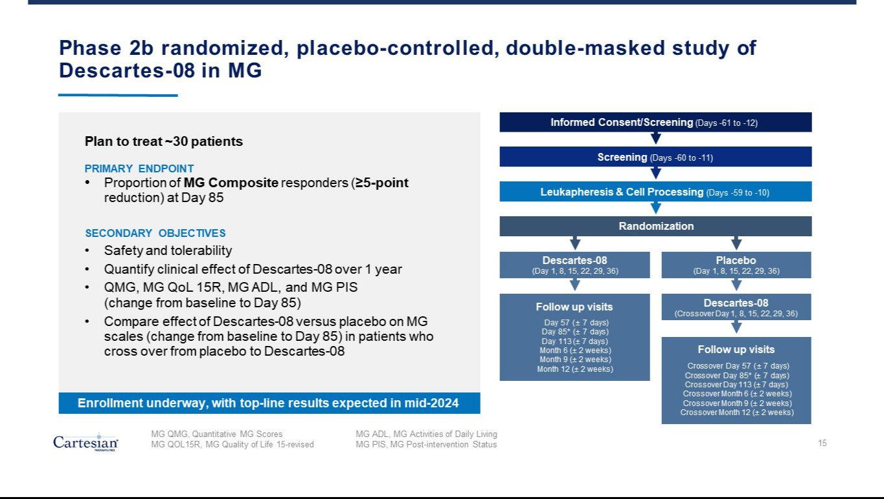

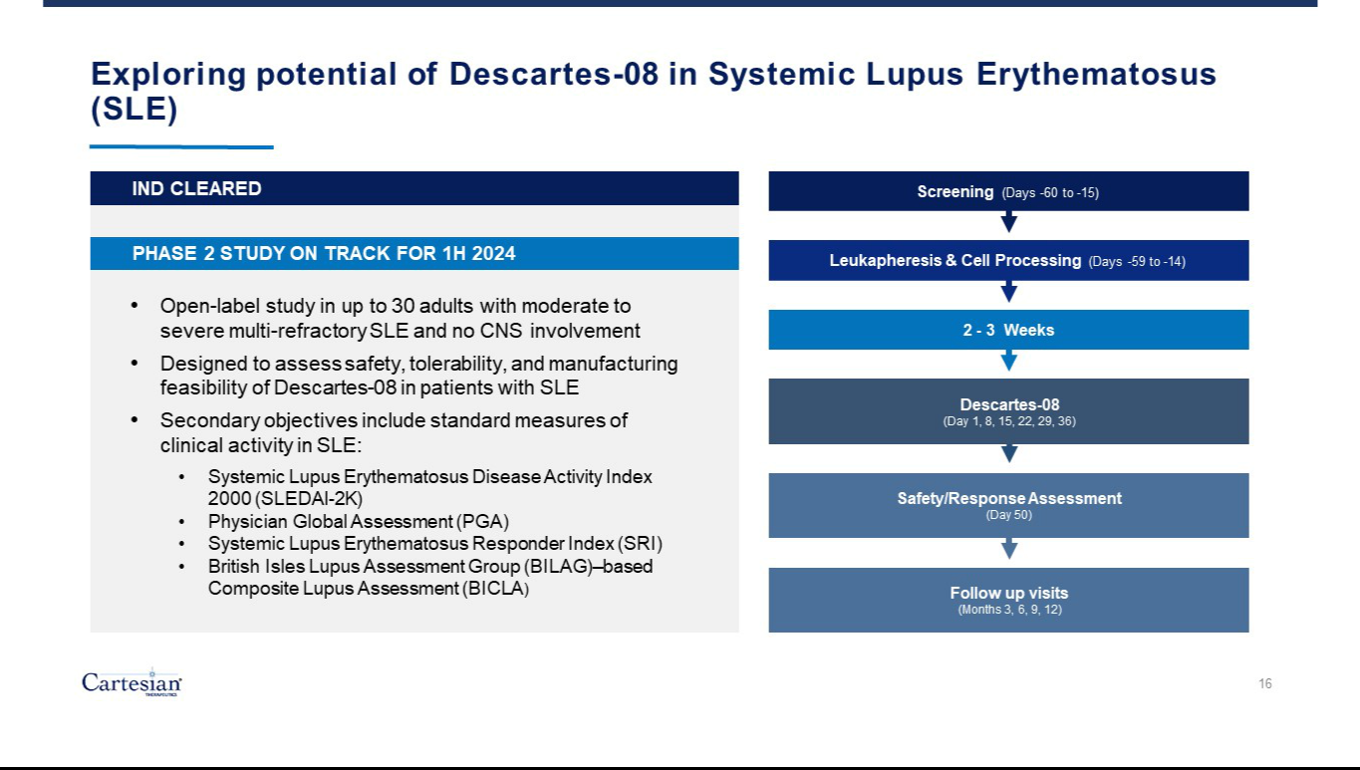

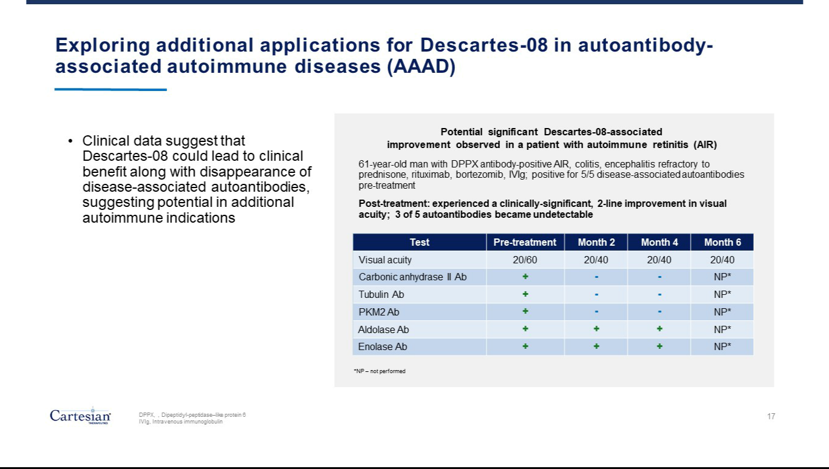

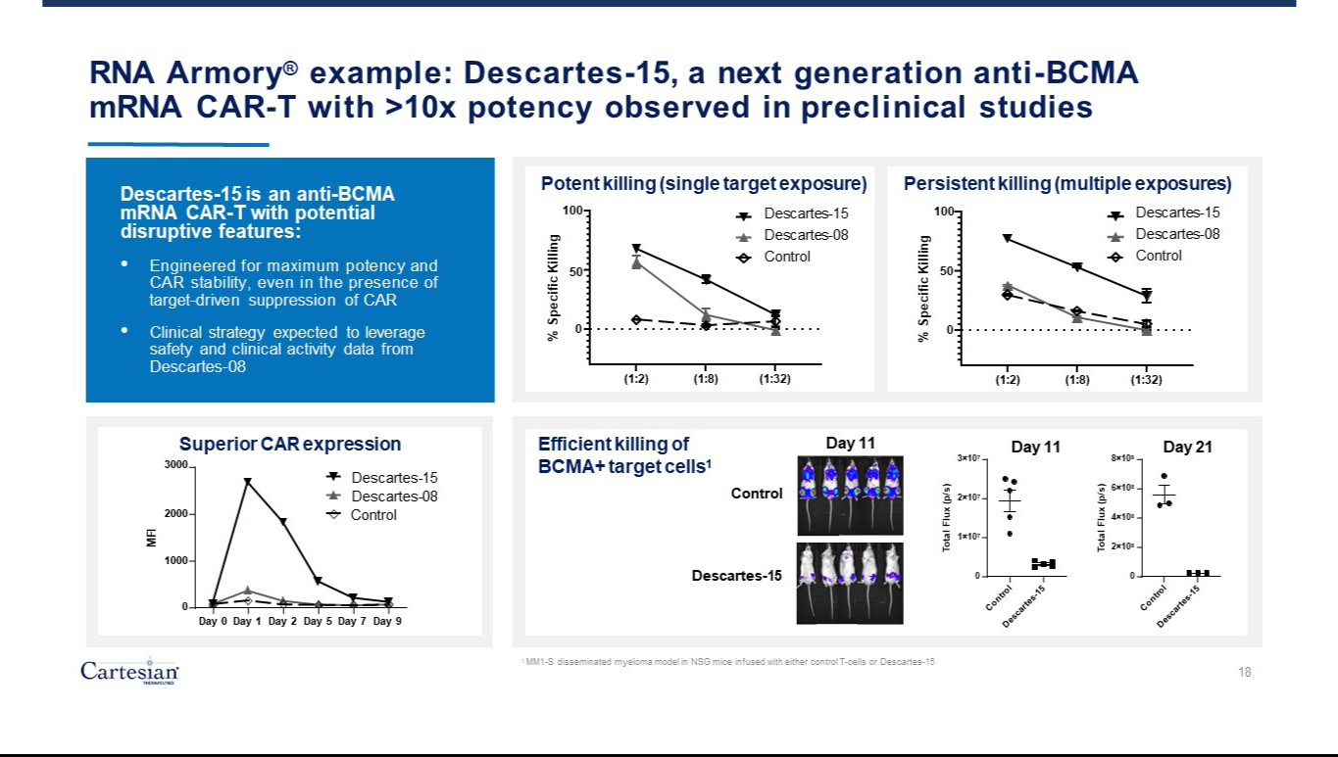

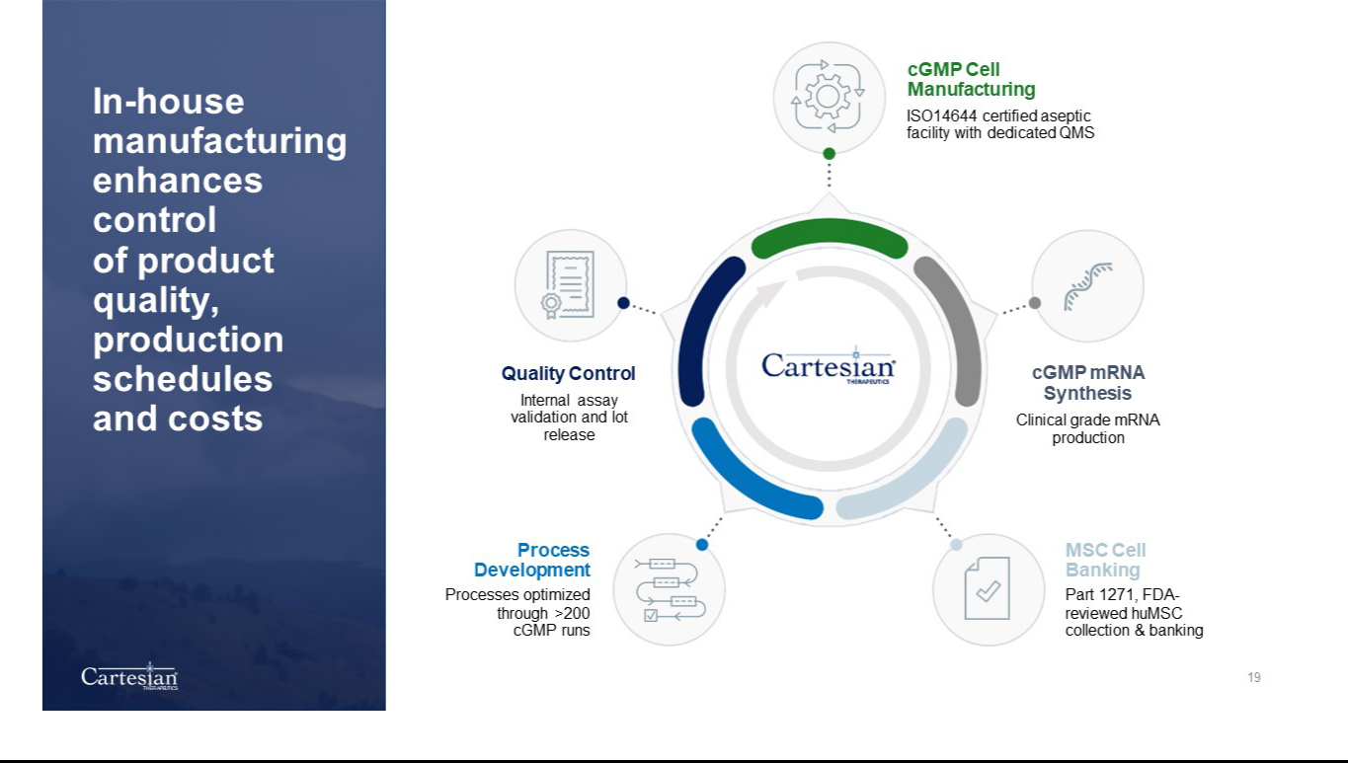

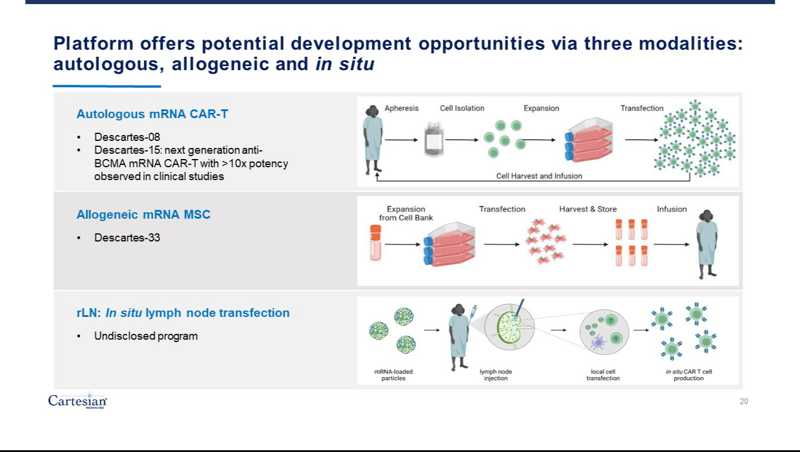

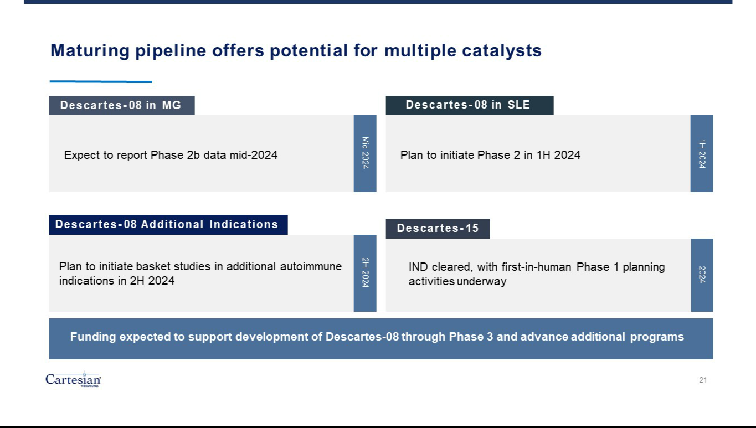

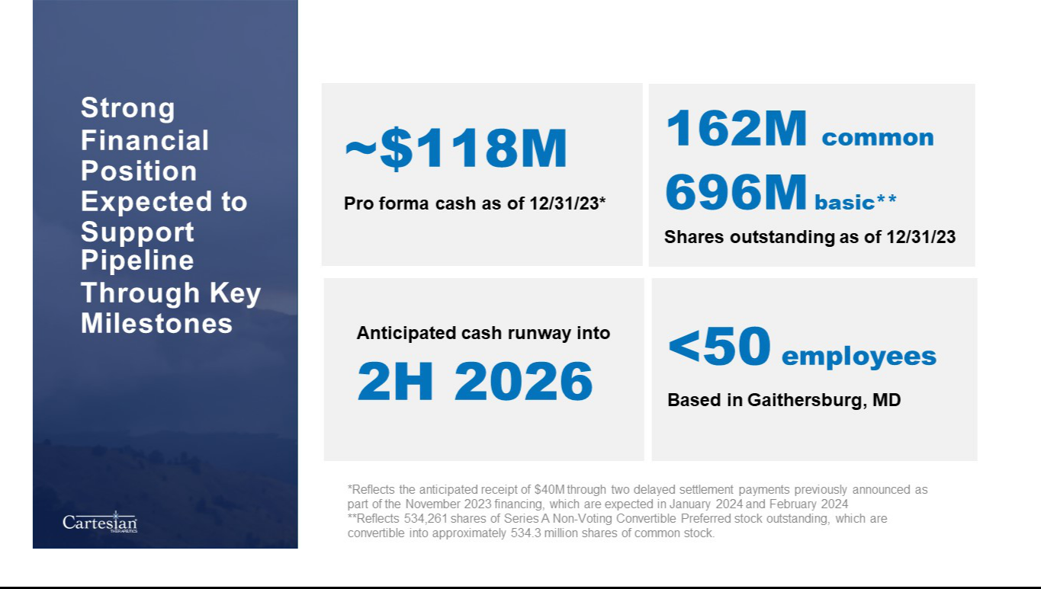

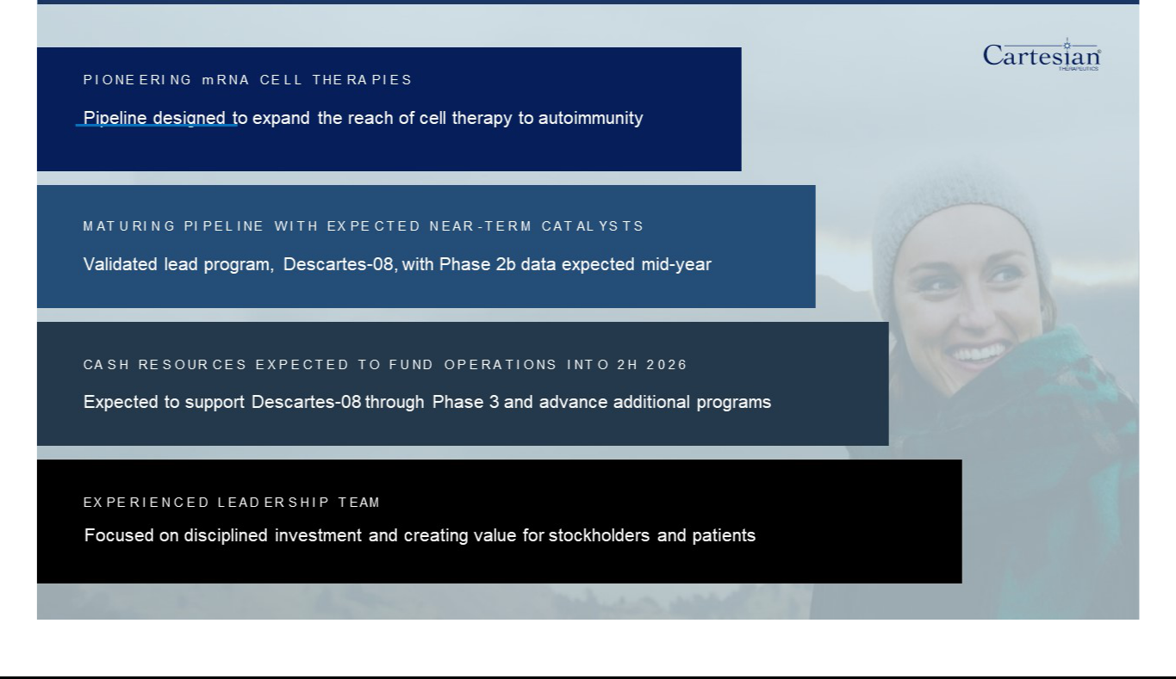

Exhibit 99.2


Cartesian Therapeutics Announces Positive Long-Term Follow-Up Data from Phase 2a Study of Lead mRNA Cell Therapy Candidate Descartes-08 in Patients with Myasthenia Gravis

Durable depletion of autoantibodies and clinically meaningful improvements in myasthenia gravis (MG) severity scores observed after one-year follow-up period without need for lymphodepleting chemotherapy

Descartes-08 observed to be well tolerated following administration in outpatient setting

Publication is in peer review and available on the preprint server, medRxiv

Topline data from Phase 2b placebo-controlled study continues to be expected in mid-2024

GAITHERSBURG, MD, January 8, 2024 (GLOBE NEWSWIRE) – Cartesian Therapeutics, Inc. (NASDAQ: RNAC), (“the Company”) a clinical-stage biotechnology company pioneering mRNA cell therapies for autoimmune diseases, today announced positive twelve-month follow-up data from its Phase 2a trial of Descartes-08 in patients with generalized myasthenia gravis (MG), a chronic autoimmune disorder that causes disabling muscle weakness and fatigue. The manuscript titled, “Twelve-Month Follow-Up of Patients With Generalized Myasthenia Gravis Receiving BCMA-Directed mRNA Cell Therapy”, has been submitted for peer-review and can be accessed on the online preprint server, medRxiv.

Descartes-08, Cartesian’s lead mRNA cell therapy candidate and a potential first-in-class mRNA-engineered chimeric antigen receptor T-cell therapy (mRNA CAR-T), is an autologous anti-B-cell maturation antigen (BCMA) mRNA CAR-T. In contrast to conventional DNA-based CAR T-cell therapies, mRNA CAR-T administration is designed to not require preconditioning chemotherapy and has been observed to have predictable and controllable pharmacokinetics that allow outpatient administration and is designed to avoid the risk of genomic integration and cancer transformation.

“The 12-month data build on the positive data reported earlier this year in The Lancet Neurology, underscoring the potential of Descartes-08 to drive deep and durable responses in patients with MG,” said Milos Miljkovic, M.D., Chief Medical Officer of Cartesian Therapeutics. “Notably, most patients maintained robust, clinically meaningful improvements across all four standard MG severity scores approximately 10 months after the last infusion. In addition, the lasting reductions in autoantibody titers are consistent with the observed clinical responses and the proposed mechanism of action for Descartes-08, supporting the deep and long-lasting effects observed in the study. As the first clinical trial using mRNA CAR-T to treat autoimmunity, the study also highlights the potential of our approach to expand the capabilities of cell therapy to address a variety of autoimmune diseases.”

The Company previously announced positive data from a Phase 1b/2a study of 14 patients with MG who received Descartes-08 in the outpatient setting and without lymphodepletion. In that dataset, Descartes-08 was observed to be safe and well-tolerated and was observed to induce deep and durable responses.

Data reported today are headlined by long-term results from all participants who received a once-weekly infusion for six weeks (N=7) during the Phase 2a portion of the study:
- Descartes-08 was infused in an outpatient setting without lymphodepleting chemotherapy. Throughout the study and long-term follow-up interval, Descartes-08 was well-tolerated, with no dose-limiting toxicities, cytokine release syndrome, or neurotoxicity.
- At Month 9 follow-up, all participants continued to experience marked and long-lasting clinical improvements across four validated MG disease scoring systems: MG Composite, MG Activities of Daily Living, Quantitative MG scores, and Quality of Life 15-revised. These assessments occurred approximately 7 months after the last Descartes-08 infusion, and no participants received new or increased MG-directed drugs during the study period.

- At Month 12, five of the seven participants maintained clinically meaningful improvement in the same four scoring systems. These assessments occurred approximately 10 months after the final Descartes-08 infusion.
- Two participants experienced loss of clinical effect at Month 12 and were eligible for retreatment. One participant was retreated, and experienced rapid improvement in clinical scores, which was ongoing at Month 6 of follow-up with minimal symptom expression.
- All three participants with detectable anti-acetylcholine receptor (AChR) antibody levels at baseline experienced marked anti-AChR antibody reductions by Month 6, which deepened further by Month 9, and were maintained at Month 12.

Enrollment is ongoing in a Phase 2b randomized, double-blind, placebo-controlled trial (NCT04146051) in patients with MG. Topline results are expected in mid-2024.

Descartes-08 has been granted Orphan Drug Designation by the U.S. Food and Drug Administration for the treatment of MG, and Investigational New Drug (IND) allowance to begin trials in patients with an additional autoimmune disease, lupus.

About Cartesian Therapeutics

Cartesian Therapeutics is a clinical-stage company pioneering mRNA cell therapies for the treatment of autoimmune diseases. The Company’s lead asset, Descartes-08, is a potential first-in-class mRNA CAR-T in Phase 2b clinical development for patients with generalized myasthenia gravis. Additional Phase 2 studies are planned in systemic lupus erythematosus under an allowed IND, as well as basket trials in additional autoimmune indications. The Company’s clinical-stage pipeline also includes Descartes-15, a next-generation, autologous anti-BCMA mRNA CAR-T. Cartesian operates a wholly owned, state-of-the-art cGMP manufacturing facility in Gaithersburg, MD.


Forward Looking Statements

Any statements in this press release about the future expectations, plans and prospects of the Company, including without limitation, statements regarding the potential of Descartes-08, Descartes-15, and the Company’s product pipeline to treat MG, ocular autoimmune diseases, vasculitic autoimmune diseases, or any other disease, the anticipated timing or the outcome of ongoing and planned clinical trials, studies and data readouts, the anticipated timing or the outcome of the FDA’s review of the Company’s regulatory filings, the Company’s ability to conduct its clinical trials and preclinical studies, the timing or making of any regulatory filings, the anticipated timing or outcome of selection of developmental product candidates, the potential of any therapies developed by the Company to fulfill unmet medical needs, and enrollment in the Company’s clinical trials and other statements containing the words “anticipate,” “believe,” “continue,” “could,” “estimate,” “expect,” “hypothesize,” “intend,” “may,” “plan,” “potential,” “predict,” “project,” “should,” “target,” “would,” and similar expressions, constitute forward-looking statements within the meaning of The Private Securities Litigation Reform Act of 1995. Actual results may differ materially from those indicated by such forward-looking statements as a result of various important factors, including, but not limited to, the following: the uncertainties inherent in the initiation, completion and cost of clinical trials, including uncertain outcomes, the availability and timing of data from ongoing and future clinical trials and the results of such trials, whether preliminary results from a particular clinical trial will be predictive of the final results of that trial and whether results of early clinical trials will be indicative of the results of later clinical trials, the ability to predict results of studies performed on human beings based on results of studies performed on non-human subjects, the unproven approach of the Company’s RNA Armory® technology, potential delays in enrollment of patients, undesirable side effects of the Company’s product candidates, its reliance on third parties to conduct its clinical trials, the Company’s inability to maintain its existing or future collaborations, licenses or contractual relationships, its inability to protect its proprietary technology and intellectual property, potential delays in regulatory approvals, the availability of funding sufficient for its foreseeable and unforeseeable operating expenses and capital expenditure requirements, the Company’s recurring losses from operations and negative cash flows, substantial fluctuation in the price of the Company’s common stock, risks related to geopolitical conflicts and pandemics and other important factors discussed in the “Risk Factors” section of the Company’s most recent Annual Report on Form 10-K and Quarterly Reports on Form 10-Q, and in other filings that the Company makes with the Securities and Exchange Commission. In addition, any forward-looking statements included in this press release represent the Company’s views only as of the date of its publication and should not be relied upon as representing its views as of any subsequent date. The Company specifically disclaims any intention to update any forward-looking statements included in this press release, except as required by law.

# # #

Contact Information:

Investor Relations:

Melissa Forst

Argot Partners

cartesian@argotpartners.com

Media:

David Rosen

Argot Partners

cartesian@argotpartners.com

Exhibit 99.3

Cartesian Therapeutics Highlights Progress and 2024 Strategic Priorities Across Innovative Pipeline of mRNA Cell Therapies for Autoimmunity

Topline data from Phase 2b study of Descartes-08, the Company’s potential first-in-class mRNA CAR-T cell therapy in myasthenia gravis (MG) remains on track for mid-2024

Positive 12-month follow-up data from Phase 2a study in MG reported today; durable depletion of autoantibodies and clinically meaningful improvements in MG severity scores observed approximately 10 months after last infusion

Phase 2 study of Descartes-08 in systemic lupus erythematosus expected to initiate in 1H24

Clinical pipeline expanded following recent IND clearance for Descartes-15, a next-generation mRNA CAR-T product candidate

Approximately $118M pro forma cash and cash equivalents as of December 31, 2023, expected to support planned operations into second half of 2026

GAITHERSBURG, MD, January 8, 2024 (GLOBE NEWSWIRE) – Cartesian Therapeutics, Inc. (NASDAQ: RNAC) (the “Company”), a clinical-stage biotechnology company pioneering mRNA cell therapy for autoimmune diseases, today highlighted its recent progress and outlined 2024 strategic priorities across its pipeline of mRNA cell therapy product candidates.

“Following a transformative 2023 for Cartesian, we believe we are well-positioned to execute on several potential value-driving milestones anticipated in the year ahead across our growing pipeline of internally manufactured, innovative mRNA cell therapy product candidates,” said Carsten Brunn, Ph.D., President and Chief Executive Officer of Cartesian. “Notably, we continue to expect topline data from the ongoing Phase 2b study of our lead asset, Descartes-08, in patients with myasthenia gravis (MG) in the middle of 2024, which, supported by positive data from the Phase 2a portion of the study, we firmly believe could serve as a meaningful treatment option for patients with MG. We continue to expect the initiation of our Phase 2 study of Descartes-08 in patients with systemic lupus erythematosus (SLE) in the first half of 2024.”

Dr. Brunn added, “Beyond Descartes-08, we are also excited to announce that the U.S. Food and Drug Administration (FDA) recently cleared our investigational new drug (IND) application for Descartes-15, a next-generation mRNA-engineered chimeric antigen receptor T-cell therapy (mRNA CAR-T). We are steadfast in our commitment to delivering meaningful new therapies to patients with autoimmune diseases in areas of high unmet need and look forward to continuing to advance this mission in the coming year.”

Program Updates and Anticipated 2024 Milestones

Cartesian’s internally manufactured portfolio of mRNA cell therapies are purposefully designed to be administered conveniently in an outpatient setting. The Company’s RNA-engineering approach is designed to expand the reach of cell therapy to autoimmunity with potent therapies that can be dosed more reliably and safely in an outpatient setting without lymphodepletion. Cartesian’s proprietary technology platform, RNA Armory®, is designed to enable precision control and optimization of engineered cells for diverse cell therapies leveraging multiple modalities, including autologous, allogeneic, and in situ transfection.


Descartes-08

Descartes-08 is an autologous anti-B cell maturation antigen (BCMA) mRNA CAR-T. Compared to conventional DNA-based CAR T-cell therapies, mRNA CAR-T is designed not to require preconditioning chemotherapy, has been observed to have predictable and controllable pharmacokinetics, and is designed to avoid the risk of genomic integration. Descartes-08 has been granted Orphan Drug Designation by the U.S. FDA for the treatment of MG, a chronic autoimmune disorder that causes disabling muscle weakness and fatigue.

- Enrollment remains ongoing in the Company’s Phase 2b randomized, double-blind, placebo-controlled trial of Descartes-08 in patients with MG (NCT04146051), with topline results expected in mid-2024. In the open label Phase 2a portion of the study, Descartes-08 was administered in an outpatient setting without preconditioning chemotherapy. The drug was observed to be safe, well tolerated, and appeared to lead to deep, durable clinical responses. These results were published earlier this year in The Lancet Neurology.

- In a separate press release issued today, the Company announced positive twelve-month follow-up data from the Phase 2a portion of the Descartes-08 trial in patients with MG. In the study, five out of seven patients maintained clinically meaningful improvements across all four standard MG severity scores approximately 10 months after the last infusion. In addition, all three participants with detectable anti-acetylcholine receptor antibody levels at baseline experienced durable depletion of autoantibodies through the one-year follow-up period. Descartes-08 was observed to be well-tolerated, with no dose-limiting toxicities, cytokine release syndrome, or neurotoxicity.

- The Company remains on track to initiate a Phase 2 study of Descartes-08 in patients with SLE (NCT06038474) in the first half of 2024. SLE is an incurable autoimmune disease marked by systemic inflammation that affects multiple organ systems. It impacts approximately 1.5 million people in the United States. The Phase 2 study, for which the Company has received IND clearance, is designed to assess the safety and tolerability of outpatient Descartes-08 administration without preconditioning chemotherapy.

- Cartesian continues to anticipate the initiation of Phase 2 basket studies in additional autoimmune indications in the second half of 2024. The studies are designed to assess the safety and tolerability of outpatient Descartes-08 administration without preconditioning chemotherapy.

Descartes-15

Descartes-15 is a next-generation, autologous anti-BCMA mRNA CAR-T. In preclinical studies, Descartes-15 was observed to be significantly more potent than Descartes-08. As with Descartes-08, Descartes-15 is designed not to require preconditioning chemotherapy, has been observed to have predictable and controllable pharmacokinetics and is designed to avoid the risk of genomic integration.

- The Company today announced that the U.S. FDA has cleared its IND application for Descartes-15. Planning for a first-in-human Phase 1 dose escalation study is underway. The study will be designed to assess the safety and tolerability of outpatient Descartes-15 administration in patients with multiple myeloma. The Company expects to subsequently assess Descartes-15 in autoimmune indications.

Financial Update

Cartesian ended 2023 with a pro forma cash position of approximately $118 million, which reflects the anticipated receipt of $40 million through two delayed settlement payments previously announced as part of the November 2023 financing, which are expected later this month and in February 2024. The Company’s current pro forma cash balance is expected to support planned operations and the development of Cartesian’s pipeline into the second half of 2026, through the Phase 3 study of lead candidate Descartes-08. As of December 31, 2023, the Company had 161.9 million shares of common stock outstanding and 534,261 shares of Series A Non-Voting Convertible Preferred Stock outstanding, which are convertible into approximately 534.3 million shares of common stock.

About Cartesian Therapeutics

Cartesian Therapeutics is a clinical-stage company pioneering mRNA cell therapies for the treatment of autoimmune diseases. The Company’s lead asset, Descartes-08, is a potential first-in-class mRNA CAR-T in Phase 2b clinical development for patients with generalized myasthenia gravis. Additional Phase 2 studies are planned in systemic lupus erythematosus under an allowed IND, as well as basket trials in additional autoimmune indications. The Company’s clinical-stage pipeline also includes Descartes-15, a next-generation, autologous anti-BCMA mRNA CAR-T. Cartesian operates a wholly owned, state-of-the-art cGMP manufacturing facility in Gaithersburg, MD.

Forward Looking Statements

Any statements in this press release about the future expectations, plans and prospects of the Company, including without limitation, statements regarding the Company’s expected cash resources and cash runway, the Company’s estimated cash on hand, the expected receipt of proceeds from the Company’s November 2023 private placement, conversion of the Company’s Series A Non-Voting Convertible Preferred Stock, the potential of RNA Armory® to enable precision control and optimization of engineered cells for diverse cell therapies leveraging multiple modalities, the potential of Descartes-08, Descartes-15, Descartes-33 and the Company’s other product candidates to treat myasthenia gravis, systemic lupus erythematosus, or any other disease, the anticipated timing or the outcome of ongoing and planned clinical trials, studies and data readouts, the anticipated timing or the outcome of the FDA’s review of the Company’s regulatory filings, the Company’s ability to conduct its clinical trials and preclinical studies, the timing or making of any regulatory filings, the anticipated timing or outcome of selection of developmental product candidates, the ability of the Company to consummate any expected agreements and licenses and to realize the anticipated benefits thereof, the novelty of treatment paradigms that the Company is able to develop, the potential of any therapies developed by the Company to fulfill unmet medical needs, the Company’s ability to enter into and maintain its strategic partnerships, and enrollment in the Company’s clinical trials and other statements containing the words “anticipate,” “believe,” “continue,” “could,” “estimate,” “expect,” “hypothesize,” “intend,” “may,” “plan,” “potential,” “predict,” “project,” “should,” “target,” “would,” and similar expressions, constitute forward-looking statements within the meaning of The Private Securities Litigation Reform Act of 1995. Actual results may differ materially from those indicated by such forward-looking statements as a result of various important factors, including, but not limited to, the following: the uncertainties inherent in the initiation, completion and cost of clinical trials including proof of concept trials, including uncertain outcomes, the availability and timing of data from ongoing and future clinical trials and the results of such trials, whether preliminary results from a particular clinical trial will be predictive of the final results of that trial and whether results of early clinical trials will be indicative of the results of later clinical trials, the ability to predict results of studies performed on human beings based on results of studies performed on non-human subjects, the unproven approach of the Company’s RNA Armory® technology, potential delays in enrollment of patients, undesirable side effects of the Company’s product candidates, its reliance on third parties to conduct its clinical trials, the Company’s inability to maintain its existing or future collaborations, licenses or contractual relationships, its inability to protect its proprietary technology and intellectual property, potential delays in regulatory approvals, the availability of funding sufficient for its foreseeable and unforeseeable operating expenses and capital expenditure requirements, the Company’s recurring losses from operations and negative cash flows, substantial fluctuation in the price of the Company’s common stock, risks related to geopolitical conflicts and pandemics and other important factors discussed in the “Risk Factors” section of the Company’s most recent Annual Report on Form 10-K and Quarterly Reports on Form 10-Q, and in other filings that the Company makes with the Securities and Exchange Commission. In addition, any forward-looking statements included in this press release represent the Company’s views only as of the date of its publication and should not be relied upon as representing its views as of any subsequent date. The Company specifically disclaims any intention to update any forward-looking statements included in this press release, except as required by law.

# # #

Contact Information:

Investor Relations:

Melissa Forst

Argot Partners

cartesian@argotpartners.com

Media:

David Rosen

Argot Partners

cartesian@argotpartners.com

