SEC Form 4

FORM 4

Check this box if no longer subject to Section
- Form 4 or Form 5 obligations may continue. See Instruction 1(b).

UNITED STATES SECURITIES AND EXCHANGE COMMISSION
Washington, D.C. 20549
Washington, D.C. 20549 |  | OMB APPROVAL
STATEMENT OF CHANGES IN BENEFICIAL OWNERSHIP
STATEMENT OF CHANGES IN BENEFICIAL OWNERSHIP |  | OMB Number: | 3235-0287
 |  | Estimated average burden
Filed pursuant to Section 16(a) of the Securities Exchange Act of 1934 |  | hours per response: | 0.5
or Section 30(h) of the Investment Company Act of 1940
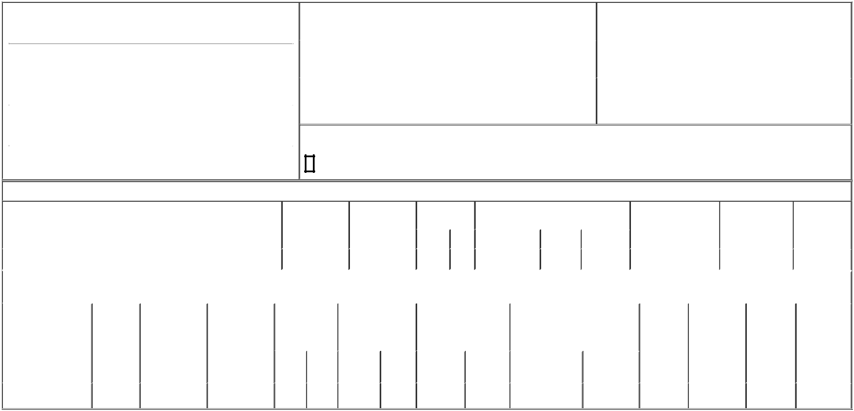

1. Name and Address of Reporting Person*
Kurtoglu Metin

 | (Last) | (First) | (Middle)
 | C/O CARTESIAN THERAPEUTICS, INC.
 | 704 QUINCE ORCHARD ROAD
(Street)
 | GAITHERSBURG | MD | 20878
 | (City) | (State) | (Zip)

2. |  | Issuer Name and Ticker or Trading Symbol |  | 5. Relationship of Reporting Person(s) to Issuer
 | Cartesian Therapeutics, Inc. [ RNAC ] |  |  | (Check all applicable)
 |  |  |  |  | Director | 10% Owner
 |  |  |  | X | Officer (give title | Other (specify below)
3. |  | Date of Earliest Transaction (Month/Day/Year) |  | X | Officer (give title | Other (specify below)
 |  |  |  | X | below) | Other (specify below)
01/02/2024 |  |  |  |  | Chief Operating Officer
4. |  | If Amendment, Date of Original Filed (Month/Day/Year) |  | 6. Individual or Joint/Group Filing (Check Applicable Line)
 |  |  |  | X | Form filed by One Reporting Person
 |  |  |  |  | Form filed by More than One Reporting Person

Rule 10b5-1(c) Transaction Indication

Check this box to indicate that a transaction was made pursuant to a contract, instruction or written plan that is intended to satisfy the affirmative defense conditions of Rule 10b5-1(c). See Instruction 10.

Table I - Non-Derivative Securities Acquired, Disposed of, or Beneficially Owned

 | 1. Title of Security (Instr. 3) |  |  |  | 2. Transaction |  | 2A. Deemed | 3. Transaction |  | 4. Securities Acquired (A) or Disposed Of |  |  |  |  | 5. Amount of Securities |  |  | 6. Ownership |  | 7. Nature of
 |  |  |  |  | Date |  | Execution Date, | Code (Instr. 8) (D) (Instr. 3, 4 and 5) |  |  |  |  |  |  | Beneficially Owned |  |  | Form: Direct (D) or |  | Indirect
 |  |  |  |  | (Month/Day/Year) |  | if any |  |  |  |  |  |  |  | Following Reported |  |  | Indirect (I) (Instr. 4) |  | Beneficial
 |  |  |  |  |  |  | (Month/Day/Year) | Code | V | Amount |  | (A) or (D) | Price |  | Transaction(s) (Instr. 3 |  |  |  |  | Ownership
 |  |  |  |  |  |  |  | Code | V | Amount |  | (A) or (D) |  |  | and 4) |  |  |  |  | (Instr. 4)
 | Common Stock |  |  |  | 01/02/2024 |  |  | _{A}(1) |  | 1,531,000 |  | A | $0 |  | 1,531,000 |  |  |  | D
 |  |  |  | Table II - Derivative Securities Acquired, Disposed of, or Beneficially Owned
 |  |  |  |  | (e.g., puts, calls, warrants, options, convertible securities)
 | 1. Title of Derivative | 2. | 3. Transaction | 3A. Deemed | 4. Transaction | 5. Number of |  | 6. Date Exercisable and |  |  | 7. Title and Amount of Securities |  |  |  |  | 8. Price of | 9. Number of |  | 10. | 11. Nature of
 | Security (Instr. 3) | Conversion | Date | Execution Date, | Code (Instr. 8) | Derivative |  | Expiration Date |  |  | Underlying Derivative Security |  |  |  |  | Derivative | derivative |  | Ownership | Indirect
 |  | or Exercise | (Month/Day/Year) | if any |  | Securities Acquired |  | (Month/Day/Year) |  |  | (Instr. 3 and 4) |  |  |  |  | Security | Securities |  | Form: | Beneficial
 |  | Price of |  | (Month/Day/Year) |  | (A) or Disposed of |  |  |  |  |  |  |  |  |  | (Instr. 5) | Beneficially |  | Direct (D) or | Ownership
 |  | Derivative |  |  |  | (D) (Instr. 3, 4 and 5) |  |  |  |  |  |  |  |  |  |  | Owned |  | Indirect (I) | (Instr. 4)
 |  | Security |  |  |  |  |  |  |  |  |  |  |  |  |  |  | Following |  | (Instr. 4)
 |  |  |  |  |  |  |  |  |  |  |  |  | Amount or |  |  |  | Reported
 |  |  |  |  |  |  |  | Date |  | Expiration |  |  | Number of |  |  |  | Transaction(s)
 |  |  |  |  | Code V | (A) | (D) | Exercisable |  | Date | Title |  | Shares |  |  |  | (Instr. 4)
 | Employee Stock Option | $0.6552 | 01/02/2024 |  | A | 1,965,000 |  | (2) |  | 01/01/2034 | Common Stock |  | 1,965,000 |  | $0 |  | 1,965,000 |  | D
 | (right to buy) | $0.6552 | 01/02/2024 |  | A |  |  | (2)

Explanation of Responses:

- Each Restricted Stock Unit represents a contingent right to receive one share of common stock, which will vest as to 25% on January 2, 2025. The remainder of the underlying shares will vest in three equal annual installments thereafter so that the underlying shares will be fully vested on January 2, 2028.

- This option vests as to 25% on January 2, 2025. The remainder of the underlying shares will vest in three equal annual installments thereafter so that the underlying shares will be fully vested on January 2, 2028.

Remarks:

Exhibit 24 - Power of Attorney

/s/ Matthew Bartholomae, Attorney-in- _{01/04/2024}
Fact for Metin Kurtoglu

** Signature of Reporting Person Date

Reminder: Report on a separate line for each class of securities beneficially owned directly or indirectly.

* If the form is filed by more than one reporting person, see Instruction 4 (b)(v).

- Intentional misstatements or omissions of facts constitute Federal Criminal Violations See 18 U.S.C. 1001 and 15 U.S.C. 78ff(a). Note: File three copies of this Form, one of which must be manually signed. If space is insufficient, see Instruction 6 for procedure.
Persons who respond to the collection of information contained in this form are not required to respond unless the form displays a currently valid OMB Number.



