UNITED STATES SECURITIES AND EXCHANGE COMMISSION

WASHINGTON, D.C. 20549

FORM 10-Q

- QUARTERLY REPORT PURSUANT TO SECTION 13 OR 15(d) OF THE SECURITIES EXCHANGE ACT OF 1934

For the quarterly period ended March 31, 2026

OR

- TRANSITION REPORT PURSUANT TO SECTION 13 OR 15(d) OF THE SECURITIES EXCHANGE ACT OF 1934

For the transition period from _______ to _______

Commission File Number: 001-37798

Cartesian Therapeutics, Inc.

 | (Exact name of registrant as specified in its charter)
Delaware |  |  |  |  |  | 26-1622110
(State or other jurisdiction |  |  |  |  |  | (I.R.S. Employer Identification No.)
of incorporation or organization)
7495 New Horizon Way, Frederick, MD |  |  |  |  |  | 21703
(Address of principal executive offices) |  |  |  |  |  | (Zip Code)
 | (301) 348-8698
 | (Registrant’s telephone number, including area code)
Securities registered pursuant to Section 12(b) of the Act:
Title of each class |  | Trading Symbol(s) |  |  |  | Name of each exchange on which registered
Common Stock, $0.0001 par value per share |  |  | RNAC |  |  | The Nasdaq Stock Market LLC
Securities registered pursuant to Section 12(g) of the Act:
 |  | Title of each class
 |  | Contingent Value Rights

Indicate by check mark whether the registrant (1) has filed all reports required to be filed by Section 13 or 15(d) of the Securities Exchange Act of 1934 during the preceding 12 months (or for such shorter period that the registrant was required to file such reports), and (2) has been subject to such filing requirements for the past 90 days. Yes ☑ No ☐

Indicate by check mark whether the registrant has submitted electronically every Interactive Data File required to be submitted pursuant to Rule 405 of Regulation S-T (§232.405 of this chapter) during the preceding 12 months (or for such shorter period that the registrant was required to submit such files). Yes ☑ No ☐

Indicate by check mark whether the registrant is a large accelerated filer, an accelerated filer, a non-accelerated filer, smaller reporting company, or an emerging growth company. See the definitions of “large accelerated filer,” “accelerated filer,” “smaller reporting company,” and “emerging growth company” in Rule 12b-2 of the Exchange Act.

Large accelerated filer | ☐ | Accelerated filer | ☐
Non-accelerated filer | ☑ | Smaller reporting company | ☑
 |  | Emerging growth company | ☐

If an emerging growth company, indicate by check mark if the registrant has elected not to use the extended transition period for complying with any new or revised financial accounting standards provided pursuant to Section 13(a) of the Exchange Act. ☐

Indicate by check mark whether the registrant is a shell company (as defined in Rule 12b-2 of the Exchange Act). Yes ☐ No ☑ As of April 23, 2026, the registrant had 29,381,514 shares of common stock, par value $0.0001 per share, outstanding.

1

 |  |  |  |  |  |  |  |  |  |  |  |  |  | TABLE OF CONTENTS
 |  |  |  |  |  |  |  |  |  |  |  | PART I. FINANCIAL INFORMATION
 | Item 1. |  |  | Financial Statements (unaudited) |  |  |  |  |  |  |  |  |  |  |  |  |  |  |  |  |  | 5
 |  |  |  | Consolidated Balance Sheets as of March 31, 2026 and December 31, 2025 |  |  |  |  |  |  |  |  |  |  |  |  |  |  |  |  |  | 5
 |  |  |  | Consolidated Statements of Operations and Comprehensive Loss for the Three Months ended March 31, 2026 and 2025 |  |  |  |  |  |  |  |  |  |  |  |  |  |  |  |  |  | 6
 |  |  |  | Consolidated Statements of Changes in Stockholders’ Deficit for the Three Months ended March 31, 2026 and 2025 |  |  |  |  |  |  |  |  |  |  |  |  |  |  |  |  |  | 7
 |  |  |  | Consolidated Statements of Cash Flows for the Three Months ended March 31, 2026 and 2025 |  |  |  |  |  |  |  |  |  |  |  |  |  |  |  |  |  | 9
 |  |  |  | Notes to Consolidated Financial Statements |  |  |  |  |  |  |  |  |  |  |  |  |  |  |  |  |  | 10
 | Item 2. |  |  | Management's Discussion and Analysis of Financial Condition and Results of Operations |  |  |  |  |  |  |  |  |  |  |  |  |  |  |  |  |  | 23
 | Item 3. |  |  | Quantitative and Qualitative Disclosures About Market Risk |  |  |  |  |  |  |  |  |  |  |  |  |  |  |  |  |  | 31
 | Item 4. |  |  | Controls and Procedures |  |  |  |  |  |  |  |  |  |  |  |  |  |  |  |  |  | 31
 |  |  |  |  |  |  |  |  |  |  |  |  |  | PART II. OTHER INFORMATION
 | Item 1. |  |  | Legal Proceedings |  |  |  |  |  |  |  |  |  |  |  |  |  |  |  |  |  | 32
 | Item 1A. |  |  | Risk Factors |  |  |  |  |  |  |  |  |  |  |  |  |  |  |  |  |  | 32
 | Item 2. |  |  | Unregistered Sales of Equity Securities and Use of Proceeds |  |  |  |  |  |  |  |  |  |  |  |  |  |  |  |  |  | 32
 | Item 3. |  |  | Defaults Upon Senior Securities |  |  |  |  |  |  |  |  |  |  |  |  |  |  |  |  |  | 32
 | Item 4. |  |  | Mine Safety Disclosures |  |  |  |  |  |  |  |  |  |  |  |  |  |  |  |  |  | 32
 | Item 5. |  |  | Other Information |  |  |  |  |  |  |  |  |  |  |  |  |  |  |  |  |  | 32
 | Item 6. |  |  | Exhibits |  |  |  |  |  |  |  |  |  |  |  |  |  |  |  |  |  | 33
 |  |  |  | Signatures
 |  |  |  | 2

FORWARD-LOOKING STATEMENTS

This Quarterly Report on Form 10-Q, or the Quarterly Report, contains forward-looking statements. We intend such forward-looking statements to be covered by the safe harbor provisions for forward-looking statements contained in Section 27A of the Securities Act of 1933, as amended, or the Securities Act, and Section 21E of the Securities Exchange Act of 1934, as amended, or the Exchange Act. All statements other than statements of historical facts contained in this Quarterly Report, including statements regarding our future results of operations and financial position, business strategy, prospective products, product approvals, research and development costs, timing and likelihood of success, the plans and objectives of management for future operations and future results of anticipated products, the impact of future pandemics or similar events on our business and operations and our future financial results, and the period over which we estimate our existing cash and cash equivalents will be sufficient to fund our future operating expenses and capital expenditure requirements are forward-looking statements. These statements involve known and unknown risks, uncertainties and other important factors that may cause our actual results, performance or achievements to be materially different from any future results, performance or achievements expressed or implied by the forward-looking statements.

In some cases, you can identify forward-looking statements by terms such as “may,” “will,” “should,” “expect,” “plan,” “anticipate,” “could,” “intend,” “target,” “project,” “contemplate,” “believe,” “estimate,” “predict,” “potential”, or “continue” or the negative of these terms or other similar expressions. The forward-looking statements in this Quarterly Report are only predictions. We have based these forward-looking statements largely on our current expectations and projections about future events and financial trends that we believe may affect our business, financial condition and results of operations. These forward-looking statements speak only as of the date of this Quarterly Report and are subject to a number of important factors that could cause actual results to differ materially from those in the forward-looking statements, including the factors described under the sections in this Quarterly Report titled “Risk Factors” and “Management’s Discussion and Analysis of Financial Condition and Results of Operations” as well as the following:

- our future results of operations and financial position, business strategy, and the length of time that we believe our existing cash resources will fund our operations;

- our market size and our potential growth opportunities;

- our preclinical and clinical development activities;

- our dependence on third-parties, including contract research organizations in the conduct of our pre-clinical studies and clinical trials;

- the efficacy and safety profile of our product candidates;

- the potential therapeutic benefits and economic value of our product candidates;

- the timing and results of preclinical studies and clinical trials;

- the potential impairment of our goodwill and indefinite lived intangible assets;

- the expected impact of macroeconomic conditions, including inflation, increasing interest rates, volatile market conditions and current or potential bank failures;

- the impact of global events, including the ongoing conflicts between Russia and Ukraine, the ongoing conflict in the Middle East and geopolitical tensions with China;

- the impact of political uncertainty on our product development;

- the receipt and timing of potential regulatory designations, approvals and commercialization of our product candidates;

- our ability to prevent or minimize the effects of litigation and other contingencies;

- our status as a development-stage company and our expectation to incur losses in the future, and the possibility that we never achieve or maintain profitability;

- uncertainties with respect to our ability to access future capital;

- our ability to maximize the value of our pipeline of product candidates;

- our unproven approach to therapeutic intervention;

3

- our ability to enroll patients in clinical trials, timely and successfully complete those trials and receive necessary regulatory approvals;

- our ability to continue to grow our manufacturing capabilities and resources;

- our ability to manufacture our product candidates, which in some cases are manufactured on a patient-by-patient basis;

- our ability to receive or manufacture sufficient quantities of our product candidates;

- our ability to maintain our existing or future collaborations or licenses and to seek new collaborations, licenses or partnerships;

- our ability to protect and enforce our intellectual property rights;

- federal, state, and foreign regulatory requirements, including U.S. Food and Drug Administration, or FDA, regulation of our product candidates;

- our ability to obtain and retain key executives and retain qualified personnel;

- developments relating to our competitors and our industry;

- any future payouts under the contingent value right, or CVR, issued to our holders of record as of the close of business on December 4, 2023; and

- our ability to monetize any of our legacy assets.

Moreover, we operate in an evolving environment. New risks and uncertainties may emerge from time to time, and it is not possible for management to predict all risk and uncertainties.

You should read this Quarterly Report and the documents that we reference in this Quarterly Report completely and with the understanding that our actual future results may be materially different from what we expect. We qualify all of our forward-looking statements by these cautionary statements. Except as required by applicable law, we do not plan to publicly update or revise any forward-looking statements contained herein, whether as a result of any new information, future events, changed circumstances or otherwise.

4

 | Table of Contents
 |  | PART I. FINANCIAL INFORMATION
 | Item 1. Financial Statements (unaudited)
 |  | Cartesian Therapeutics, Inc. and Subsidiaries
 |  | Consolidated Balance Sheets
 |  | (Amounts in thousands, except share data and par value)
 |  |  |  | March 31, |  |  | December 31,
 |  |  |  | 2026 |  |  | 2025
Assets
Current assets:
Cash and cash equivalents |  |  | $ | 118,641 |  | $ | 125,139
Accounts receivable |  |  |  | 261 |  |  | 1,115
Prepaid expenses and other current assets |  |  |  | 3,137 |  |  | 3,022
Total current assets |  |  |  | 122,039 |  |  | 129,276
Property and equipment, net |  |  |  | 11,637 |  |  | 12,185
Right-of-use assets, net |  |  |  | 5,366 |  |  | 5,601
In-process research and development asset |  |  |  | 93,900 |  |  | 93,900
Goodwill |  |  |  | 48,163 |  |  | 48,163
Long-term restricted cash |  |  |  | 1,735 |  |  | 1,735
Long-term prepaid expenses and other assets |  |  |  | 5,551 |  |  | 5,551
 | Total assets |  | $ | 288,391 |  | $ | 296,411
Liabilities and stockholders’ deficit
Current liabilities:
Accounts payable |  |  | $ | 1,598 |  | $ | 1,288
Accrued expenses and other current liabilities |  |  |  | 10,161 |  |  | 9,498
Lease liabilities |  |  |  | 4,186 |  |  | 4,151
Total current liabilities |  |  |  | 15,945 |  |  | 14,937
Lease liabilities, net of current portion |  |  |  | 7,669 |  |  | 8,525
Warrant liability |  |  |  | 47 |  |  | 141
Contingent value right liability |  |  |  | 405,900 |  |  | 392,100
Deferred tax liabilities, net |  |  |  | 6,948 |  |  | 6,948
 | Total liabilities |  |  | 436,509 |  |  | 422,651
Commitments and contingencies (Note 14)
Stockholders’ deficit:
Series A Preferred Stock, $0.0001 par value; 134,904.563 shares authorized as of March 31, 2026 and December 31, 2025; 120,790.402 shares
issued and outstanding as of March 31, 2026 and December 31, 2025 |  |  |  | — |  |  | —
Series B Preferred Stock, $0.0001 par value; 437,927 shares authorized as of March 31, 2026 and December 31, 2025; 437,927 shares issued
and outstanding as of March 31, 2026 and December 31, 2025 |  |  |  | — |  |  | —
Preferred stock, $0.0001 par value; 9,427,168.437 shares authorized as of March 31, 2026 and December 31, 2025; no shares issued and
outstanding as of March 31, 2026 and December 31, 2025 |  |  |  | — |  |  | —
Common stock, $0.0001 par value; 350,000,000 shares authorized as of March 31, 2026 and December 31, 2025; 28,544,728 and 26,011,106
shares issued and outstanding as of March 31, 2026 and December 31, 2025, respectively |  |  |  | 3 |  |  | 3
Additional paid-in capital |  |  |  | 718,017 |  |  | 700,706
Accumulated deficit |  |  |  | (861,555) |  |  | (822,373)
Accumulated other comprehensive loss |  |  |  | (4,583) |  |  | (4,576)
Total stockholders’ deficit |  |  |  | (148,118) |  |  | (126,240)
 | Total liabilities and stockholders’ deficit |  | $ | 288,391 |  | $ | 296,411

The accompanying notes are an integral part of these unaudited consolidated financial statements.

5

 | Table of Contents
 |  | Cartesian Therapeutics, Inc. and Subsidiaries
 |  | Consolidated Statements of Operations and Comprehensive Loss
 |  | (Amounts in thousands, except share and per share data)
 |  |  |  | Three Months Ended March 31,
 |  |  |  | 2026 |  |  | 2025
Revenues:
Collaboration and license |  |  | $ | — |  | $ | 400
Grant |  |  |  | 78 |  |  | 700
Total revenues |  |  |  | 78 |  |  | 1,100
Operating expenses:
Research and development |  |  |  | 19,463 |  |  | 14,674
General and administrative |  |  |  | 7,114 |  |  | 8,315
Total operating expenses |  |  |  | 26,577 |  |  | 22,989
Operating loss |  |  |  | (26,499) |  |  | (21,889)
Other (expense) income:
Interest income |  |  |  | 1,026 |  |  | 2,015
Gain on change in fair value of warrant liabilities |  |  |  | 94 |  |  | 1,818
(Loss) gain on change in fair value of contingent value right liability |  |  |  | (13,800) |  |  | 346
Other expense, net |  |  |  | (3) |  |  | —
Total other (expense) income, net |  |  |  | (12,683) |  |  | 4,179
Net loss |  |  | $ | (39,182) |  | $ | (17,710)
Other comprehensive (loss) income:
Foreign currency translation adjustment |  |  |  | (7) |  |  | 32
Total comprehensive loss |  |  | $ | (39,189) |  | $ | (17,678)
Net loss |  |  | $ | (39,182) |  | $ | (17,710)
Net loss per share allocable to common stockholders:
Basic and diluted |  |  | $ | (1.46) |  | $ | (0.68)
Weighted-average common shares outstanding:
Basic and diluted |  |  |  | 26,855,158 |  |  | 25,902,650

The accompanying notes are an integral part of these unaudited consolidated financial statements.

6

Table of Contents

Cartesian Therapeutics, Inc. and Subsidiaries

Consolidated Statements of Changes in Stockholders’ Deficit

(Amounts in thousands, except share data)

 | Series A |  |  |  | Series B
 | Preferred Stock |  |  |  | Preferred Stock
 | Shares |  | Amount |  | Shares |  | Amount
Balance at December 31, 2025 | 120,790.402 | $ | — |  | 437,927 | $ | —
Issuance of common stock upon exercise of options
Issuance of common stock upon exercise of options | — |  | — |  | — |  | —
Issuance of common stock upon vesting of restricted
stock units | — |  | — |  | — |  | —
Issuance of common stock through at the market
offering, net of commissions and expenses | — |  | — |  | — |  | —
Stock-based compensation expense | — |  | — |  | — |  | —
Currency translation adjustment | — |  | — |  | — |  | —
Net loss | — |  | — |  | — |  | —
Balance at March 31, 2026 | 120,790.402 | $ | — |  | 437,927 | $ | —

 |  |  |  | Additional |  |  |  |  |  | Accumulated
Common stock |  |  |  |  |  |  |  |  |  |  | other
 |  |  |  |  | paid-in |  | Accumulated |  |  | comprehensive |  |  | Stockholders’
Shares |  | Amount |  |  | capital |  |  | deficit |  |  | loss |  |  | deficit
26,011,106 | $ | 3 |  | $ | 700,706 |  | $ | (822,373) |  | $ | (4,576) |  | $ | (126,240)
93,632 |  | — |  |  | 304 |  |  | — |  |  | — |  |  | 304
169,278 |  | — |  |  | — |  |  | — |  |  | — |  |  | —
2,270,712 |  | — |  |  | 14,584 |  |  | — |  |  | — |  |  | 14,584
— |  | — |  |  | 2,423 |  |  | — |  |  | — |  |  | 2,423
— |  | — |  |  | — |  |  | — |  |  | (7) |  |  | (7)
— |  | — |  |  | — |  |  | (39,182) |  |  | — |  |  | (39,182)
28,544,728 | $ | 3 |  | $ | 718,017 |  | $ | (861,555) |  | $ | (4,583) |  | $ | (148,118)

The accompanying notes are an integral part of these unaudited consolidated financial statements.

7

 | Table of Contents
 |  |  |  |  | Cartesian Therapeutics, Inc. and Subsidiaries
 |  |  |  | Consolidated Statements of Changes in Stockholders’ Deficit
 |  |  |  |  | (Amounts in thousands, except share data)
 |  |  | Series A |  |  |  | Series B |  |  |  |  |  |  |  | Additional |  |  |  |  |  | Accumulated
 |  |  | Preferred Stock |  |  |  | Preferred Stock |  |  |  | Common stock |  |  |  |  |  |  |  |  |  |  | other
 |  |  |  |  |  |  |  |  |  |  |  |  |  |  |  | paid-in |  | Accumulated |  |  | comprehensive |  |  | Stockholders’
 |  |  | Shares | Amount |  |  | Shares |  | Amount |  | Shares |  | Amount |  |  | capital |  |  | deficit |  |  | loss |  |  | deficit
Balance at December 31, 2024 |  |  | 120,790.402 | $ | — |  | 437,927 | $ | — |  | 25,767,369 | $ | 3 |  | $ | 689,887 |  | $ | (692,071) |  | $ | (4,621) |  | $ | (6,802)
Issuance of common stock upon exercise of options
 |  |  | — |  | — |  | — |  | — |  | 55,690 |  | — |  |  | 183 |  |  | — |  |  | — |  |  | 183
Issuance of vested restricted stock units |  |  | — |  | — |  | — |  | — |  | 113,042 |  | — |  |  | — |  |  | — |  |  | — |  |  | —
Stock-based compensation expense |  |  | — |  | — |  | — |  | — |  | — |  | — |  |  | 2,508 |  |  | — |  |  | — |  |  | 2,508
Currency translation adjustment |  |  | — |  | — |  | — |  | — |  | — |  | — |  |  | — |  |  | — |  |  | 32 |  |  | 32
Net loss |  |  | — |  | — |  | — |  | — |  | — |  | — |  |  | — |  |  | (17,710) |  |  | — |  |  | (17,710)
Balance at March 31, 2025 |  |  | 120,790.402 | $ | — |  | 437,927 | $ | — |  | 25,936,101 | $ | 3 |  | $ | 692,578 |  | $ | (709,781) |  | $ | (4,589) |  | $ | (21,789)

The accompanying notes are an integral part of these unaudited consolidated financial statements.

8

 | Table of Contents
 |  |  | Cartesian Therapeutics, Inc. and Subsidiaries
 |  |  | Consolidated Statements of Cash Flows
 |  |  | (Amounts in thousands)
 |  |  |  | Three Months Ended March 31,
 |  |  |  | 2026 |  |  | 2025
Cash flows from operating activities
Net loss |  |  | $ |  | (39,182) |  | $ | (17,710)
Adjustments to reconcile net loss to net cash used in operating activities:
Depreciation and amortization |  |  |  |  | 615 |  |  | 1,156
Non‑cash lease expense |  |  |  |  | 235 |  |  | 184
Stock‑based compensation expense |  |  |  |  | 2,423 |  |  | 2,508
Gain on change in warrant liability |  |  |  |  | (94) |  |  | (1,818)
Loss (gain) on change in fair value of CVR liability |  |  |  |  | 13,800 |  |  | (346)
Changes in operating assets and liabilities:
Accounts receivable |  |  |  |  | 854 |  |  | (893)
Prepaid expenses and other assets |  |  |  |  | (246) |  |  | (5,830)
Accounts payable |  |  |  |  | 310 |  |  | 1,819
Accrued expenses and other liabilities |  |  |  |  | (850) |  |  | (2,178)
 | Net cash used in operating activities |  |  |  | (22,135) |  |  | (23,108)
Cash flows from investing activities
Purchases of property and equipment |  |  |  |  | (27) |  |  | (1,075)
 | Net cash used in investing activities |  |  |  | (27) |  |  | (1,075)
Cash flows from financing activities
Equity offering costs |  |  |  |  | — |  |  | (454)
Proceeds from exercise of stock options |  |  |  |  | 279 |  |  | 183
Proceeds from at the market offering, net of commissions and expenses |  |  |  |  | 15,392 |  |  | —
Distribution of Contingent Value Rights |  |  |  |  | — |  |  | (7,754)
 | Net cash provided by (used in) financing activities |  |  |  | 15,671 |  |  | (8,025)
Effect of exchange rate changes on cash |  |  |  |  | (7) |  |  | 32
Net change in cash, cash equivalents, and restricted cash |  |  |  |  | (6,498) |  |  | (32,176)
Cash, cash equivalents and restricted cash at beginning of period |  |  |  |  | 126,874 |  |  | 214,279
Cash, cash equivalents and restricted cash at end of period |  |  |  | $ | 120,376 |  | $ | 182,103
Non-cash investing and financing activities
Purchase of property and equipment not yet paid |  |  | $ |  | 59 |  | $ | 535
Equity offering costs in accrued liabilities |  |  | $ |  | 707 |  | $ | —

The accompanying notes are an integral part of these unaudited consolidated financial statements.

9

Table of Contents

Cartesian Therapeutics, Inc. and Subsidiaries

Notes to Consolidated Financial Statements

1. Description of the Business

Cartesian Therapeutics, Inc., or the Company, was incorporated in Delaware on December 10, 2007, and is headquartered in Frederick, Maryland. The Company is a late clinical-stage biotechnology company pioneering cell therapy for the treatment of autoimmune diseases. The Company leverages its proprietary technology and manufacturing platform to introduce mRNA into cells to provide a therapeutic effect to patients suffering from a variety of autoimmune conditions. Unlike DNA, mRNA degrades naturally over time without integrating into the cell’s genetic material. The Company’s cell therapies are designed to be dosed repeatedly like conventional drugs, administered in an outpatient setting and given without pre-treatment chemotherapy, which is required with many conventional cell therapies.

The Company’s Product Candidates

The Company aims to provide a personalized approach to treating patients that begins with the collection of a patient’s cells, which are then used to manufacture the Company’s cell therapy product candidates. Once a patient’s cells have expanded in the Company’s process, mRNA is introduced to deliver a chimeric antigen receptor into the cell. Once the manufacturing process is complete, the product candidate is sent back to the treating physician where they administer six weekly infusions of the Company’s cell therapy candidate to the patient. The Company’s product candidates are specifically designed to target and destroy the pathogenic, self-reactive cells that are the underlying cause of the autoimmune disease, with the goal of creating a precision immune reset for the patient.

Descartes-08, the Company’s lead cell therapy product candidate, is an autologous chimeric antigen receptor T-cell therapy, or CAR-T, product targeting B-cell maturation antigen, or BCMA, in clinical development for the treatment of generalized myasthenia gravis, or MG, and myositis, specifically, moderate to severe multi-refractory dermatomyositis and antisynthetase syndrome. In contrast to conventional DNA-based CAR T-cell therapies, the Company’s CAR-T administration is designed to not require preconditioning chemotherapy, to be administered in the outpatient setting and does not carry the risk of genomic integration associated with cancerous transformation. Descartes-08 has been granted Orphan Drug Designation and Regenerative Medicine Advanced Therapy Designation by the U.S. Food and Drug Administration, or FDA, for the treatment of MG, and Rare Pediatric Disease Designation for the treatment of juvenile dermatomyositis.

Liquidity and Management’s Plan

As of March 31, 2026, the Company had an accumulated deficit of $861.6 million. The Company anticipates operating losses to continue for the foreseeable future due to, among other things, costs related to research and development of its product candidates and its administrative organization. The future success of the Company is dependent on its ability to develop its product candidates and ultimately upon its ability to attain and sustain profitable operations. The successful development of product candidates requires substantial working capital, which may not be available to the Company on favorable terms or at all.

As of March 31, 2026, the Company’s cash, cash equivalents, and restricted cash were $120.4 million, of which $1.7 million was restricted cash related to lease commitments. The Company believes the cash, cash equivalents and restricted cash as of March 31, 2026 will enable it to fund its current planned operations for at least the next 12 months.

Further, the liability associated with the CVR Agreement (as defined below) will be settled solely through cash flow received under the Company’s License and Development Agreement, or as so amended, the Sobi License, with Swedish Orphan Biovitrum AB (publ.), or Sobi, and any other Gross Proceeds (as defined in the CVR Agreement) net of certain agreed deductions. Under the CVR Agreement, 100% of all milestone payments, royalties and other amounts paid to the Company or controlled entities under the Sobi License, and any other Gross Proceeds will be distributed, net of specified deductions, to holders of the CVRs. There is no obligation to the Company to fund any amount related to the CVR liability. See Note 5, “Fair Value Measurements”.

If the Company is unable to obtain additional funding on a timely basis, it may be forced to significantly curtail, delay, or discontinue one or more of its planned research or development programs or be unable to expand its operations or otherwise capitalize on its commercialization of its product candidates.

- Summary of Significant Accounting Policies Basis of presentation and consolidation

The consolidated financial statements include the accounts of the Company and its wholly owned subsidiaries, Selecta (RUS), LLC, or Selecta (RUS), a Russian limited liability corporation, and Cartesian Bio, LLC, a Delaware limited liability

10

Table of Contents

company, which is a variable interest entity for which the Company is the primary beneficiary and have been prepared in conformity with accounting principles generally accepted in the United States of America, or U.S. GAAP. Any reference in these notes to applicable guidance is meant to refer to the authoritative United States generally accepted accounting principles as found in the relevant Accounting Standards Codification, or ASC and Accounting Standards Update, or ASU, of the Financial Accounting Standards Board, or FASB. All significant intercompany accounts and transactions have been eliminated.

The accompanying unaudited consolidated financial statements for the three months ended March 31, 2026 and 2025 have been prepared by the Company pursuant to the rules and regulations of the Securities and Exchange Commission, or the SEC, for interim financial statements. Certain information and footnote disclosures normally included in financial statements prepared in accordance with U.S. GAAP have been condensed or omitted pursuant to such rules and regulations. These consolidated financial statements should be read in conjunction with the Company’s audited consolidated financial statements and the notes thereto for the year ended December 31, 2025 included in the Company’s Annual Report on Form 10-K that was filed with the SEC on March 9, 2026. The unaudited interim financial statements have been prepared on the same basis as the audited consolidated financial statements. In the opinion of management, the accompanying unaudited interim consolidated financial statements contain all adjustments that are necessary for a fair statement of the Company’s financial position as of March 31, 2026, the consolidated results of operations for the three months ended March 31, 2026, and cash flows for the three months ended March 31, 2026. Such adjustments are of a normal and recurring nature. The results of operations for the three months ended March 31, 2026 are not necessarily indicative of the results of operations that may be expected for the year ending December 31, 2026.

Significant accounting policies

The Company disclosed its significant accounting policies in Note 2, “Summary of Significant Accounting Policies” included in the Company’s Annual Report on Form 10-K for the year ended December 31, 2025. There have been no material changes to the Company’s significant accounting policies during the three months ended March 31, 2026.

Recent Accounting Pronouncements

Not Yet Adopted

In November 2024, the FASB issued ASU 2024-03, Income Statement Reporting- Comprehensive Income- Expense Disaggregation Disclosures (ASU 2024-03), which requires public companies to disclose, in interim and annual reporting periods, additional information about certain expenses in notes to financial statements, including purchases of inventory, employee compensation, depreciation, amortization of intangible assets, and selling expenses. This guidance will be effective for the annual period beginning the year ended December 31, 2027 and for interim periods beginning January 1, 2028, with early adoption permitted. The Company is currently evaluating the impact of the standard’s adoption on its consolidated financial statements and related disclosures.

In December 2025, the FASB issued ASU 2025-10, Government Grants (Topic 832): Accounting for Government Grants Received by Business Entities (ASU 2025-10), which establishes authoritative guidance on the recognition, measurement, presentation, and disclosure of government grants. Under ASU 2025-10, government grants are recognized when it is probable that the entity will both comply with the conditions of the grant and the grant will be received. The ASU provides specific accounting models for grants related to assets and grants related to income, including options to recognize government grants as deferred income or as a reduction of the asset’s cost basis. The ASU also requires enhanced disclosures regarding the nature of government grants, significant terms and conditions, accounting policies applied, and amounts recognized in the financial statements. ASU 2025-10 is effective for fiscal years beginning after December 15, 2028, including interim periods within those fiscal years, with early adoption permitted. The Company is currently evaluating the impact of adopting ASU 2025-10 on its consolidated financial statements and related disclosures.

In December 2025, the FASB issued ASU 2025-11, Interim Reporting (Topic 270): Narrow-Scope Improvements (ASU 2025-11), which clarifies the guidance in Topic 270 to improve the consistency of interim financial reporting. The ASU provides a comprehensive list of required interim disclosures and introduces a disclosure principle requiring entities to disclose events since the end of the last annual reporting period that have a material impact on the entity. ASU 2025-11 is effective for fiscal years beginning after December 15, 2027, including interim periods within those fiscal years, with early adoption permitted. The Company is currently evaluating the impact of adopting ASU 2025-11 on its consolidated financial statements and related disclosures.

11

Table of Contents

3. Goodwill and Indefinite-Lived Intangible Assets

As of March 31, 2026, the Company has goodwill of approximately $48.2 million and an indefinite-lived intangible asset of $93.9 million related to Descartes-08 for MG.

There were no changes to the carrying value of the Company’s goodwill or in-process research and development asset related to Descartes-08 for MG during the three months ended March 31, 2026 and 2025.

4. Net Loss Per Share Allocable to Common Stockholders

The following table sets forth the computation of basic and diluted net loss per share allocable to common stockholders for the three months ended March 31, 2026 and 2025 (in thousands, except share and per-share data):

 |  | Three Months Ended March 31,
 |  | 2026 |  |  | 2025
Numerator:
Net loss | $ | (39,182) |  | $ | (17,710)
Denominator:
Weighted-average common shares outstanding - basic and diluted |  | 26,855,158 |  |  | 25,902,650
Net loss per share allocable to common stockholders:
Basic and diluted | $ | (1.46) |  | $ | (0.68)

The following table represents the potential dilutive shares of common stock excluded from the computation of the diluted net loss per share allocable to common stockholders for all periods presented, as the effect would have been anti-dilutive:

 |  | Three Months Ended March 31,
 |  | 2026 |  | 2025
Common stock options and restricted stock units |  | 4,278,679 |  | 3,047,628
Warrants to purchase common stock | 692,272 |  |  | 692,523
Series A Preferred Stock | 4,026,346 |  |  | 4,026,346
Series B Preferred Stock | 437,927 |  |  | 437,927
Total |  | 9,435,224 |  | 8,204,424
 | 12

Table of Contents

5. Fair Value Measurements

The following tables present the Company’s assets and liabilities that are measured at fair value on a recurring basis as of March 31, 2026 and December 31, 2025 (in thousands):

 |  |  |  |  | March 31, 2026
 |  | Total |  |  | Level 1 |  | Level 2 |  |  |  | Level 3
Assets:
Money market funds (included in cash equivalents) | $ | 117,674 |  | $ | 117,674 |  | $ | — |  | $ | —
Total assets | $ | 117,674 |  | $ | 117,674 |  | $ | — |  | $ | —
Liabilities:
Warrant liability | $ | 47 |  | $ | — |  | $ | — |  | $ | 47
Contingent value right liability |  | 405,900 |  |  | — |  |  | — |  |  | 405,900
Total liabilities | $ | 405,947 |  | $ | — |  | $ | — |  | $ | 405,947

 |  |  |  |  | December 31, 2025
 |  | Total |  |  | Level 1 |  | Level 2 |  |  |  | Level 3
Assets:
Money market funds (included in cash equivalents) | $ | 122,724 |  | $ | 122,724 |  | $ | — |  | $ | —
Total assets | $ | 122,724 |  | $ | 122,724 |  | $ | — |  | $ | —
Liabilities:
Warrant liability | $ | 141 |  | $ | — |  | $ | — |  | $ | 141
Contingent value right liability |  | 392,100 |  |  | — |  |  | — |  |  | 392,100
Total liabilities | $ | 392,241 |  | $ | — |  | $ | — |  | $ | 392,241

There were no transfers within the fair value hierarchy during the three months ended March 31, 2026 or the year ended December 31, 2025.

Cash, Cash Equivalents, and Restricted Cash

As of March 31, 2026 and December 31, 2025, money market funds were classified as cash and cash equivalents on the accompanying consolidated balance sheets as they mature within 90 days from the date of purchase.

As of March 31, 2026, the Company had restricted cash balances relating to secured letters of credit in connection with its real estate leases. The Company’s consolidated statements of cash flows include the following as of March 31, 2026 and 2025 (in thousands):

 |  | March 31,
 | 2026 |  |  |  | 2025
Cash and cash equivalents | $ | 118,641 |  | $ | 180,434
Long-term restricted cash |  | 1,735 |  |  | 1,669
Total cash, cash equivalents, and restricted cash | $ | 120,376 |  | $ | 182,103

Warrants to Purchase Common Stock

In April 2022, the Company issued warrants in connection with an underwritten offering, or the 2022 Warrants. Pursuant to the terms of the 2022 Warrants, the Company could be required to settle the 2022 Warrants in cash in the event of an acquisition of the Company under certain circumstances and, as a result, the 2022 Warrants are required to be measured at fair value and reported as a liability on the balance sheet.

The Company recorded the fair value of the 2022 Warrants upon issuance using the Black-Scholes valuation model and is required to revalue the 2022 Warrants at each reporting date, with any changes in fair value recorded in the statements of operations and comprehensive loss. The valuation of the 2022 Warrants is classified as Level 3 of the fair value hierarchy due to the need to use assumptions in the valuation that are both significant to the fair value measurement and unobservable,

13

Table of Contents

including the stock price volatility and the expected life of the 2022 Warrants. Generally, increases (decreases) in the fair value of the underlying stock and estimated term would result in a directionally similar impact to the fair value measurement.

The estimated fair value of the 2022 Warrants was determined using the following inputs to the Black-Scholes simulation valuation:

- Estimated fair value of the underlying stock. The Company estimates the fair value of the common stock based on the closing stock price at the end of each reporting period.

- Risk-free interest rate. The risk-free interest rate is based on the U.S. Treasury at the valuation date commensurate with the expected remaining life assumption.

- Dividend rate. The dividend rate is based on the historical rate, which the Company anticipates will remain at zero.

- Expected life. The expected life of the 2022 Warrants is assumed to be equivalent to their remaining contractual term which expires on April 11, 2027.

- Volatility. The Company estimates stock price volatility based on the Company’s historical volatility for a period of time commensurate with the expected remaining life of the 2022 Warrants.

A summary of the Black-Scholes pricing model assumptions used to record the fair value of the 2022 Warrants liability is as follows:
 | March 31, 2026 |  | December 31, 2025
Risk-free interest rate | 3.68% |  | 3.48%
Dividend yield | — |  | —
Expected life (in years) | 1.03 |  | 1.28
Expected volatility | 89.14% |  | 87.36%

The following table reflects a roll-forward of fair value for the Company’s Level 3 warrant liabilities (see Note 9, “Equity” to these unaudited consolidated financial statements) for the three months ended March 31, 2026 (in thousands):

 |  | Warrant Liability
Fair value as of December 31, 2025 | $ | 141
Change in fair value |  | (94)
Fair value as of March 31, 2026 | $ | 47

Contingent Value Right

In December 2023, the Company entered into a contingent value rights agreement, or the CVR Agreement, pursuant to which each holder of common stock or a 2022 Warrant in December 2023 was distributed a CVR by the Company. Each CVR entitles its holder to distributions of milestone and royalty payments under the Sobi License, net of deductions. See Note 6, “Fair Value Measurements” to the consolidated financial statements included in the Company’s Annual Report on Form 10-K for the year ended December 31, 2025 for further discussion of the terms related to the CVR Agreement.

The CVRs represent financial instruments that are accounted for under the fair value option election in ASC 825, Financial Instruments, or ASC 825. Under the fair value option election, the CVRs are initially measured at the aggregate estimated fair value of the CVRs and will be subsequently remeasured at estimated fair value on a recurring basis at each reporting period date. The estimated fair value of the CVR liability was determined using a Monte Carlo simulation model to estimate future cash flows associated with the legacy assets, including the expected milestone and royalty payments under the Sobi License, net of deductions. Changes in fair value of the CVR liability are presented in the consolidated statements of operations and comprehensive loss. The liability value is based on significant inputs not observable in the market such as estimated cash flows, estimated probabilities of success, and expected volatility of future revenues, which represent a Level 3 measurement within the fair value hierarchy. The significant inputs used to estimate the fair value of the CVR liability, which represented a financial instrument being accounted for under the fair value option, were as follows:

14

 | Table of Contents
 |  |  | March 31, 2026 |  | December 31, 2025
Estimated cash flow dates |  |  | 2026 - 2038 |  | 2026 - 2037
Estimated probability of success |  |  | 95.0% - 100.0% |  | 95.0% - 100.0%
Expected volatility of future revenues |  |  | 23.0% |  | 23.0%

The following table reflects a roll-forward of fair value for the Company’s Level 3 CVR liability for the three months ended March 31, 2026 (in thousands):

 |  |  |  |  | CVR Liability
Fair value as of December 31, 2025 |  |  |  | $ | 392,100
Change in fair value |  |  |  |  | 13,800
Fair value as of March 31, 2026 |  |  |  | $ | 405,900
6. Property and Equipment
Property and equipment consists of the following (in thousands):
 |  | March 31, 2026 |  |  | December 31, 2025
Laboratory equipment | $ | 9,323 |  | $ | 8,419
Computer equipment and software |  | 417 |  |  | 417
Leasehold improvements |  | 6,709 |  |  | 4,177
Furniture and fixtures |  | 307 |  |  | 269
Office equipment |  | 170 |  |  | 170
Construction in process |  | 59 |  |  | 3,466
Total property and equipment |  | 16,985 |  |  | 16,918
Less: Accumulated depreciation |  | (5,348) |  |  | (4,733)
Property and equipment, net | $ | 11,637 |  | $ | 12,185
Depreciation expense was $0.6 million for each of the three months ended March 31, 2026 and 2025, respectively.
7. Accrued Expenses
Accrued expenses consist of the following (in thousands):
 |  | March 31, 2026 |  |  | December 31, 2025
Payroll and employee related expenses | $ | 1,319 |  | $ | 3,985
Collaboration and licensing |  | 385 |  |  | 320
Accrued patent fees |  | 195 |  |  | 205
Accrued research and development costs |  | 4,858 |  |  | 2,521
Accrued professional and consulting services |  | 2,187 |  |  | 2,059
Accrued equity offering costs |  | 707 |  |  | 30
Other |  | 510 |  |  | 378
Accrued expenses | $ | 10,161 |  | $ | 9,498

8. Leases

The Company maintains operating leases for manufacturing, laboratory and office space located in Maryland and Massachusetts. In Frederick, Maryland, the Company occupies over 35,000 total square feet of integrated space under a lease agreement, or the Frederick Lease Agreement, and subsequent amendments entered into between February 2024 and June 2025, or the Amended Frederick Lease Agreement. The Amended Fredrick Lease Agreement is set to expire in 2031, carries an aggregate annual base rent of approximately $1.4 million and is subject to annual increases in accordance with the terms of the

15

Table of Contents

Amended Frederick Lease Agreement. See Note 9, “Leases” to the consolidated financial statements included in the Company’s Annual Report on Form 10-K for the year ended December 31, 2025 for further discussion of the Company’s leases.

For the three months ended March 31, 2026 and 2025, the components of lease costs were as follows (in thousands):
 |  |  | Three Months Ended March 31,
 |  |  | 2026 |  |  |  | 2025
Operating lease cost |  | $ | 583 |  |  | $ | 584
Variable lease cost |  |  | 431 |  |  |  | 406
Short-term lease cost |  |  | 4 |  |  |  | 11
Total lease cost |  | $ | 1,018 |  |  | $ | 1,001
The maturity of the Company’s operating lease liabilities as of March 31, 2026 were as follows (in thousands):
 |  |  |  |  |  |  | March 31, 2026
2026 (remainder) |  |  |  |  |  | $ | 3,571
2027 |  |  |  |  |  |  | 4,554
2028 |  |  |  |  |  |  | 2,529
2029 |  |  |  |  |  |  | 1,630
2030 |  |  |  |  |  |  | 1,679
Thereafter |  |  |  |  |  |  | 852
Total future minimum lease payments |  |  |  |  |  |  | 14,815
Less: Imputed interest |  |  |  |  |  |  | (2,960)
Total operating lease liabilities |  |  |  |  |  | $ | 11,855
Other information related to operating leases was as follows:
 |  |  | March 31,
 |  |  | 2026 |  |  |  | 2025
Cash paid for amounts included in the measurement of lease liabilities (in thousands) | $ |  | 1,169 |  | $ |  | 317
Weighted-average remaining lease term |  |  | 3.7 years |  |  |  | 4.4 years
Weighted-average discount rate |  |  | 12.2% |  |  |  | 11.8%

The changes in the Company’s right-of-use assets and lease liabilities for the three months ended March 31, 2026 and 2025 are reflected in the non-cash lease expense and accrued expenses and other liabilities, respectively, in the consolidated statements of cash flows.

9. Equity

Equity Financings

“At the Market” Sales Agreement

On December 13, 2024, the Company entered into a Sales Agreement, or the Sales Agreement, with Leerink Partners LLC to sell shares of the Company’s common stock, from time to time, through an “at the market” equity offering program under which Leerink Partners LLC will act as sales agent. The shares of common stock sold pursuant to the Sales Agreement will be issued pursuant to the Company’s shelf registration statement on Form S-3 (File No. 333-283803), filed on December 13, 2024 with the SEC and related prospectus supplement, filed on January 8, 2025 with the SEC, for aggregate gross sales proceeds of up to $100.0 million.

During the three months ended March 31, 2026, the Company sold 2,270,712 shares of its common stock pursuant to the Sales Agreement for net proceeds of approximately $14.6 million after commissions and expenses. There were no shares sold pursuant to the Sales Agreement during the three months ended March 31, 2025.

16

Table of Contents

Warrants

During the three months ended March 31, 2026, there were no warrants issued, exercised, or cancelled. The following is a summary of the Company’s warrants as of March 31, 2026:

 |  |  | Number of Warrants
 | Equity |  | Liability classified |  | Total |  |  | Weighted-average
 | classified |  |  |  |  |  |  | exercise price
Outstanding at March 31, 2026 | 6,560 |  | 685,712 |  | 692,272 |  | $ | 46.76

See Note 11, “Equity” to the consolidated financial statements included in the Company’s Annual Report on Form 10-K for the year ended December 31, 2025 for further discussion of the terms related to the Company’s warrants.

Preferred Stock

As of March 31, 2026, the Company had 120,790.402 shares of Series A Preferred Stock and 437,927 shares of Series B Preferred Stock issued and outstanding, respectively, which are convertible into 4,464,273 shares of common stock.

Reserved Shares
The Company has authorized shares of common stock for future issuance as of March 31, 2026 as follows:
 | March 31, 2026
Exercise of warrants | 692,272
Shares available for future stock incentive awards | 3,641,284
Unvested restricted stock units | 736,272
Outstanding common stock options | 3,542,407
Series A Preferred Stock | 4,026,346
Series B Preferred Stock | 437,927
Total | 13,076,508

10. Stock Incentive Plans

In June 2016, the Company’s stockholders approved the 2016 Incentive Award Plan, or the 2016 Plan, which initially authorized 40,341 shares of common stock for future issuance under the 2016 Plan. Pursuant to the terms of the 2016 Plan, the Board of Directors is authorized to grant awards with respect to common stock, and may delegate to a committee of one or more members of the Board of Directors or executive officers of the Company the authority to grant options and restricted stock units. The Board of Directors established a Stock Option Committee which is authorized to grant awards to certain employees and consultants subject to conditions and limitations within the 2016 Plan. In January 2026, the number of shares of common stock that may be issued under the 2016 Plan was increased by 1,040,444. As of March 31, 2026, 3,044,044 shares remain available for future issuance under the 2016 Plan.

In September 2018, the Company’s 2018 Employment Inducement Incentive Award Plan, or the 2018 Inducement Incentive Award Plan, was adopted by the Board of Directors without stockholder approval pursuant to Rule 5635(c)(4) of the Nasdaq Stock Market LLC listing rules, which initially authorized 39,166 shares of its common stock for issuance. As of March 31, 2026, there are 502,296 shares available for future grant under the 2018 Inducement Incentive Award Plan.

On November 2023, the Company assumed the 2016 Stock Incentive Plan, or the Old Cartesian Plan, of the then private company that merged with the Company in November 2023, or Old Cartesian. . The Old Cartesian Plan permits the granting of options or restricted stock to employees, officers, directors, consultants and advisors to the Company. The unvested common stock options and Series A Preferred Stock options assumed by the Company generally vest over a four-year period. Additionally, the stock options granted have a contractual term of ten years and only full shares can be exercised as per the individual award agreements. As of March 31, 2026, there are 49,149 shares available for future grant under the Old Cartesian Plan.

The outstanding stock options to purchase Old Cartesian common stock were converted into stock options to purchase 776,865 shares of common stock and 14,112.299 shares of Series A Preferred Stock of the Company. The replacement awards that were issued as a part of the assumption of the Old Cartesian Plan resulted in $2.6 million attributed to post-combination

17

Table of Contents

service to be recognized as stock-based compensation expense over the remaining terms of the replacement awards, of which $0.1 million and $0.2 million was recognized during the three months ended March 31, 2026 and 2025, respectively as research and development expense in the consolidated statements of operations and comprehensive loss.

Stock-Based Compensation Expense

Stock-based compensation expense by classification included within the consolidated statements of operations and comprehensive loss, was as follows (in thousands):

 | Three Months Ended March 31,
 | 2026 |  |  | 2025
Research and development | $ | 949 |  | $ | 1,275
General and administrative |  | 1,474 |  |  | 1,233
Total stock-based compensation expense | $ | 2,423 |  | $ | 2,508

Stock Options

The estimated grant date fair values of stock option awards granted under the 2016 Plan and the 2018 Inducement Incentive Award Plan were calculated using the Black-Scholes option pricing model based on the following weighted-average assumptions:

 | Three Months Ended March 31,
 | 2026 |  |  | 2025
Risk-free interest rate |  | 3.93% |  |  | 4.46%
Dividend yield |  | — |  |  | —
Expected term (in years) |  | 5.97 |  |  | 6.20
Expected volatility |  | 92.71% |  |  | 97.44%
Weighted-average fair value of common stock | $ | 6.81 |  | $ | 17.46

The expected term of the Company’s stock options granted has been determined utilizing the “simplified” method for awards that qualify as “plain-vanilla” options. Under the simplified method, the expected term is presumed to be the midpoint between the vesting date and the end of the contractual term. The Company utilizes this method due to lack of historical exercise data and the plain nature of its stock-based awards. Expected volatilities are based on the Company’s historical volatility.

The weighted-average grant date fair value of stock options granted during the three months ended March 31, 2026 and 2025 was $5.25 and $14.03, respectively.

As of March 31, 2026, total unrecognized compensation expense related to unvested common stock options was $15.5 million, which is expected to be recognized over a weighted average period of 3.0 years.

The following table summarizes the stock option activity under the 2016 Plan, the 2018 Inducement Incentive Award Plan, and the Old Cartesian Plan for options for common stock:

18

 | Table of Contents
 |  |  |  |  |  |  |  | Weighted-average
 |  |  | Number of Common |  |  | Weighted-average |  | Remaining |  | Aggregate Intrinsic
 |  |  | Number of Common |  |  |  |  | Contractual Term
 |  |  | Stock Options |  |  | Exercise Price ($) |  | (in years) |  | Value (in thousands)
Outstanding at December 31, 2025 |  |  | 2,463,747 |  | $ | 13.72 |  | 6.41 |  | $ | 2,962
Granted |  |  | 1,304,450 | $ |  | 6.81
Exercised |  |  | (86,132) | $ |  | 3.25
Forfeited |  |  | (139,658) | $ |  | 15.90
Outstanding at March 31, 2026 |  |  | 3,542,407 | $ |  | 11.34 |  | 7.74 |  | $ | 2,002
Vested at March 31, 2026 |  |  | 1,204,110 | $ |  | 11.35 |  | 5.11 |  | $ | 1,926
Vested and expected to vest at March 31, 2026 |  |  | 3,139,038 | $ |  | 11.33 |  | 7.64 |  | $ | 2,002

Restricted Stock Units

During the three months ended March 31, 2026, the Company granted 420,650 restricted stock unit awards with a weighted-average fair value of $6.76 per share based on the closing price of the Company’s common stock on the date of grant under the 2016 Plan, which generally vest over a four-year term. Forfeitures are estimated at the time of grant and are adjusted, if necessary, in subsequent periods if actual forfeitures differ from those estimates. The Company has estimated a forfeiture rate of 10% for restricted stock unit awards based on historical experience.

Unrecognized compensation expense related to the restricted stock units was $6.4 million as of March 31, 2026, which is expected to be recognized over a weighted-average period of 3.1 years.

The following table summarizes the Company’s restricted stock units under the 2016 Plan and the Old Cartesian Plan:
 |  |  |  | Weighted-average
 | Number of Shares |  |  | Grant Date
 |  |  |  | Fair Value ($)
Unvested at December 31, 2025 | 522,498 |  | $ | 18.44
Granted | 420,650 |  |  | 6.76
Vested | (169,278) |  |  | 18.59
Forfeited | (37,598) |  |  | 16.61
Unvested at March 31, 2026 | 736,272 |  | $ | 11.82

11. Revenue Arrangements

Collaboration and license revenue

Swedish Orphan Biovitrum AB (publ.)

In June 2020, the Company and Sobi entered into the Sobi License, which was subsequently amended in October 2023. Pursuant to the Sobi License, the Company agreed to grant Sobi an exclusive, worldwide (except as to Greater China) license to develop, manufacture and commercialize the Nanoecapsulated Sirolimus plus Pegadricase, or NASP, formerly known as SEL-212, drug candidate , which is currently in development for the treatment of chronic refractory gout. The NASP drug candidate is a pharmaceutical composition containing a combination of a pegylated uricase known as SEL-037, or the Compound, and nanoparticle-encapsulated form of rapamycin, known as ImmTOR. Pursuant to the Sobi License, in consideration of the license, Sobi agreed to pay the Company a one-time, upfront payment of $75.0 million. Sobi has also agreed to make milestone payments totaling up to $630.0 million to the Company upon the achievement of various development and regulatory milestones and, if commercialized, sales thresholds for annual net sales of NASP, and tiered royalty payments ranging from the low double digits on the lowest sales tier to the high teens on the highest sales tier. A more detailed description of the Sobi License and the Company’s evaluation of this agreement under ASC 606 can be found in Note 13, “Revenue Arrangements” to the consolidated financial statements in the Company’s Annual Report on Form 10-K for the year ended December 31, 2025. Any proceeds received from milestone payments or royalties relating to the Sobi License would be required to be distributed to holders of CVRs, net of certain deductions.

19

Table of Contents

On June 28, 2024, Sobi initiated a rolling biologics license application to the FDA for NASP for the potential treatment of chronic refractory gout which resulted in the achievement of a development milestone and a $30.0 million payment obligation from Sobi to the Company. As a result, the development milestone was no longer constrained and $30.0 million was recognized as revenue during the year ended December 31, 2024 as there were no remaining performance obligations under the Sobi License. The proceeds from the achievement of the development milestone were received from Sobi in July 2024 and were included, net of deductions as specified in the CVR Agreement, in the distribution to holders of the CVRs in March 2025.

Grant revenue

National Institute of Neurological Disorders and Stroke of the National Institutes of Health

In June 2024, the Company received funding approval from the National Institute of Neurological Disorders and Stroke of the National Institutes of Health, or NINDS, for an award of $1.5 million granted for the budget period, which ran from June 2024 through May 2025. In June 2025, the Company received funding approval from NINDS for an additional award of $1.5 million granted for the budget period that runs from June 2025 through May 2026. The funding was provided by NINDS to further the Company’s use of RNA-based CAR-T cells to combat autoantibody-associated autoimmune disorders. Grant funding is to be used solely for manufacturing of RNA-based CAR-T cells and analysis of samples to inform mechanism of action. The award period runs through May 31, 2026. The Company will recognize grant revenue when expenses reimbursable under the grant have been incurred.

As of March 31, 2026 and December 31, 2025, the Company recorded a receivable of $0.1 million and $0.9 million, respectively, that is subject to reimbursement by NINDS. The Company recognized grant revenue of $0.1 million and $0.7 million during the three months ended March 31, 2026 and 2025, respectively.

Transaction Price Allocated to Future Performance Obligations

Remaining performance obligations represent the transaction price of contracts for which work has not been performed, or has been partially performed. As of March 31, 2026 and December 31, 2025, there were no unsatisfied performance obligations from contracts with customers.

- Collaboration and License Agreements Biogen MA, Inc.

On September 8, 2023, the Company entered into a non-exclusive, sublicensable, worldwide, perpetual patent license agreement, or the Biogen Agreement, with Biogen MA, Inc., or Biogen, to research, develop, make, use, offer, sell and import products or processes containing or using an engineering T-cell modified with an mRNA comprising, or encoding a protein comprising, certain sequences licensed under the Biogen Agreement for the prevention, treatment, palliation and management of autoimmune diseases and disorders, excluding cancers, neoplastic disorders, and paraneoplastic disorders. The Company is not obligated to pay Biogen any expenses, fees, or royalties.

The Company may terminate the Biogen Agreement for any reason or no reason, and Biogen may terminate the agreement after a notice-and-cure period of 30 days if the Company fails to pay a fee owed to Biogen or for any other material breach of the agreement. The Biogen Agreement will otherwise expire when all claims of all issued patents within the patents and patent applications licensed to the Company under the Biogen Agreement have expired or been finally rendered revoked, invalid or unenforceable by a decision of a court or government agency.

The Biogen Agreement encompasses patents and patent applications in the PCT/US2010/026825 patent family, which was filed March 10, 2010. In general, all patents that issue in this family have an expected expiration date of March 10, 2030, subject to potential patent term adjustments and/or extensions. For the U.S. patents and applications in this family, U.S. Patent 9,034,324 was awarded 677 days of patent term adjustment, which would extend the expiration date of this patent to January 16, 2032, absent any challenges to the patent term. The other issued patent in this family was not awarded any patent term adjustment, so its expected expiration date is March 10, 2030.

National Cancer Institute of the National Institutes of Health

Effective September 16, 2019, the Company entered into a nonexclusive, worldwide license agreement, or the NCI Agreement, with the U.S. Department of Health and Human Services, represented by the National Cancer Institute of the National Institutes of Health, or NCI.

Under the NCI Agreement, the Company was granted a license under certain NCI patents and patent applications designated in the agreement, to make, use, sell, offer and import products and processes within the scope of the patents and applications licensed under the NCI Agreement when developing and manufacturing anti-BCMA CAR-T cell products for the

20

Table of Contents

treatment of MG pemphigus vulgaris, and immune thrombocytopenic purpura according to methods designated in the NCI Agreement.

In connection with the Company’s entry into the NCI Agreement, Old Cartesian paid to NCI a one-time $0.1 million license royalty payment. Under the NCI Agreement, the Company is further required to pay NCI a low five-digit annual royalty. The Company must also pay earned royalties on net sales in a low single-digit percentage and pay up to $0.8 million in benchmark royalties upon the Company’s achievement of designated benchmarks that are based on the commercial development plan agreed between the parties.

Under the NCI Agreement, the Company must use reasonable commercial efforts to bring licensed products and licensed processes to the point of Practical Application (as defined in the NCI Agreement). Upon the Company’s first commercial sale, the Company must use reasonable commercial efforts to make licensed products and licensed processes reasonably accessible to the United States public. After the Company’s first commercial sale, the Company must make reasonable quantities of licensed products or materials produced via licensed processes available to patient assistance programs and develop educational materials detailing the licensed products. Unless the Company obtains a waiver from NCI, the Company must have licensed products and licensed processes manufactured substantially in the United States. Prior to the first commercial sale, upon NCI’s request, the Company is obligated to provide NCI with commercially reasonable quantities of licensed products made through licensed processes to be used for in vitro research.

Additionally, the Company must use reasonable commercial efforts to submit a BLA with respect to a licensed product by the fourth quarter of 2026 and make a first commercial sale of a licensed product by the fourth quarter of 2028.

The NCI Agreement terminates upon the expiration of the last to expire of the patent rights licensed thereunder, if not sooner terminated. The NCI Agreement encompasses patents and patent applications in the PCT/US2013/032029 patent family, which was filed March 15, 2013. In general, all patents that issue in this family have an expected expiration of March 15, 2033, subject to potential patent term adjustments and/or extensions. For the U.S. patents and applications in this family, only two patents were awarded patent term adjustments. U.S. Patent 9,765,342 was awarded 297 days of patent term adjustment, which would extend the expiration date of this patent to January 6, 2034, absent any challenges to the patent term. The other patent, U.S. Patent 10,876,123, was awarded three days of patent term adjustment, but this patent is subject to terminal disclaimers filed against other family members, so this patent will not extend beyond the March 15, 2033 date. The other issued patents in this family were not awarded any patent term adjustment, so the expected expiration date for these patents also remains March 15, 2033. There is also a pending patent application which, if issued, will expire on March 15, 2033, but could also be subject to patent term adjustment and to any potential future terminal disclaimers.

NCI has the right to terminate the NCI Agreement, after giving written notice and providing a cure period in accordance with its terms, if the Company is in default of a material obligation. The Company has the unilateral right to terminate the agreement in any country or territory by giving NCI 60 days’ written notice. The Company agreed to indemnify NCI against any liability arising out of the Company’s, sublicensees’ or third parties’ use of the licensed patent rights and licensed products or licensed processes developed in connection with the licensed patent rights.

Shenyang Sunshine Pharmaceutical Co., Ltd

In May 2014, the Company entered into a license agreement, or the 3SBio License, with Shenyang Sunshine Pharmaceutical Co., Ltd., or 3SBio. The Company has paid to 3SBio an aggregate of $7.0 million in upfront and milestone-based payments under the 3SBio License as of March 31, 2026. The Company is required to make future payments to 3SBio contingent upon the occurrence of events related to the achievement of clinical and regulatory approval milestones of up to an aggregate of $15.0 million for products containing the Company’s ImmTOR platform.

13. Income Taxes

As of March 31, 2026, the Company has not recorded any U.S. federal or state income tax benefits for either the net losses the Company has incurred or its earned research and orphan drug credits, due to the uncertainty of realizing a benefit from those items in the future.

14. Commitments and Contingencies

As of March 31, 2026, the Company was not a party to any litigation that could have a material adverse effect on the Company’s business, financial position, results of operations or cash flows.

Other

As permitted under Delaware law, the Company indemnifies its officers, directors, consultants and employees for certain events or occurrences that happen by reason of the relationship with, or position held at the Company. Through March 31,

21

Table of Contents

2026, the Company had not experienced any losses related to these indemnification obligations, and no claims were outstanding. The Company does not expect significant claims related to these indemnification obligations and, consequently, concluded that the fair value of these obligations is negligible, and no related reserves were established.

Additionally, as permitted under Delaware law, the Company indemnifies its directors for certain events or occurrences while the director is, or was, serving at the Company’s request in such capacity. The term of the indemnification is for the director’s lifetime. The maximum potential amount of future payments the Company could be required to make is unlimited; however, the Company has directors’ insurance coverage that limits its exposure and enables it to recover a portion of any future amounts paid. The Company also has indemnification arrangements under certain of its facility leases that require it to indemnify the landlord against certain costs, expenses, fines, suits, claims, demands, liabilities, and actions directly resulting from certain breaches, violations, or non-performance of any covenant or condition of the Company’s lease. The term of the indemnification is for the term of the related lease agreement. The maximum potential amount of future payments the Company could be required to make under these indemnification agreements is unlimited. To date, the Company had not experienced any material losses related to any of its indemnification obligations, and no material claims with respect thereto were outstanding.

15. Segment Reporting

The following table presents selected financial information with respect to the Company’s single operating segment for the three months ended March 31, 2026 and 2025 (in thousands):

 | Three Months Ended March 31,
 | 2026 |  |  |  | 2025
Revenue:
Collaboration and license revenue | $ | — |  | $ | 400
Grant revenue |  | 78 |  |  | 700
Total revenue |  | 78 |  |  | 1,100
Less:
Operating expenses:
Descartes-08 for MG |  | 12,135 |  |  | 7,036
Descartes-08 for dermatomyositis |  | 227 |  |  | —
Early stage programs |  | 355 |  |  | 990
Research and development employee expenses |  | 3,828 |  |  | 3,702
Research and development stock-based compensation expense |  | 949 |  |  | 1,275
Research and development facilities and other expenses |  | 1,969 |  |  | 1,671
General and administrative |  | 7,114 |  |  | 8,315
Other expense (income), net ⁽¹⁾ |  | 12,683 |  |  | (4,179)
Net loss | $ | (39,182) |  | $ | (17,710)

- Includes interest income; gain on change in fair value of warrant liabilities; (loss) gain on change in fair value of contingent value right liability; and other expense, net.

16. Subsequent Events

The Company has evaluated subsequent events through the date on which the consolidated financial statements were issued. The Company has concluded that no subsequent events have occurred that require disclosure.

22

Table of Contents

Item 2. Management’s Discussion and Analysis of Financial Condition and Results of Operations

The following discussion and analysis of our financial condition and results of operations should be read in conjunction with our unaudited consolidated financial statements and related notes appearing elsewhere in this Quarterly Report and with our audited financial statements and the notes thereto included in our Annual Report on Form 10-K for the year ended December 31, 2025, which we filed with the Securities and Exchange Commission, or the SEC, on March 9, 2026. In addition, you should read the “Risk Factors” and “Information Regarding Forward-Looking Statements” sections of this Quarterly Report and our Annual Report on Form 10-K for the year ended December 31, 2025 for a discussion of important factors that could cause actual results to differ materially from the results described in or implied by the forward-looking statements contained in the following discussion and analysis.

Overview

We are a late clinical-stage biotechnology company pioneering cell therapy for the treatment of autoimmune diseases. We leverage our proprietary technology and manufacturing platform to introduce mRNA into cells to provide a therapeutic effect to patients suffering from a variety of autoimmune conditions. Unlike DNA, mRNA degrades naturally over time without integrating into the cell’s genetic material. Our cell therapies are designed to be dosed repeatedly like conventional drugs, administered in an outpatient setting, and given without pre-treatment chemotherapy, which is required with many conventional cell therapies.

Financial Operations

To date, we have financed our operations primarily through public offerings and private placements of our securities, funding received from research grants, collaboration and license arrangements and a credit facility. We do not have any products approved for sale and have not generated any product sales.

We incurred net losses of $39.2 million and $17.7 million for the three months ended March 31, 2026 and 2025, respectively. As of March 31, 2026, we had an accumulated deficit of $861.6 million. We expect to continue to incur significant expenses and operating losses for the foreseeable future as we:

- continue to advance Descartes-08 for myasthenia gravis, or MG, through Phase 3 development;

- advance Descartes-08 for myositis into Phase 2 development;

- continue to develop our preclinical and clinical-stage product candidates;

- seek regulatory approvals for any product candidates that successfully complete clinical trials;

- maintain, expand and protect our intellectual property portfolio, including through licensing arrangements;

- hire additional staff, including clinical, scientific and management personnel; and

- incur additional costs associated with continuing to operate as a public company.

Until we can generate substantial product revenues, we expect to finance our cash needs through a combination of equity offerings, debt financings, and license and collaboration agreements. We may be unable to raise capital when needed or on reasonable terms, if at all, which would force us to delay, limit, reduce or terminate our product development or future commercialization efforts. We will need to generate significant revenues to achieve profitability, and we may never do so.

We believe that our existing cash, cash equivalents, and restricted cash as of March 31, 2026 will enable us to fund our operating expenses and capital expenditure requirements for at least the next 12 months. We have based this estimate on assumptions that may prove to be wrong, and we could use our capital resources sooner than we currently expect.

Components of our Results of Operations

Collaboration and license revenue

To date, we have not generated any revenue from product sales. Our revenue consists primarily of collaboration and license revenue, which includes amounts recognized related to upfront and milestone payments for research and development funding under collaboration and license agreements. We expect that any revenue we generate will fluctuate from quarter to quarter because of the timing and amounts of fees, research and development reimbursements and other payments from collaborators. We do not expect to generate revenue from product sales for at least the next several years. If we or our collaborators fail to complete the development of our product candidates in a timely manner or fail to obtain regulatory approval as needed, our ability to generate future revenue will be harmed, and will affect the results of our operations and financial position. For further

23

Table of Contents

descriptions of the agreements underlying our collaboration and license revenue, see Note 11, “Revenue Arrangements” to our unaudited consolidated financial statements included elsewhere in this Quarterly Report.

Grant revenue

We generate grant revenue, which consists of funding received to perform specific research and development services under grant arrangements.

Research and development expenses

Our research and development expenses consist of internal and external research and development costs, which primarily include fees paid to contract research organizations, internal manufacturing and quality related expenses, process development costs, internal research and development expenses, as well as fees paid to contract manufacturing organizations. These costs are primarily associated with compensation expenses for our research and development employees, capital equipment and supplies for our process development and manufacturing process, and other related expenses. Our internal research and development employees as well as our indirect costs are shared across multiple development programs and are not solely dedicated to individual programs.

We expense research and development costs as incurred. Conducting a significant amount of research and development is central to our business model. Product candidates in clinical development generally have higher development costs than those in earlier stages of development, primarily due to the size, duration and cost of clinical trials. The successful development of our clinical and preclinical product candidates is highly uncertain. Clinical development timelines, the probability of success and development costs can differ materially from our expectations. For example, if the FDA or another regulatory authority were to require us to conduct clinical trials beyond those which we currently expect will be required for the completion of clinical development of a product candidate, or if we experience significant delays in enrollment in any of our clinical trials, we could be required to expend significant additional financial resources and time to complete any clinical development.

General and administrative expenses

General and administrative expenses consist primarily of salaries and related benefits, including stock-based compensation, related to our executive, finance, business development and support functions. Other general and administrative expenses include facility-related costs not otherwise allocated to research and development expenses, travel expenses for our general and administrative personnel and professional fees for auditing, tax and corporate legal services, including intellectual property-related legal services.

Interest income

Interest income consists primarily of income earned on our cash, cash equivalents and marketable securities.

Gain on change in fair value of warrant liabilities

Common warrants classified as liabilities are remeasured quarterly at fair value with the change in fair value recognized as a component of earnings.

(Loss) gain on change in fair value of contingent value right liability

The contingent value right liability is remeasured quarterly at fair value with the change in fair value recognized as a component of earnings.

Other (expense) income, net

Other (expense) income, net consists of non-operating income and non-operating expenses.

24

 | Table of Contents
Results of Operations
Comparison of the Three Months Ended March 31, 2026 and 2025
 |  |  | Three Months Ended March 31,
 |  |  | 2026 |  |  |  | 2025 |  |  | Increase (Decrease)
 |  |  |  |  |  |  | (in thousands, except percentages)
Revenue:
Collaboration and license revenue |  |  | $ | — |  | $ | 400 |  | $ | (400) |  |  | (100)%
Grant revenue |  |  |  | 78 |  |  | 700 |  |  | (622) |  |  | (89)%
Total revenue |  |  |  | 78 |  |  | 1,100 |  |  | (1,022) |  |  | (93)%
Operating expenses:
Research and development |  |  |  | 19,463 |  |  | 14,674 |  |  | 4,789 |  |  | 33 %
General and administrative |  |  |  | 7,114 |  |  | 8,315 |  |  | (1,201) |  |  | (14)%
Total operating expenses |  |  |  | 26,577 |  |  | 22,989 |  |  | 3,588 |  |  | 16 %
Operating loss |  |  |  | (26,499) |  |  | (21,889) |  |  | (4,610) |  |  | 21 %
Other (expense) income:
Interest income |  |  |  | 1,026 |  |  | 2,015 |  |  | (989) |  |  | (49)%
Gain on change in fair value of warrant liabilities |  |  |  | 94 |  |  | 1,818 |  |  | (1,724) |  |  | (95)%
(Loss) gain on change in fair value of contingent value right liability |  |  |  | (13,800) |  |  | 346 |  |  | (14,146) |  |  | NM
Other expense, net |  |  |  | (3) |  |  | — |  |  | (3) |  |  | NM
Total other (expense) income, net |  |  |  | (12,683) |  |  | 4,179 |  |  | (16,862) |  |  | NM
Net loss |  |  | $ | (39,182) |  | $ | (17,710) |  | $ | (21,472) |  |  | 121 %
NM - Not meaningful

Grant revenue

During the three months ended March 31, 2026, we recognized $0.1 million of grant revenue, compared to $0.7 million for the three months ended March 31, 2025, a decrease of $0.6 million. The decrease was primarily due to decreased expenses reimbursable under the grant from the National Institute of Neurological Disorders and Stroke of the National Institutes of Health, or NINDS, incurred during the three months ended March 31, 2026.

25

Table of Contents

Research and development expenses

The following is a comparison of research and development expenses for the three months ended March 31, 2026 and 2025 (in thousands, except percentages):

 | Three Months Ended March 31,
 | 2026 |  |  |  | 2025 |  |  | Increase (Decrease)
Descartes-08 for MG |  | 12,135 |  |  | 7,036 |  |  | 5,099 |  |  | 72 %
Descartes-08 for dermatomyositis |  | 227 |  |  | — |  |  | 227 |  |  | NM
Early stage programs |  | 355 |  |  | 990 |  |  | (635) |  |  | (64)%
Research and development employee expenses |  | 3,828 |  |  | 3,702 |  |  | 126 |  |  | 3 %
Research and development stock-based compensation expense |  | 949 |  |  | 1,275 |  |  | (326) |  |  | (26)%
Research and development facilities and other expenses |  | 1,969 |  |  | 1,671 |  |  | 298 |  |  | 18 %
Total research and development expenses | $ | 19,463 |  | $ | 14,674 |  | $ | 4,789 |  |  | 33 %

NM - Not meaningful

For the three months ended March 31, 2026, our research and development expenses were $19.5 million, compared to $14.7 million for the three months ended March 31, 2025, an increase of $4.8 million. The increase was primarily due to an increase in expenses for Descartes-08 for MG, primarily related to the expenses for the ongoing Phase 3 AURORA trial. This increase was partially offset by a decrease in expenses for early stage programs, primarily related to our decision to no longer pursue development of Descartes-08 in systemic lupus erythematosus.

General and administrative expenses

For the three months ended March 31, 2026, our general and administrative expenses were $7.1 million, compared to $8.3 million for the three months ended March 31, 2025, a decrease of $1.2 million. The decrease was primarily the result of lower professional and consulting fees.

Interest income

Interest income for the three months ended March 31, 2026 was $1.0 million, compared to $2.0 million for the three months ended March 31, 2025, a decrease of $1.0 million. The decrease in interest income was due to decreased cash and cash equivalents balance.

Gain on change in fair value of warrant liabilities

For the three months ended March 31, 2026, we recognized $0.1 million of income from the decrease in the fair value of warrant liabilities, compared to $1.8 million of income from the decrease in the fair value of warrant liabilities for the three months ended March 31, 2025, a decrease of $1.7 million. Fair value of warrant liabilities was determined utilizing the Black-Scholes valuation methodology. The decrease in warrant value was primarily driven by a decrease in the per-share price of our common stock and a decrease in the remaining expected life of the warrants.

(Loss) gain on change in fair value of contingent value right liability

For the three months ended March 31, 2026, we recognized $13.8 million of expense associated with the increase in the fair value of the CVR liability, compared to $0.3 million of income from the decrease in the fair value of the CVR liability for the three months ended March 31, 2025, an increase of $14.1 million. The fair value of the CVR liability was determined utilizing a Monte Carlo simulation model. The increase in the fair value of the CVR liability was primarily due to the passage of time.

Other expense, net

During the three months ended March 31, 2026, we recognized immaterial other expense, net, compared to no other expense, net for the three months ended March 31, 2025.

Net loss

Net loss for three months ended March 31, 2026 was $39.2 million as compared to net loss of $17.7 million for the three months ended March 31, 2025, an increase of $21.5 million. The increase in net loss was primarily due to higher expense from

26

Table of Contents

the change in the fair value of the CVR liability, an increase in research and development expenses and lower revenue and interest income the three months ended March 31, 2026. Liquidity and Capital Resources

We have incurred recurring net losses since our inception. We expect that we will continue to incur losses and that such losses will increase for the foreseeable future. We expect that our research and development and general and administrative expenses will continue to increase and, as a result, we will need additional capital to fund our operations, which we may raise through a combination of equity offerings, debt financings, third-party funding, potential royalty and/or milestone monetization transactions and other collaborations and strategic alliances.

Our cash, cash equivalents, and restricted cash were $120.4 million as of March 31, 2026, of which $1.7 million was restricted cash related to lease commitments.

In addition to our existing cash equivalents, we from time to time have received and may receive in the future research and development funding pursuant to our collaboration and license agreements. Currently, funding from payments under our collaboration agreements represent our only source of committed external funds.

The liability associated with the contingent value rights agreement, or CVR Agreement, entered into on December 6, 2023, will be settled solely through cash flow received under the Sobi License (as defined below) and any other Gross Proceeds (as such term is defined in the CVR Agreement) net of certain agreed deductions. Under the CVR Agreement, 100% of all milestone payments, royalties, and other amounts paid to us or our controlled entities under the Sobi License, and any other Gross Proceeds, in each case net of certain agreed deductions, will be distributed to holders of the CVRs. There is no contractual obligation for us to fund any amount related to the CVR liability.

Collaboration and License Agreements

In-licenses

In September 2023, we entered into a non-exclusive, sublicensable, worldwide, perpetual patent license agreement, or the Biogen Agreement, with Biogen MA, Inc., or Biogen, to research, develop, make, use, offer, sell and import products or processes containing or using an engineering T-cell modified with an mRNA comprising, or encoding a protein comprising, certain sequences licensed under the Biogen Agreement for the prevention, treatment, palliation and management of autoimmune diseases and disorders, excluding cancers, neoplastic disorders, and paraneoplastic disorders. We are not obligated to pay Biogen any expenses, fees, or royalties. For further description of the Biogen Agreement, see Note 12, “Collaboration and License Agreements” to our unaudited consolidated financial statements included elsewhere in this Quarterly Report.

Effective September 2019, we entered into a non-exclusive, worldwide license agreement, or the NCI Agreement, with the U.S. Department of Health and Human Services, represented by the National Cancer Institute of the National Institutes of Health, or NCI. Under the NCI Agreement, we were granted a license under certain NCI patents and patent applications designated in the agreement, to make, use, sell, offer and import products and processes within the scope of the patents and applications licensed under the NCI Agreement when developing and manufacturing anti-BCMA CAR-T cell products for the treatment of MG, pemphigus vulgaris, and immune thrombocytopenic purpura according to methods designated in the NCI Agreement. In connection with our entry into the NCI Agreement, we paid to NCI a one-time $0.1 million license royalty payment. Under the NCI Agreement, we are further required to pay NCI a low five-digit annual royalty. We must also pay earned royalties on net sales in a low single-digit percentage and pay up to $0.8 million in benchmark royalties upon our achievement of designated benchmarks that are based on the commercial development plan agreed between the parties. For further description of the NCI Agreement, see Note 12, “Collaboration and License Agreements” to our unaudited consolidated financial statements included elsewhere in this Quarterly Report.

Out-licenses

In June 2020, we entered into a License and Development Agreement, or as so amended, the Sobi License, with Swedish Orphan Biovitrum AB (publ.), or Sobi. Sobi paid us a one-time, upfront payment of $75 million, and upon the closing of a private placement of our common stock to Sobi at a price of $138.468 per share, we received an additional $25 million from Sobi. We are eligible to receive $630.0 million in milestone payments upon the achievement of various development and regulatory milestones and sales thresholds for annual net sales of Nanoecapsulated Sirolimus plus Pegadricase, or NASP, and tiered royalty payments ranging from the low double digits on the lowest sales tier to the high teens on the highest sales tier. Sobi has agreed to fund the Phase 3 clinical program of NASP, which commenced in September 2020. In July 2022, we received $10.0 million for the completion of the enrollment of the DISSOLVE II trial. In July 2024, we received $30.0 million for the milestone associated with the initiation of a rolling biologics license application to the FDA for NASP for the potential treatment of chronic refractory gout by Sobi. Proceeds from milestone payments and royalties on sales of NASP, if any, are

27

Table of Contents

required to be distributed, net of certain agreed deductions, to holders of the CVRs. For further description of the Sobi License, see Note 11, “Revenue Arrangements” to our unaudited consolidated financial statements included elsewhere in this Quarterly Report.

Financings

“At the Market” Sales Agreement

On December 13, 2024, the Company entered into a Sales Agreement, or the Sales Agreement, with Leerink Partners LLC to sell shares of the Company’s common stock, from time to time, through an “at the market” equity offering program under which Leerink Partners LLC acts as sales agent. The shares of common stock sold pursuant to the Sales Agreement will be issued pursuant to the Company’s shelf registration statement on Form S-3 (File No. 333-283803), filed on December 13, 2024 with the SEC and related prospectus supplement, filed on January 8, 2025 with the SEC, for aggregate gross sales proceeds of up to $100.0 million.

During the three months ended March 31, 2026, the Company sold 2,270,712 shares of its common stock pursuant to the Sales Agreement for net proceeds of approximately $14.6 million after commissions and expenses. No shares were sold pursuant to the Sales Agreement during the three months ended March 31, 2025.

Future funding requirements

As of the date of this Quarterly Report, we have not generated any revenue from product sales. We do not know when, or if, we will generate revenue from product sales. We will not generate significant revenue from product sales unless and until we obtain regulatory approval and commercialize one of our current or future product candidates. Our primary uses of capital are, and we expect will continue to be, compensation and related expenses, third-party clinical research and development services, laboratory and related supplies, clinical costs, legal and other regulatory expenses, milestone and royalty payments for in-licenses, and general overhead costs. We expect that we will continue to generate losses for the foreseeable future, and we expect the losses to increase as we continue the development of, and seek regulatory approvals for, our product candidates, and begin to commercialize any approved products. We are subject to risks in the development of our products, and we may encounter unforeseen expenses, difficulties, complications, delays and other unknown factors that may adversely affect our business. We expect that we will need substantial additional funding to support our continuing operations.

As of March 31, 2026, we had an accumulated deficit of $861.6 million. We anticipate operating losses to continue for the foreseeable future due to, among other things, costs related to research, development of our product candidates, conducting preclinical studies and clinical trials, and our administrative organization. We will require substantial additional financing to fund our operations and to continue to execute our strategy, and we will pursue a range of options to secure additional capital.

We regularly evaluate various potential sources of additional funding such as strategic collaborations, license agreements, debt issuance, potential royalty and/or milestone monetization transactions and the issuance of equity instruments to fund our operations. If we raise additional funds through strategic collaborations and alliances, which may include existing collaboration partners, we may have to relinquish valuable rights to our technologies or product candidates, or grant licenses on terms that are not favorable to us. To the extent that we raise additional capital through the sale of equity instruments, the ownership interest of our existing stockholders will be diluted, and other preferences may be necessary that adversely affect the rights of existing stockholders.

We believe that our existing cash, cash equivalents, and restricted cash as of March 31, 2026 will enable us to fund our operating expenses and capital expenditure requirements for at least the next 12 months. We may pursue additional cash resources through public or private equity or debt financings, by establishing collaborations with other companies or through the monetization of potential royalty and/or milestone payments pursuant to our existing collaboration and license arrangements. Management’s expectations with respect to our ability to fund current and long-term planned operations are based on estimates that are subject to risks and uncertainties. If actual results are different from management’s estimates, we may need to seek additional strategic or financing opportunities sooner than would otherwise be expected. However, there is no guarantee that any of these strategic or financing opportunities will be executed on favorable terms, and some could be dilutive to existing stockholders. If we are unable to obtain additional funding on a timely basis, we may be forced to significantly curtail, delay, or discontinue one or more of our planned research or development programs or be unable to expand our operations, meet long-term obligations or otherwise capitalize on our commercialization of our product candidates.

Our future capital requirements will depend on many factors, including:

- the scope, progress, results and costs of our clinical trials, preclinical development, manufacturing, laboratory testing and logistics;

- the number of product candidates that we pursue and the speed with which we pursue development;

28

Table of Contents

- our headcount growth and associated costs;

- the costs, timing and outcome of regulatory review of our product candidates;

- the costs and timing of future commercialization activities, including manufacturing, marketing, sales and distribution, for any of our product candidates for which we receive marketing approval;

- the revenue, if any, from commercial sales of our product candidates for which we receive marketing approval;

- the costs and timing of preparing, filing and prosecuting patent applications, maintaining and enforcing our intellectual property rights and defending any intellectual property-related claims;

- the effect of competing technological and market developments; and

- the extent to which we acquire or invest in businesses, products and technologies, including entering into licensing or collaboration arrangements for product candidates.

Cash Requirements due to Contractual Obligations and Other Commitments

We are under agreement to lease approximately 32,294 square feet of laboratory and office space in Watertown, Massachusetts through May 2028. Remaining lease payments from March 31, 2026 through the end of the lease term total approximately $6.1 million. Payments made and remaining obligations on this lease liability are subject to potential reimbursement through deductions to CVR distributions as described in Note 5, “Fair Value Measurements” to our unaudited consolidated financial statements included elsewhere in this Quarterly Report and were reimbursed in the March 2025 CVR distribution.

In November 2023 we acquired two leases for office and laboratory space in Gaithersburg, Maryland, which expire in January 2027. Annualized rent is approximately $0.3 million and remaining lease payments from March 31, 2026 through the end of the lease term total approximately $0.3 million.

In February 2024, we entered into an agreement to lease approximately 19,199 square feet of integrated manufacturing and office space in Frederick, Maryland. In May 2024, we entered into an amendment to lease an additional approximately 7,842 square feet at the same site. In August 2024, we entered into a second amendment to lease an additional approximately 2,009 square feet at the same site. In March 2025, we entered into a third amendment to lease an additional approximately 6,439 square feet at the same site. The leases expire coterminously in June 2031. Annualized base rent under the leases is approximately $1.4 million and is subject to annual increases in accordance with the terms of the lease agreement. The leases provide for a tenant improvement allowance of $0.8 million. Remaining lease payments total $8.4 million through the end of the lease term.

We are also party to certain license and collaboration agreements with Biogen, NCI, and Shenyang Sunshine Pharmaceutical Co., Ltd., or 3SBio. We may be obligated to make certain future payments which are contingent upon future events such as our achievement of specified regulatory and commercial milestones, or royalties on net product sales under these agreements. As of March 31, 2026, we were unable to estimate the timing or likelihood of achieving these milestones or generating future product sales. Payments made and remaining obligations on the license agreement with 3SBio are subject to potential reimbursement through deductions to CVR distributions as described in Note 5, “Fair Value Measurements” to our unaudited consolidated financial statements included elsewhere in this Quarterly Report.

29

 | Table of Contents
Summary of Cash Flows
 |  |  |  | Three Months Ended March 31,
(In thousands) |  |  |  | 2026 |  |  | 2025
Cash (used in) provided by:
Operating activities |  |  | $ | (22,135) |  | $ | (23,108)
Investing activities |  |  |  | (27) |  |  | (1,075)
Financing activities |  |  |  | 15,671 |  |  | (8,025)
Effect of exchange rate changes on cash |  |  |  | (7) |  |  | 32
Net change in cash, cash equivalents, and restricted cash |  |  | $ | (6,498) |  | $ | (32,176)

Operating activities

Net cash used in operating activities for the three months ended March 31, 2026 was $22.1 million compared to $23.1 million for the three months ended March 31, 2025. The decrease in cash used in operating activities of approximately $1.0 million was primarily due to $22.2 million of net loss, adjusted for non-cash items, and $0.1 million of cash provided by changes in operating assets and liabilities, in each case during the three months ended March 31, 2026 compared to $16.0 million of net loss, adjusted for non-cash items, and $7.1 million of cash used in changes in operating assets and liabilities during the three months ended March 31, 2025.

Investing activities

Net cash used in investing activities for the three months ended March 31, 2026 was immaterial compared to $1.1 million for the three months ended March 31, 2025, a decrease of approximately $1.1 million. The net cash used in investing activities for the three months ended March 31, 2026 and 2025 consisted of purchases of property and equipment.

Financing activities

Net cash provided by financing activities for the three months ended March 31, 2026 was $15.7 million compared to net cash used in financing activities of $8.0 million for the three months ended March 31, 2025, an increase of approximately $23.7 million. The net cash provided by financing activities in the three months ended March 31, 2026 was primarily from $15.4 million in proceeds from sales of our common stock pursuant to the Sales Agreement, net of commissions and expenses. The net cash used in financing activities in the three months ended March 31, 2025 was primarily the result of payments for the CVR distribution.

Recent Accounting Pronouncements

For a discussion of recently adopted or issued accounting pronouncements refer to Note 2, “Summary of Significant Accounting Policies” to our unaudited consolidated financial statements included elsewhere in this Quarterly Report.

Off-Balance Sheet Arrangements

As of March 31, 2026, we did not have any off-balance sheet arrangements as defined in the rules and regulations of the SEC.

Critical Accounting Policies and Use of Estimates

Our management’s discussion and analysis of our financial condition and results of operations is based on our consolidated financial statements, which have been prepared in accordance with accounting principles generally accepted in the United States of America, or U.S. GAAP. The preparation of these consolidated financial statements requires us to make estimates and judgments that affect the reported amounts of assets, liabilities, revenues and expenses, and disclosure of contingent assets and liabilities in our consolidated financial statements. Actual results may differ from these estimates under different assumptions or conditions. During the three months ended March 31, 2026, there were no material changes to our critical accounting policies from those described in our Annual Report on Form 10-K for the year ended December 31, 2025.

Smaller Reporting Company

We qualify as a “smaller reporting company” under the rules of the Securities Act and the Exchange Act. As a result, we may choose to take advantage of certain scaled disclosure requirements available specifically to smaller reporting companies. We will remain a smaller reporting company until the last day of the fiscal year in which the aggregate market value of our common stock held by non-affiliated persons and entities, or our public float, is more than $700 million as of the last business

30

Table of Contents

day of our most recently completed second fiscal quarter, or until the fiscal year following the year in which we have at least $100 million in revenue and at least $250 million in public float as of the last business day of our most recently completed second fiscal quarter.

Item 3. Quantitative and Qualitative Disclosures About Market Risk

The market risk inherent in our financial instruments and in our financial position represents the potential loss arising from adverse changes in interest rates. As of March 31, 2026 and December 31, 2025, we had cash, cash equivalents, and restricted cash of $120.4 million and $126.9 million, respectively, consisting of non-interest and interest-bearing money market accounts. Our primary exposure to market risk is interest rate sensitivity, which is affected by changes in the general level of U.S. interest rates. Due to the short-term and the low risk profile of our money market accounts and marketable securities, and our current policy to hold marketable securities to maturity, an immediate 100 basis point change in interest rates would not have a material effect on the fair market value of our cash equivalents or short-term marketable securities.

Item 4. Controls and Procedures

Evaluation of Disclosure Controls and Procedures

Our management, with the participation of our Chief Executive Officer and Chief Financial Officer, evaluated, as of the end of the period covered by this Quarterly Report, the effectiveness of our disclosure controls and procedures (as defined in Rules 13a-15(e) and 15d-15(e) under the Exchange Act). Based on that evaluation, our Chief Executive Officer and Chief Financial Officer concluded that our disclosure controls and procedures were effective at the reasonable assurance level as of March 31, 2026.

Inherent Limitations on Effectiveness of Controls

There are inherent limitations to the effectiveness of any system of internal control over financial reporting. Accordingly, even an effective system of internal control over financial reporting can only provide reasonable assurance with respect to financial statement preparation and presentation in accordance with U.S. GAAP. Our internal controls over financial reporting are subject to various inherent limitations, including cost limitations, judgments used in decision making, assumptions about the likelihood of future events, the soundness of our systems, the possibility of human error, and the risk of fraud. Moreover, projections of any evaluation of effectiveness to future periods are subject to the risk that controls may be inadequate because of changes in conditions and the risk that the degree of compliance with policies or procedures may deteriorate over time.

Changes in Internal Control over Financial Reporting

There were no changes in our internal control over financial reporting (as defined in Rules 13a-15(f) and 15d-15(f) under the Exchange Act) during the three months ended March 31, 2026 that have materially affected, or are reasonably likely to materially affect, our internal control over financial reporting.

31

Table of Contents

PART II. OTHER INFORMATION

Item 1. Legal Proceedings

None.

Item 1A. Risk Factors

See the risk factors previously disclosed in Item 1A of our Annual Report on Form 10-K for the year ended December 31, 2025. There have been no material changes from the risk factors previously disclosed in such filings.

Item 2. Unregistered Sales of Equity Securities and Use of Proceeds

Not applicable.

Item 3. Defaults Upon Senior Securities

None.

Item 4. Mine Safety Disclosures

None.

Item 5. Other Information

During the fiscal quarter ended March 31, 2026, no officer or director, as defined in Rule 16a-1(f) of the Exchange Act, informed us of the adoption, modification or termination of any “Rule

10b5-1 trading arrangement” or a “non-Rule 10b5-1 trading arrangement,” as those terms are defined in Item 408 of Regulation S-K .

32

 | Table of Contents
 | Item 6. Exhibits
 |  |  |  |  |  |  |  |  |  |  |  | EXHIBIT INDEX
 |  |  |  |  |  |  |  |  |  |  |  |  |  |  |  |  |  |  |  |  |  |  |  | Incorporated by Reference
 | Exhibit |  |  |  |  |  |  |  | Exhibit Description |  |  |  |  |  |  |  |  |  |  |  |  | Form |  | File No. |  | Exhibit |  | Filing
 | Number |  |  |  |  |  |  |  |  |  |  |  |  |  |  |  |  |  |  |  |  |  |  |  |  |  |  | Date
 | 2.1* |  | Agreement and Plan of Merger, dated November 13, 2023, by and among Selecta Biosciences, Inc., |  |  |  |  |  |  |  |  |  |  |  |  |  |  |  |  |  |  | 8-K |  | 001-37798 |  | 2.1 |  | 11/13/2023
 |  |  | Sakura Merger Sub I, Inc., Sakura Merger Sub II, LLC, and Cartesian Therapeutics, Inc.
 | 3.1(a) |  | Restated Certificate of Incorporation of Selecta Biosciences, Inc. |  |  |  |  |  |  |  |  |  |  |  |  |  |  |  |  |  |  | 8-K |  | 001-37798 |  | 3.1 |  | 6/29/2016
 | 3.1(b) |  | Certificate of Amendment to the Restated Certificate of Incorporation of Selecta Biosciences, Inc., |  |  |  |  |  |  |  |  |  |  |  |  |  |  |  |  |  |  | 8-K |  | 001-37798 |  | 3.1 |  | 6/21/2022
 |  |  | dated June 21, 2022
 | 3.1(c) |  | Certificate of Amendment to the Restated Certificate of Incorporation of Selecta Biosciences, Inc., |  |  |  |  |  |  |  |  |  |  |  |  |  |  |  |  |  |  | 8-K |  | 001-37798 |  | 3.3 |  | 11/13/2023
 |  |  | dated November 13, 2023
 | 3.1(d) |  | Certificate of Amendment to the Restated Certificate of Incorporation, as amended, of Cartesian |  |  |  |  |  |  |  |  |  |  |  |  |  |  |  |  |  |  | 8-K |  | 001-37798 |  | 3.2 |  | 3/28/2024
 |  |  | Therapeutics, Inc., dated March 28, 2024.
 | 3.2 |  | Amended and Restated By-laws of Cartesian Therapeutics, Inc. |  |  |  |  |  |  |  |  |  |  |  |  |  |  |  |  |  |  | 8-K |  | 001-37798 |  | 3.2 |  | 10/30/2025
 | 4.1(a) |  | Certificate of Designation of Preferences, Rights and Limitations of Series A Non-Voting |  |  |  |  |  |  |  |  |  |  |  |  |  |  |  |  |  |  | 8-K |  | 001-37798 |  | 3.4 |  | 11/13/2023
 |  |  | Convertible Preferred Stock
 | 4.1(b) |  | Certificate of Amendment to the Certificate of Designation of Series A Non-Voting Convertible |  |  |  |  |  |  |  |  |  |  |  |  |  |  |  |  |  |  | 8-K |  | 001-37798 |  | 3.1 |  | 3/28/2024
 |  |  | Preferred Stock, dated March 26, 2024.
 | 4.2 |  | Certificate of Designation of Preferences, Rights and Limitations of Series B Non-Voting |  |  |  |  |  |  |  |  |  |  |  |  |  |  |  |  |  |  | 8-K |  | 001-37798 |  | 3.1 |  | 7/2/2024
 |  |  | Convertible Preferred Stock
 | 10.1# |  | Employment Agreement, dated as of March 26, 2024, by and between the Registrant and Milos |  |  |  |  |  |  |  |  |  |  |  |  |  |  |  |  |  |  |  |  |  |  |  |  | Filed herewith
 |  |  | Miljkovic, MD.

31.1 | Certification of Principal Executive Officer pursuant to Rule 13a-14(a) or Rule 15d-14(a) of the
 | Securities Exchange Act of 1934, as adopted pursuant to Section 302 of the Sarbanes-Oxley Act |  |  |  | of
 | 2002
31.2 | Certification of Principal Financial Officer pursuant to Rule 13a-14(a) or Rule 15d-14(a) of the
 | Securities Exchange Act of 1934, as adopted pursuant to Section 302 of the Sarbanes-Oxley Act of
 | 2002
32.1 | Certification of Principal Executive Officer and Principal Financial Officer pursuant to 18 U.S.C.
 | Section 1350, as adopted pursuant to Section 906 of the Sarbanes-Oxley Act of 2002

- | - | - | Filed herewith
- | - | - | Filed herewith
- | - | - | Furnished herewith

101.INS | Inline XBRL Instance Document (the Instance Document does not appear in the interactive data
 | file because its XBRL tags are embedded within the Inline XBRL document)
101.SCH | Inline XBRL Taxonomy Extension Schema Document
101.CAL | Inline XBRL Taxonomy Extension Calculation Linkbase Document
101.DEF | Inline XBRL Taxonomy Extension Definition Linkbase Document
101.LAB | Inline XBRL Taxonomy Extension Label Linkbase Document
101.PRE | Inline XBRL Taxonomy Extension Presentation Linkbase Document
104 | Cover Page Interactive Data File (formatted as Inline XBRL and contained in Exhibit 101)

- | - | - | Filed herewith
- | - | - | Filed herewith
- | - | - | Filed herewith
- | - | - | Filed herewith
- | - | - | Filed herewith
- | - | - | Filed herewith
- | - | - | Filed herewith
- | - | - | Filed herewith
- | - | - | Filed herewith
- | - | - | Filed herewith
- | - | - | Filed herewith
- | - | - | Filed herewith

- Certain annexes, schedules and exhibits have been omitted pursuant to Item 601(a)(5) of Regulation S-K. The Company agrees to furnish supplementally a copy of any omitted attachment to the SEC on a confidential basis upon request.

# Indicates management contract or compensatory plan.

33

Table of Contents

SIGNATURES

Pursuant to the requirements of the Securities Exchange Act of 1934, this report has been signed by the following persons on behalf of the registrant in the capacities and on the dates indicated.

 | CARTESIAN THERAPEUTICS, INC.
Date: April 30, 2026 | By: | /s/ Carsten Brunn, Ph.D.
 |  | Carsten Brunn, Ph.D.
 |  | President, Chief Executive Officer and Chairman of the Board
 |  | (Principal Executive Officer)
Date: April 30, 2026 | By: | /s/ Blaine Davis
 |  | Blaine Davis
 |  | Chief Financial Officer
 |  | (Principal Financial Officer)
 | 34

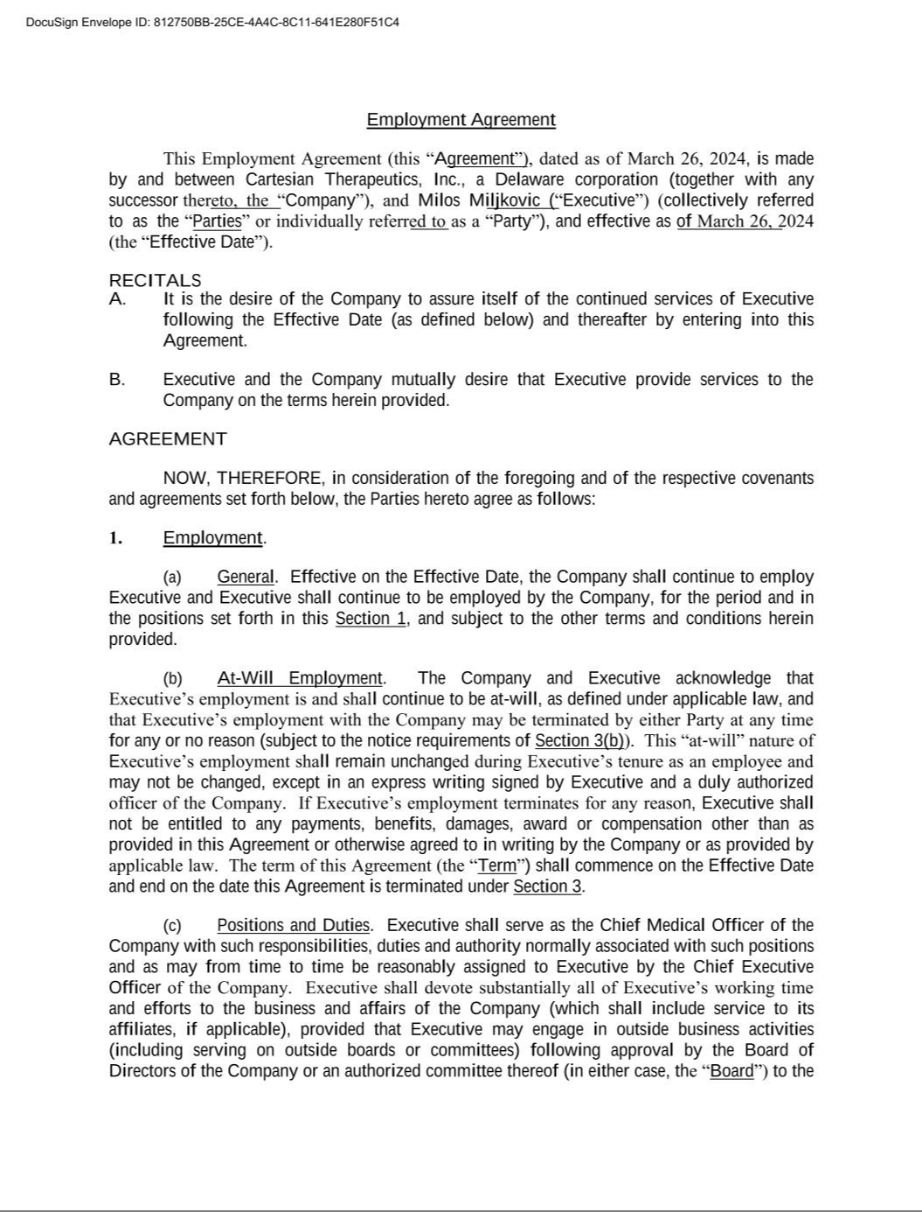

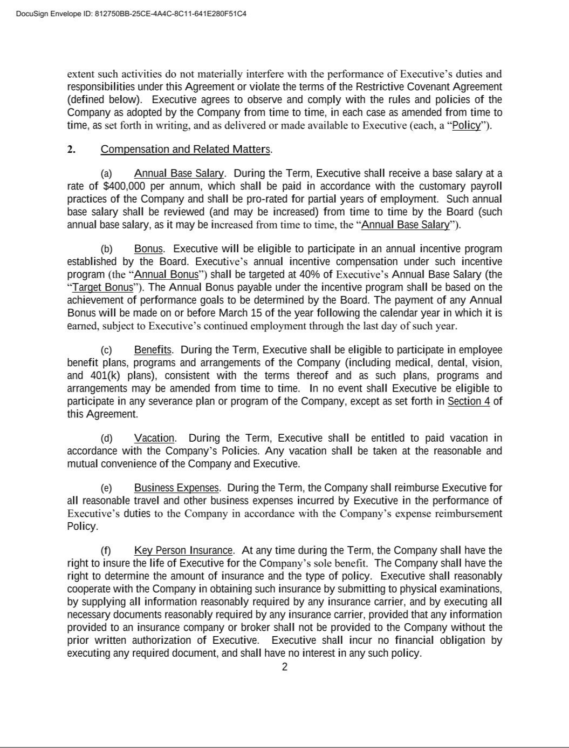

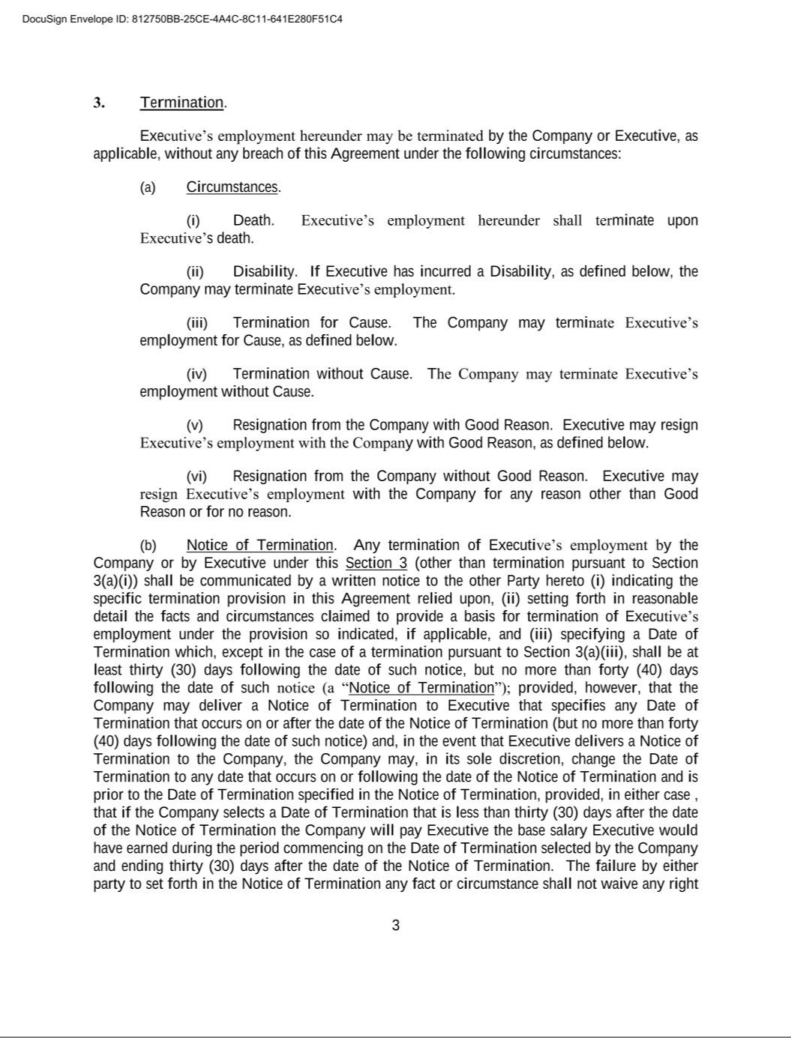

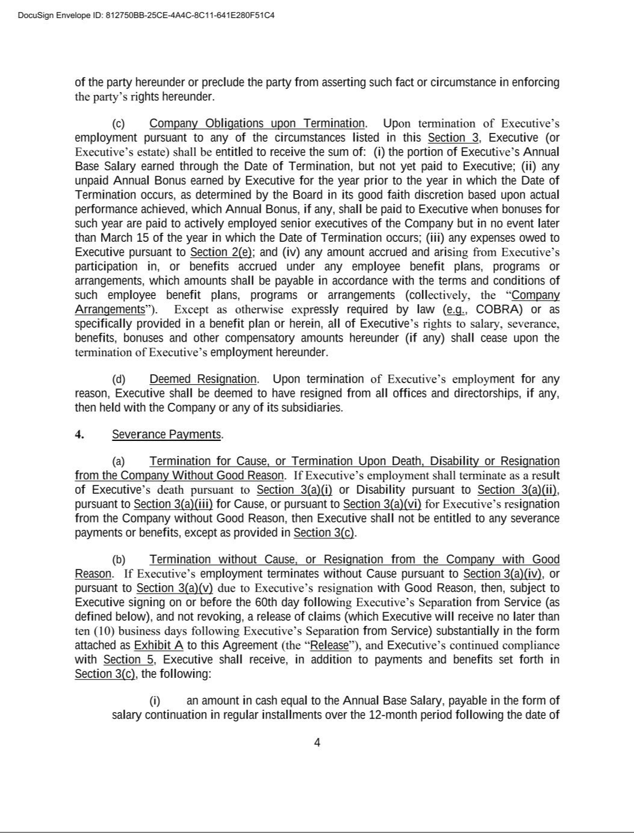

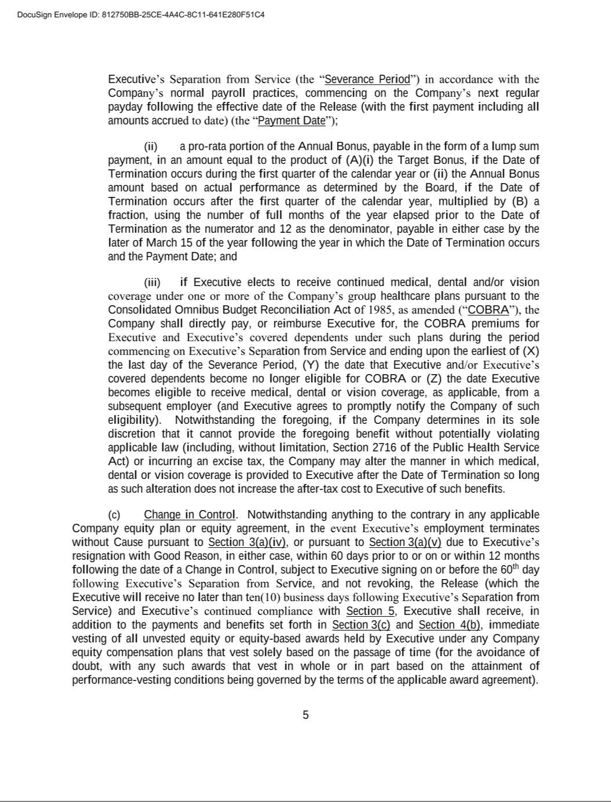

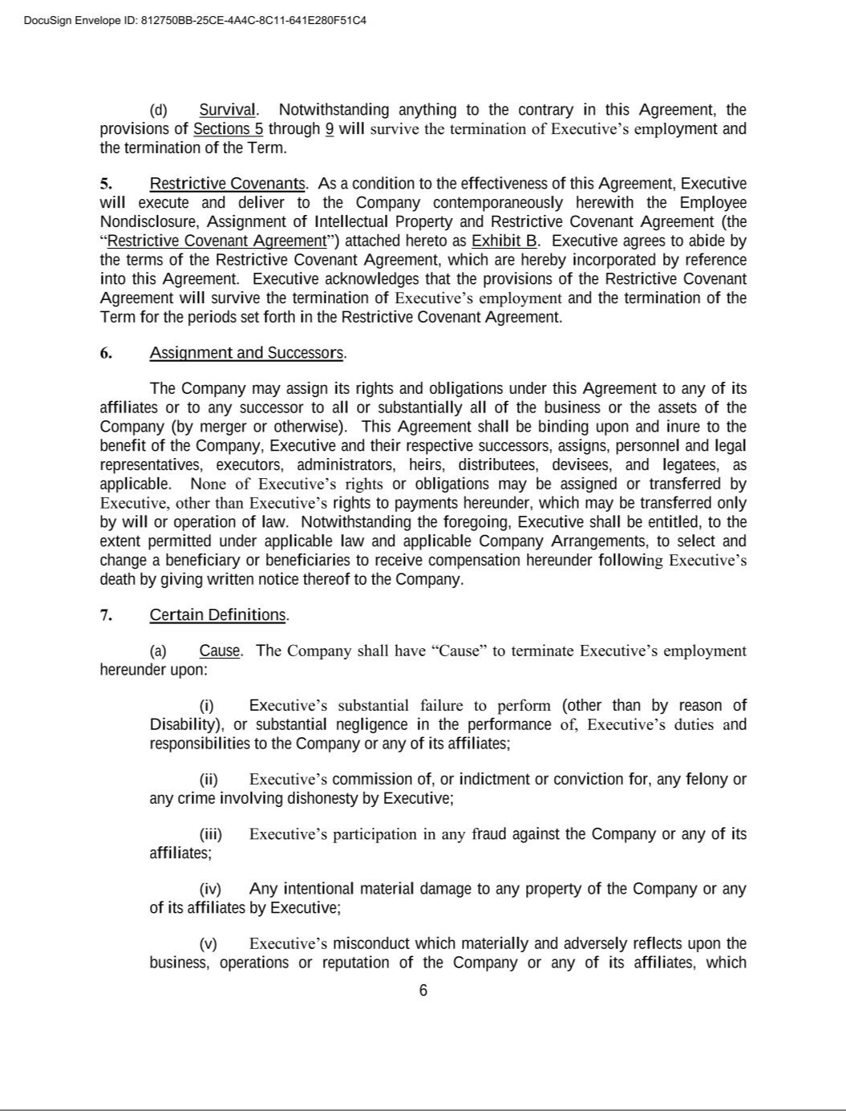

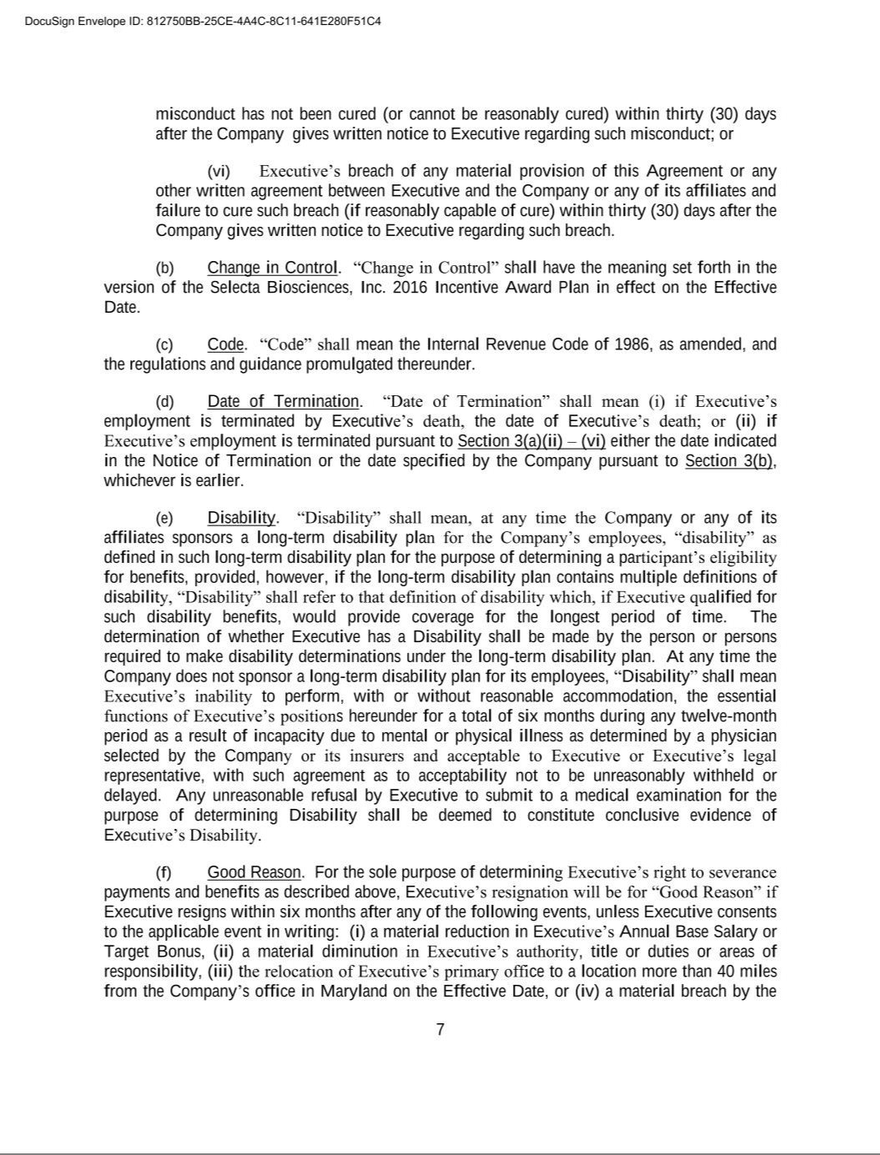

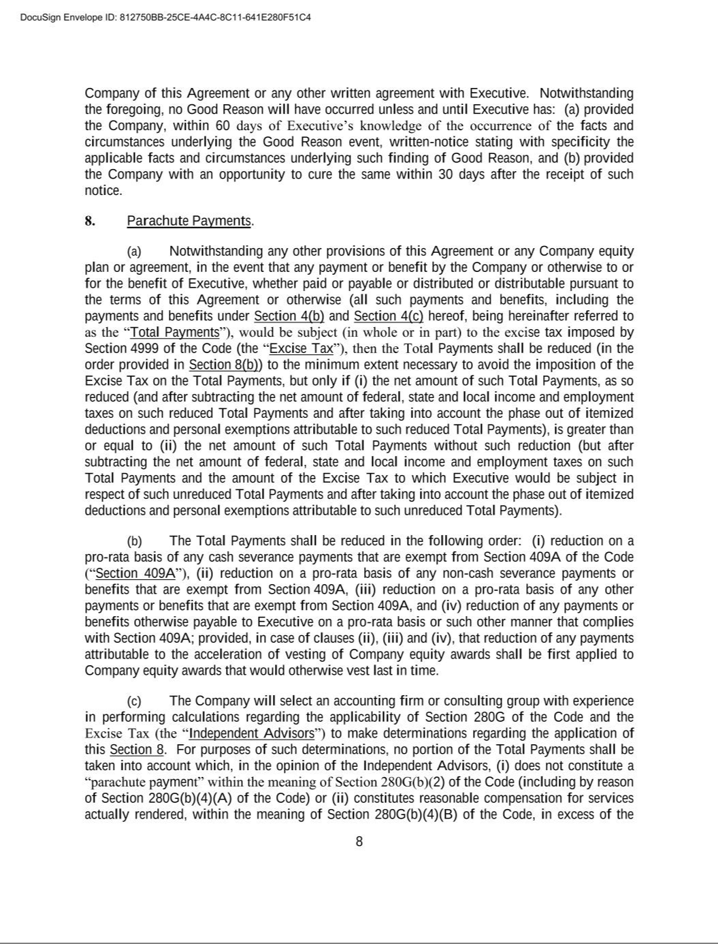

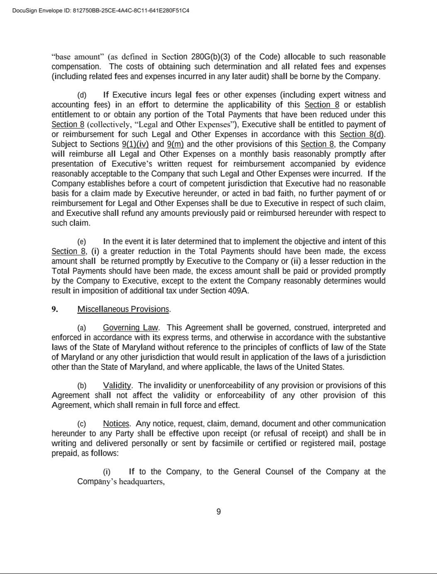

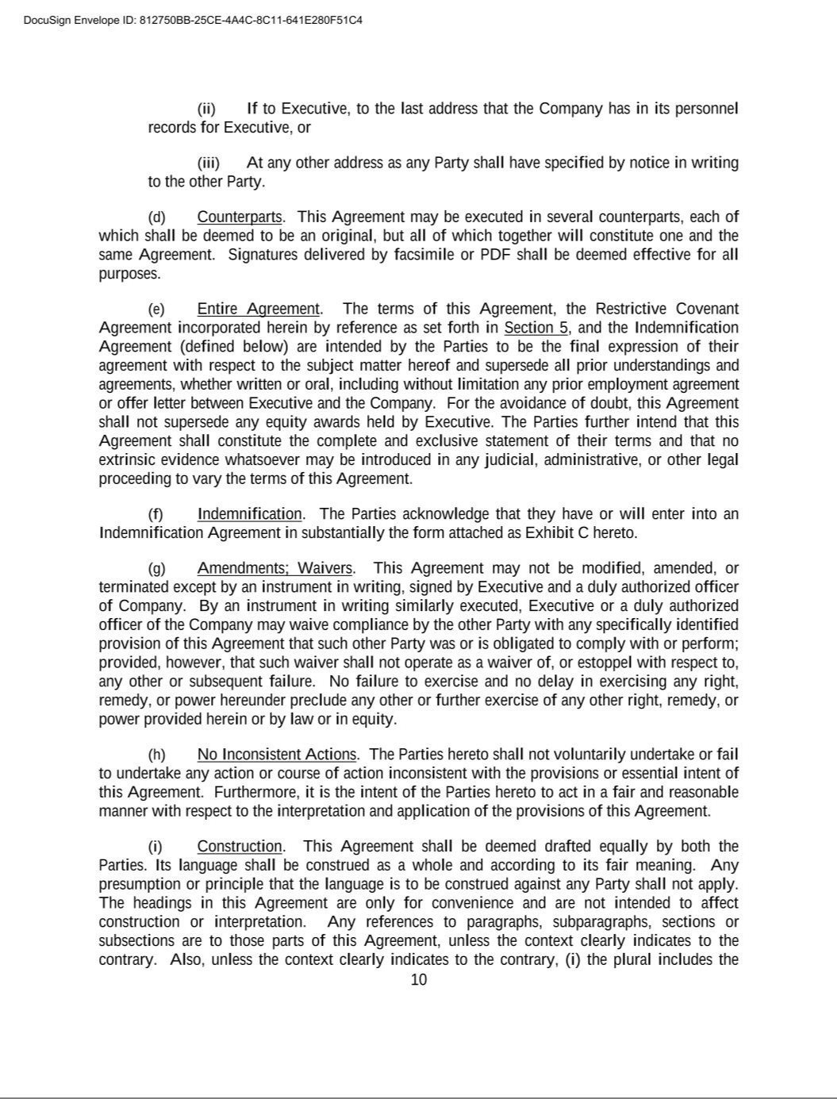

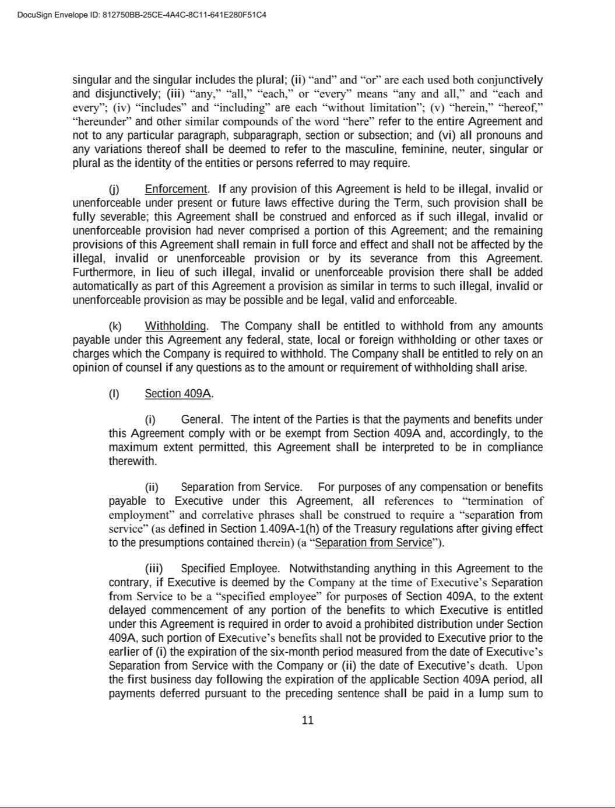

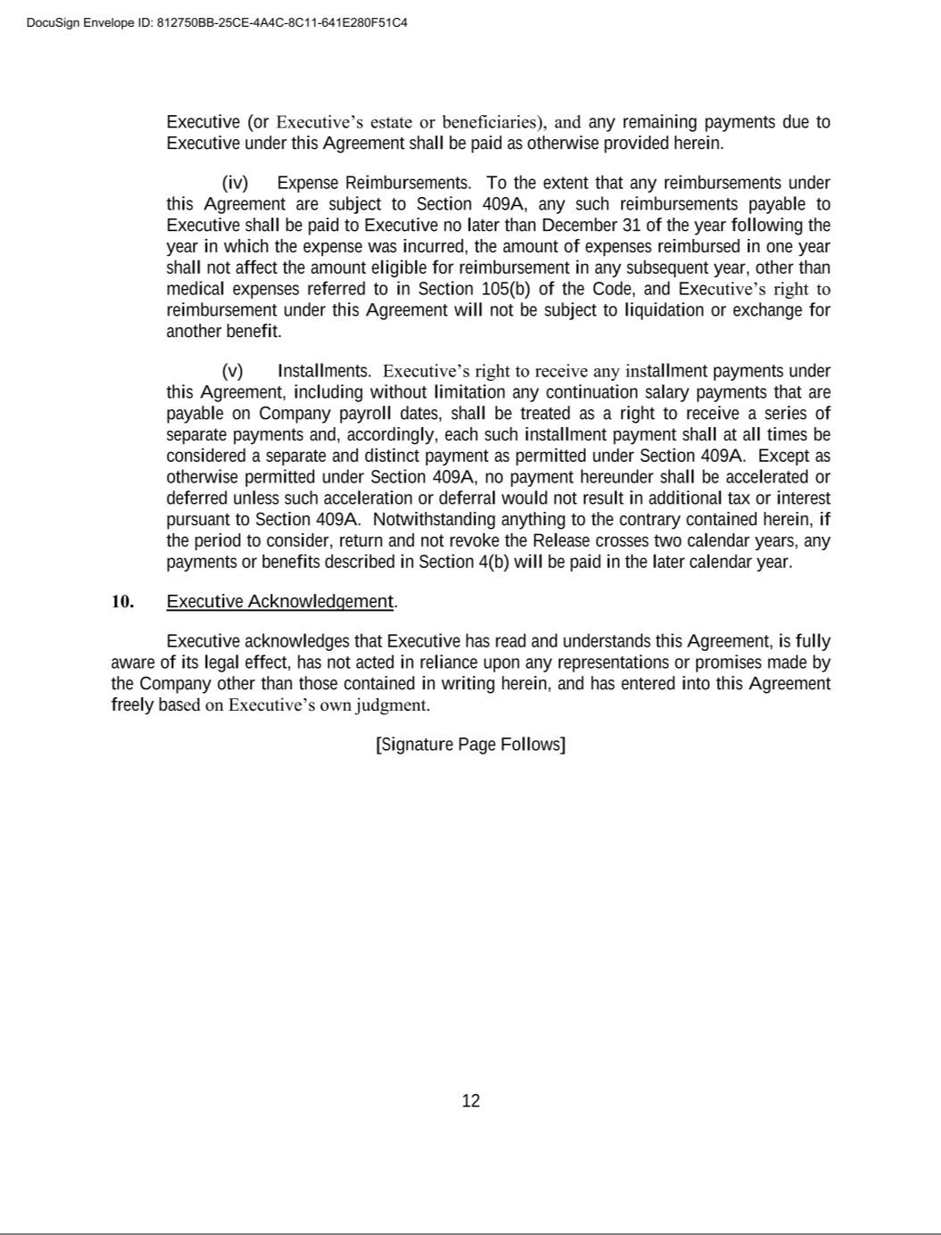

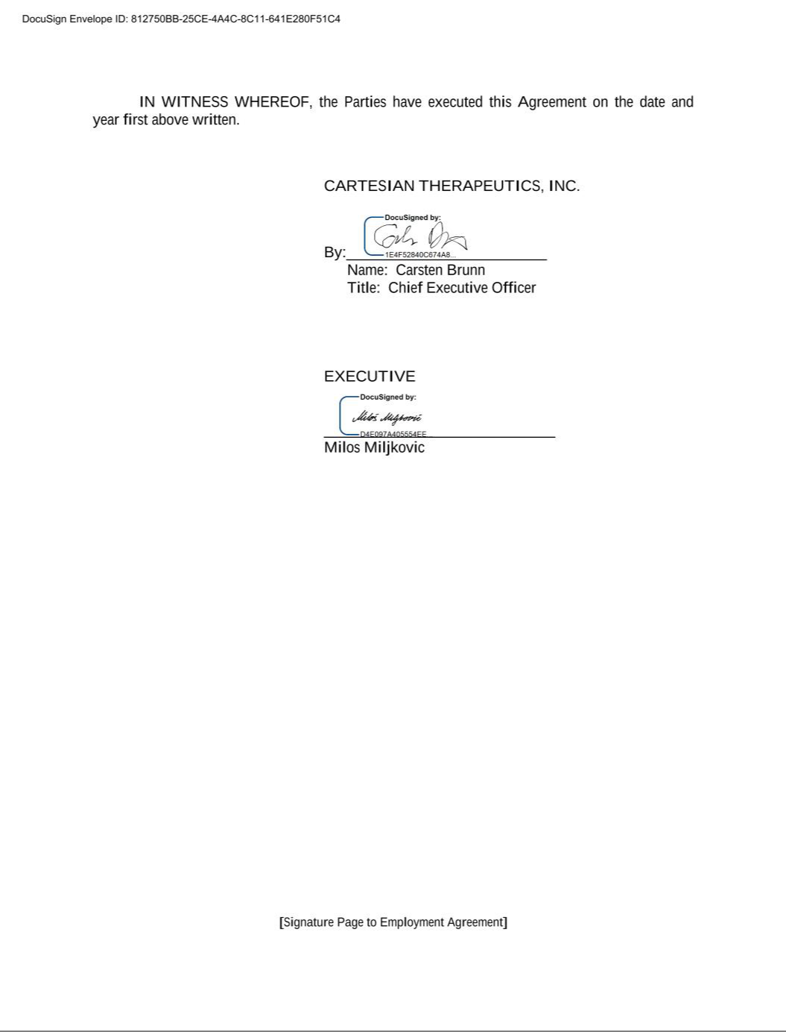

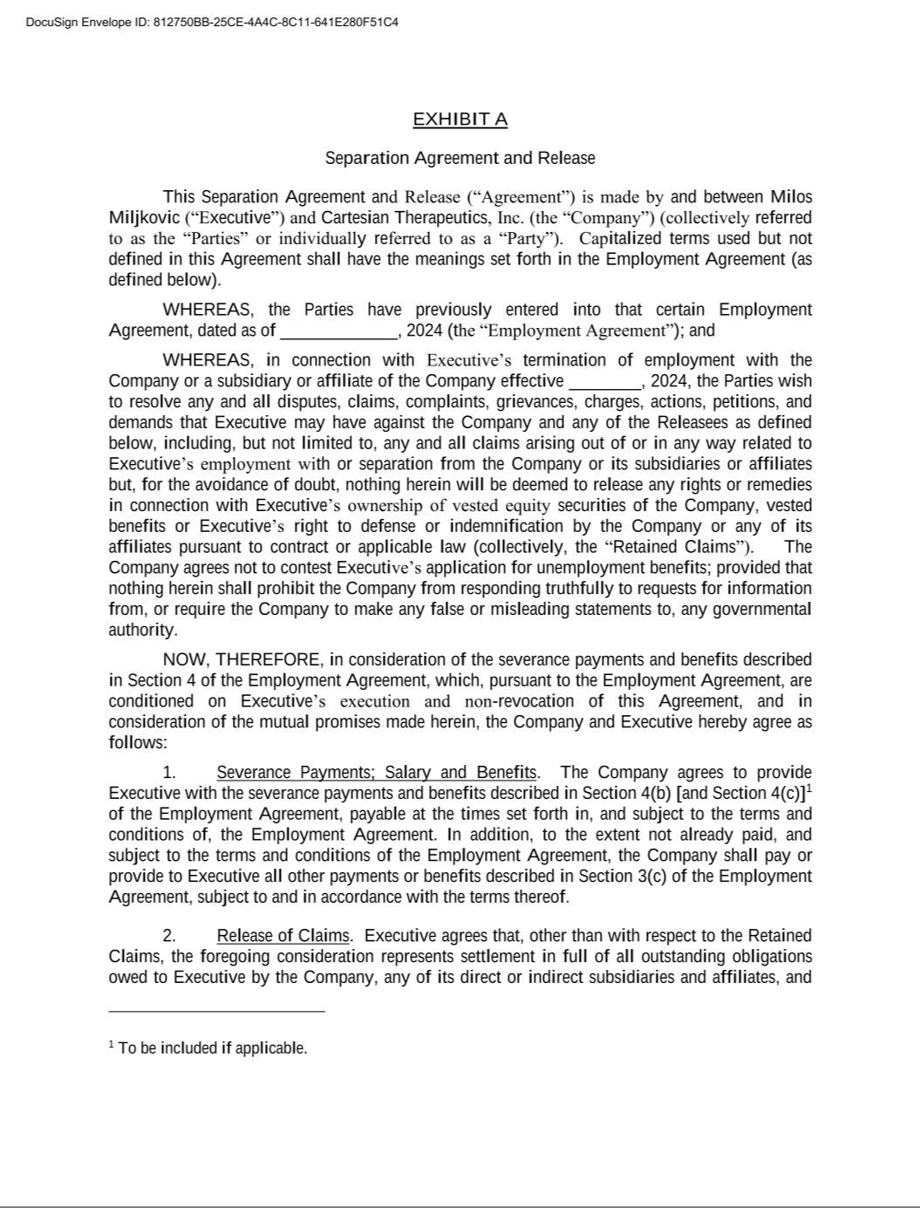

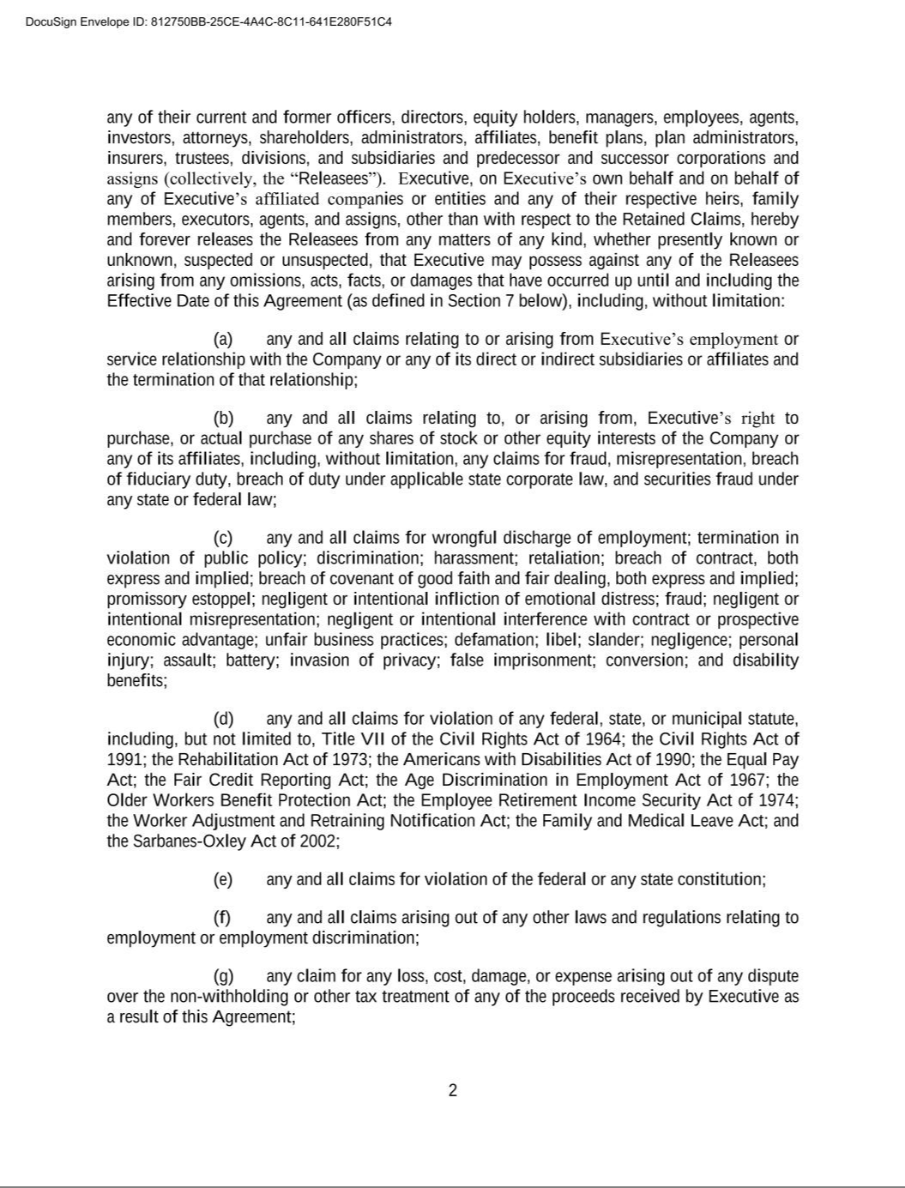

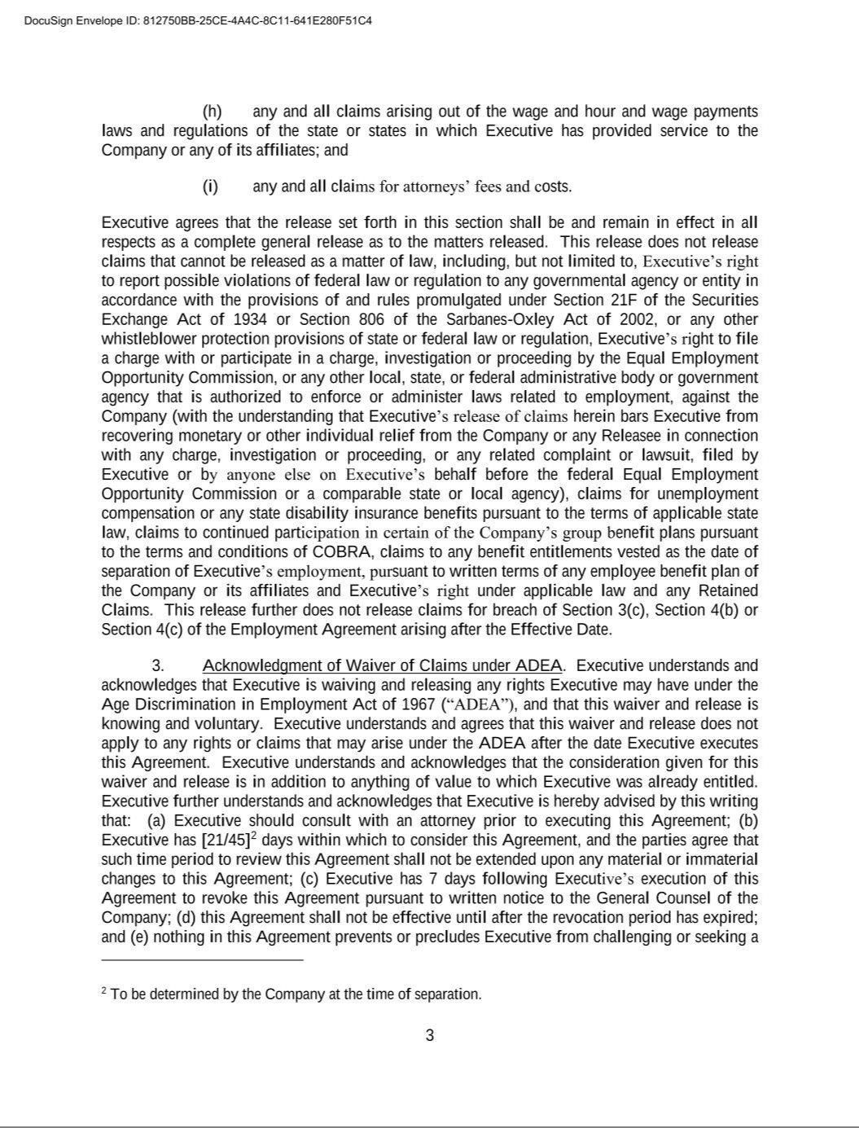

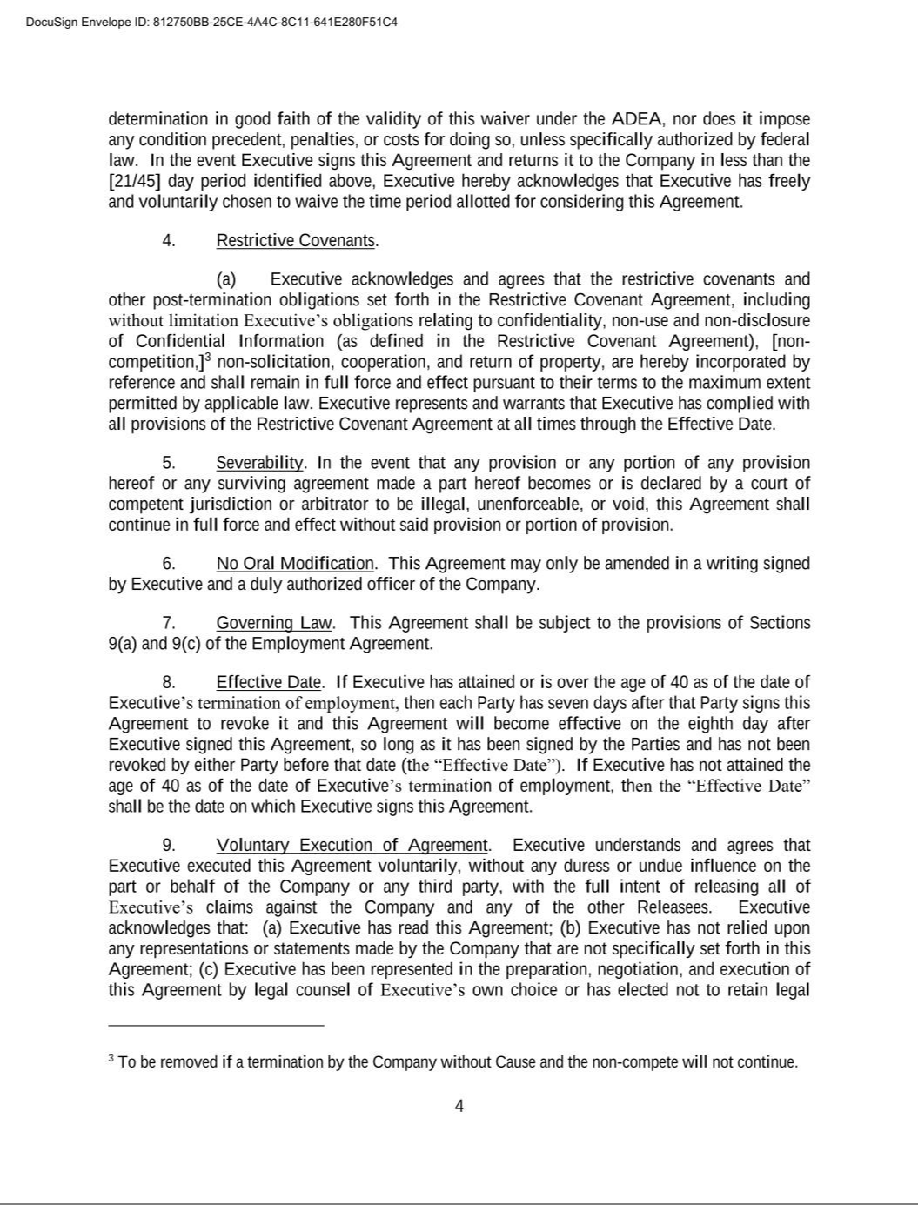

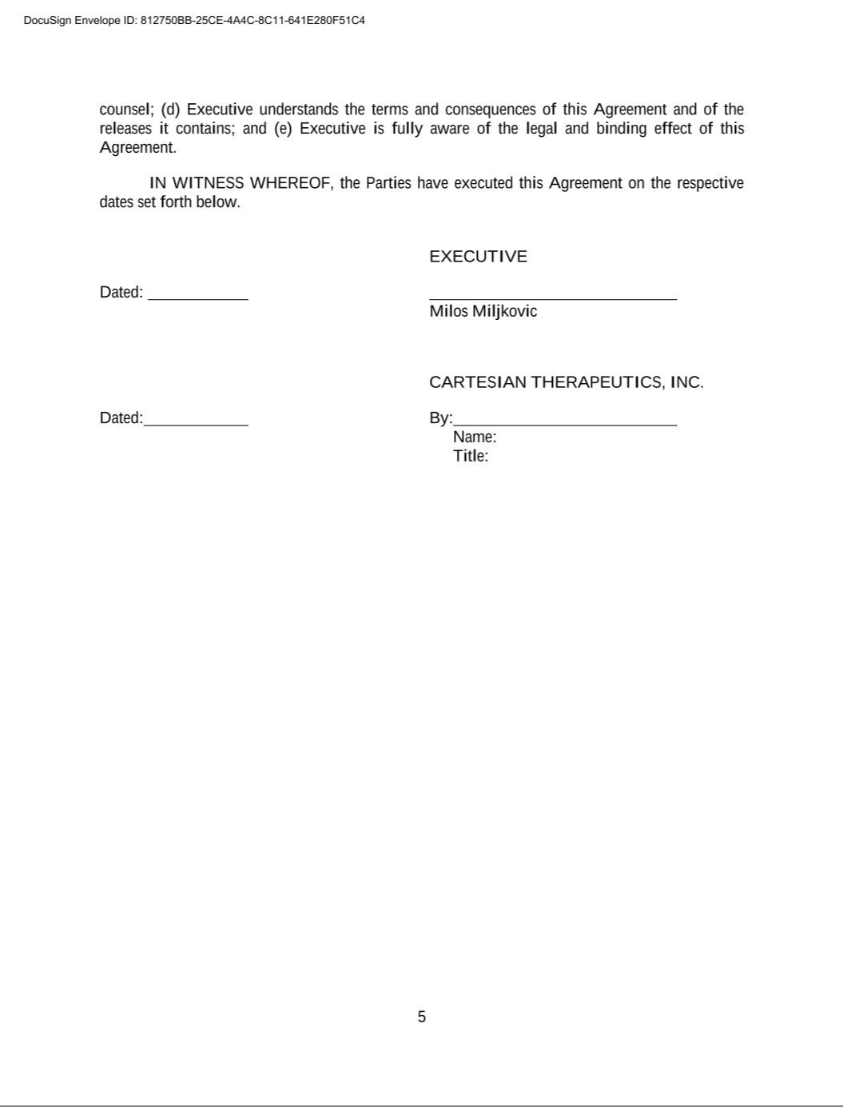





Exhibit 31.1

CERTIFICATION PURSUANT TO

SECTION 302 OF THE SARBANES-OXLEY ACT OF 2002

I, Carsten Brunn, Ph.D., certify that:

- I have reviewed this Quarterly Report on Form 10-Q of Cartesian Therapeutics, Inc.;

- Based on my knowledge, this report does not contain any untrue statement of a material fact or omit to state a material fact necessary to make the statements made, in light of the circumstances under which such statements were made, not misleading with respect to the period covered by this report;

- Based on my knowledge, the financial statements, and other financial information included in this report, fairly present in all material respects the financial condition, results of operations and cash flows of the registrant as of, and for, the periods presented in this report;

- The registrant’s other certifying officer and I are responsible for establishing and maintaining disclosure controls and procedures (as defined in Exchange Act Rules 13a-15(e) and 15d-15(e)) and internal control over financial reporting (as defined in Exchange Act Rules 13a-15(f) and 15d-15(f)) for the registrant and have:

  - Designed such disclosure controls and procedures, or caused such disclosure controls and procedures to be designed under our supervision, to ensure that material information relating to the registrant, including its consolidated subsidiaries, is made known to us by others within those entities, particularly during the period in which this report is being prepared;

  - Designed such internal control over financial reporting, or caused such internal control over financial reporting to be designed under our supervision, to provide reasonable assurance regarding the reliability of financial reporting and the preparation of financial statements for external purposes in accordance with generally accepted accounting principles;

  - Evaluated the effectiveness of the registrant’s disclosure controls and procedures and presented in this report our conclusions about the effectiveness of the disclosure controls and procedures, as of the end of the period covered by this report based on such evaluation; and

  - Disclosed in this report any change in the registrant’s internal control over financial reporting that occurred during the registrant’s most recent fiscal quarter (the registrant’s fourth fiscal quarter in the case of an annual report) that has materially affected, or is reasonably likely to materially affect, the registrant’s internal control over financial reporting; and

- The registrant’s other certifying officer and I have disclosed, based on our most recent evaluation of internal control over financial reporting, to the registrant’s auditors and the audit committee of the registrant’s board of directors (or persons performing the equivalent functions):

  - All significant deficiencies and material weaknesses in the design or operation of internal control over financial reporting which are reasonably likely to adversely affect the registrant’s ability to record, process, summarize and report financial information; and

  - Any fraud, whether or not material, that involves management or other employees who have a significant role in the registrant’s internal control over financial reporting.

April 30, 2026 | /s/ Carsten Brunn, Ph.D.
 | Carsten Brunn, Ph.D.
 | President, Chief Executive Officer and Chairman of the Board
 | (Principal Executive Officer)

Exhibit 31.2

CERTIFICATION PURSUANT TO

SECTION 302 OF THE SARBANES-OXLEY ACT OF 2002

I, Blaine Davis, certify that:

- I have reviewed this Quarterly Report on Form 10-Q of Cartesian Therapeutics, Inc.;

- Based on my knowledge, this report does not contain any untrue statement of a material fact or omit to state a material fact necessary to make the statements made, in light of the circumstances under which such statements were made, not misleading with respect to the period covered by this report;

- Based on my knowledge, the financial statements, and other financial information included in this report, fairly present in all material respects the financial condition, results of operations and cash flows of the registrant as of, and for, the periods presented in this report;

- The registrant’s other certifying officer and I are responsible for establishing and maintaining disclosure controls and procedures (as defined in Exchange Act Rules 13a-15(e) and 15d-15(e)) and internal control over financial reporting (as defined in Exchange Act Rules 13a-15(f) and 15d-15(f)) for the registrant and have:

  - Designed such disclosure controls and procedures, or caused such disclosure controls and procedures to be designed under our supervision, to ensure that material information relating to the registrant, including its consolidated subsidiaries, is made known to us by others within those entities, particularly during the period in which this report is being prepared;

  - Designed such internal control over financial reporting, or caused such internal control over financial reporting to be designed under our supervision, to provide reasonable assurance regarding the reliability of financial reporting and the preparation of financial statements for external purposes in accordance with generally accepted accounting principles;

  - Evaluated the effectiveness of the registrant’s disclosure controls and procedures and presented in this report our conclusions about the effectiveness of the disclosure controls and procedures, as of the end of the period covered by this report based on such evaluation; and

  - Disclosed in this report any change in the registrant’s internal control over financial reporting that occurred during the registrant’s most recent fiscal quarter (the registrant’s fourth fiscal quarter in the case of an annual report) that has materially affected, or is reasonably likely to materially affect, the registrant’s internal control over financial reporting; and

- The registrant’s other certifying officer and I have disclosed, based on our most recent evaluation of internal control over financial reporting, to the registrant’s auditors and the audit committee of the registrant’s board of directors (or persons performing the equivalent functions):

  - All significant deficiencies and material weaknesses in the design or operation of internal control over financial reporting which are reasonably likely to adversely affect the registrant’s ability to record, process, summarize and report financial information; and

  - Any fraud, whether or not material, that involves management or other employees who have a significant role in the registrant’s internal control over financial reporting.

April 30, 2026 | /s/ Blaine Davis
 | Blaine Davis
 | Chief Financial Officer
 | (Principal Financial Officer)

Exhibit 32.1

CERTIFICATION PURSUANT TO

18 U.S.C. SECTION 1350,

AS ADOPTED PURSUANT TO

SECTION 906 OF THE SARBANES-OXLEY ACT OF 2002

In connection with the Quarterly Report on Form 10-Q of Cartesian Therapeutics, Inc. (the “Company”) for the period ended March 31, 2026 as filed with the Securities and Exchange Commission on the date hereof (the “Report”), each of the undersigned officers of the Company hereby certifies, pursuant to 18 U.S.C. Section 1350, that to his knowledge:

- The Quarterly Report on Form 10-Q of the Company for the period ended March 31, 2026 (the “Report”) fully complies with the requirements of Section 13(a) or 15(d) of the Securities Exchange Act of 1934, as amended; and

- The information contained in the Report fairly presents, in all material respects, the financial condition and results of operations of the Company.

April 30, 2026 |  | /s/ Carsten Brunn, Ph.D.
 |  | Carsten Brunn, Ph.D.
 |  | President, Chief Executive Officer and Chairman of the Board
 |  | (Principal Executive Officer)
April 30, 2026 |  | /s/ Blaine Davis
 |  | Blaine Davis
 |  | Chief Financial Officer
 |  | (Principal Financial Officer)

