UNITED STATES

SECURITIES AND EXCHANGE COMMISSION

Washington, D.C. 20549

FORM 8-K

CURRENT REPORT

Pursuant to Section 13 or 15(d) of

the Securities Exchange Act of 1934

Date of Report (Date of earliest event reported): January 13, 2025

CARTESIAN THERAPEUTICS, INC.

(Exact name of registrant as specified in its charter)

Delaware | 001-37798 | 26-1622110
(State or other jurisdiction | (Commission | (IRS Employer
of incorporation) | File Number) | Identification No.)
 | 7495 New Horizon Way, Frederick, MD 21703
 | (Address of principal executive offices)(Zip Code)
 | (301) 348-8698
 | Registrant’s telephone number, including area code

N/A

(Former name or former address, if changed since last report)

Check the appropriate box below if the Form 8-K filing is intended to simultaneously satisfy the filing obligation of the registrant under any of the following provisions:

- Written communications pursuant to Rule 425 under the Securities Act (17 CFR 230.425)

- Soliciting material pursuant to Rule 14a-12 under the Exchange Act (17 CFR 240.14a-12)

- Pre-commencement communications pursuant to Rule 14d-2(b) under the Exchange Act (17 CFR 240.14d-2(b))

- Pre-commencement communications pursuant to Rule 13e-4(c) under the Exchange Act (17 CFR 240.13e-4(c))

Securities registered pursuant to Section 12(b) of the Act:

Title of each class | Trading Symbol(s) | Name of each exchange on which registered
Common Stock (Par Value $0.0001) | RNAC | The Nasdaq Stock Market LLC

Indicate by check mark whether the registrant is an emerging growth company as defined in Rule 405 of the Securities Act of 1933 (§230.405 of this chapter) or Rule 12b-2 of the Securities Exchange Act of 1934 (§240.12b-2 of this chapter).

Emerging growth company o

If an emerging growth company, indicate by check mark if the registrant has elected not to use the extended transition period for complying with any new or revised financial accounting standards provided pursuant to Section 13(a) of the Exchange Act. o

Item 7.01. Regulation FD Disclosure.

Cartesian Therapeutics, Inc. (the “Company”) from time to time presents and/or distributes to the investment community at various industry and other conferences slide presentations to provide updates and summaries of its business. A copy of its current corporate slide presentation is attached to this Current Report on Form 8-K as Exhibit 99.1.

Additionally, on January 13, 2025, the Company issued a press release announcing its 2025 strategic priorities. This press release is attached to this Current Report on Form 8-K as Exhibit 99.2.

The information in Item 7.01 of this Form 8-K, including Exhibits 99.1 and 99.2 attached hereto, shall not be deemed “filed” for purposes of Section 18 of the Securities Exchange Act of 1934, as amended (the “Exchange Act”), or otherwise subject to the liabilities of that section, nor shall it be deemed incorporated by reference in any filing under the Securities Act of 1933, as amended, or the Exchange Act, except as expressly set forth by specific reference in such a filing. The Company undertakes no obligation to update, supplement or amend the materials attached hereto as Exhibits 99.1 or 99.2, except as required by law.

Item 9.01 Financial Statements and Exhibits.

(d) Exhibits

Exhibit |  |  |  |  |  | Exhibit Description
 | No. |  |  |  |  | Exhibit Description
99.1 |  |  |  | Corporate slide presentation of Cartesian Therapeutics, Inc. dated January 2025.
99.2 |  |  |  | Press release of Cartesian Therapeutics, Inc. issued on January 13, 2025.
 | 104 |  |  | Cover Page Interactive Data File (embedded within the Inline XBRL document)

SIGNATURES

Pursuant to the requirements of the Securities Exchange Act of 1934, the registrant has duly caused this report to be signed on its behalf by the undersigned hereunto duly authorized.

 | CARTESIAN THERAPEUTICS, INC.
Date: January 13, 2025 | By: | /s/ Carsten Brunn, Ph.D.
 |  | Carsten Brunn, Ph.D.
 |  | President and Chief Executive Officer



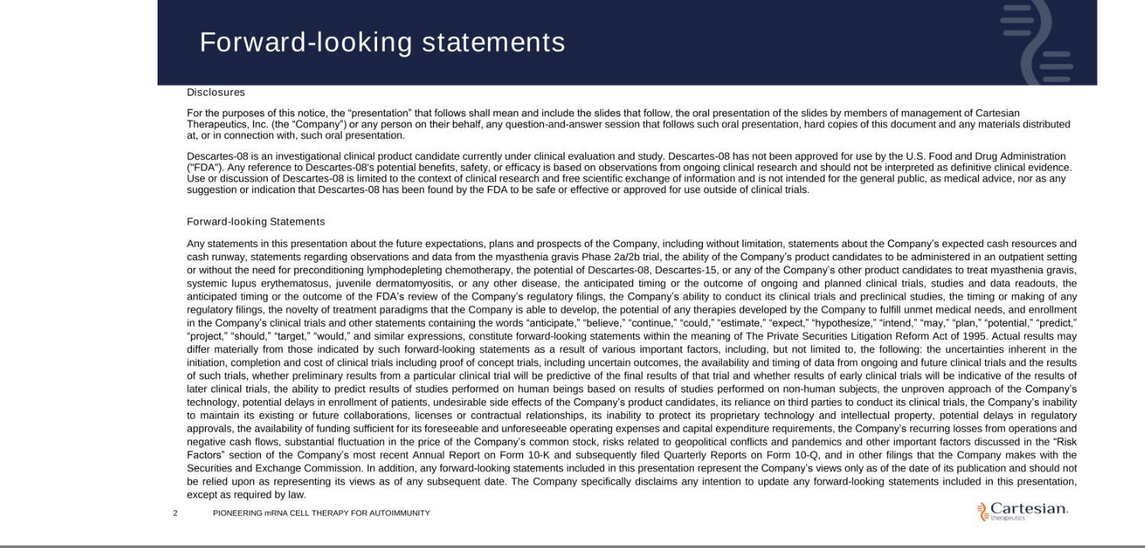

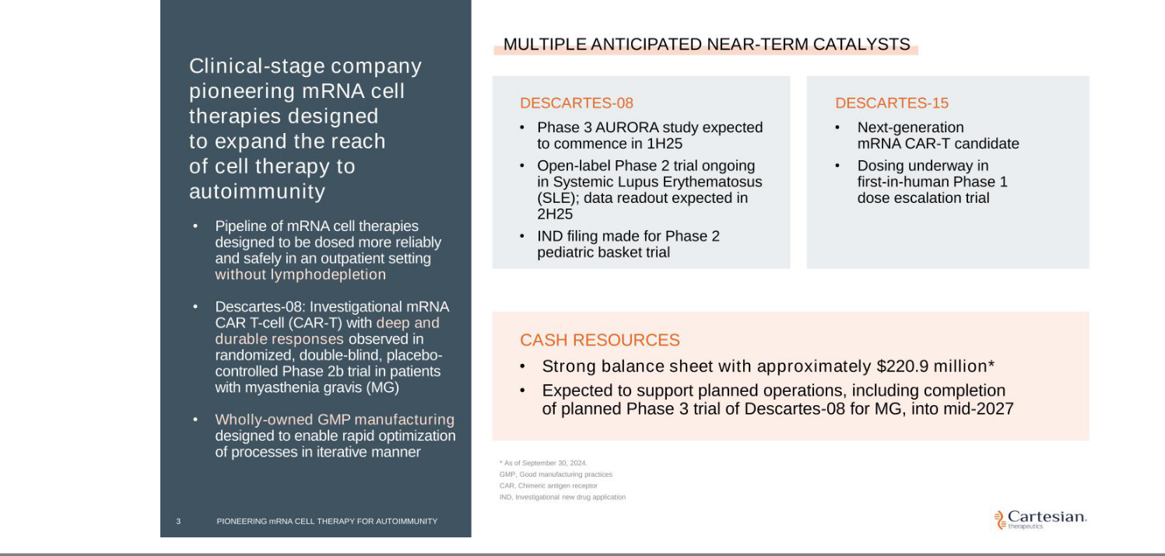

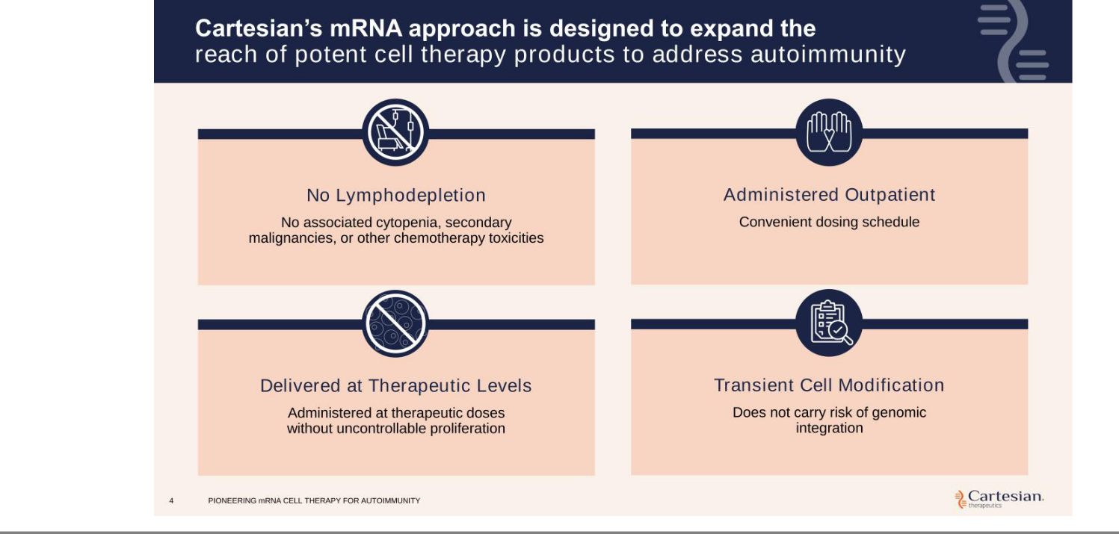

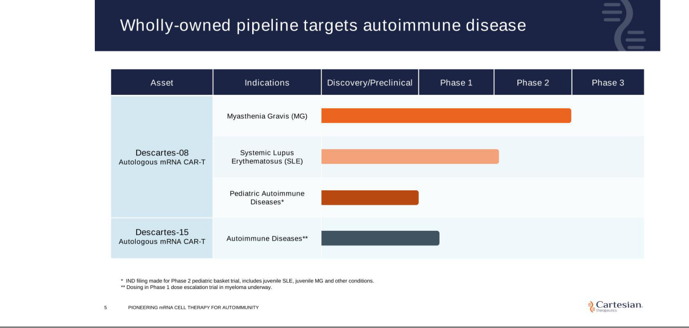

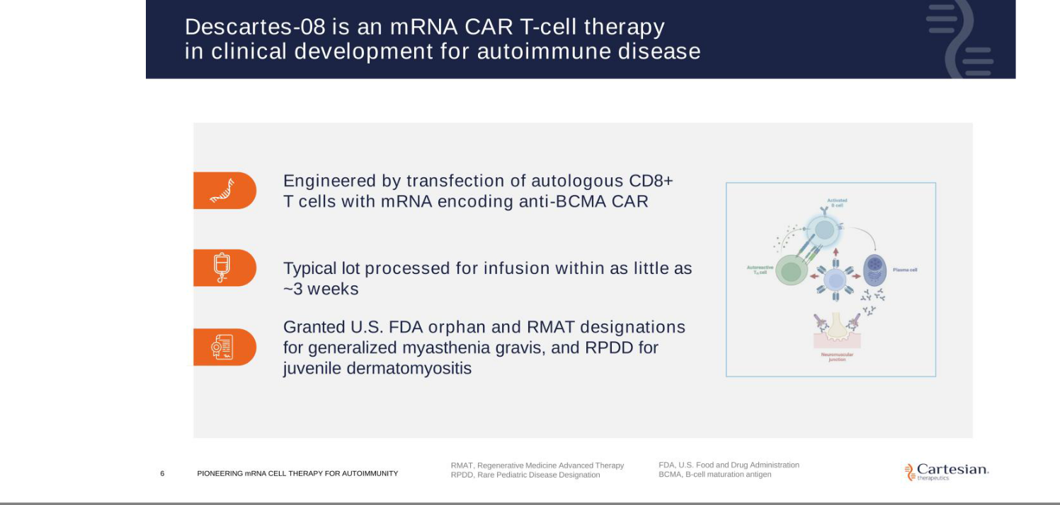

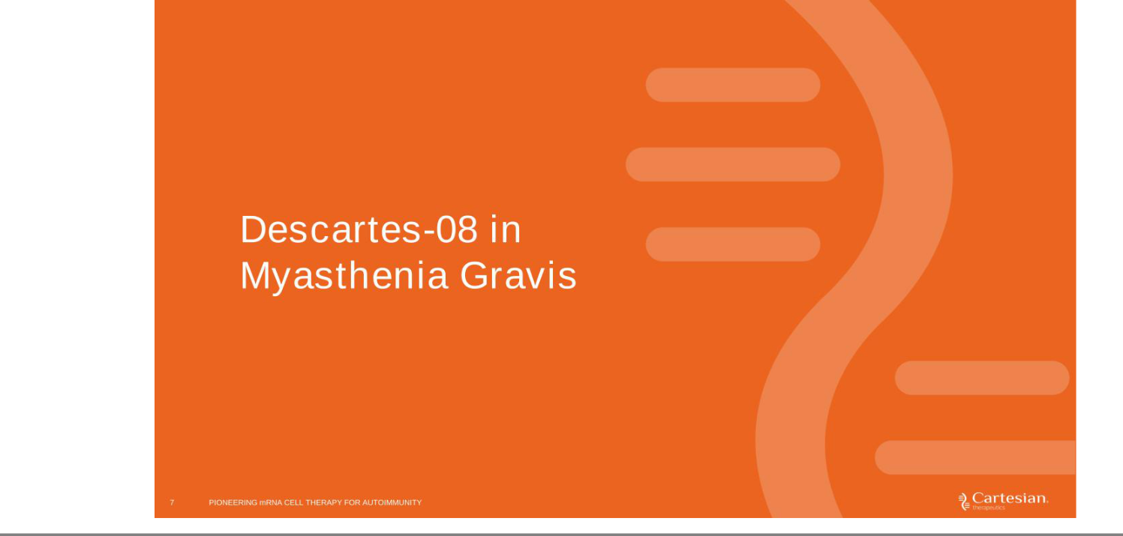

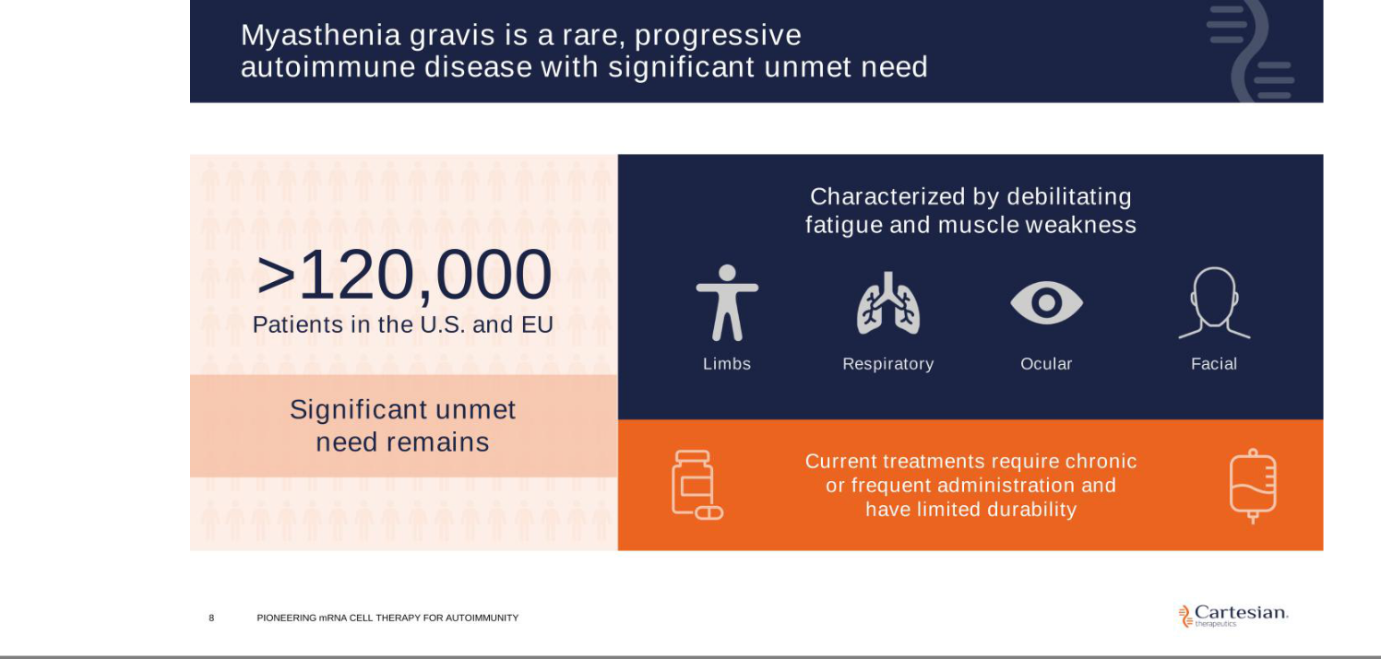

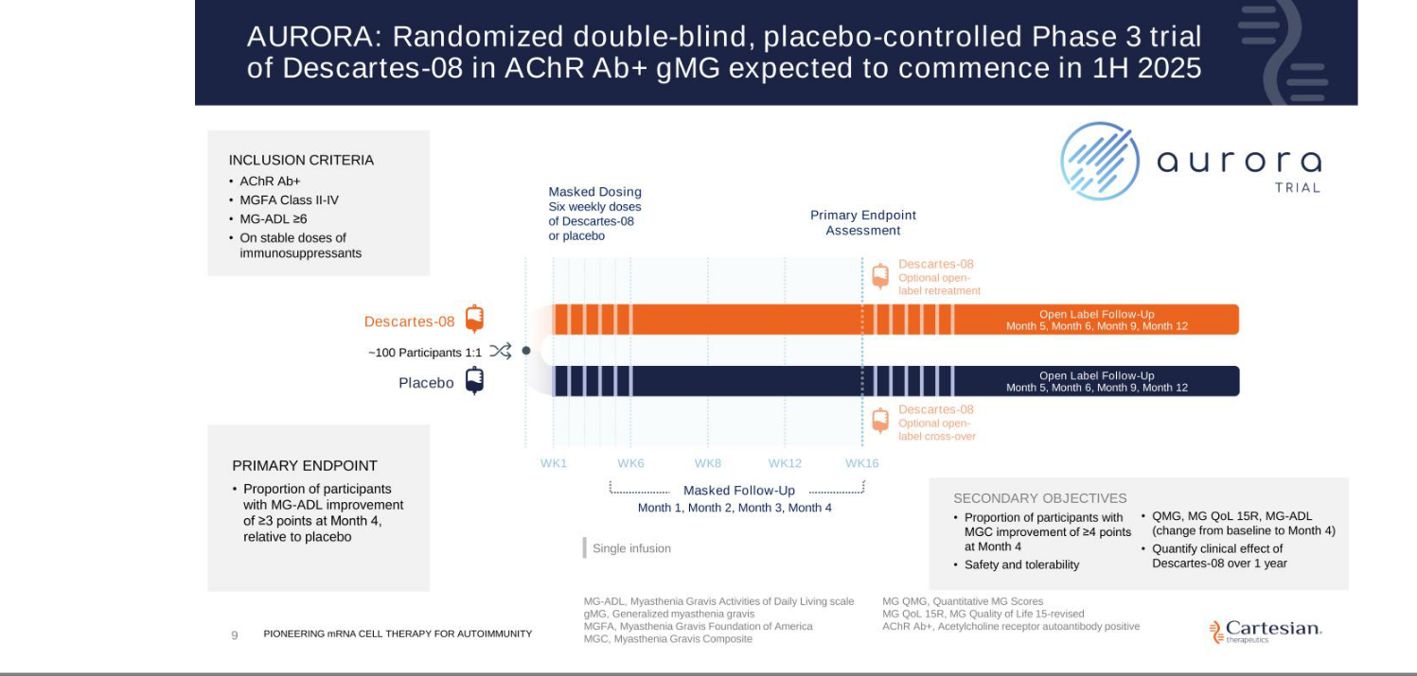

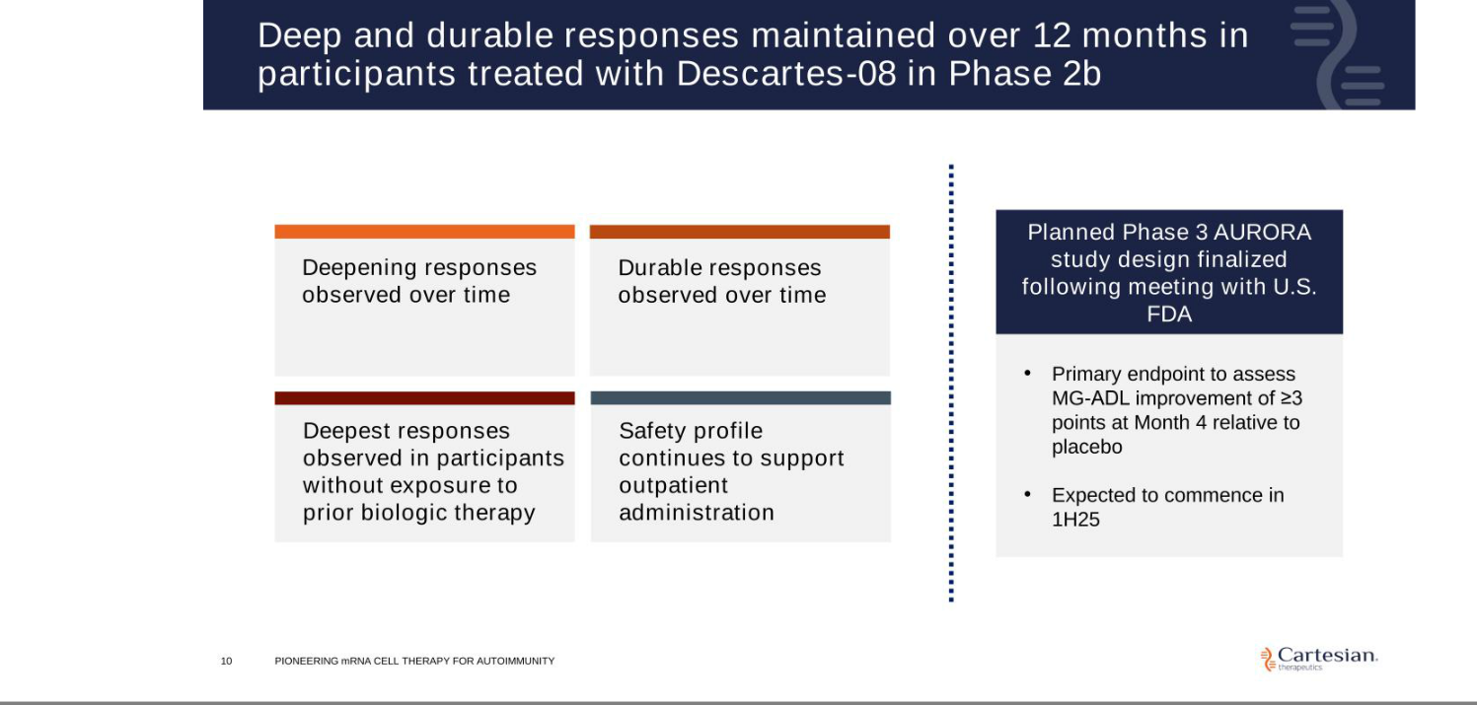

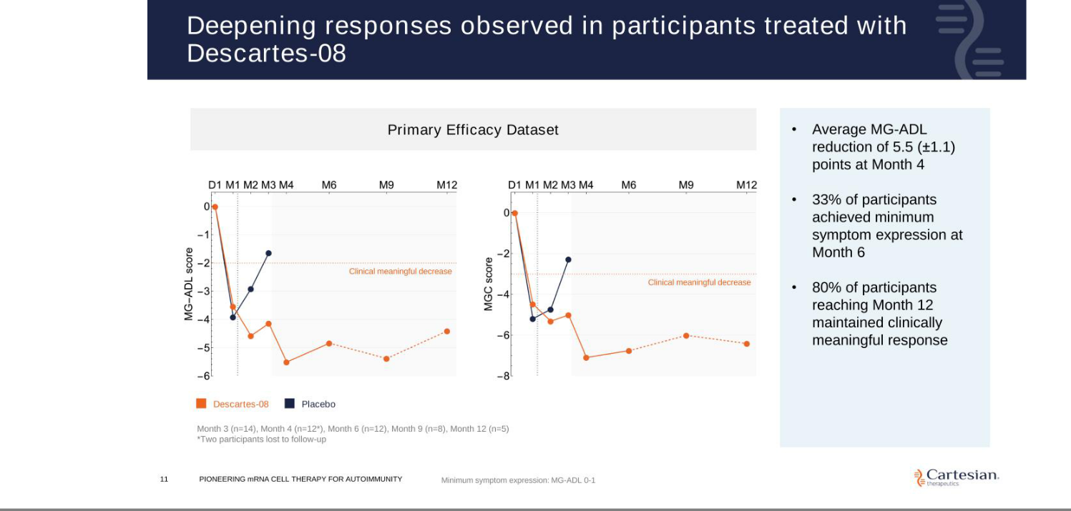

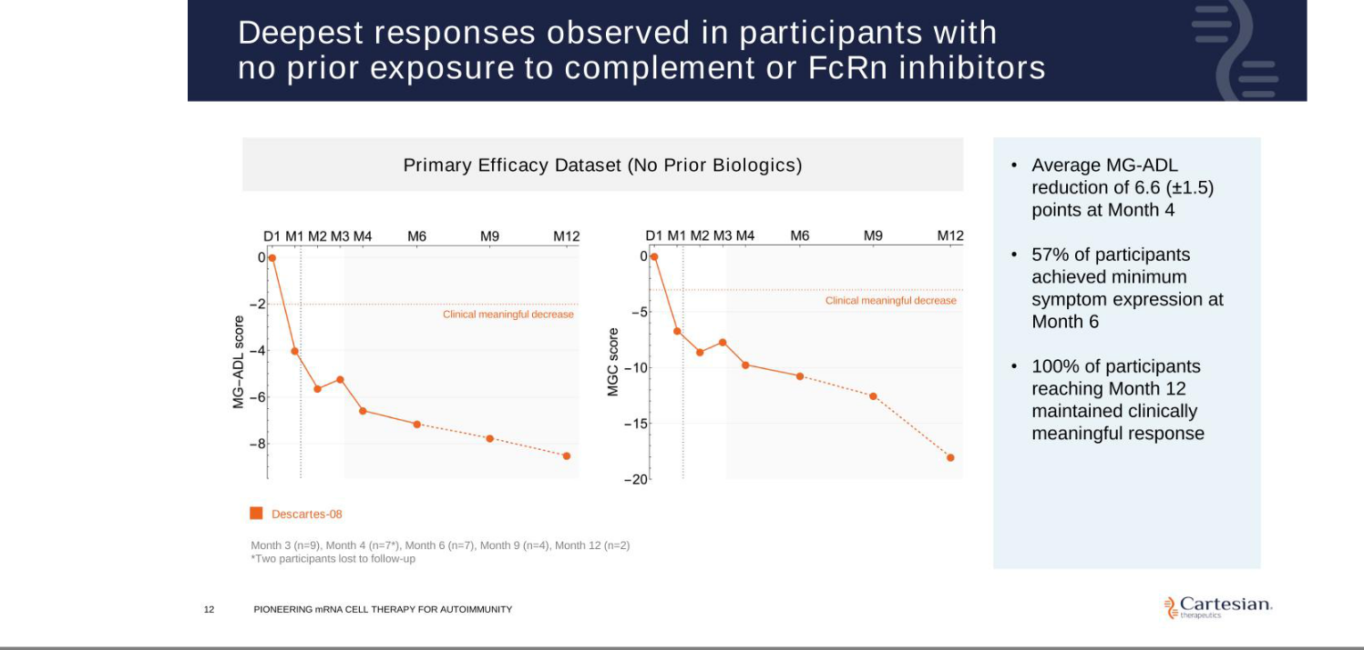

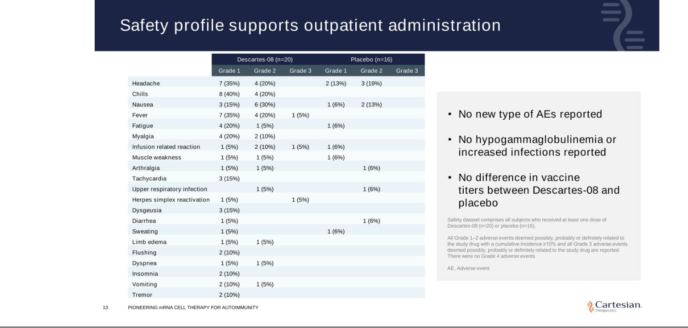

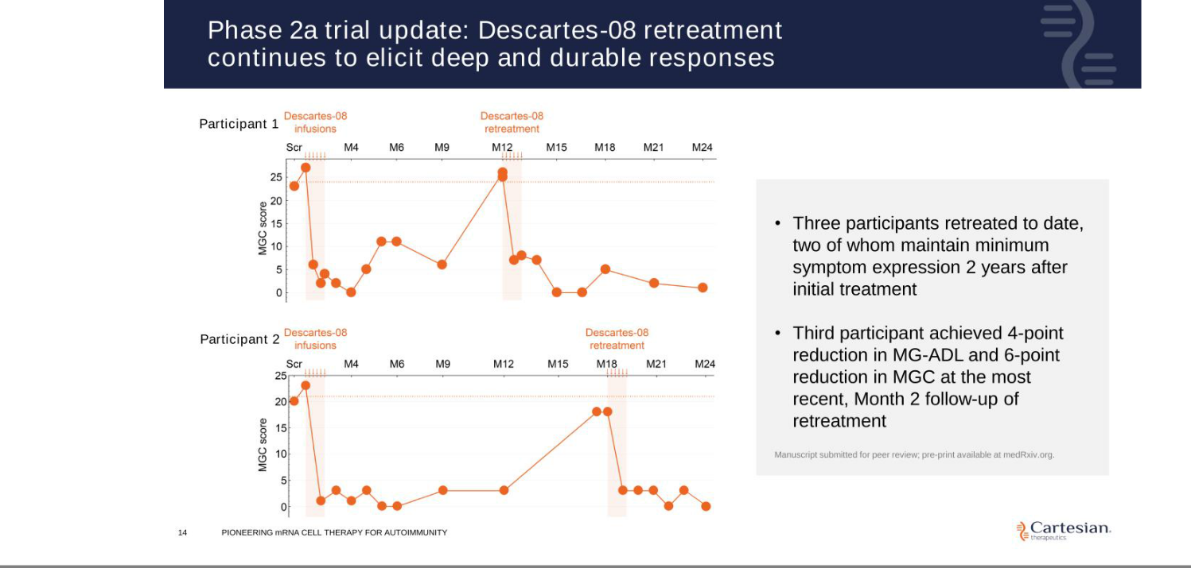

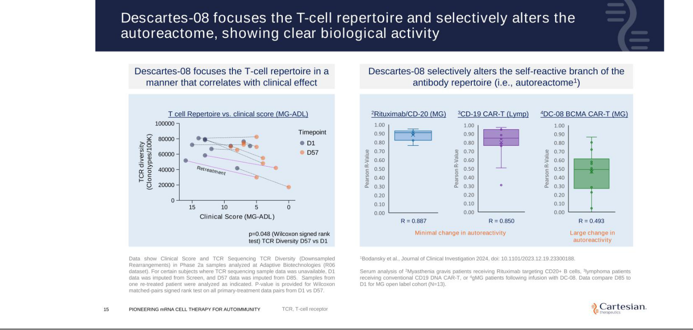



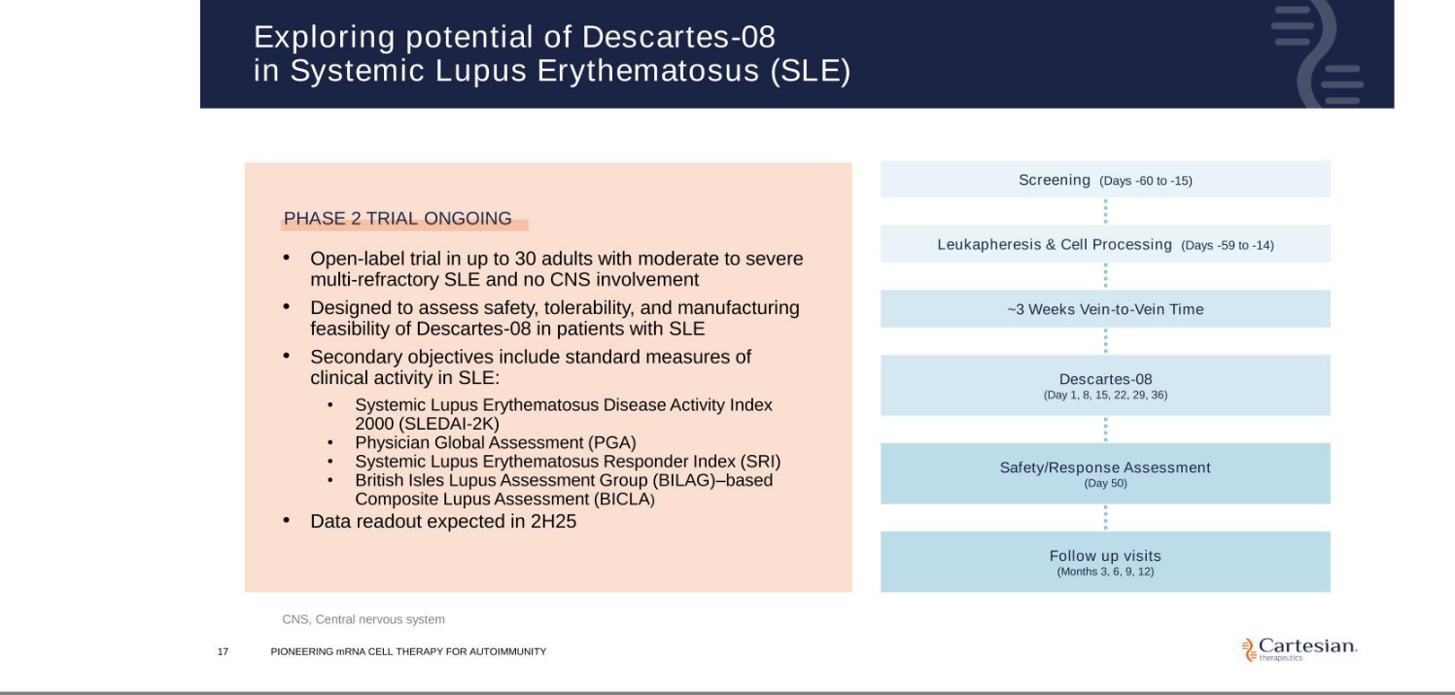

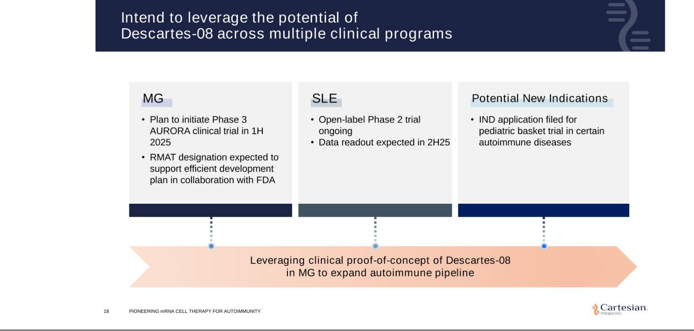



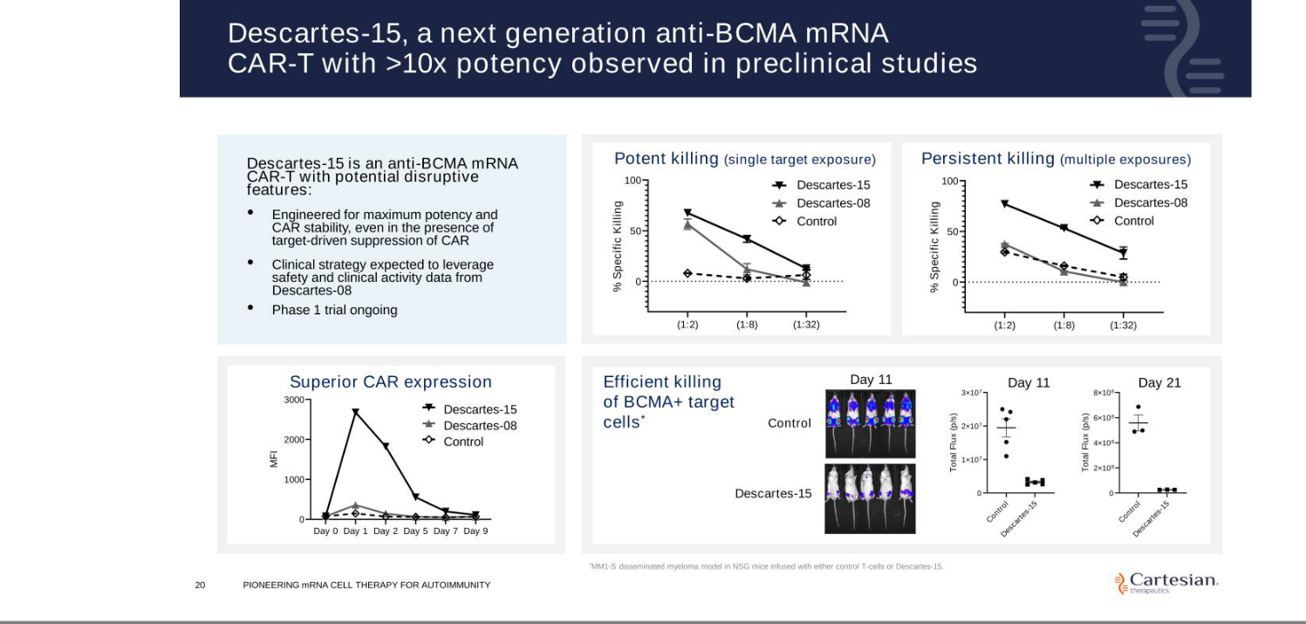

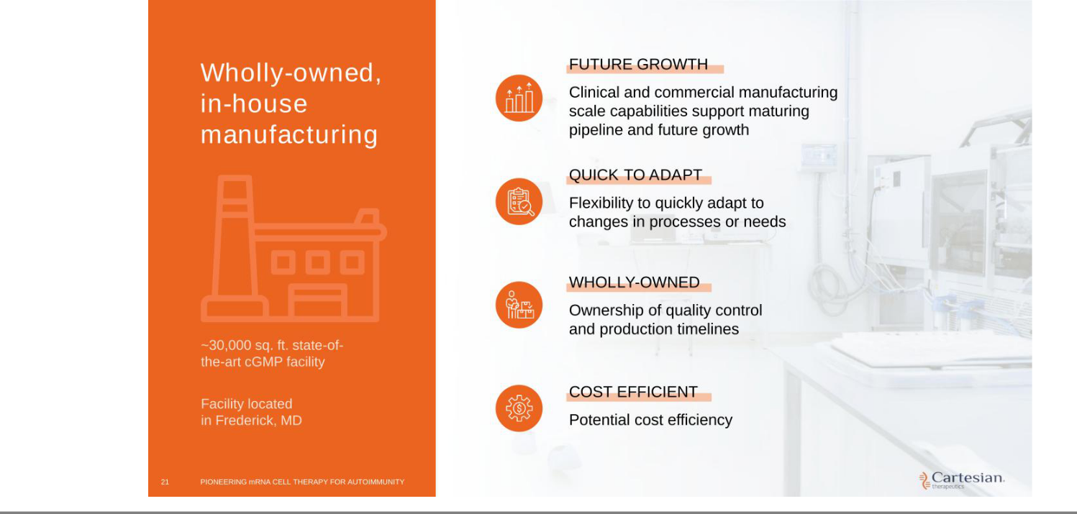

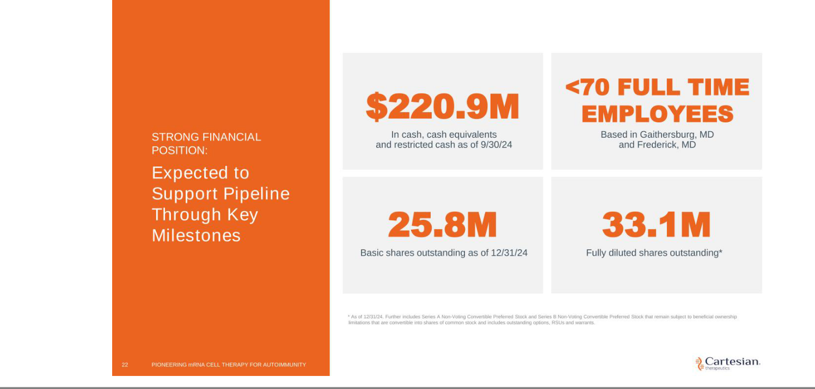



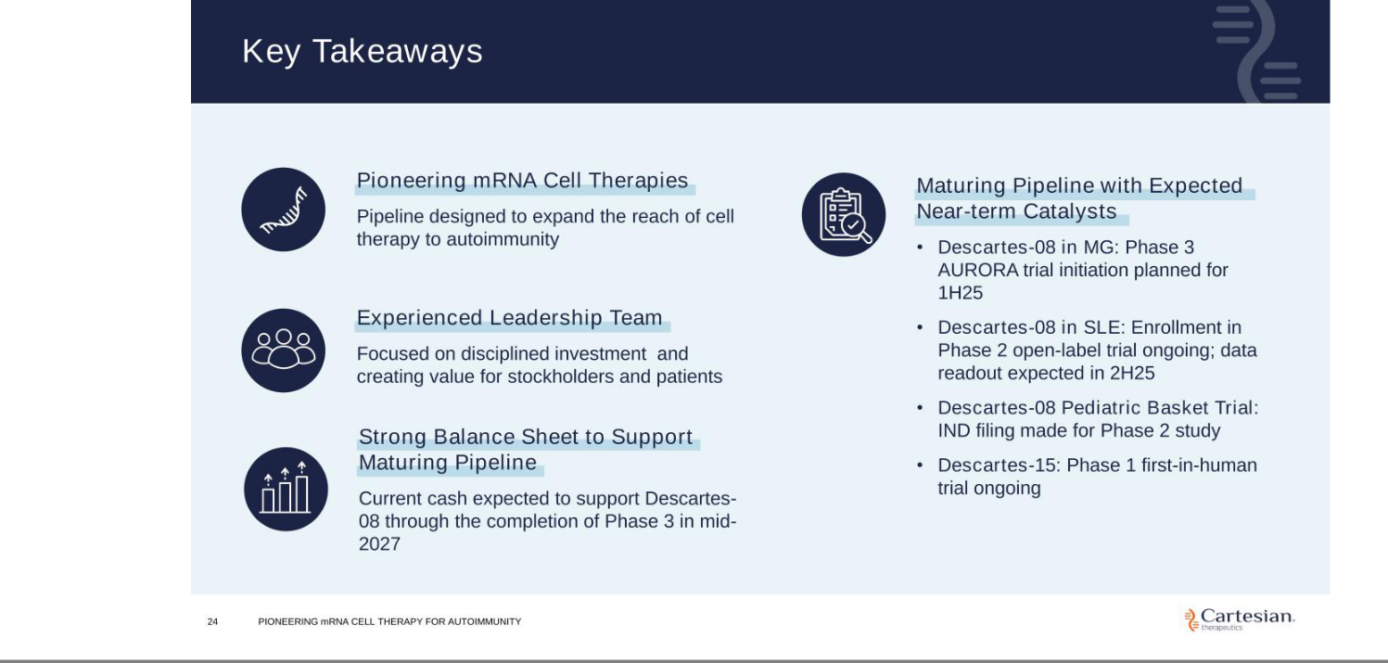





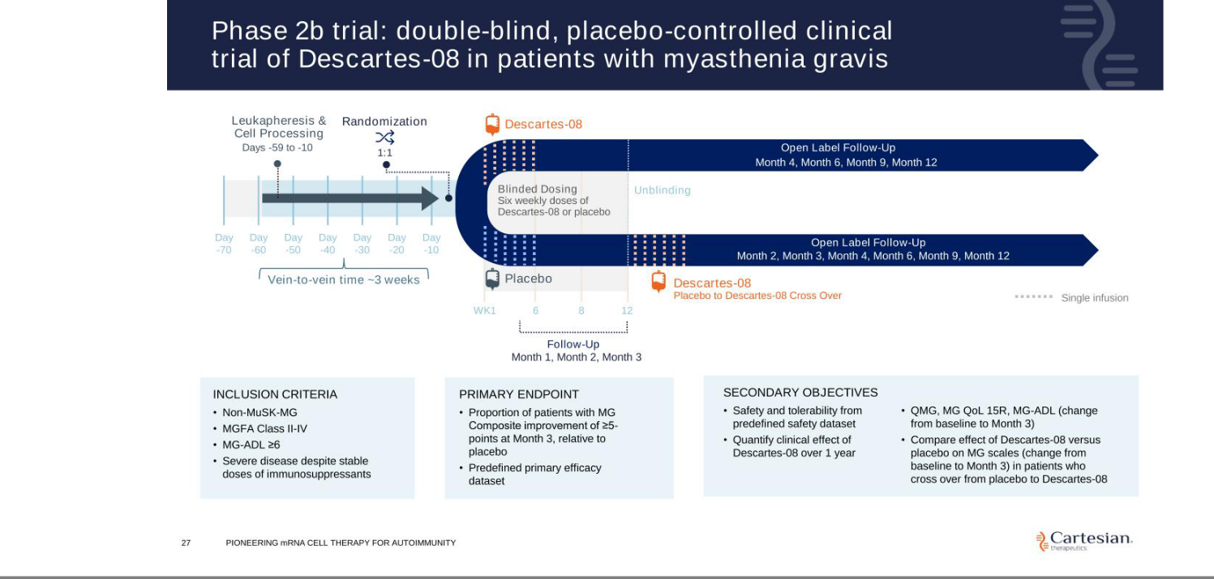

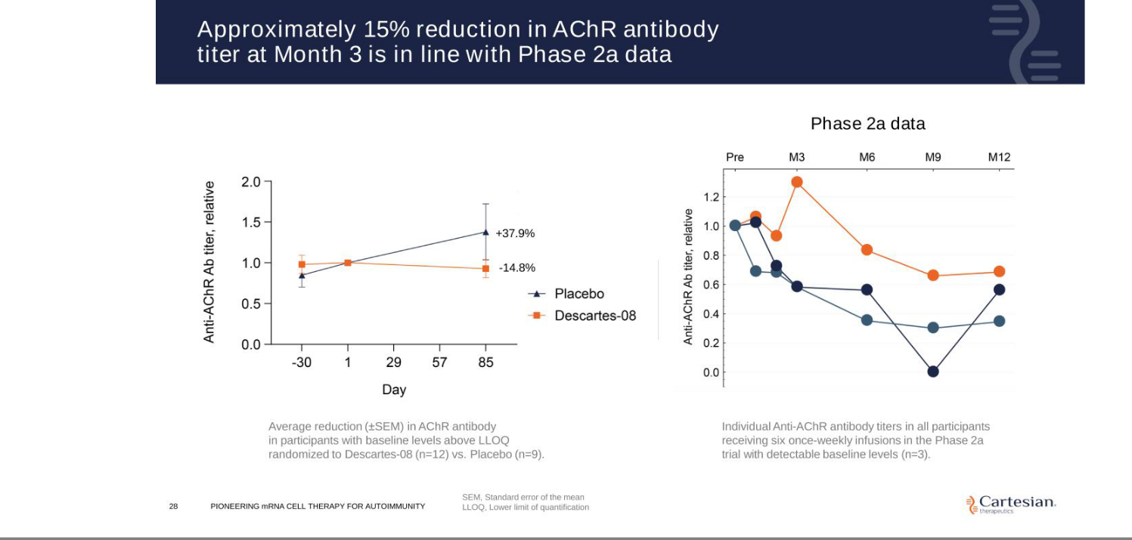

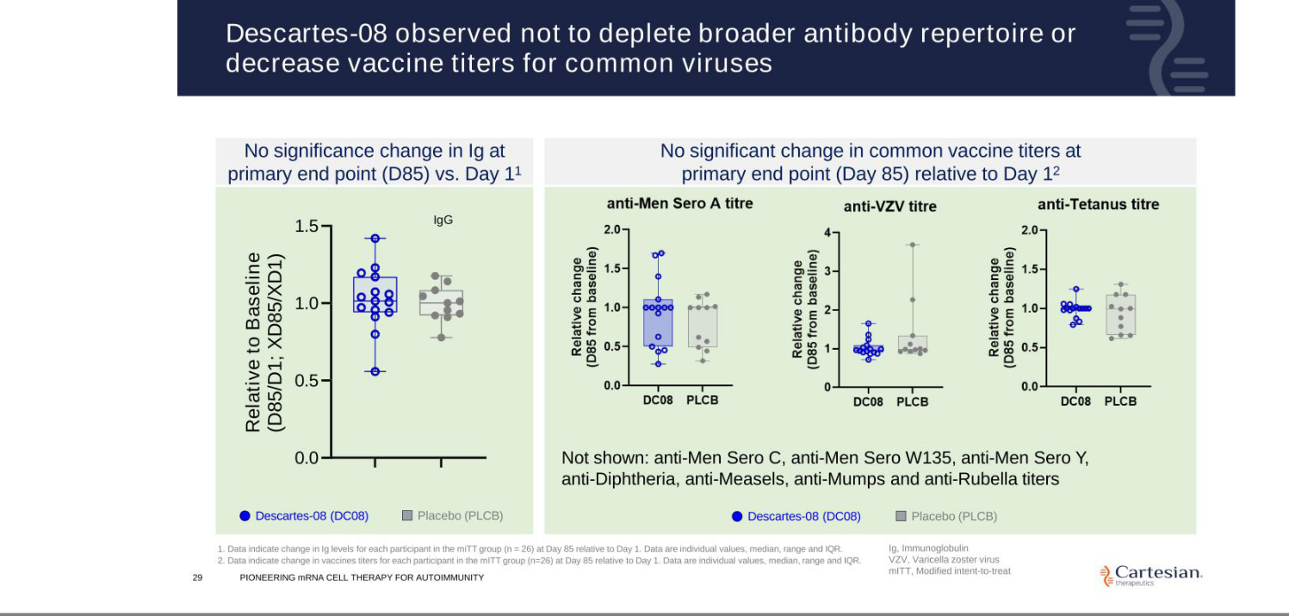

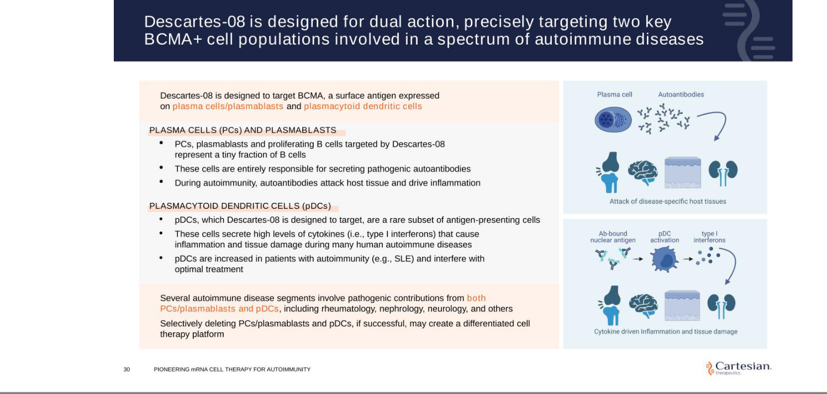

Exhibit 99.2


Cartesian Therapeutcs Highlights Progress and 2025 Strategic Priorites Across Pipeline of mRNA Cell Therapies for Autoimmune Diseases

Phase 3 AURORA trial of Descartes-08 in myasthenia gravis on track to commence in 1H25

Deepening responses observed over tme in Descartes-08-treated partcipants in Phase 2b trial in myasthenia gravis; Safety profle contnues to support outpatent administraton based on updated data shared in December 2024

Phase 2 systemic lupus erythematosus (SLE) trial of Descartes-08 ongoing with expected data readout in 2H25

Cash resources expected to support planned operatons, including completon of planned Phase 3 trial for Descartes-08 for myasthenia gravis, into mid-2027

FREDERICK, Md., Jan. 13, 2025 (GLOBE NEWSWIRE) – Cartesian Therapeutcs, Inc. (NASDAQ: RNAC) (the “Company”), a clinical-stage biotechnology company pioneering mRNA cell therapy for autoimmune diseases, today highlighted its recent progress and outlined its 2025 strategic priorites across its pipeline of mRNA cell therapy product candidates.

“On the heels of what was a highly productve 2024, we are entering the new year with strong momentum and believe we are well positoned to contnue to make meaningful progress advancing our pipeline in 2025,” said Carsten Brunn, Ph.D., President and Chief Executve Ofcer of Cartesian. “With respect to Descartes-08 for the treatment of myasthenia gravis (MG), we recently shared updated Phase 2b results which contnue to support the potental for Descartes-08 to provide deep and durable improvements for patents with MG in the convenient outpatent setng without the need for preconditoning chemotherapy. We believe these results provide strong support for the design of our planned Phase 3 program in this patent populaton, and we remain on track to commence our Phase 3 AURORA trial in the frst half of this year.”

Dr. Brunn contnued, “In additon, we remain focused on exploring the potental of Descartes-08 beyond MG, with enrollment ongoing in our Phase 2 open-label trial in patents with systemic lupus erythematosus (SLE), and our planned Phase 2 basket trial in pediatric patents with select autoimmune conditons expected to commence later this year. We also contnue to develop our work of Descartes-15, our next-gen, autologous ant-BCMA mRNA CAR-T cell therapy, as we move through our Phase 1 dose escalaton trial.”

Program Updates and Antcipated 2025 Milestones

Descartes-08

- In December 2024, the Company announced positve updated results from the Phase 2b trial of Descartes-08 in partcipants with MG. Deepening responses were observed over tme, with Descartes-08-treated partcipants included in the primary efcacy dataset (n=12) experiencing an average MG Actvites of Daily Living (MG-ADL) reducton of 5.5 (±1.1) at Month 4. Consistent


with previously reported data, Descartes-08 was observed to be well-tolerated, supportng outpatent administraton without the need for lymphodepletng chemotherapy.

- The Company expects to commence its Phase 3 AURORA trial of Descartes-08 in patents with MG in the frst half of 2025. The randomized, double-blind, placebo-controlled Phase 3 trial is designed to assess Descartes-08 versus placebo (1:1 randomizaton) administered as six once weekly infusions without preconditoning chemotherapy in approximately 100 partcipants with acetylcholine receptor autoantbody positve (AChR Ab+) MG. The primary endpoint will assess the proporton of Descartes-08 partcipants with an improvement in MG-ADL score of three points or more at Month 4 compared to placebo.

- Enrollment remains ongoing in the Company’s Phase 2 open-label trial evaluatng Descates-08 in SLE. The trial is designed to assess the safety, tolerability and clinical actvity of outpatent Descartes-08 administraton without preconditoning chemotherapy in patents with SLE. A data readout for this trial is expected in the second half of 2025. SLE is an incurable autoimmune disease marked by systemic infammaton that afects multple organ systems and impacts approximately 1.5 million people in the United States.

- The Company expects to commence a Phase 2 basket trial of Descartes-08 in pediatric patents with select autoimmune diseases, including juvenile dermatomyosits (JDM), in 2025. The U.S. Food and Drug Administraton (FDA) previously granted Rare Pediatric Disease Designaton to Descartes-08 for the treatment of JDM, a rare pediatric autoimmune disorder.

Descartes-15

- Dosing is underway in the Company’s frst-in-human Phase 1 clinical trial of Descartes-15, its next-generaton, autologous ant-BCMA mRNA CAR-T cell therapy. The Phase 1 dose escalaton trial is designed to assess the safety and tolerability of outpatent Descartes-15 administraton in patents with multple myeloma. Following the Phase 1 dose escalaton trial, the Company expects to subsequently assess Descartes-15 in autoimmune indicatons.

About Descartes-08

Descartes-08, Cartesian’s lead mRNA cell therapy candidate, is an autologous mRNA-engineered chimeric antgen receptor T-cell therapy (mRNA CAR-T) product targetng B-cell maturaton antgen (BCMA) in clinical development for generalized myasthenia gravis (MG) and systemic lupus erythematosus. In contrast to conventonal DNA-based CAR T-cell therapies, mRNA CAR-T administraton is designed to not require preconditoning chemotherapy, can be administered in the outpatent setng, and does not carry the risk of genomic integraton associated with cancerous transformaton. Descartes-08 has been granted Orphan Drug Designaton and Regeneratve Medicine Advanced Therapy Designaton by the U.S. Food and Drug Administraton for the treatment of MG, and Rare Pediatric Disease Designaton for the treatment of juvenile dermatomyosits.

About Descartes-15

Descartes-15 is a next-generaton, autologous ant-BCMA mRNA CAR-T cell therapy. In preclinical studies, Descartes-15 has been observed to achieve an approximately ten-fold increase in CAR

expression and selectve target-specifc killing, relatve to Descartes-08. Similar to Descartes-08, Descartes-15 is designed to be administered without preconditoning chemotherapy and does not use integratng vectors.

About Cartesian Therapeutcs

Cartesian Therapeutcs is a clinical-stage company pioneering mRNA cell therapy for the treatment of autoimmune diseases. The Company’s lead asset, Descartes-08, is an mRNA CAR-T in Phase 2b clinical development for patents with generalized myasthenia gravis and Phase 2 development for systemic lupus erythematosus, with a Phase 2 basket trial planned in additonal autoimmune indicatons. The Company’s clinical-stage pipeline also includes Descartes-15, a next-generaton, autologous ant-BCMA mRNA CAR-T. For more informaton, please visit www.cartesiantherapeutcs.com or follow the Company on LinkedIn or X, formerly known as Twiter.

Forward Looking Statements

Any statements in this press release about the future expectatons, plans and prospects of the Company, including without limitaton, statements about the Company’s expected cash resources and cash runway, statements regarding observatons and data from the myasthenia gravis Phase 2a/2b trial, the ability of the Company’s product candidates to be administered in an outpatent setng or without the need for preconditoning lymphodepletng chemotherapy, the potental of Descartes-08, Descartes-15, or any of the Company’s other product candidates to treat myasthenia gravis, systemic lupus erythematosus, juvenile dermatomyosits, or any other disease, the antcipated tming or the outcome of ongoing and planned clinical trials, studies and data readouts, the antcipated tming or the outcome of the FDA’s review of the Company’s regulatory flings, the Company’s ability to conduct its clinical trials and preclinical studies, the tming or making of any regulatory flings, the novelty of treatment paradigms that the Company is able to develop, the potental of any therapies developed by the Company to fulfll unmet medical needs, and enrollment in the Company’s clinical trials and other statements containing the words “antcipate,” “believe,” “contnue,” “could,” “estmate,” “expect,” “hypothesize,” “intend,” “may,” “plan,” “potental,” “predict,” “project,” “should,” “target,” “would,” and similar expressions, consttute forward-looking statements within the meaning of The Private Securites Litgaton Reform Act of 1995. Actual results may difer materially from those indicated by such forward-looking statements as a result of various important factors, including, but not limited to, the following: the uncertaintes inherent in the initaton, completon and cost of clinical trials including proof of concept trials, including uncertain outcomes, the availability and tming of data from ongoing and future clinical trials and the results of such trials, whether preliminary results from a partcular clinical trial will be predictve of the fnal results of that trial and whether results of early clinical trials will be indicatve of the results of later clinical trials, the ability to predict results of studies performed on human beings based on results of studies performed on non-human subjects, the unproven approach of the Company’s technology, potental delays in enrollment of patents, undesirable side efects of the Company’s product candidates, its reliance on third partes to conduct its clinical trials, the Company’s inability to maintain its existng or future collaboratons, licenses or contractual relatonships, its inability to protect its proprietary technology and intellectual property, potental delays in regulatory approvals, the availability of funding sufcient for its foreseeable and unforeseeable operatng expenses and capital expenditure requirements, the Company’s recurring losses from operatons and negatve cash fows, substantal fuctuaton in the price of the Company’s common stock, risks related to geopolitcal conficts and pandemics and other important factors discussed in the “Risk Factors” secton of the Company’s

most recent Annual Report on Form 10-K and subsequently fled Quarterly Reports on Form 10-Q, and in other flings that the Company makes with the Securites and Exchange Commission. In additon, any forward-looking statements included in this press release represent the Company’s views only as of the date of its publicaton and should not be relied upon as representng its views as of any subsequent date. The Company specifcally disclaims any intenton to update any forward-looking statements included in this press release, except as required by law.

Investor Contact

Megan LeDuc

Associate Director, Investor Relatons

megan.leduc@cartesiantx.com

Media Contact

David Rosen

Argot Partners

david.rosen@argotpartners.com

