UNITED STATES

SECURITIES AND EXCHANGE COMMISSION

Washington, D.C. 20549

FORM 8-K

CURRENT REPORT

Pursuant to Section 13 or 15(d) of

the Securities Exchange Act of 1934

Date of Report (Date of earliest event reported): January 9, 2026

CARTESIAN THERAPEUTICS, INC.

(Exact name of registrant as specified in its charter)

Delaware | 001-37798 | 26-1622110
(State or other jurisdiction | (Commission | (IRS Employer
of incorporation) | File Number) | Identification No.)
 | 7495 New Horizon Way, Frederick, MD 21703
 | (Address of principal executive offices)(Zip Code)
 | (301) 348-8698
 | Registrant’s telephone number, including area code

N/A

(Former name or former address, if changed since last report)

Check the appropriate box below if the Form 8-K filing is intended to simultaneously satisfy the filing obligation of the registrant under any of the following provisions:

- Written communications pursuant to Rule 425 under the Securities Act (17 CFR 230.425)

- Soliciting material pursuant to Rule 14a-12 under the Exchange Act (17 CFR 240.14a-12)

- Pre-commencement communications pursuant to Rule 14d-2(b) under the Exchange Act (17 CFR 240.14d-2(b))

- Pre-commencement communications pursuant to Rule 13e-4(c) under the Exchange Act (17 CFR 240.13e-4(c))

Securities registered pursuant to Section 12(b) of the Act:

Title of each class | Trading Symbol(s) | Name of each exchange on which registered
Common Stock (Par Value $0.0001) | RNAC | The Nasdaq Stock Market LLC

Indicate by check mark whether the registrant is an emerging growth company as defined in Rule 405 of the Securities Act of 1933 (§230.405 of this chapter) or Rule 12b-2 of the Securities Exchange Act of 1934 (§240.12b-2 of this chapter).

Emerging growth company o

If an emerging growth company, indicate by check mark if the registrant has elected not to use the extended transition period for complying with any new or revised financial accounting standards provided pursuant to Section 13(a) of the Exchange Act. o

Item 7.01. Regulation FD Disclosure.

Cartesian Therapeutics, Inc. (the “Company”) from time to time presents and/or distributes to the investment community at various industry and other conferences slide presentations to provide updates and summaries of its business. A copy of its current corporate slide presentation is attached to this Current Report on Form 8-K as Exhibit 99.1.

Additionally, on January 9, 2026, the Company issued a press release highlighting recent progress and outlining its 2026 outlook. This press release is attached to this Current Report on Form 8-K as Exhibit 99.2.

The information in Item 7.01 of this Form 8-K, including Exhibits 99.1 and 99.2 attached hereto, shall not be deemed “filed” for purposes of Section 18 of the Securities Exchange Act of 1934, as amended (the “Exchange Act”), or otherwise subject to the liabilities of that section, nor shall it be deemed incorporated by reference in any filing under the Securities Act of 1933, as amended, or the Exchange Act, except as expressly set forth by specific reference in such a filing. The Company undertakes no obligation to update, supplement or amend the materials attached hereto as Exhibits 99.1 or 99.2, except as required by law.

Item 9.01 Financial Statements and Exhibits.

(d) Exhibits

Exhibit |  |  |  | Exhibit Description
No. |  |  |  | Exhibit Description
99.1 |  | Corporate slide presentation of Cartesian Therapeutics, Inc. dated January 2026.
99.2 |  | Press release of Cartesian Therapeutics, Inc. issued on January 9, 2026.
104 |  | Cover Page Interactive Data File (embedded within the Inline XBRL document)

SIGNATURES

Pursuant to the requirements of the Securities Exchange Act of 1934, the registrant has duly caused this report to be signed on its behalf by the undersigned hereunto duly authorized.

 | CARTESIAN THERAPEUTICS, INC.
Date: January 9, 2026 | By: | /s/ Carsten Brunn, Ph.D.
 |  | Carsten Brunn, Ph.D.
 |  | President and Chief Executive Officer



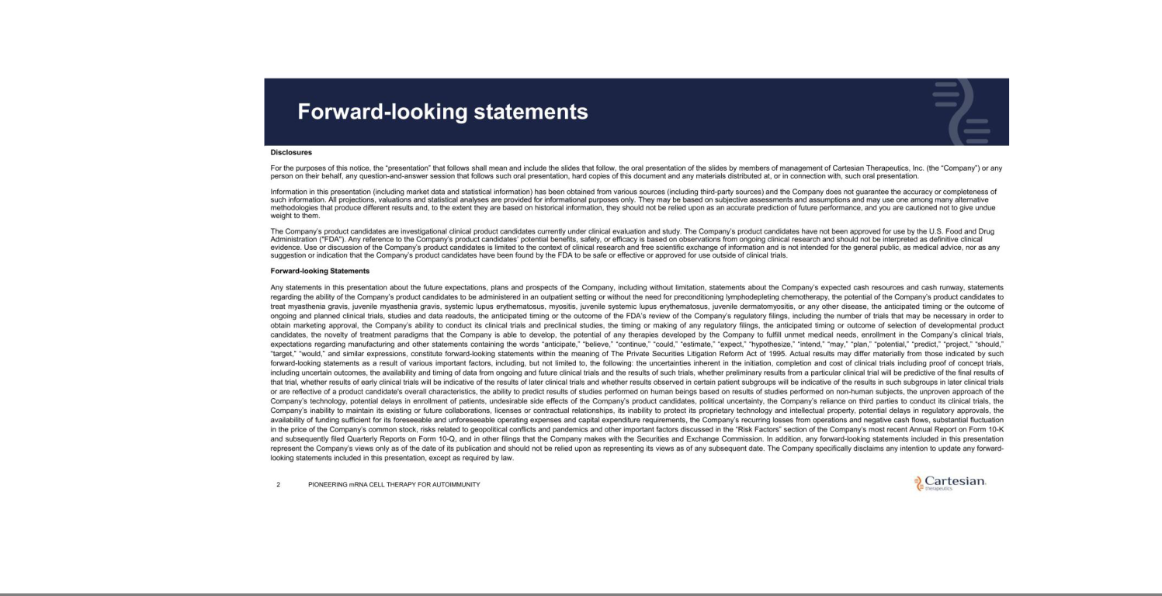

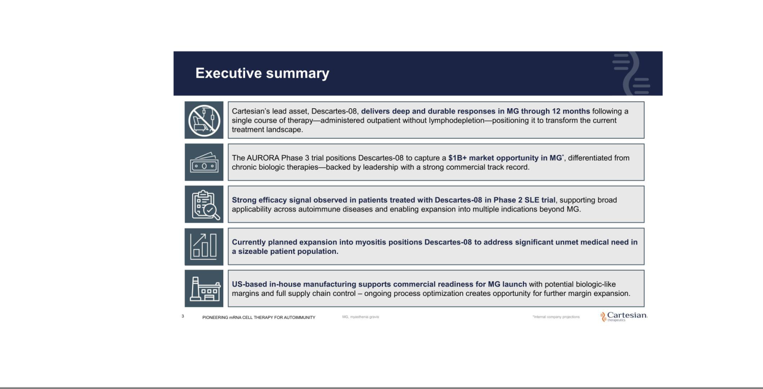

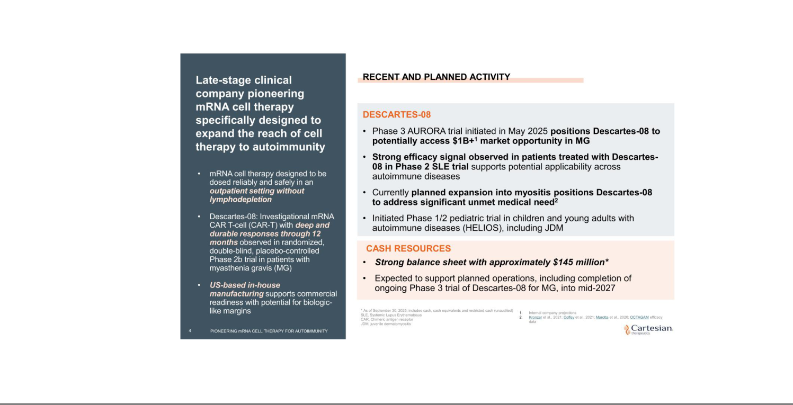

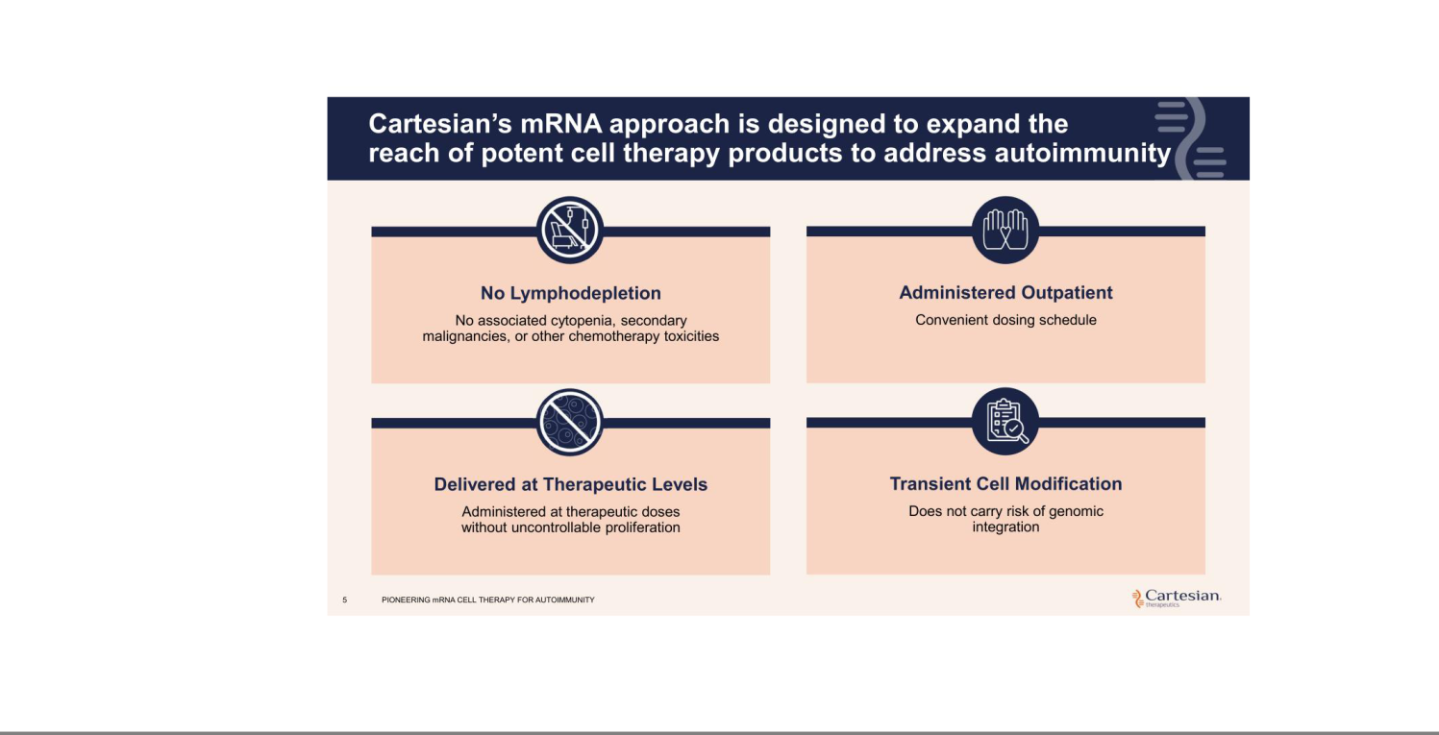

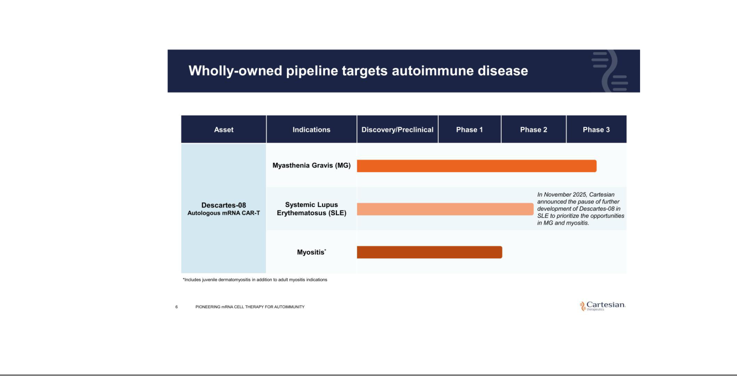

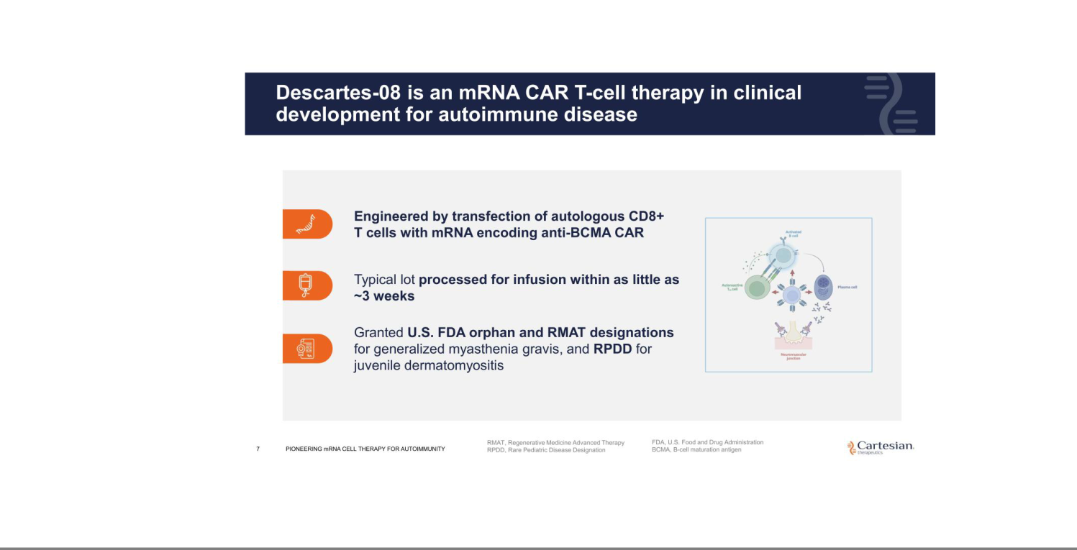

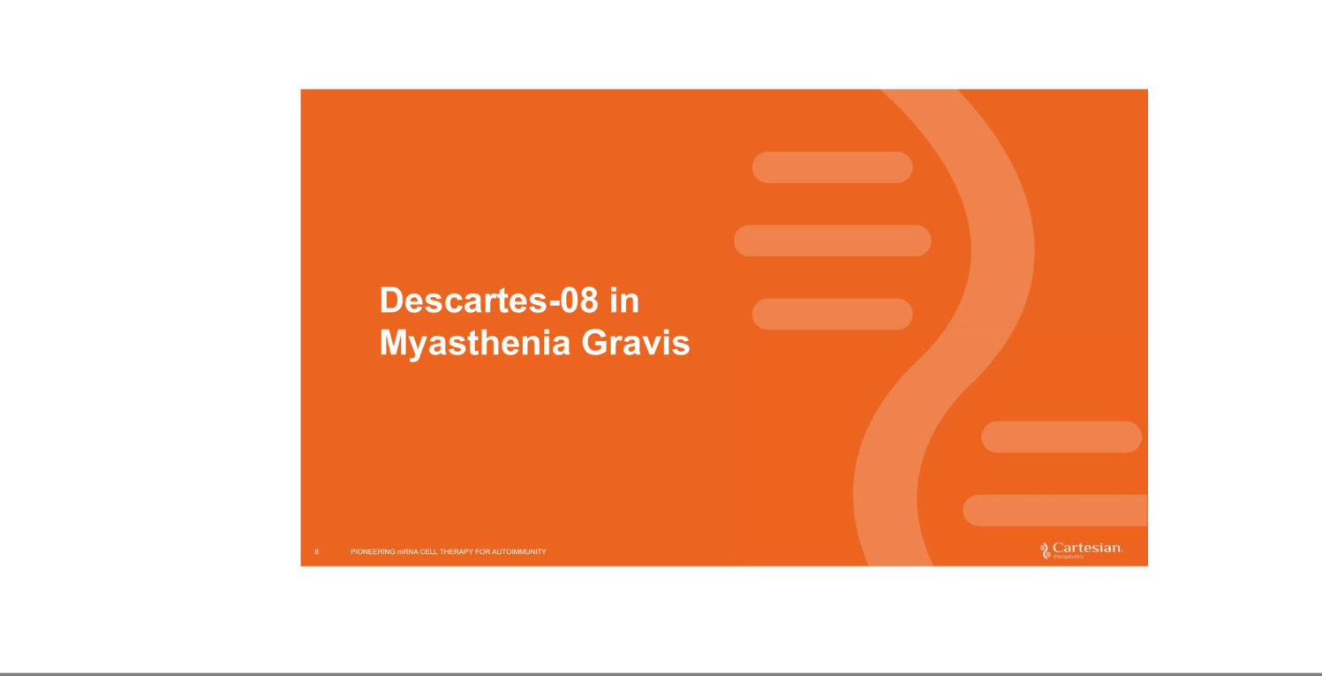

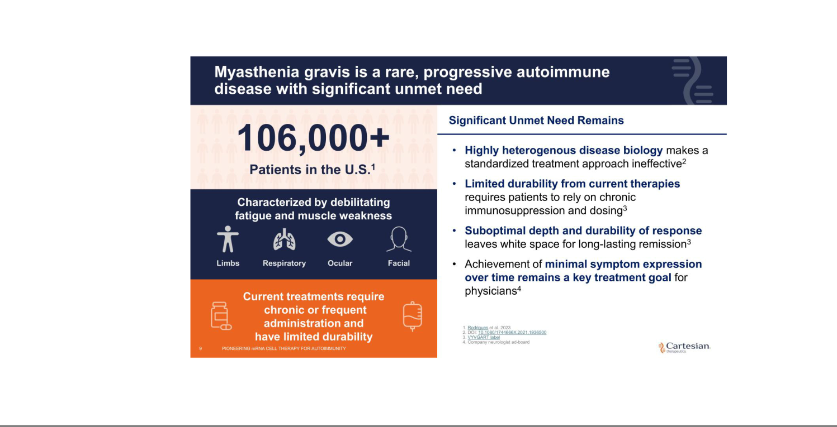

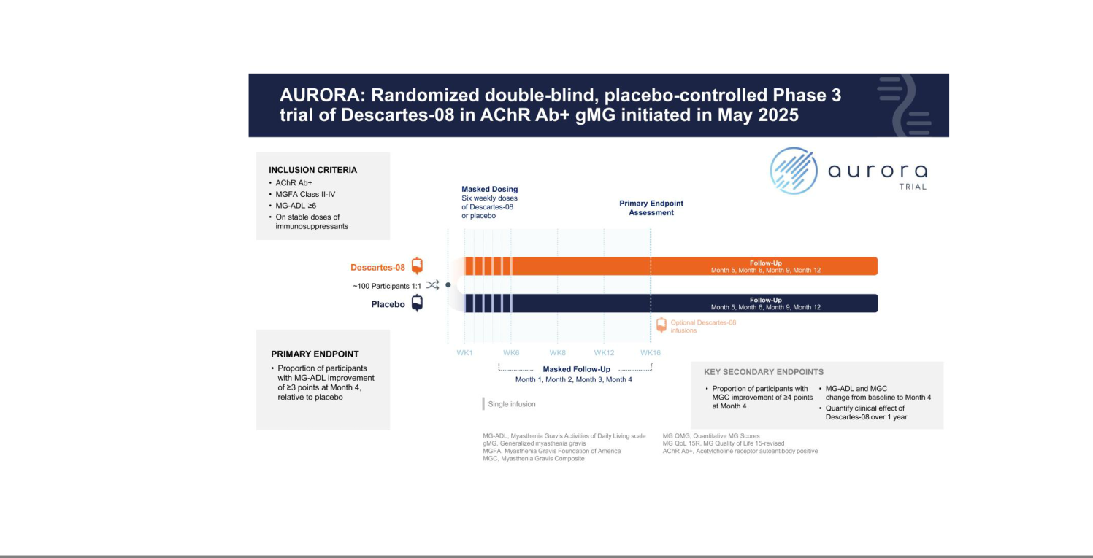

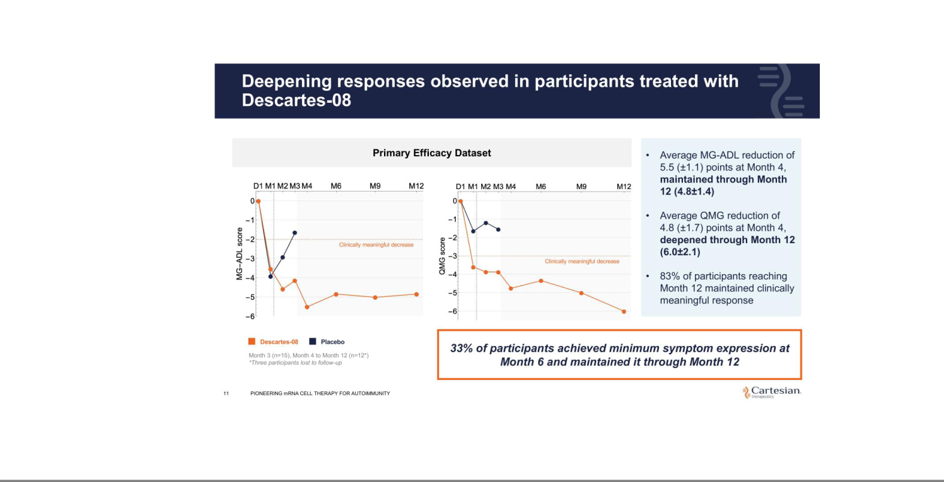

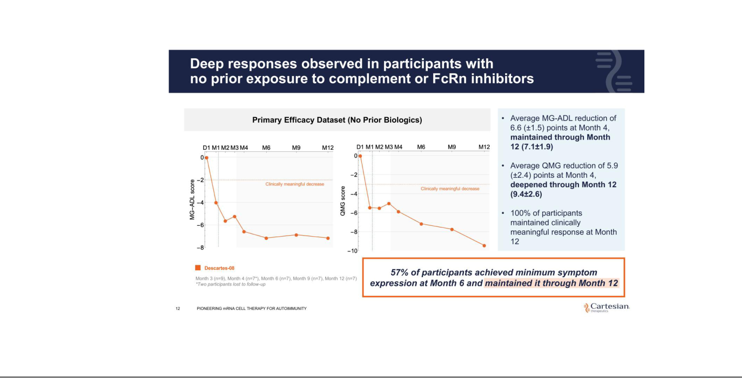

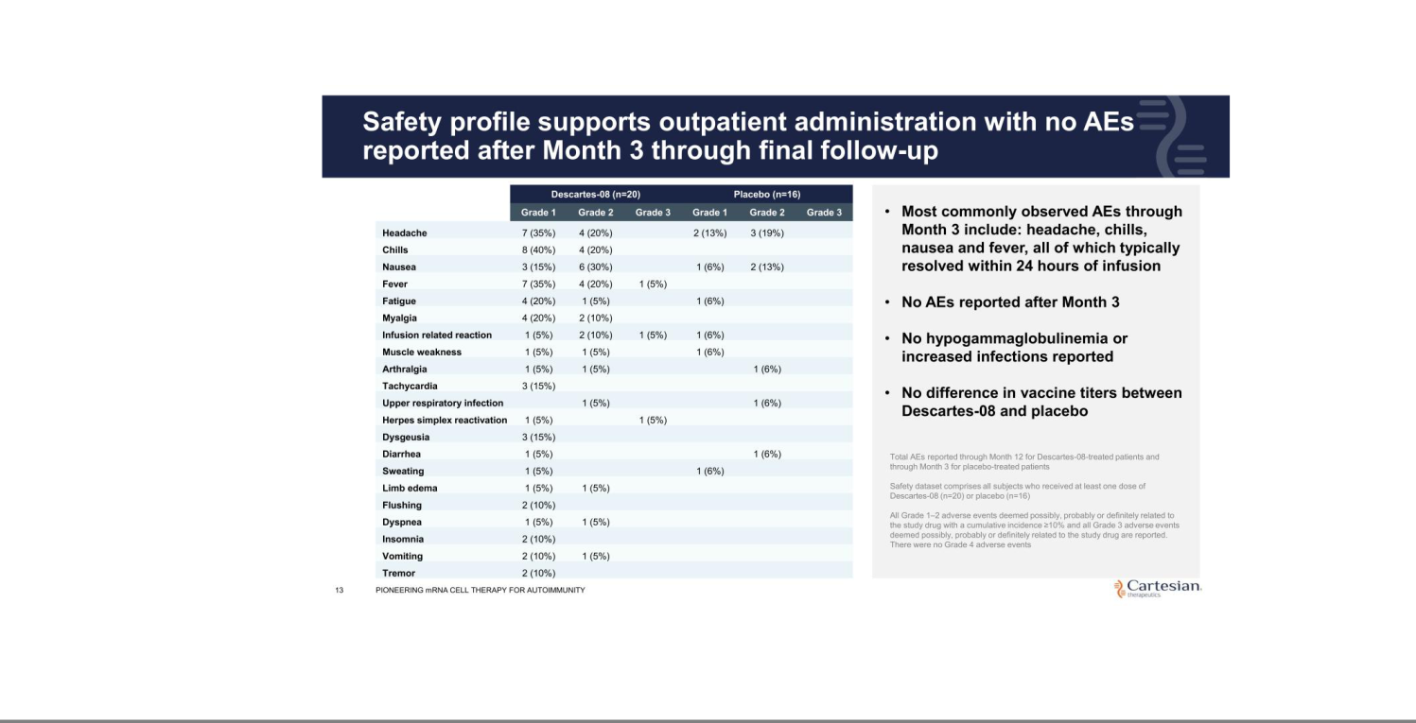

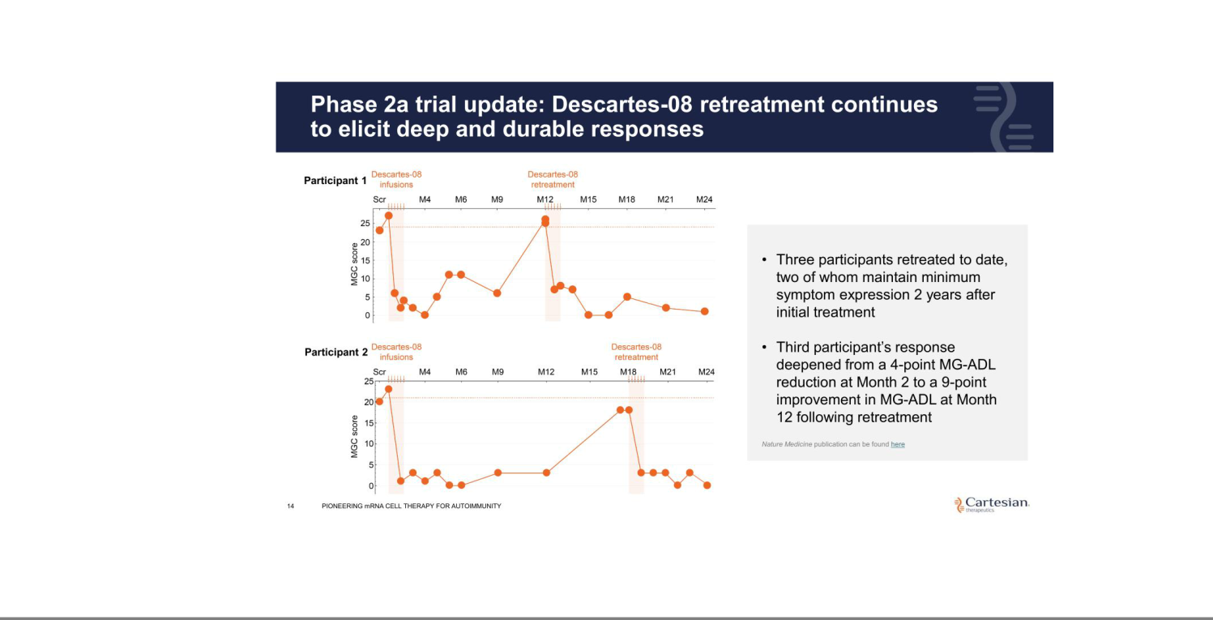

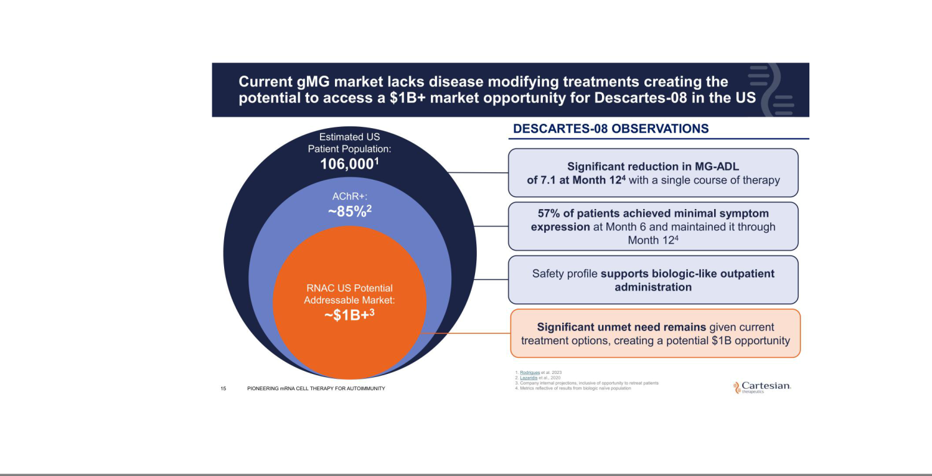

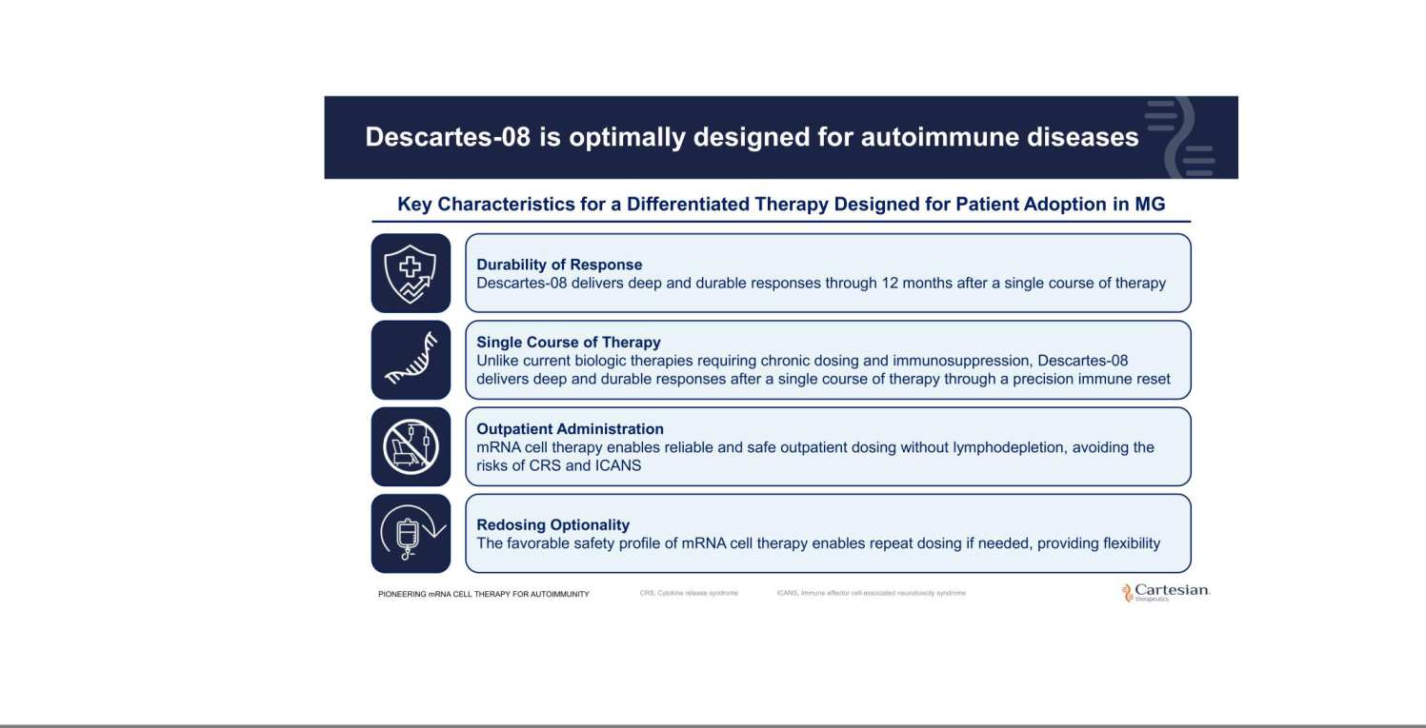

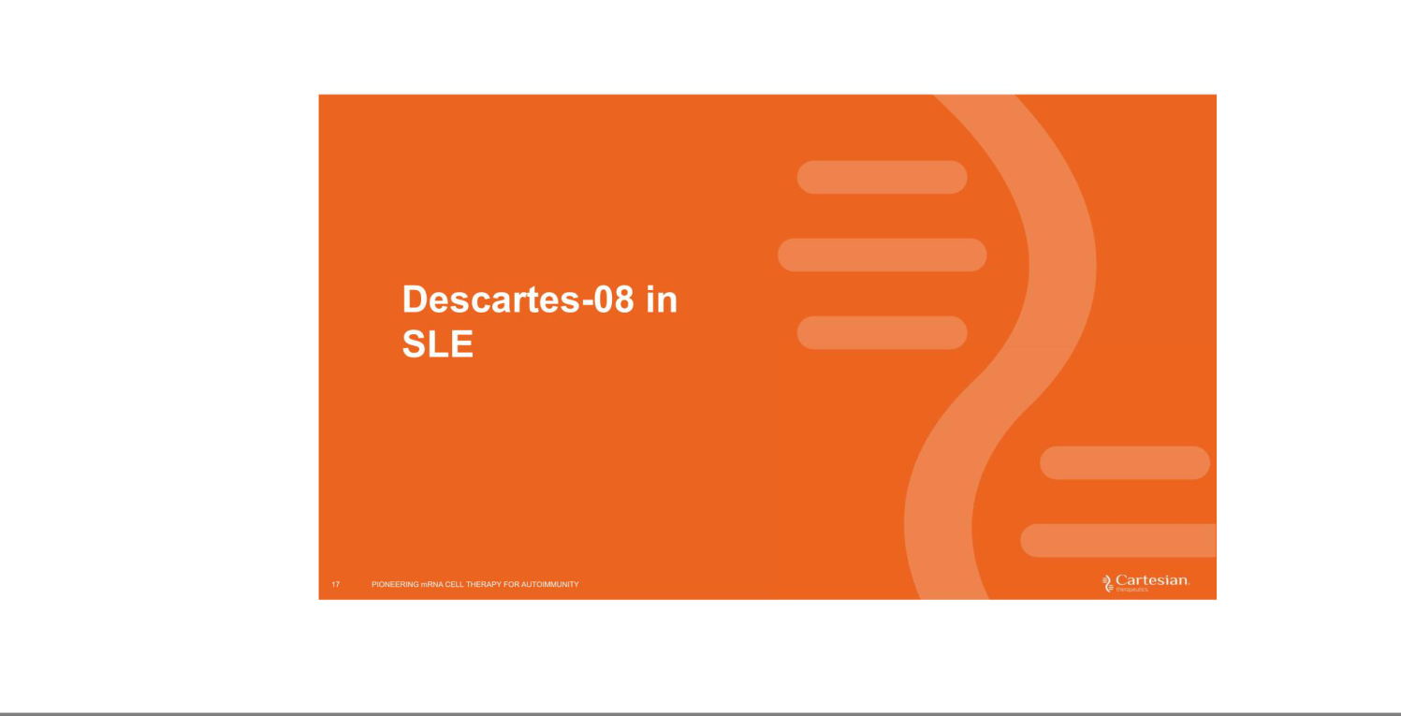

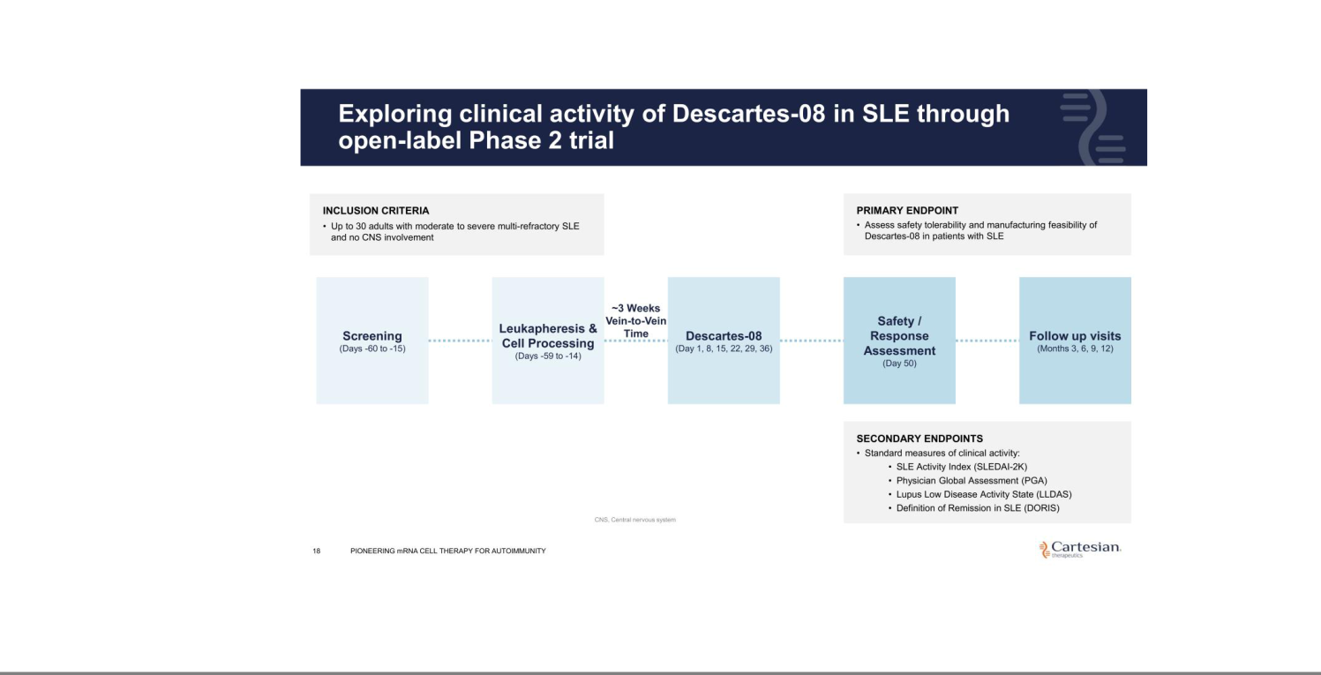

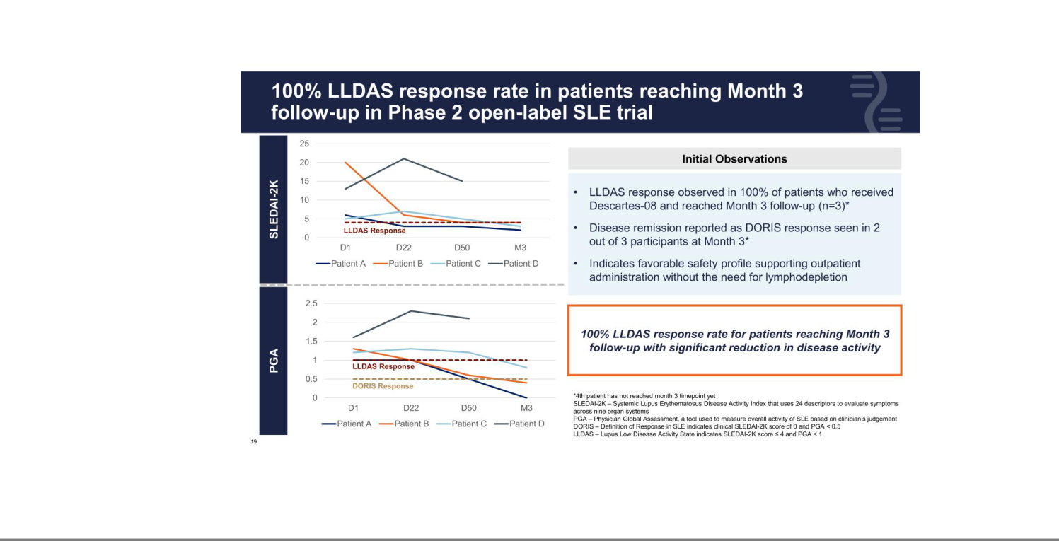

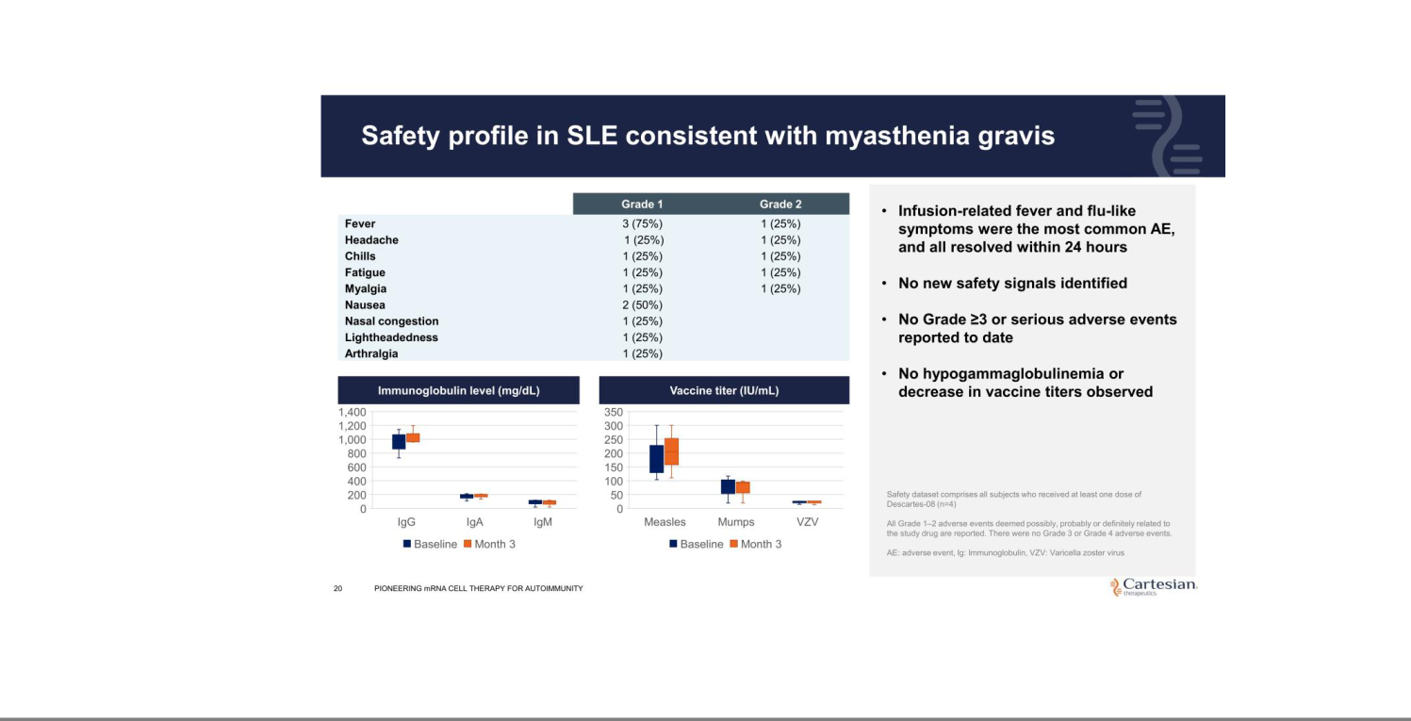

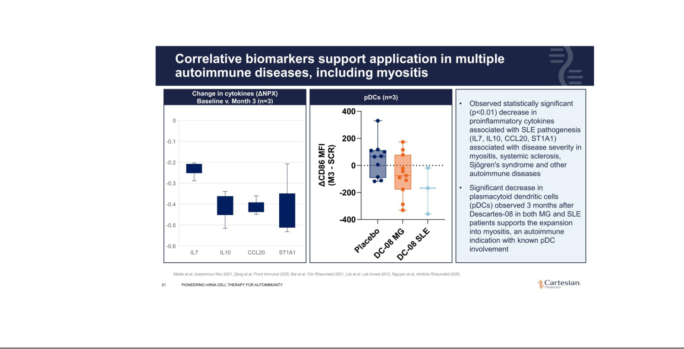

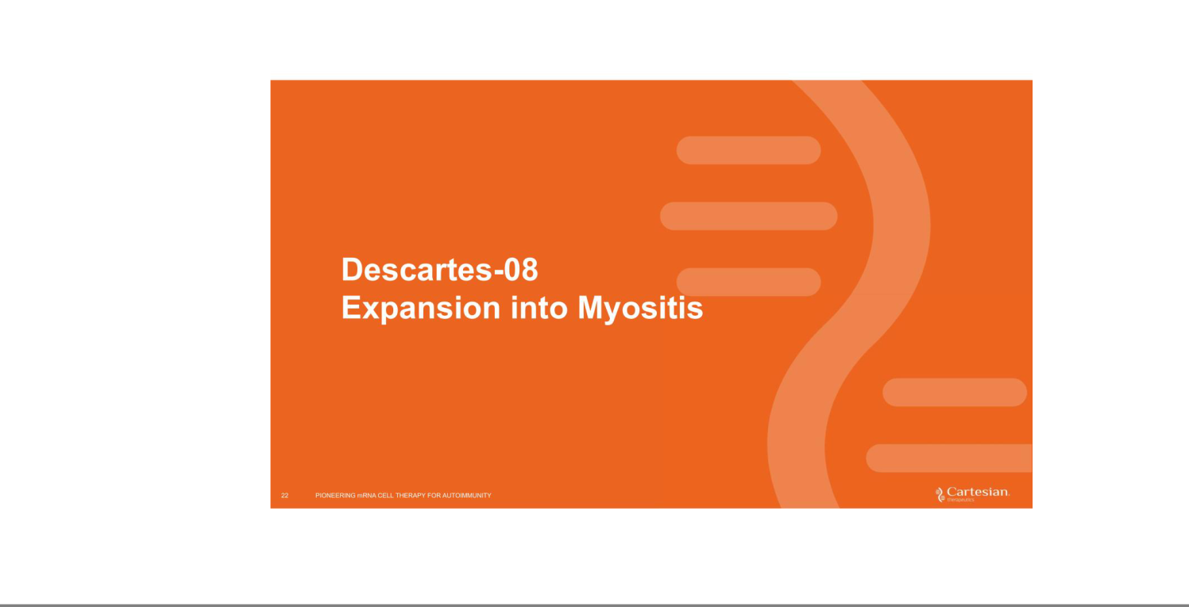

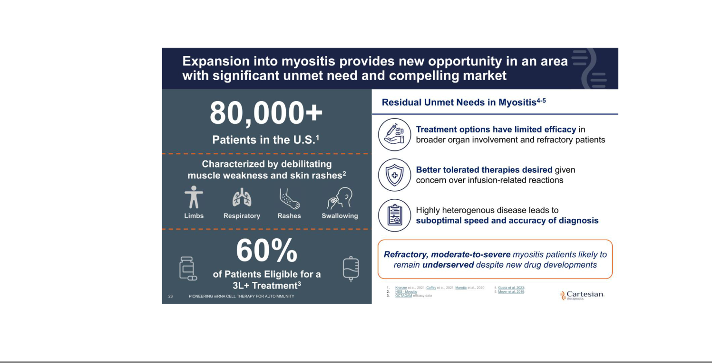

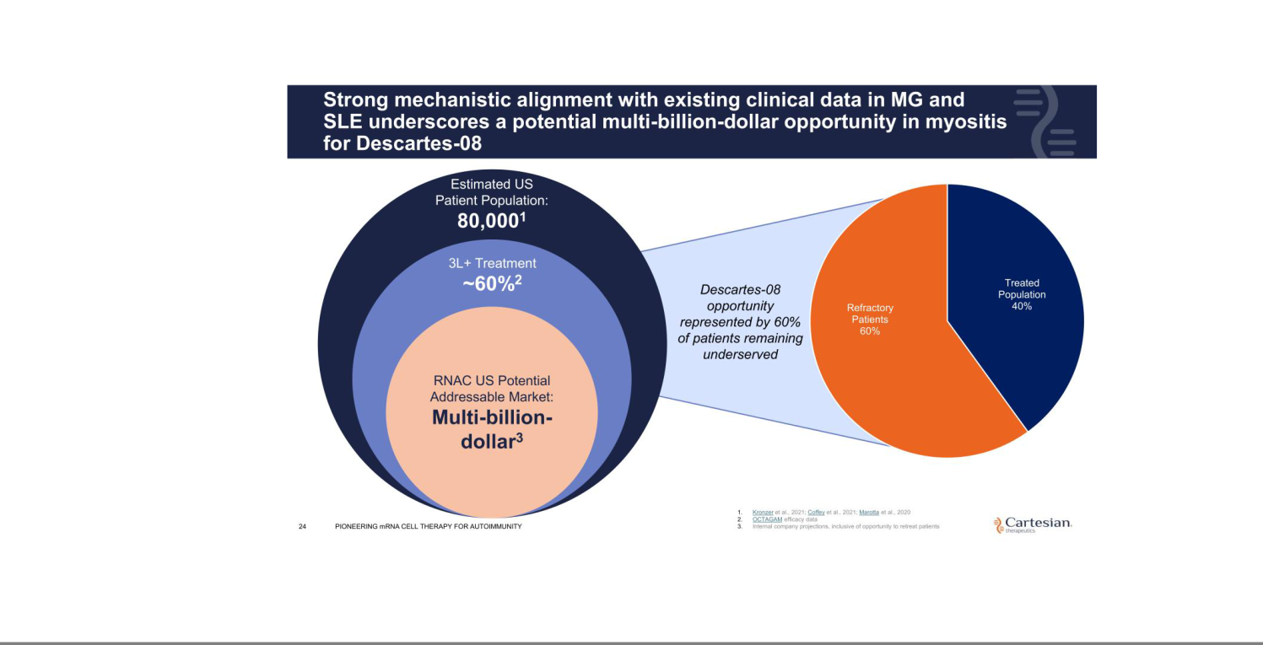

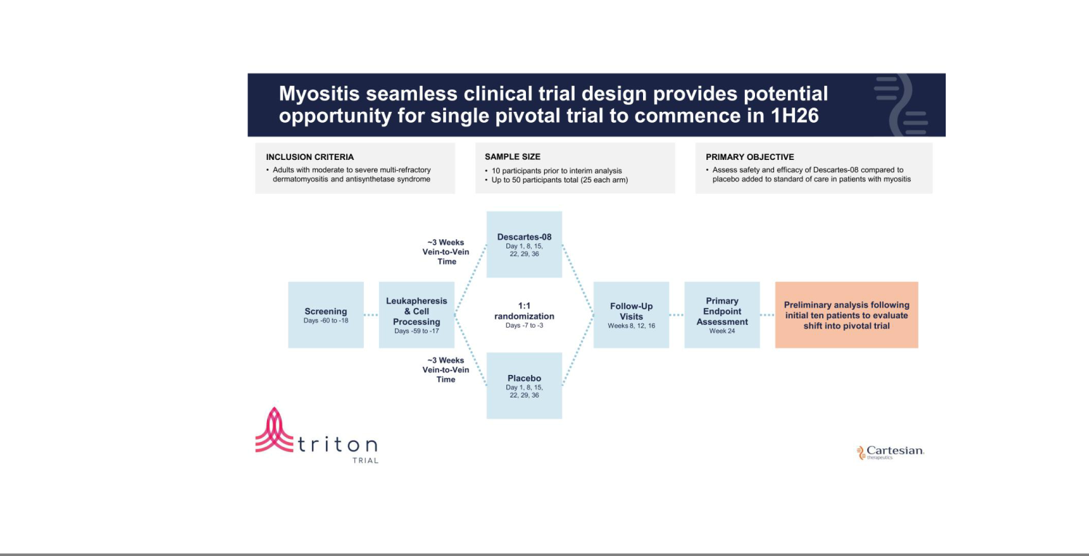

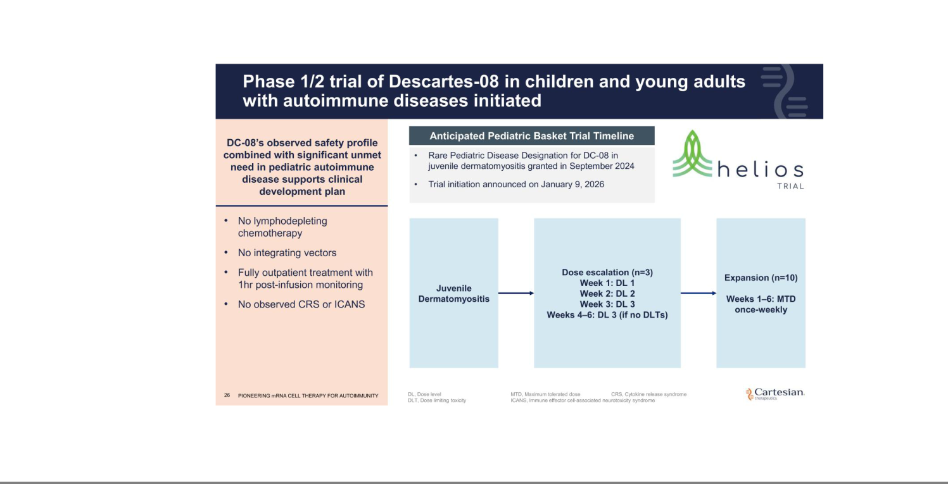



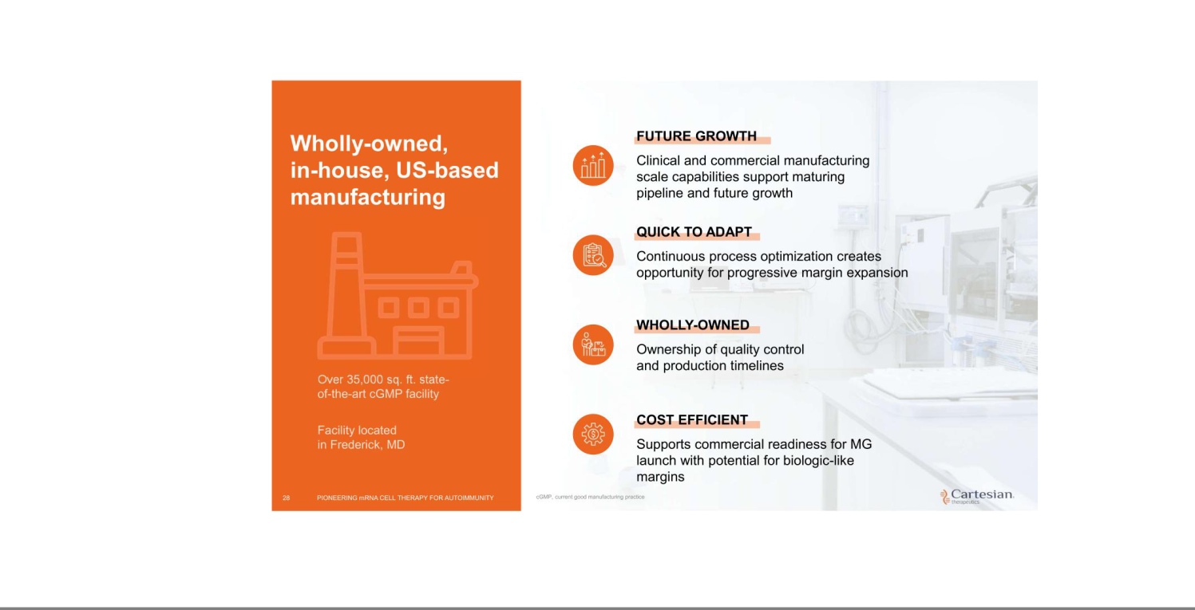

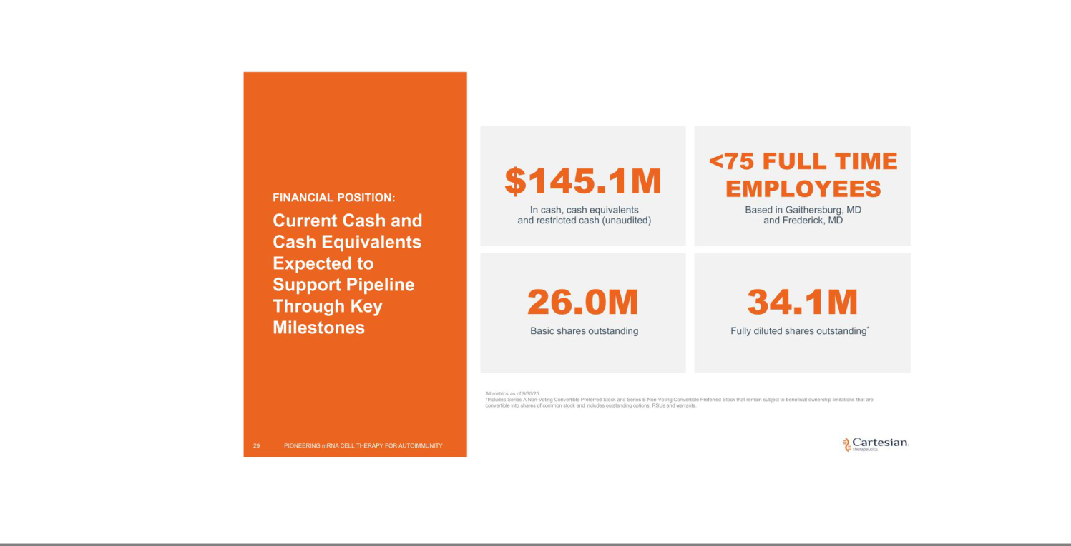



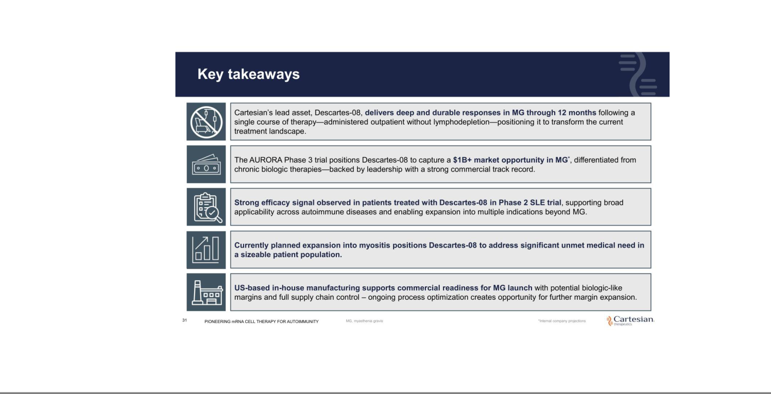



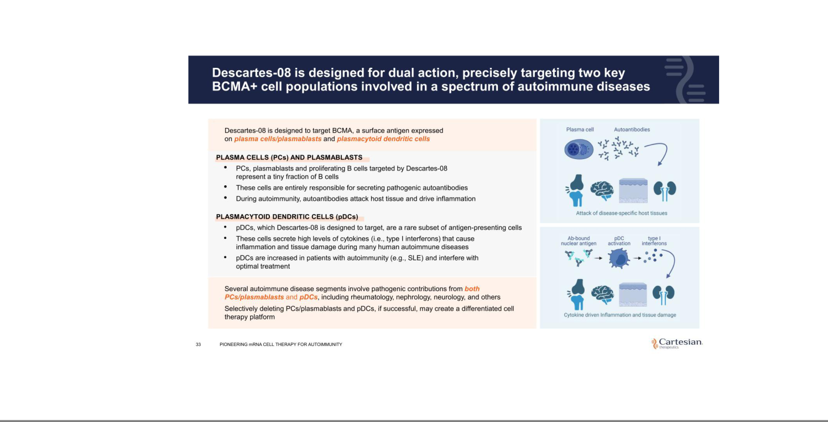

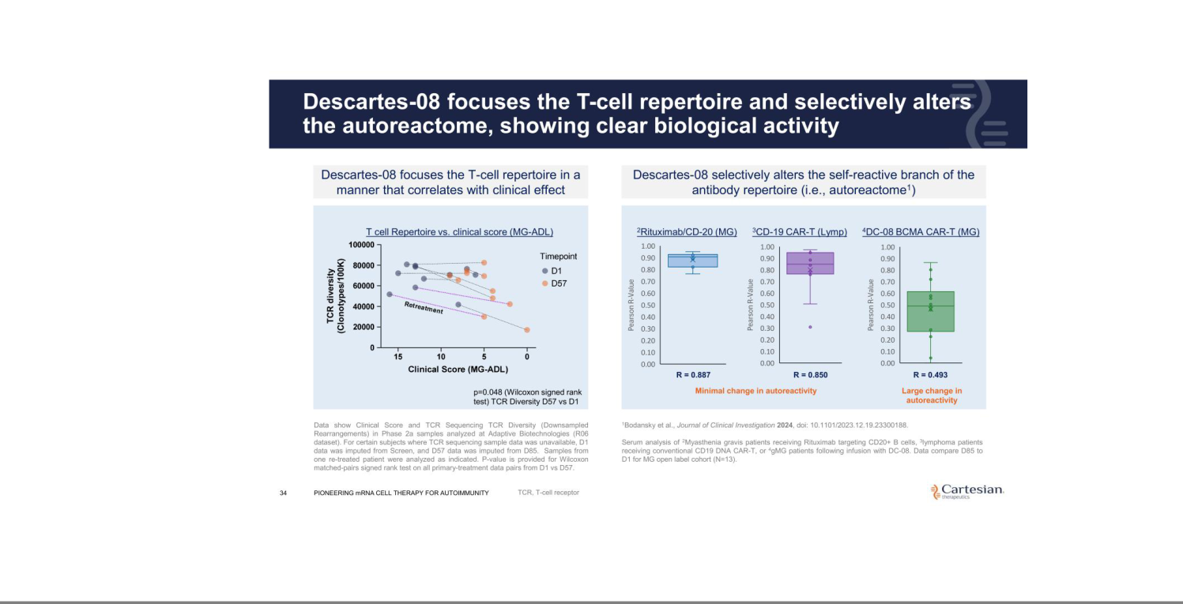

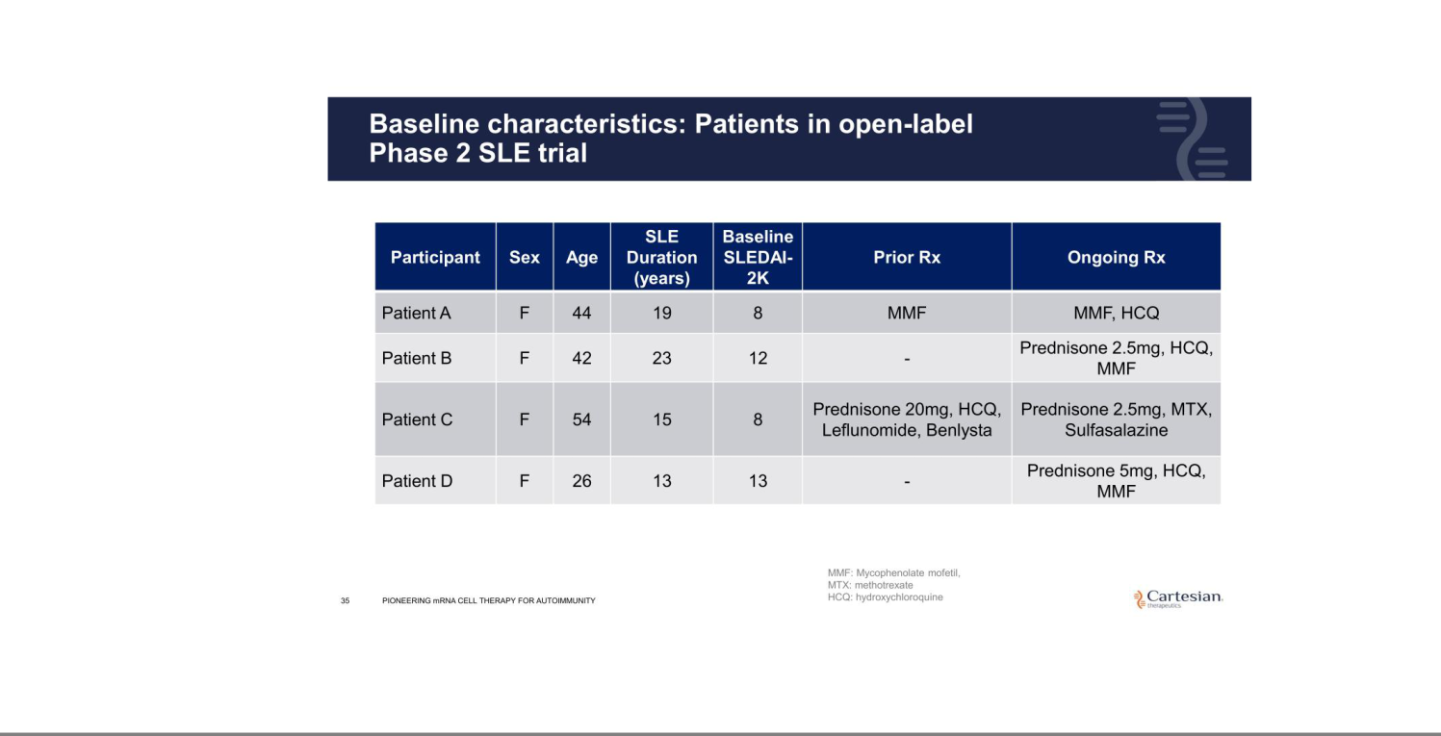

Exhibit 99.2


Cartesian Therapeutics Highlights Recent Progress and Outlines 2026 Outlook

Enrollment on track in Phase 3 AURORA trial of Descartes-08 in myasthenia gravis

IND application for Descartes-08 in myositis accepted by FDA; seamless adaptive clinical trial offering potential opportunity for a single pivotal trial expected to commence in 1H26

Phase 1/2 pediatric trial of Descartes-08 in juvenile dermatomyositis initiated

Cash resources expected to support planned operations, including completion of planned Phase 3 trial for Descartes-08 for myasthenia gravis, into mid-2027

FREDERICK, Md., Jan. 9, 2026 (GLOBE NEWSWIRE) -- Cartesian Therapeutics, Inc. (NASDAQ: RNAC) (the “Company”), a clinical-stage biotechnology company pioneering cell therapy for autoimmune diseases, today highlighted its recent progress and outlined its 2026 strategic priorities across its cell therapy pipeline targeting autoimmune diseases.

“Following a year marked by significant progress advancing our autoimmune-focused pipeline, we are entering 2026 with strong momentum as we focus on advancing Descartes-08 across multiple indications,” said Carsten Brunn, Ph.D., President and Chief Executive Officer of Cartesian. “This includes our ongoing Phase 3 AURORA trial for the treatment of myasthenia gravis (MG), an indication in which Descartes-08 demonstrated deep and sustained responses through long-term follow-up in our Phase 2b trial. Given the favorable safety profile observed in Descartes-08 supporting outpatient administration, we are confident that Descartes-08 could represent a meaningful addition to the MG treatment landscape.”

Dr. Brunn continued, “We are also excited to initiate our Phase 2 trial in myositis in the first half of 2026, with the potential opportunity for a single pivotal trial following an interim analysis once ten participants are enrolled and reach the primary endpoint. In addition, we continue to advance the development of next-generation agents that have the potential to improve potency and therapeutic targeting while we explore enhanced cell therapy delivery through in-vivo platforms which have demonstrated encouraging initial results.”

Descartes-08 Program Updates

- Enrollment remains on track in the Phase 3 AURORA trial of Descartes-08, Cartesian’s autologous anti-B cell maturation antigen (BCMA) chimeric antigen receptor T-cell therapy (CAR-T), in participants with MG. Recently named to Nature Medicine’s “Eleven clinical trials that will shape medicine in 2026” list, the randomized, double-blind, placebo-controlled Phase 3 AURORA trial is designed to assess Descartes-08 versus placebo (1:1 randomization) administered as six once-weekly outpatient infusions without preconditioning chemotherapy in approximately 100 participants with acetylcholine receptor autoantibody positive (AChR Ab+) MG. The primary endpoint will assess the proportion of Descartes-08 participants with an improvement in MG Activities of Daily Living (MG-ADL) score of three points or more at Month 4 compared to placebo.

- In November 2025, the Company announced its planned expansion into myositis given the strong mechanistic alignment with existing clinical data in MG and systemic lupus erythematosus (SLE). Today, Cartesian announced the U.S. Food and Drug Administration (FDA) accepted the investigational new drug (IND) application for its planned Phase 2 trial in myositis. The Company plans to initiate this Phase 2 seamless adaptive clinical trial, which offers a potential opportunity for a single pivotal trial in the first half of 2026. The randomized, double-

blind, placebo-controlled Phase 2 trial in myositis (TRITON) is designed to assess Descartes-08 versus placebo (1:1 randomization) administered as six once-weekly outpatient infusions without preconditioning chemotherapy in up to 50 participants with moderate to severe multi-refractory dermatomyositis and antisynthetase syndrome. The primary endpoint is expected to assess safety and efficacy of Descartes-08 compared to placebo added to standard of care in participants with myositis at Week 24. An interim analysis is expected after ten participants are enrolled and reach the primary endpoint, at which point sample size assumptions will be revised to what is necessary to support a potential seamless pivotal trial, pending FDA review based on the preliminary efficacy data available at such time.

- Beyond myositis in adult indications, Cartesian today announced the initiation of its Phase 1/2 (HELIOS) pediatric trial of Descartes-08 in children and young adults with autoimmune diseases, including juvenile dermatomyositis (JDM), a rare pediatric autoimmune disorder marked by pathognomonic skin rash and muscle inflammation affecting multiple organ systems. The FDA previously granted Rare Pediatric Disease Designation to Descartes-08 for the treatment of JDM, a rare pediatric autoimmune disorder.

- Today, the Company announced the publication of two peer-reviewed journal articles in Nature Medicine detailing the mechanism of action of Descartes-08 as well as reiterating data surrounding the Phase 2b trial of Descartes-08 in patients with MG.

Data illustrated within the mechanism of action article observed that transient targeting of BCMA with Descartes-08 achieved precision retuning of autoreactivity in MG. Descartes-08 eliminated pathogenic target (BCMA+) cells with high levels of immune function while also initiating a non-cellular immune reset and selectively modulating inflammatory proteins without depleting protective immune function.

Consistent with the previously announced 12-month data from the Phase 2b trial of Descartes-08 in patients with MG, the second publication outlines deep and durable responses observed through 12 months after a single course of therapy. Deepest and most compelling sustained responses were observed in patients without prior biologic therapies (n=7) with 57% of these participants achieving minimal symptom expression by Month 6 and maintaining it through Month 12. Beyond the previously disclosed data, the Company also reported that after beginning medication tapering at Month 6 follow-up, the median reduction in prednisone daily dose was 55% at Month 12. Per trial protocol, changes in other MG-specific medications were not permitted. With no immunosuppression required to receive Descartes-08 treatment, safety data remains consistent with no instances of cytokine release syndrome (CRS) or immune effector cell-associated neurotoxicity syndrome (ICANS) reported, further supporting outpatient administration of Descartes-08.

In-vivo CAR-T Cell Therapy

The Company continues to evaluate the potential of enhanced delivery platforms for its cell therapies with multiple agreements in place to explore optimizing in-vivo delivery of Descartes-08,

Descartes-15 and next generation agents currently in development. The recent appointment of Adrian Bot, M.D., Ph.D., to the Company’s Board of Directors supports this strategic expansion as Dr. Bot brings a unique perspective shaped by pioneering work in first-in-class CAR-T cell therapies, including the recent historic acquisition of Capstan’s novel in-vivo CAR-T technology by

AbbVie, as well as the development of next generation RNA-based precision medicines.

Cash Runway

The Company continues to expect current cash resources to support planned operations, including the completion of its ongoing Phase 3 AURORA trial for Descartes-08 in MG and initiation of its Phase 2 myositis trial, through mid-2027.

About Descartes-08

Descartes-08, Cartesian’s lead cell therapy candidate, is an autologous chimeric antigen receptor T-cell therapy (CAR-T) product targeting B-cell maturation antigen (BCMA) in clinical development for generalized myasthenia gravis (MG) and myositis. In contrast to conventional DNA-based CAR T-cell therapies, Cartesian’s CAR-T administration is designed to not require

preconditioning chemotherapy, can be administered in the outpatient setting, and does not carry the risk of genomic integration associated with cancerous transformation. Descartes-08 has been granted Orphan Drug Designation and Regenerative Medicine Advanced Therapy Designation by the U.S. Food and Drug Administration for the treatment of MG, and Rare Pediatric Disease Designation for the treatment of juvenile dermatomyositis.

About Cartesian Therapeutics

Cartesian Therapeutics is a clinical-stage company pioneering cell therapy for the treatment of autoimmune diseases. The Company’s lead asset, Descartes-08, is a CAR-T in Phase 3 clinical development for patients with generalized myasthenia gravis with plans to initiate a Phase 2 trial in myositis. For more information, please visit www.cartesiantherapeutics.com or follow the Company on LinkedIn or X.

Forward Looking Statements

Any statements in this press release about the future expectations, plans and prospects of the Company, including without limitation, statements regarding the Company’s expected cash resources and cash runway, the ability of the Company’s product candidates to be administered in an outpatient setting or without the need for preconditioning lymphodepleting chemotherapy, the potential of Descartes-08, Descartes-15, or any of the Company’s other product candidates to treat myasthenia gravis, juvenile myasthenia gravis, myositis, systemic lupus erythematosus, juvenile systemic lupus erythematosus, juvenile dermatomyositis, or any other disease, the anticipated timing or the outcome of ongoing and planned clinical trials, studies and data readouts, including the ongoing Phase 3 AURORA trial of Descartes-08 in myasthenia gravis, the planned Phase 2 TRITON trial of Descartes-08 in myositis, the planned Phase 2 pediatric HELIOS trial of Descartes-08 in autoimmune diseases, including juvenile dermatomyositis, and the ongoing Phase 2 trial of Descartes-08 in systemic lupus erythematosus, the anticipated timing or the outcome of the FDA’s review of the Company’s regulatory filings, including the number of trials that may be necessary in order to obtain marketing approval, the potential for in-vivo delivery of the Company’s product candidates, the Company’s ability to conduct its clinical trials and preclinical studies, the timing or making of any regulatory filings, the anticipated timing or outcome of selection of developmental product candidates, the ability of the Company to enter into and maintain potential collaborations or partnerships, the novelty of treatment paradigms that the Company is able to develop, the potential of any therapies developed by the Company to fulfill unmet medical needs, and enrollment in the Company’s clinical trials and other statements containing the words “anticipate,” “believe,” “continue,” “could,” “estimate,” “expect,” “hypothesize,” “intend,” “may,” “plan,” “potential,” “predict,” “project,” “should,” “target,” “would,” and similar expressions, constitute forward-looking statements within the meaning of The Private Securities Litigation Reform Act of 1995. Actual results may differ materially from those indicated by such forward-looking statements as a result of various important factors, including, but not limited to, the following: the uncertainties inherent in the initiation, completion and cost of clinical trials including proof of concept trials, including uncertain outcomes, the availability and timing of data from ongoing and future clinical trials and the results of

such trials, whether preliminary results from a particular clinical trial will be predictive of the final results of that trial and whether results of early clinical trials will be indicative of the results of later clinical trials, the ability to predict results of studies performed on human beings based on results of studies performed on non-human subjects, the unproven approach of the Company’s technology, potential delays in enrollment of patients, undesirable side effects of the Company’s product candidates, political uncertainty, the Company’s reliance on third parties to conduct its clinical trials, the Company’s inability to maintain its existing or future collaborations, licenses or contractual relationships, its inability to protect its proprietary technology and intellectual property, potential delays in regulatory approvals, the availability of funding sufficient for its foreseeable and unforeseeable operating expenses and capital expenditure requirements, the Company’s recurring losses from operations and negative cash flows, substantial fluctuation in the price of the Company’s common stock, risks related to geopolitical conflicts, pandemics, and macroeconomic impacts, and other important factors discussed in the “Risk Factors” section of the Company’s most recent Annual Report on Form 10-K and subsequently filed Quarterly Reports on Form 10-Q, and in other filings that the Company makes with the Securities and Exchange Commission. In addition, any forward-looking statements included in this press release represent the Company’s views only as of the date of its publication and should not be relied upon as representing its views as of any subsequent date. The Company specifically disclaims any intention to update any forward-looking statements included in this press release, except as required by law.

Investor Contact
Megan LeDuc
Associate Director of Investor Relations
megan.leduc@cartesiantx.com

Media Contact
David Rosen
Argot Partners
david.rosen@argotpartners.com

