UNITED STATES
SECURITIES AND EXCHANGE COMMISSION
Washington, D.C. 20549

FORM 8-K

CURRENT REPORT

Pursuant to Section 13 or 15(d) of
the Securities Exchange Act of 1934

Date of Report (Date of earliest event reported): November 13, 2025

CARTESIAN THERAPEUTICS, INC.
(Exact name of registrant as specified in its charter)

Delaware |  |  |  |  |  | 001-37798 |  |  |  |  |  | 26-1622110
(State or other jurisdiction  of incorporation) |  |  |  |  |  | (Commission  File Number) |  |  |  |  |  | (IRS Employer  Identification No.)

7495 New Horizon Way, Frederick, MD 21703
(Address of principal executive offices)(Zip Code)

(301) 348-8698
Registrant’s telephone number, including area code

N/A
(Former name or former address, if changed since last report)

Check the appropriate box below if the Form 8-K filing is intended to simultaneously satisfy the filing obligation of the registrant under any of the following provisions:
☐ |  |  | Written communications pursuant to Rule 425 under the Securities Act (17 CFR 230.425)
☐ |  |  | Soliciting material pursuant to Rule 14a-12 under the Exchange Act (17 CFR 240.14a-12)
☐ |  |  | Pre-commencement communications pursuant to Rule 14d-2(b) under the Exchange Act (17 CFR 240.14d-2(b))
☐ |  |  | Pre-commencement communications pursuant to Rule 13e-4(c) under the Exchange Act (17 CFR 240.13e-4(c))
Securities registered pursuant to Section 12(b) of the Act:
Title of each class |  |  | Trading Symbol(s) |  |  | Name of each exchange on which registered
Common Stock (Par Value $0.0001) |  |  | RNAC |  |  | The Nasdaq Stock Market LLC
Indicate by check mark whether the registrant is an emerging growth company as defined in Rule 405 of the Securities Act of 1933 (§230.405 of this chapter) or Rule 12b-2 of the Securities Exchange Act of 1934 (§240.12b-2 of this chapter).

Emerging growth company o

If an emerging growth company, indicate by check mark if the registrant has elected not to use the extended transition period for complying with any new or revised financial accounting standards provided pursuant to Section 13(a) of the Exchange Act. o

Item 7.01 Regulation FD Disclosure
Descartes-08 SLE Data and Myositis Indication
On November 13, 2025, Cartesian Therapeutics, Inc. (the “Company”) issued a press release announcing initial data from its ongoing Phase 2 open-label trial of Descartes-08 in participants with systemic lupus erythematosus (“SLE”) and its planned expansion of Descartes-08 into myositis. A copy of the press release is attached hereto as Exhibit 99.1 and incorporated herein by reference.
Corporate Presentation
The Company from time to time presents and/or distributes to the investment community at various industry and other conferences slide presentations to provide updates and summaries of its business. A copy of the Company’s corporate slide presentation highlighting the initial SLE data and the Company’s planned expansion of Descartes-08 into myositis is attached hereto as Exhibit 99.2 and incorporated herein by reference.
The information in Item 7.01 of this Current Report on Form 8-K, including Exhibits 99.1 and 99.2 attached hereto, shall not be deemed “filed” for purposes of Section 18 of the Securities Exchange Act of 1934, as amended (the “Exchange Act”), or otherwise subject to the liabilities of that section, nor shall it be deemed incorporated by reference in any filing under the Securities Act of 1933, as amended, or the Exchange Act, except as expressly set forth by specific reference in such a filing.
Item 8.01 Other Events
On November 13, 2025, the Company announced initial data from its ongoing Phase 2 trial of Descartes-08 in participants with SLE. The Phase 2 open-label trial was designed to evaluate outpatient administration of Descartes-08 without preconditioning chemotherapy or integrating vectors for the treatment of participants with moderate or severe SLE refractory to immunosuppressant therapy. The primary outcome measure assesses safety and tolerability, with secondary outcome measures assessing preliminary efficacy.
•Initial data reported significant reduction in disease activity following initial Descartes-08 treatment with 100% of participants who reached Month 3 follow-up (n=3) achieving Lupus Low Disease Activity State (LLDAS) response, defined by specific criteria that indicate low disease activity, improved patient outcomes, and sustained symptom improvement. A fourth patient has not yet reached Month 3 as of November 13, 2025. These results further validate the clinical effect of Descartes-08 in the field of autoimmune disease and the Company will continue to analyze the data from SLE to determine the next steps for the program.
•Disease remission reported as DORIS response was seen in two out of three participants at Month 3. DORIS is defined as the Definition of Response in SLE indicating a clinical SLE Disease Activity Index (SLEDAI)-2K score of 0 and physician global assessment (PGA) of less than 0.5.
•Descartes-08 continues to be observed as well-tolerated, supporting outpatient administration without the need for lymphodepleting chemotherapy. Adverse events were transient and mostly mild, and notably, there were no cases of cytokine release syndrome (CRS), and no cases of immune effector cell-associated neurotoxicity syndrome (ICANS).
•Correlative biomarkers support application of Descartes-08 in multiple autoimmune diseases observed through a statistically significant (p<0.01) decrease in proinflammatory cytokines associated with SLE pathogenesis (IL7, IL10, CCL20, ST1A1). Additionally, significant decreases were observed in plasmacytoid dendritic cells (pDCs) three months after receiving Descartes-08 in both myasthenia gravis (MG) and SLE patients, supporting the expansion into myositis, an autoimmune indication with a known pDC correlation.
On November 13, 2025, the Company also announced the planned expansion of Descartes-08 into myositis. The Company plans to initiate a seamless adaptive clinical trial design which provides a potential opportunity for a single pivotal trial planned to commence in the first half of 2026.
The randomized, double-blind, placebo-controlled Phase 2 trial in myositis is designed to assess Descartes-08 versus placebo (1:1 randomization) administered as six weekly outpatient infusions without preconditioning chemotherapy in up to 50 patients with moderate to severe multi-refractory dermatomyositis and antisynthetase syndrome. The primary endpoint is expected to assess safety and efficacy of Descartes-08 compared to placebo added to standard of care in patients with myositis at Week 24. An interim analysis is expected after ten patients are enrolled and reach the primary endpoint, at which point sample size assumptions will be revised to what is necessary to support a seamless pivotal trial pending Food and Drug Administration review based on the preliminary efficacy data available at such time. The Company plans to file an investigational new drug application for this trial by the end of 2025.

On November 13, 2025, the Company also reported preliminary results from the Phase 1 dose escalation trial designed to assess safety and tolerability of outpatient administration of Descartes-15 in patients with multiple myeloma. In this trial, no significant adverse events or dose-limiting toxicities were reported in any participants (n=3). The only Descartes-15-related adverse event was a grade 2 hypotension occurring after the first two infusions.
At this time, the Company plans to pause further development of Descartes-08 in SLE, including enrollment in the ongoing Phase 2 trial, and Descartes-15 to prioritize opportunities in Descartes-08 in MG, currently in Phase 3, and myositis.
Forward-Looking Statements
Any statements in this Current Report on Form 8-K about the future expectations, plans and prospects of the Company, including without limitation, statements regarding the ability of the Company’s product candidates to be administered in an outpatient setting or without the need for preconditioning lymphodepleting chemotherapy, the potential of Descartes-08, Descartes-15, or any of the Company’s other product candidates to treat myasthenia gravis, juvenile myasthenia gravis, systemic lupus erythematosus, juvenile systemic lupus erythematosus, juvenile dermatomyositis, anti-neutrophil cytoplasmic antibody-associated vasculitis, myositis, or any other disease, the anticipated timing or the outcome of ongoing and planned clinical trials, studies and data readouts, including the ongoing Phase 3 AURORA trial of Descartes-08 in myasthenia gravis, the planned Phase 2 pediatric basket trial of Descartes-08 in juvenile dermatomyositis, juvenile systemic lupus erythematosus, juvenile myasthenia gravis, and anti-neutrophil cytoplasmic antibody-associated vasculitis, the ongoing Phase 2 trial of Descartes-08 in systemic lupus erythematosus, and the planned Phase 2 trial of Descartes-08 in myositis, the anticipated timing or the outcome of the FDA’s review of the Company’s regulatory filings, including the number of trials that may be necessary in order to obtain marketing approval, the Company’s ability to conduct its clinical trials and preclinical studies, the timing or making of any regulatory filings, the anticipated timing or outcome of selection of developmental product candidates, the novelty of treatment paradigms that the Company is able to develop, the potential of any therapies developed by the Company to fulfill unmet medical needs, and enrollment in the Company’s clinical trials and other statements containing the words “anticipate,” “believe,” “continue,” “could,” “estimate,” “expect,” “hypothesize,” “intend,” “may,” “plan,” “potential,” “predict,” “project,” “should,” “target,” “would,” and similar expressions, constitute forward-looking statements within the meaning of The Private Securities Litigation Reform Act of 1995. Actual results may differ materially from those indicated by such forward-looking statements as a result of various important factors, including, but not limited to, the following: the uncertainties inherent in the initiation, completion and cost of clinical trials including proof of concept trials, including uncertain outcomes, the availability and timing of data from ongoing and future clinical trials and the results of such trials, whether preliminary results from a particular clinical trial will be predictive of the final results of that trial and whether results of early clinical trials will be indicative of the results of later clinical trials, the ability to predict results of studies performed on human beings based on results of studies performed on non-human subjects, the unproven approach of the Company’s technology, potential delays in enrollment of patients, undesirable side effects of the Company’s product candidates, political uncertainty, the Company’s reliance on third parties to conduct its clinical trials, the Company’s inability to maintain its existing or future collaborations, licenses or contractual relationships, its inability to protect its proprietary technology and intellectual property, potential delays in regulatory approvals, the availability of funding sufficient for its foreseeable and unforeseeable operating expenses and capital expenditure requirements, the Company’s recurring losses from operations and negative cash flows, substantial fluctuation in the price of the Company’s common stock, risks related to geopolitical conflicts, pandemics, and macroeconomic impacts, and other important factors discussed in the “Risk Factors” section of the Company’s most recent Annual Report on Form 10-K and subsequently filed Quarterly Reports on Form 10-Q, and in other filings that the Company makes with the Securities and Exchange Commission. In addition, any forward-looking statements included in this Current Report on Form 8-K represent the Company’s views only as of the date of its publication and should not be relied upon as representing its views as of any subsequent date. The Company specifically disclaims any intention to update any forward-looking statements included in this Current Report on Form 8-K, except as required by law.
Item 9.01 Financial Statements and Exhibits.
(d) Exhibits
Exhibit No. |  |  |  |  |  | Exhibit Description
99.1 |  |  |  |  |  | Press release of Cartesian Therapeutics, Inc. issued on November 13, 2025.
99.2 |  |  |  |  |  | Corporate slide presentation of Cartesian Therapeutics, Inc. dated November 2025.
104 |  |  |  |  |  | Cover Page Interactive Data File (embedded within the Inline XBRL document)

SIGNATURES

Pursuant to the requirements of the Securities Exchange Act of 1934, the registrant has duly caused this report to be signed on its behalf by the undersigned hereunto duly authorized.

 |  |  | CARTESIAN THERAPEUTICS, INC.
Date: November 13, 2025 |  |  | By: |  |  | /s/ Carsten Brunn, Ph.D.
 |  |  |  |  |  | Carsten Brunn, Ph.D.
 |  |  |  |  |  | President and Chief Executive Officer

Exhibit 99.1

Cartesian Therapeutics Announces Strong Efficacy Signal in Phase 2 Trial of Descartes-08 in Patients with SLE and Expansion of Clinical Development into Myositis
100% LLDAS response rate observed in patients with SLE who received Descartes-08 in Phase 2 open-label trial reaching Month 3 follow-up (n=3)
Disease remission reported as DORIS response seen in 2 out of 3 patients reaching Month 3 follow-up (n=3)
Descartes-08 in SLE patients was observed to have a favorable safety profile supporting outpatient administration without the need for lymphodepleting chemotherapy
Myositis seamless adaptive clinical trial design provides potential opportunity for a single pivotal trial expected to commence in 1H26
FREDERICK, Md., Nov. 13, 2025 (GLOBE NEWSWIRE) -- Cartesian Therapeutics, Inc. (NASDAQ: RNAC) (the “Company”), a clinical-stage biotechnology company pioneering cell therapy for autoimmune diseases, today announced positive initial data from the ongoing Phase 2 open-label trial of Descartes-08 in patients with systemic lupus erythematosus (SLE). Descartes-08, Cartesian’s lead cell therapy candidate, is an autologous anti-B cell maturation antigen (BCMA) chimeric antigen receptor T-cell therapy (CAR-T).
"The responses observed in all participants reaching Month 3 follow-up to date in the ongoing Phase 2 SLE trial serves as strong validation for our proprietary platform technology and supports the potential of Descartes-08 to expand the reach of cell therapy for the treatment of autoimmune diseases,” said Carsten Brunn, Ph.D., President and Chief Executive Officer of Cartesian. “Consistent with clinical data reported to date from our myasthenia gravis program, Descartes-08 was well-tolerated in the outpatient setting and we saw a 100% LLDAS response rate in the three patients who reached Month 3. With the positive data in SLE supporting the clinical effect of Descartes-08, we are now optimistic about the opportunity to initiate a Phase 2 trial in myositis. Myositis is a disease with significant unmet medical need which we believe will provide Cartesian with a streamlined clinical development pathway in a disease with a large, underserved community.”
Topline Data from Phase 2 Trial of Descartes-08 in SLE
The Phase 2 open-label trial was designed to evaluate outpatient administration of Descartes-08 without preconditioning chemotherapy or integrating vectors for the treatment of patients with moderate or severe SLE refractory to immunosuppressant therapy. The primary outcome measure assesses safety and tolerability, with secondary outcome measures assessing preliminary efficacy.
•Initial data reported significant reduction in disease activity following initial Descartes-08 treatment with 100% of participants who reached Month 3 follow-up (n=3) achieving Lupus Low Disease Activity State (LLDAS) response, defined by specific criteria that indicate low disease activity, improved patient outcomes, and sustained symptom improvement1. These results further validate the clinical effect of Descartes-08 in the field of autoimmune disease and the Company will continue to analyze the data from SLE to determine the next steps for the program.
•Disease remission reported as DORIS response was seen in 2 out of 3 participants at Month 3. DORIS is defined as the Definition of Response in SLE indicating a clinical SLE Disease Activity Index (SLEDAI)-2K score of 0 and physician global assessment (PGA) of less than 0.5.
1 A fourth patient has not yet reached Month 3 as of November 13, 2025.
•Descartes-08 continues to be observed as well-tolerated, supporting outpatient administration without the need for lymphodepleting chemotherapy. Adverse events were transient and mostly mild, and notably, there were no cases of cytokine release syndrome (CRS), and no cases of immune effector cell-associated neurotoxicity syndrome (ICANS).
•Correlative biomarkers support application of Descartes-08 in multiple autoimmune diseases observed through a statistically significant (p<0.01) decrease in proinflammatory cytokines associated with SLE pathogenesis (IL7, IL10, CCL20, ST1A1). Additionally, significant decreases were observed in plasmacytoid dendritic cells (pDCs) 3 months after receiving Descartes-08 in both myasthenia gravis (MG) and SLE patients, supporting the expansion into myositis, an autoimmune indication with a known pDC correlation.
At this time, Cartesian plans to pause further development of Descartes-08 in SLE, including enrollment in the Phase 2 trial, to prioritize the opportunities in MG, currently in Phase 3, and myositis.
Myositis Expansion
With strong mechanistic alignment with existing clinical data in MG and SLE, Cartesian today announced the planned expansion of Descartes-08 into myositis, a significantly underserved market with high unmet need. The Company plans to initiate a seamless adaptive clinical trial design which provides a potential opportunity for a single pivotal trial planned to commence in the first half of 2026.
The randomized, double-blind, placebo-controlled Phase 2 trial in myositis is designed to assess Descartes-08 versus placebo (1:1 randomization) administered as six weekly outpatient infusions without preconditioning chemotherapy in up to 50 patients with moderate to severe multi-refractory dermatomyositis and antisynthetase syndrome. The primary endpoint is expected to assess safety and efficacy of Descartes-08 compared to placebo added to standard of care in patients with myositis at Week 24. An interim analysis is expected after ten patients are enrolled and reach the primary endpoint, at which point sample size assumptions will be revised to what is necessary to support a seamless pivotal trial pending FDA review based on the preliminary efficacy data available at such time. The Company plans to file an investigational new drug application (IND) for this trial by the end of 2025.
Preliminary Descartes-15 Safety Data
The Company today reported results from the Phase 1 dose escalation trial designed to assess safety and tolerability of outpatient administration of Descartes-15 in patients with multiple myeloma.
In this trial, no significant adverse events or dose-limiting toxicities were reported in any participants (n=3). The only Descartes-15-related adverse event was a grade 2 hypotension occurring after the first two infusions.
Despite favorable safety data now in hand, Cartesian plans to pause the development of Descartes-15 to prioritize opportunities for Descartes-08 in MG and myositis.
Cash Runway
Following the pause in development of both Descartes-15 in multiple myeloma and Descartes-08 in SLE, the Company expects current cash resources to support planned operations, including the completion of its ongoing Phase 3 AURORA trial for Descartes-08 in MG and initiation of its Phase 2 myositis trial, through mid-2027.

About Systemic Lupus Erythematosus
Systemic lupus erythematosus (SLE) is an incurable chronic autoimmune disease marked by systemic inflammation that affects multiple organ systems including the skin, joints, kidneys, brain, and heart. The symptoms of SLE can range from mild to life-threatening and often include fatigue, joint pain, rash, and fever. SLE impacts approximately 1.5 million people in the United States.
About Myositis
Myositis is a rare set of pathogenic autoantibody-driven diseases characterized by inflammation and muscle weakness. Myositis symptoms can range from mild to life-threatening and symptoms often include muscle weakness, joint or muscle pain, fatigue, swelling, trouble breathing or swallowing, and arrythmia. Myositis impacts approximately 80,000 people in the United States.
About Descartes-08
Descartes-08, Cartesian’s lead cell therapy candidate, is an autologous chimeric antigen receptor T-cell therapy (CAR-T) product targeting B-cell maturation antigen (BCMA) in clinical development for generalized myasthenia gravis (MG) and myositis. In contrast to conventional DNA-based CAR T-cell therapies, Cartesian’s CAR-T administration is designed to not require preconditioning chemotherapy, can be administered in the outpatient setting, and does not carry the risk of genomic integration associated with cancerous transformation. Descartes-08 has been granted Orphan Drug Designation and Regenerative Medicine Advanced Therapy Designation by the U.S. Food and Drug Administration for the treatment of MG, and Rare Pediatric Disease Designation for the treatment of juvenile dermatomyositis.
About Descartes-15
Descartes-15 is a next-generation, autologous anti-BCMA CAR-T cell therapy. In preclinical studies, Descartes-15 has been observed to achieve an approximately ten-fold increase in CAR expression and selective target-specific killing, relative to Descartes-08. Similar to Descartes-08, Descartes-15 is designed to be administered without preconditioning chemotherapy and does not use integrating vectors.
About Cartesian Therapeutics
Cartesian Therapeutics is a clinical-stage company pioneering cell therapy for the treatment of autoimmune diseases. The Company’s lead asset, Descartes-08, is a CAR-T in Phase 3 clinical development for patients with generalized myasthenia gravis with plans to initiate a Phase 2 trial in myositis. For more information, please visit www.cartesiantherapeutics.com or follow the Company on LinkedIn or X, formerly known as Twitter.
Forward Looking Statements
Any statements in this press release about the future expectations, plans and prospects of the Company, including without limitation, statements regarding the Company’s expected cash resources and cash runway, the ability of the Company’s product candidates to be administered in an outpatient setting or without the need for preconditioning lymphodepleting chemotherapy, the potential of Descartes-08, Descartes-15, or any of the Company’s other product candidates to treat myasthenia gravis, juvenile myasthenia gravis, systemic lupus erythematosus, juvenile systemic lupus erythematosus, juvenile dermatomyositis, anti-neutrophil cytoplasmic antibody-associated vasculitis, myositis, or any other disease, the anticipated timing or the outcome of ongoing and planned clinical trials, studies and data readouts, including the ongoing Phase 3 AURORA trial of Descartes-08 in myasthenia gravis, the planned

Phase 2 pediatric basket trial of Descartes-08 in juvenile dermatomyositis, juvenile systemic lupus erythematosus, juvenile myasthenia gravis, and anti-neutrophil cytoplasmic antibody-associated vasculitis, the ongoing Phase 2 trial of Descartes-08 in systemic lupus erythematosus, and the planned Phase 2 trial of Descartes-08 in myositis, the anticipated timing or the outcome of the FDA’s review of the Company’s regulatory filings, including the number of trials that may be necessary in order to obtain marketing approval, the Company’s ability to conduct its clinical trials and preclinical studies, the timing or making of any regulatory filings, the anticipated timing or outcome of selection of developmental product candidates, the novelty of treatment paradigms that the Company is able to develop, the potential of any therapies developed by the Company to fulfill unmet medical needs, and enrollment in the Company’s clinical trials and other statements containing the words “anticipate,” “believe,” “continue,” “could,” “estimate,” “expect,” “hypothesize,” “intend,” “may,” “plan,” “potential,” “predict,” “project,” “should,” “target,” “would,” and similar expressions, constitute forward-looking statements within the meaning of The Private Securities Litigation Reform Act of 1995. Actual results may differ materially from those indicated by such forward-looking statements as a result of various important factors, including, but not limited to, the following: the uncertainties inherent in the initiation, completion and cost of clinical trials including proof of concept trials, including uncertain outcomes, the availability and timing of data from ongoing and future clinical trials and the results of such trials, whether preliminary results from a particular clinical trial will be predictive of the final results of that trial and whether results of early clinical trials will be indicative of the results of later clinical trials, the ability to predict results of studies performed on human beings based on results of studies performed on non-human subjects, the unproven approach of the Company’s technology, potential delays in enrollment of patients, undesirable side effects of the Company’s product candidates, political uncertainty, the Company’s reliance on third parties to conduct its clinical trials, the Company’s inability to maintain its existing or future collaborations, licenses or contractual relationships, its inability to protect its proprietary technology and intellectual property, potential delays in regulatory approvals, the availability of funding sufficient for its foreseeable and unforeseeable operating expenses and capital expenditure requirements, the Company’s recurring losses from operations and negative cash flows, substantial fluctuation in the price of the Company’s common stock, risks related to geopolitical conflicts, pandemics, and macroeconomic impacts, and other important factors discussed in the “Risk Factors” section of the Company’s most recent Annual Report on Form 10-K and subsequently filed Quarterly Reports on Form 10-Q, and in other filings that the Company makes with the Securities and Exchange Commission. In addition, any forward-looking statements included in this press release represent the Company’s views only as of the date of its publication and should not be relied upon as representing its views as of any subsequent date. The Company specifically disclaims any intention to update any forward-looking statements included in this press release, except as required by law.

Investor Contact
Megan LeDuc
Associate Director of Investor Relations
megan.leduc@cartesiantx.com
Media Contact
David Rosen
Argot Partners
david.rosen@argotpartners.com



Pioneering mRNA Cell Therapy for Autoimmunity November 2025 Exhibit 99.2

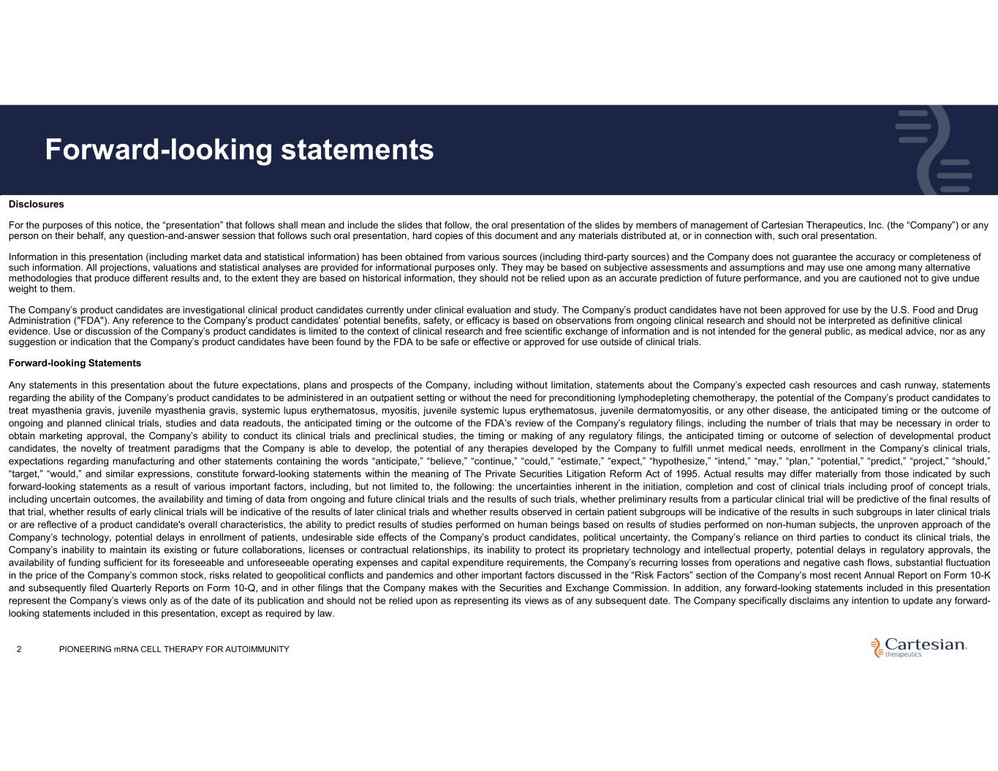
Disclosures For the purposes of this notice, the “presentation” that follows shall mean and include the slides that follow, the oral presentation of the slides by members of management of Cartesian Therapeutics, Inc. (the “Company”) or any person on their behalf, any question-and-answer session that follows such oral presentation, hard copies of this document and any materials distributed at, or in connection with, such oral presentation. Information in this presentation (including market data and statistical information) has been obtained from various sources (including third-party sources) and the Company does not guarantee the accuracy or completeness of such information. All projections, valuations and statistical analyses are provided for informational purposes only. They may be based on subjective assessments and assumptions and may use one among many alternative methodologies that produce different results and, to the extent they are based on historical information, they should not be relied upon as an accurate prediction of future performance, and you are cautioned not to give undue weight to them. The Company’s product candidates are investigational clinical product candidates currently under clinical evaluation and study. The Company’s product candidates have not been approved for use by the U.S. Food and Drug Administration ("FDA"). Any reference to the Company’s product candidates’ potential benefits, safety, or efficacy is based on observations from ongoing clinical research and should not be interpreted as definitive clinical evidence. Use or discussion of the Company’s product candidates is limited to the context of clinical research and free scientific exchange of information and is not intended for the general public, as medical advice, nor as any suggestion or indication that the Company’s product candidates have been found by the FDA to be safe or effective or approved for use outside of clinical trials. Forward-looking Statements Any statements in this presentation about the future expectations, plans and prospects of the Company, including without limitation, statements about the Company’s expected cash resources and cash runway, statements regarding the ability of the Company’s product candidates to be administered in an outpatient setting or without the need for preconditioning lymphodepleting chemotherapy, the potential of the Company’s product candidates to treat myasthenia gravis, juvenile myasthenia gravis, systemic lupus erythematosus, myositis, juvenile systemic lupus erythematosus, juvenile dermatomyositis, or any other disease, the anticipated timing or the outcome of ongoing and planned clinical trials, studies and data readouts, the anticipated timing or the outcome of the FDA’s review of the Company’s regulatory filings, including the number of trials that may be necessary in order to obtain marketing approval, the Company’s ability to conduct its clinical trials and preclinical studies, the timing or making of any regulatory filings, the anticipated timing or outcome of selection of developmental product candidates, the novelty of treatment paradigms that the Company is able to develop, the potential of any therapies developed by the Company to fulfill unmet medical needs, enrollment in the Company’s clinical trials, expectations regarding manufacturing and other statements containing the words “anticipate,” “believe,” “continue,” “could,” “estimate,” “expect,” “hypothesize,” “intend,” “may,” “plan,” “potential,” “predict,” “project,” “should,” “target,” “would,” and similar expressions, constitute forward-looking statements within the meaning of The Private Securities Litigation Reform Act of 1995. Actual results may differ materially from those indicated by such forward-looking statements as a result of various important factors, including, but not limited to, the following: the uncertainties inherent in the initiation, completion and cost of clinical trials including proof of concept trials, including uncertain outcomes, the availability and timing of data from ongoing and future clinical trials and the results of such trials, whether preliminary results from a particular clinical trial will be predictive of the final results of that trial, whether results of early clinical trials will be indicative of the results of later clinical trials and whether results observed in certain patient subgroups will be indicative of the results in such subgroups in later clinical trials or are reflective of a product candidate's overall characteristics, the ability to predict results of studies performed on human beings based on results of studies performed on non-human subjects, the unproven approach of the Company’s technology, potential delays in enrollment of patients, undesirable side effects of the Company’s product candidates, political uncertainty, the Company’s reliance on third parties to conduct its clinical trials, the Company’s inability to maintain its existing or future collaborations, licenses or contractual relationships, its inability to protect its proprietary technology and intellectual property, potential delays in regulatory approvals, the availability of funding sufficient for its foreseeable and unforeseeable operating expenses and capital expenditure requirements, the Company’s recurring losses from operations and negative cash flows, substantial fluctuation in the price of the Company’s common stock, risks related to geopolitical conflicts and pandemics and other important factors discussed in the “Risk Factors” section of the Company’s most recent Annual Report on Form 10-K and subsequently filed Quarterly Reports on Form 10-Q, and in other filings that the Company makes with the Securities and Exchange Commission. In addition, any forward-looking statements included in this presentation represent the Company’s views only as of the date of its publication and should not be relied upon as representing its views as of any subsequent date. The Company specifically disclaims any intention to update any forward- looking statements included in this presentation, except as required by law. Forward-looking statements 2 PIONEERING mRNA CELL THERAPY FOR AUTOIMMUNITY

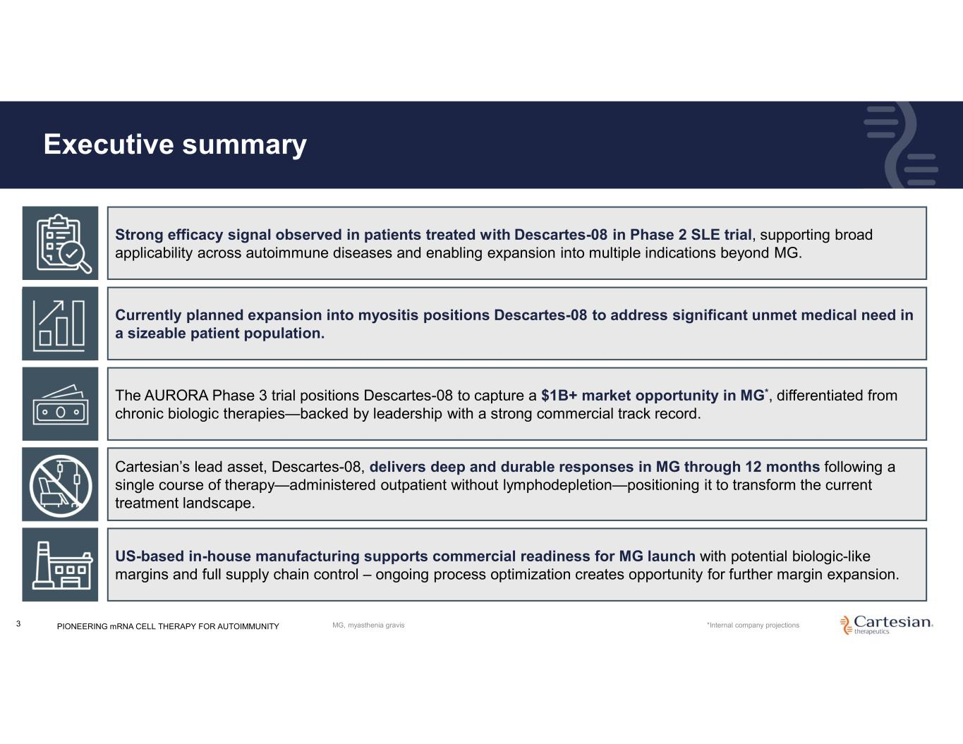
Executive summary 3 Cartesian’s lead asset, Descartes-08, delivers deep and durable responses in MG through 12 months following a single course of therapy—administered outpatient without lymphodepletion—positioning it to transform the current treatment landscape. The AURORA Phase 3 trial positions Descartes-08 to capture a $1B+ market opportunity in MG*, differentiated from chronic biologic therapies—backed by leadership with a strong commercial track record. US-based in-house manufacturing supports commercial readiness for MG launch with potential biologic-like margins and full supply chain control – ongoing process optimization creates opportunity for further margin expansion. Currently planned expansion into myositis positions Descartes-08 to address significant unmet medical need in a sizeable patient population. Strong efficacy signal observed in patients treated with Descartes-08 in Phase 2 SLE trial, supporting broad applicability across autoimmune diseases and enabling expansion into multiple indications beyond MG. *Internal company projectionsPIONEERING mRNA CELL THERAPY FOR AUTOIMMUNITY MG, myasthenia gravis

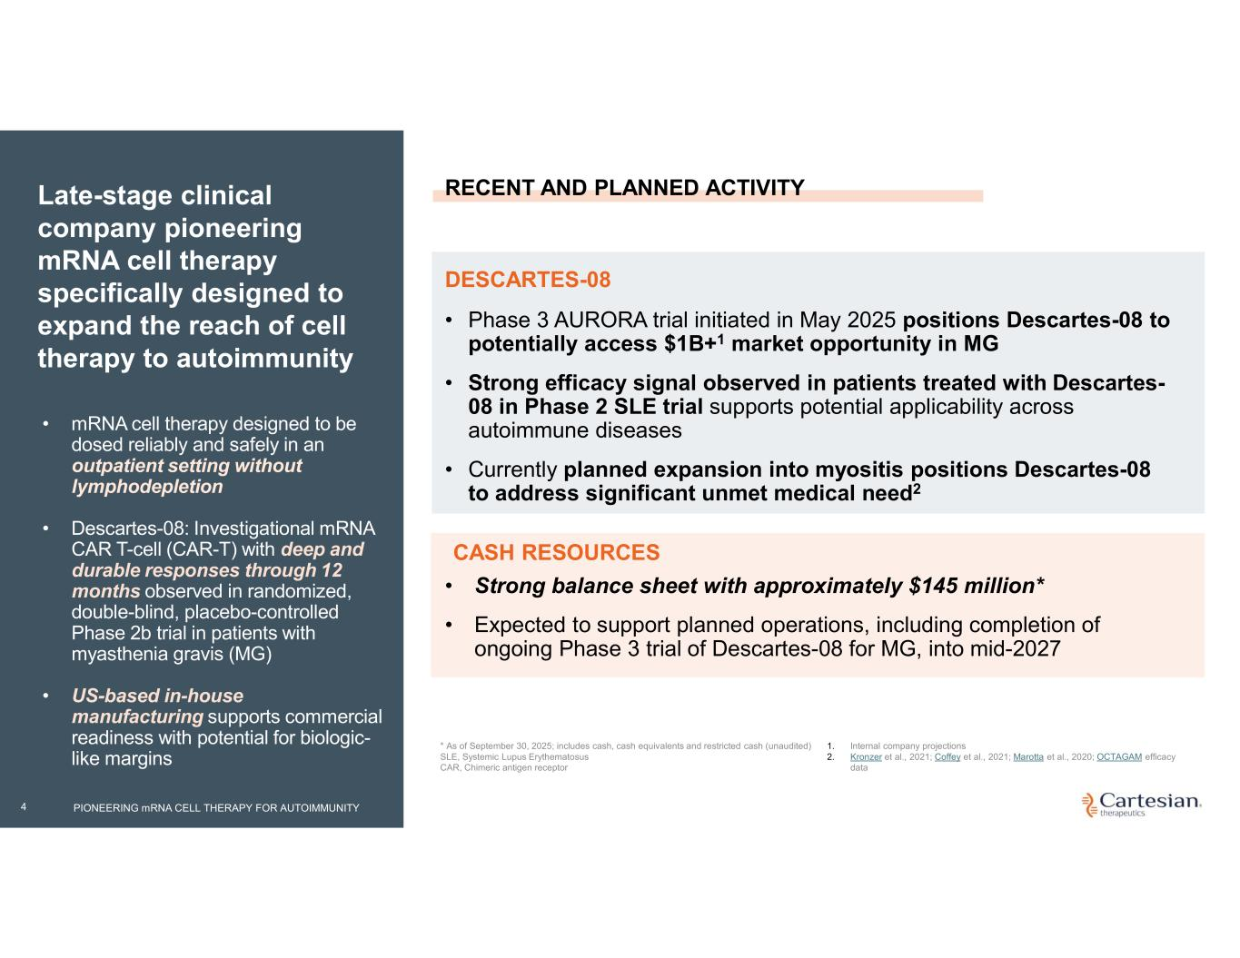
4 Late-stage clinical company pioneering mRNA cell therapy specifically designed to expand the reach of cell therapy to autoimmunity • mRNA cell therapy designed to be dosed reliably and safely in an outpatient setting without lymphodepletion • Descartes-08: Investigational mRNA CAR T-cell (CAR-T) with deep and durable responses through 12 months observed in randomized, double-blind, placebo-controlled Phase 2b trial in patients with myasthenia gravis (MG) • US-based in-house manufacturing supports commercial readiness with potential for biologic- like margins * As of September 30, 2025; includes cash, cash equivalents and restricted cash (unaudited) SLE, Systemic Lupus Erythematosus CAR, Chimeric antigen receptor • Phase 3 AURORA trial initiated in May 2025 positions Descartes-08 to potentially access $1B+1 market opportunity in MG • Strong efficacy signal observed in patients treated with Descartes- 08 in Phase 2 SLE trial supports potential applicability across autoimmune diseases • Currently planned expansion into myositis positions Descartes-08 to address significant unmet medical need2 DESCARTES-08 RECENT AND PLANNED ACTIVITY • Strong balance sheet with approximately $145 million* • Expected to support planned operations, including completion of ongoing Phase 3 trial of Descartes-08 for MG, into mid-2027 CASH RESOURCES 1. Internal company projections 2. Kronzer et al., 2021; Coffey et al., 2021; Marotta et al., 2020; OCTAGAM efficacy data PIONEERING mRNA CELL THERAPY FOR AUTOIMMUNITY

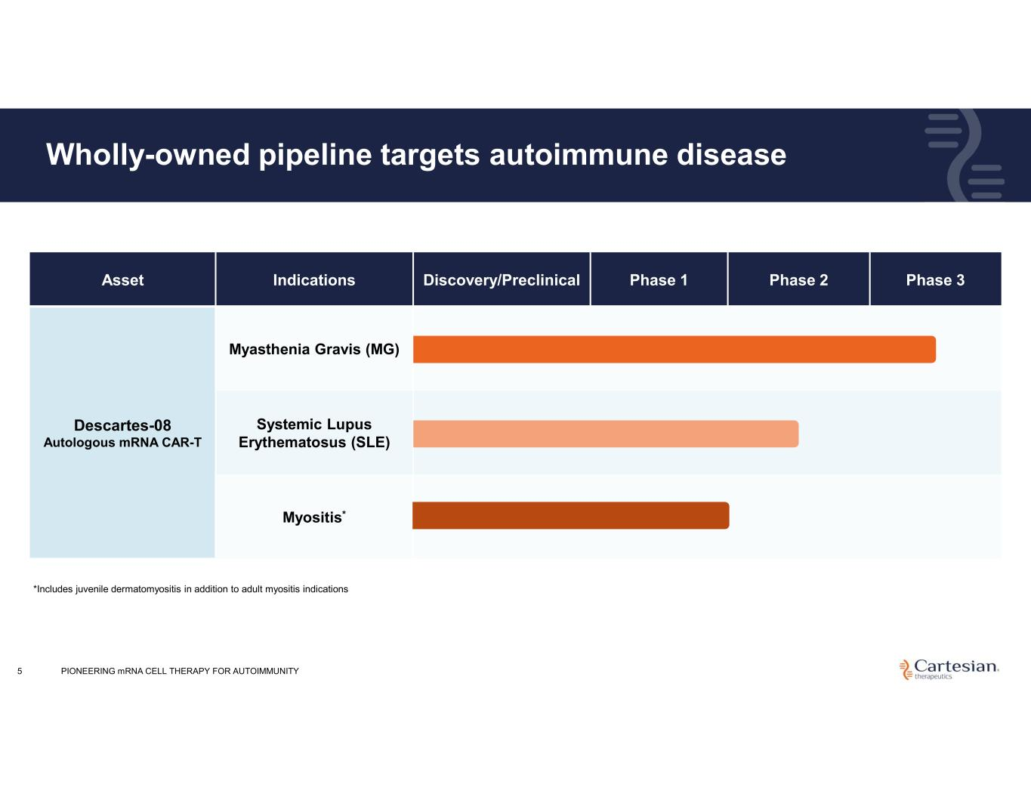
Phase 3Phase 2Phase 1Discovery/PreclinicalIndicationsAsset Myasthenia Gravis (MG) Descartes-08 Autologous mRNA CAR-T Systemic Lupus Erythematosus (SLE) Myositis* Wholly-owned pipeline targets autoimmune disease 5 *Includes juvenile dermatomyositis in addition to adult myositis indications PIONEERING mRNA CELL THERAPY FOR AUTOIMMUNITY

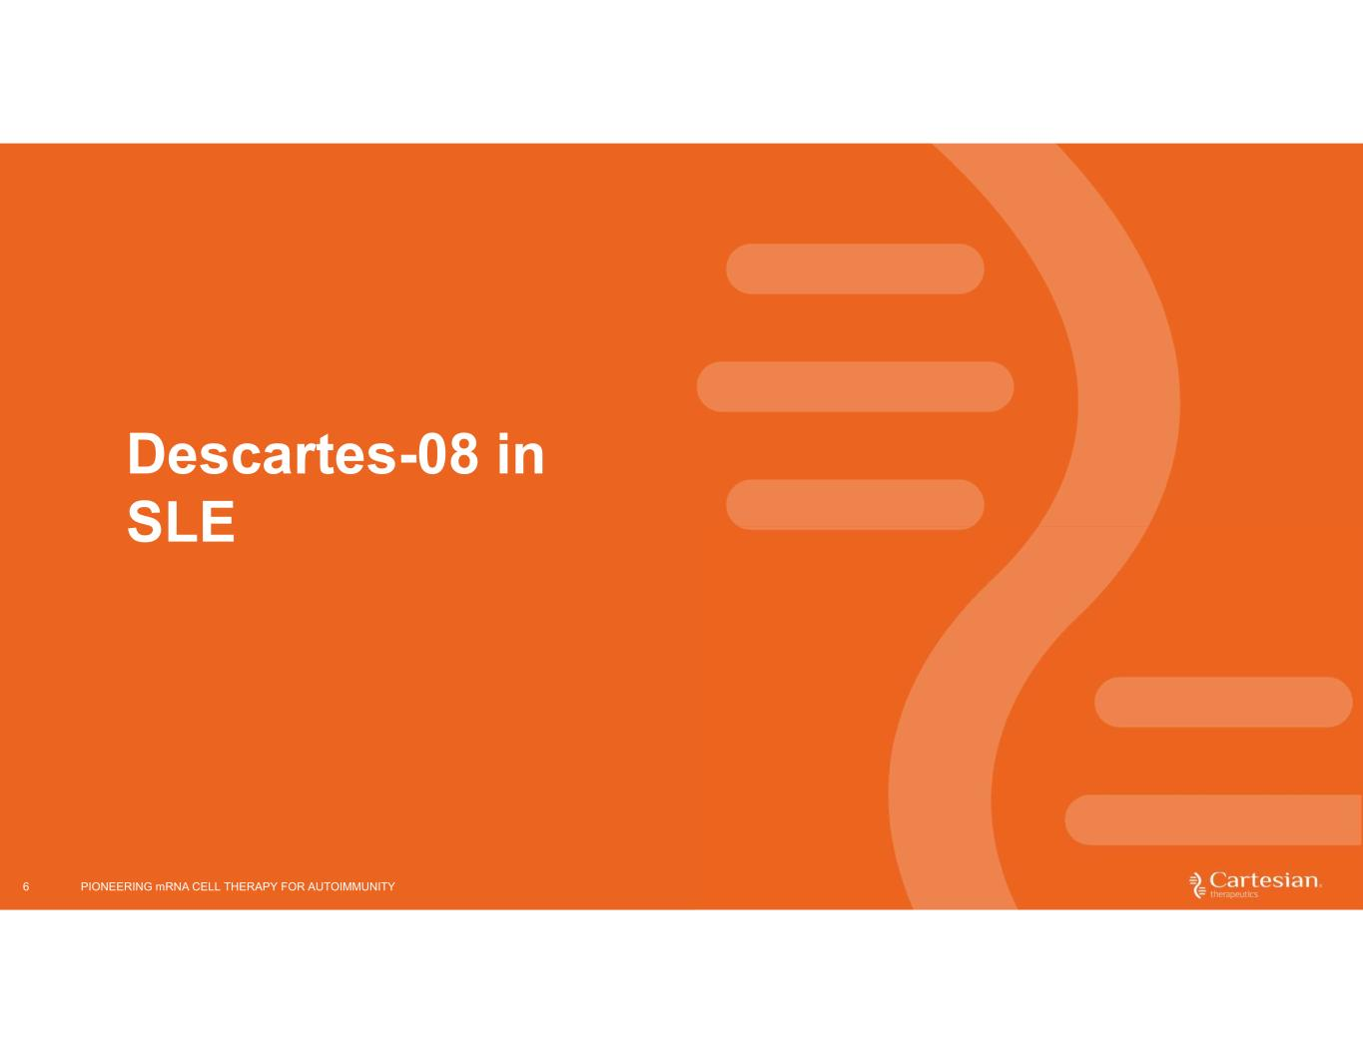
6 Descartes-08 in SLE PIONEERING mRNA CELL THERAPY FOR AUTOIMMUNITY

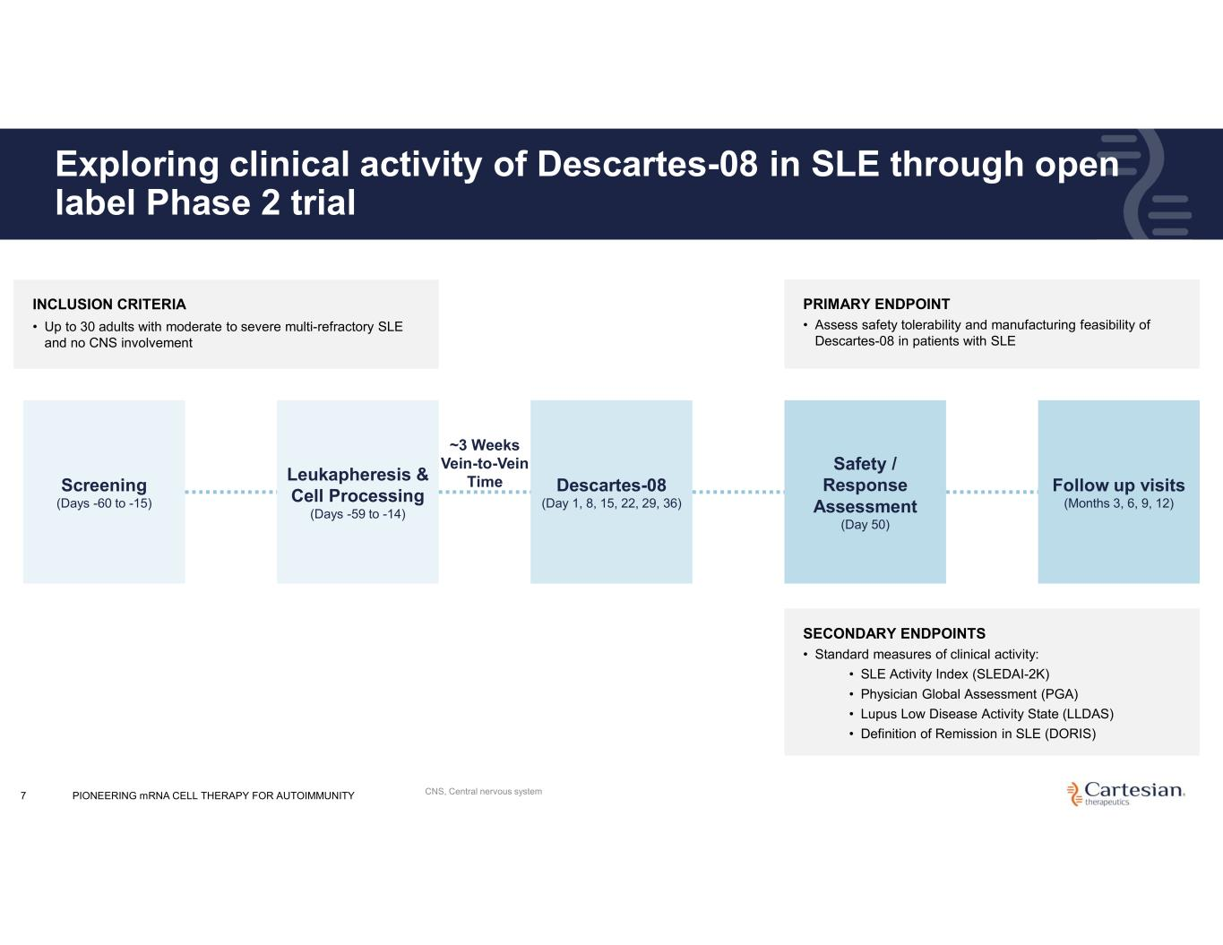
7 Exploring clinical activity of Descartes-08 in SLE through open label Phase 2 trial Screening (Days -60 to -15) Leukapheresis & Cell Processing (Days -59 to -14) ~3 Weeks Vein-to-Vein Time Descartes-08 (Day 1, 8, 15, 22, 29, 36) Safety / Response Assessment (Day 50) Follow up visits (Months 3, 6, 9, 12) INCLUSION CRITERIA • Up to 30 adults with moderate to severe multi-refractory SLE and no CNS involvement PRIMARY ENDPOINT • Assess safety tolerability and manufacturing feasibility of Descartes-08 in patients with SLE SECONDARY ENDPOINTS • Standard measures of clinical activity: • SLE Activity Index (SLEDAI-2K) • Physician Global Assessment (PGA) • Lupus Low Disease Activity State (LLDAS) • Definition of Remission in SLE (DORIS) PIONEERING mRNA CELL THERAPY FOR AUTOIMMUNITY CNS, Central nervous system

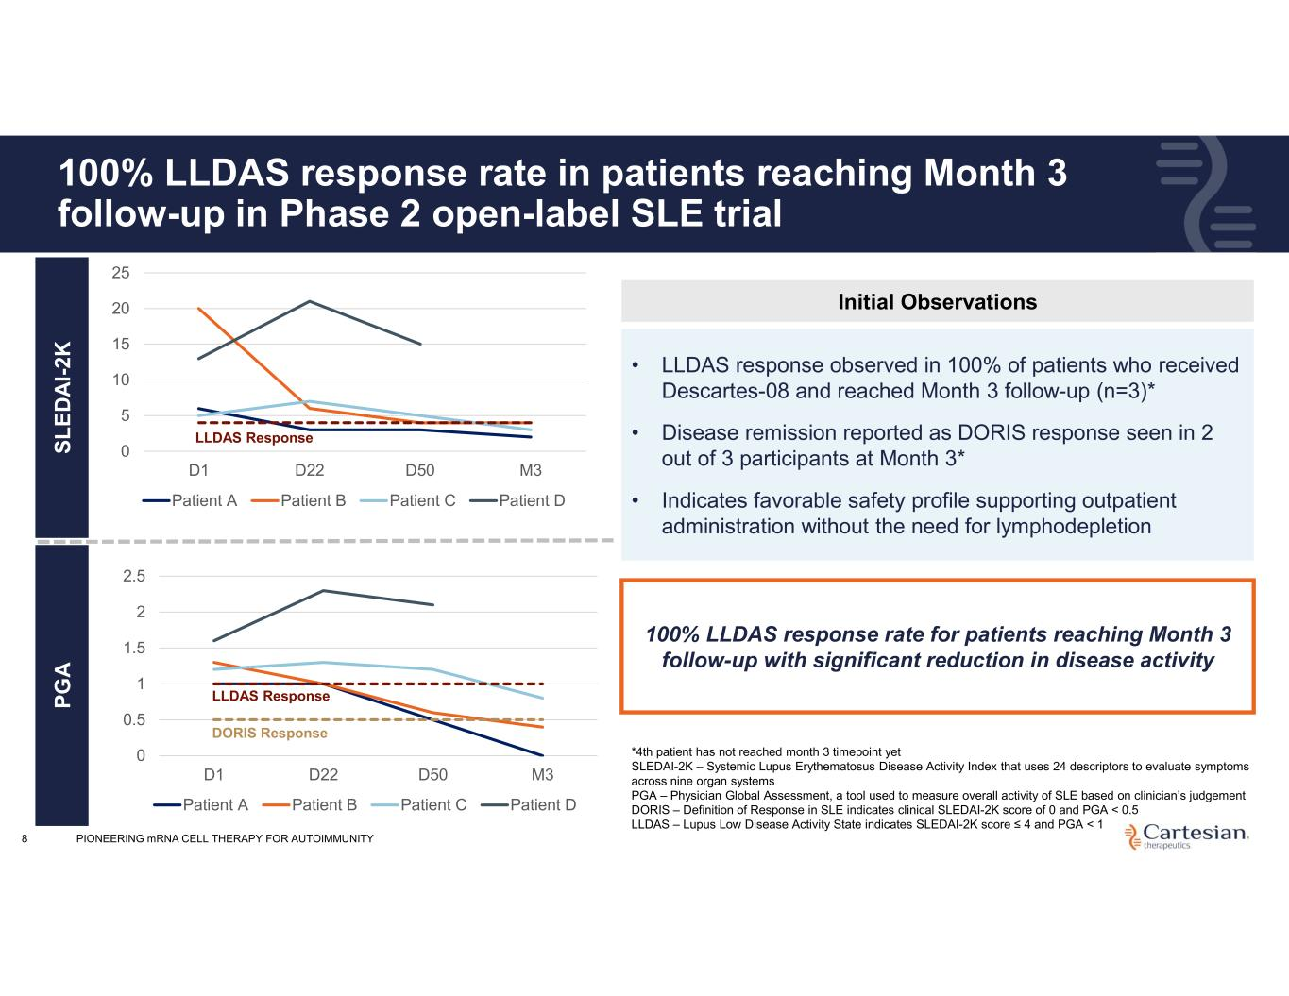
8 100% LLDAS response rate in patients reaching Month 3 follow-up in Phase 2 open-label SLE trial • LLDAS response observed in 100% of patients who received Descartes-08 and reached Month 3 follow-up (n=3)* • Disease remission reported as DORIS response seen in 2 out of 3 participants at Month 3* • Indicates favorable safety profile supporting outpatient administration without the need for lymphodepletion *4th patient has not reached month 3 timepoint yet SLEDAI-2K – Systemic Lupus Erythematosus Disease Activity Index that uses 24 descriptors to evaluate symptoms across nine organ systems PGA – Physician Global Assessment, a tool used to measure overall activity of SLE based on clinician’s judgement DORIS – Definition of Response in SLE indicates clinical SLEDAI-2K score of 0 and PGA < 0.5 LLDAS – Lupus Low Disease Activity State indicates SLEDAI-2K score ≤ 4 and PGA < 1 100% LLDAS response rate for patients reaching Month 3 follow-up with significant reduction in disease activity S L E D A I- 2 K P G A Initial Observations 0 5 10 15 20 25 D1 D22 D50 M3 Patient A Patient B Patient C Patient D 0 0.5 1 1.5 2 2.5 D1 D22 D50 M3 Patient A Patient B Patient C Patient D LLDAS Response LLDAS Response DORIS Response PIONEERING mRNA CELL THERAPY FOR AUTOIMMUNITY

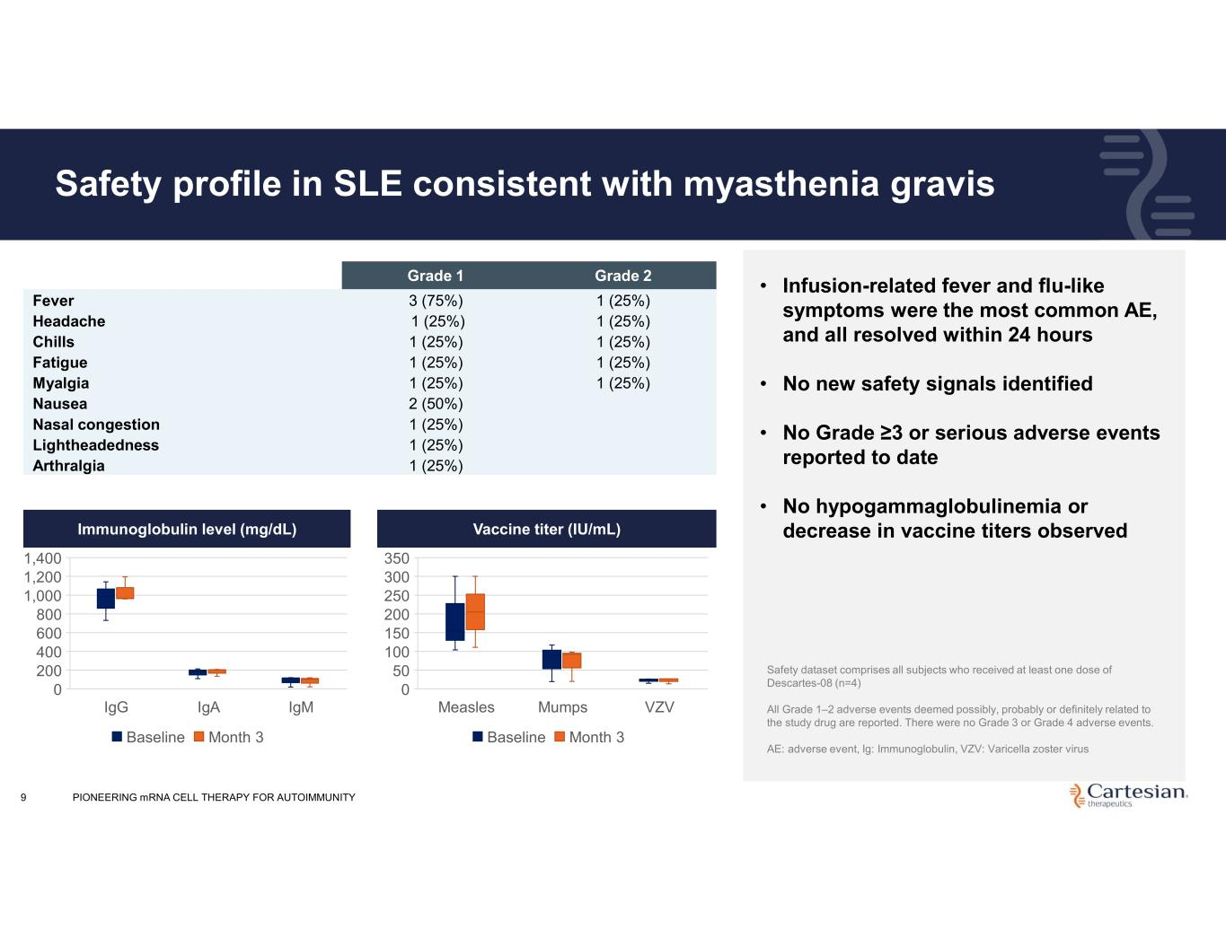
9 Safety profile in SLE consistent with myasthenia gravis Grade 2Grade 1 1 (25%)3 (75%)Fever 1 (25%)1 (25%)Headache 1 (25%)1 (25%)Chills 1 (25%)1 (25%)Fatigue 1 (25%)1 (25%)Myalgia 2 (50%)Nausea 1 (25%)Nasal congestion 1 (25%)Lightheadedness 1 (25%)Arthralgia • Infusion-related fever and flu-like symptoms were the most common AE, and all resolved within 24 hours • No new safety signals identified • No Grade ≥3 or serious adverse events reported to date • No hypogammaglobulinemia or decrease in vaccine titers observed Safety dataset comprises all subjects who received at least one dose of Descartes-08 (n=4) All Grade 1–2 adverse events deemed possibly, probably or definitely related to the study drug are reported. There were no Grade 3 or Grade 4 adverse events. AE: adverse event, Ig: Immunoglobulin, VZV: Varicella zoster virus IgG IgA IgM 0 200 400 600 800 1,000 1,200 1,400 Immunoglobulin level (mg/dL) Baseline Month 3 Measles Mumps VZV 0 50 100 150 200 250 300 350 Vaccine titer (IU/mL) Baseline Month 3 Immunoglobulin level (mg/dL) Vaccine titer (IU/mL) PIONEERING mRNA CELL THERAPY FOR AUTOIMMUNITY

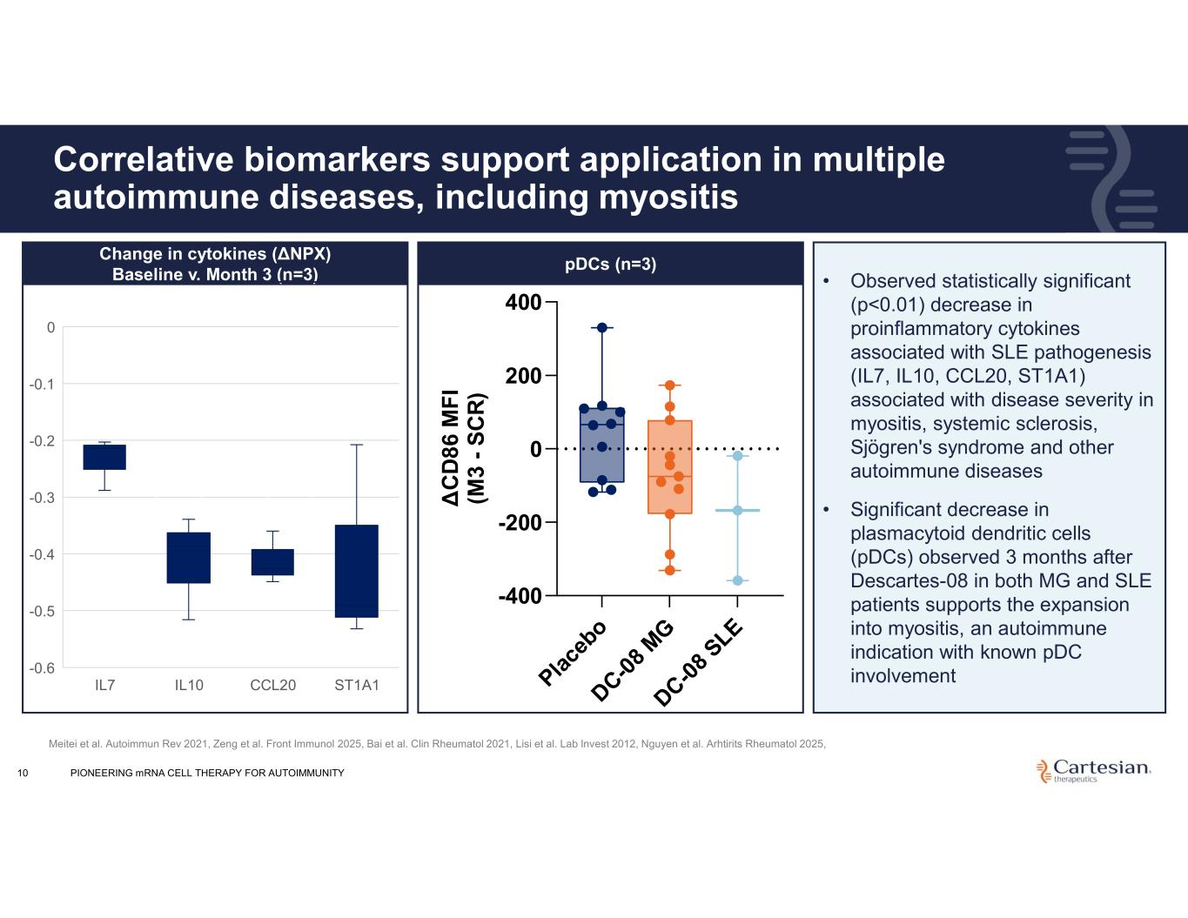
Pla ce bo DC-0 8 M G DC-0 8 SLE -400 -200 0 200 400 pDCs Δ C D 8 6 M F I (M 3 - S C R ) 10 Correlative biomarkers support application in multiple autoimmune diseases, including myositis • Observed statistically significant (p<0.01) decrease in proinflammatory cytokines associated with SLE pathogenesis (IL7, IL10, CCL20, ST1A1) associated with disease severity in myositis, systemic sclerosis, Sjögren's syndrome and other autoimmune diseases • Significant decrease in plasmacytoid dendritic cells (pDCs) observed 3 months after Descartes-08 in both MG and SLE patients supports the expansion into myositis, an autoimmune indication with known pDC involvement IL7 IL10 CCL20 ST1A1 0 -0.1 -0.2 -0.3 -0.4 -0.5 -0.6 Change in cytokines (ΔNPX) Baseline v. Month 3 (n=3) Meitei et al. Autoimmun Rev 2021, Zeng et al. Front Immunol 2025, Bai et al. Clin Rheumatol 2021, Lisi et al. Lab Invest 2012, Nguyen et al. Arhtirits Rheumatol 2025, pDCs (n=3) Change in cytokines (ΔNPX) Baseline v. Month 3 PIONEERING mRNA CELL THERAPY FOR AUTOIMMUNITY

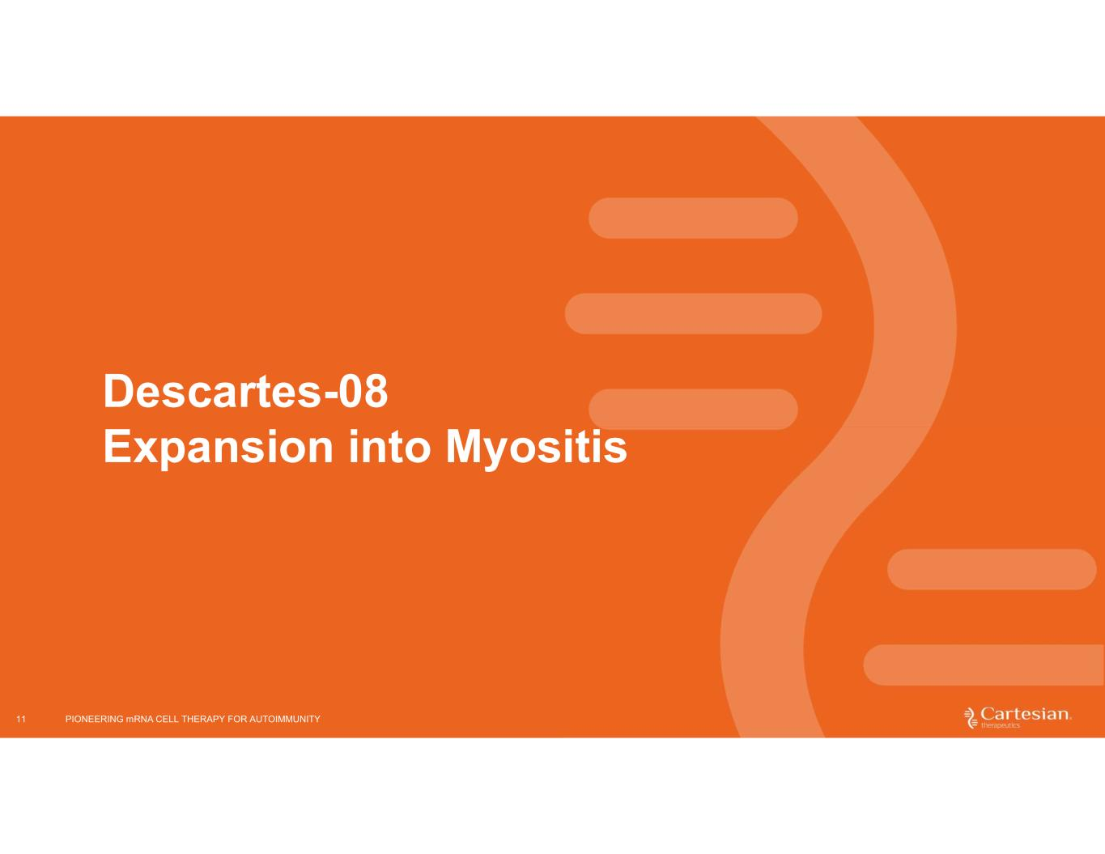
11 Descartes-08 Expansion into Myositis PIONEERING mRNA CELL THERAPY FOR AUTOIMMUNITY

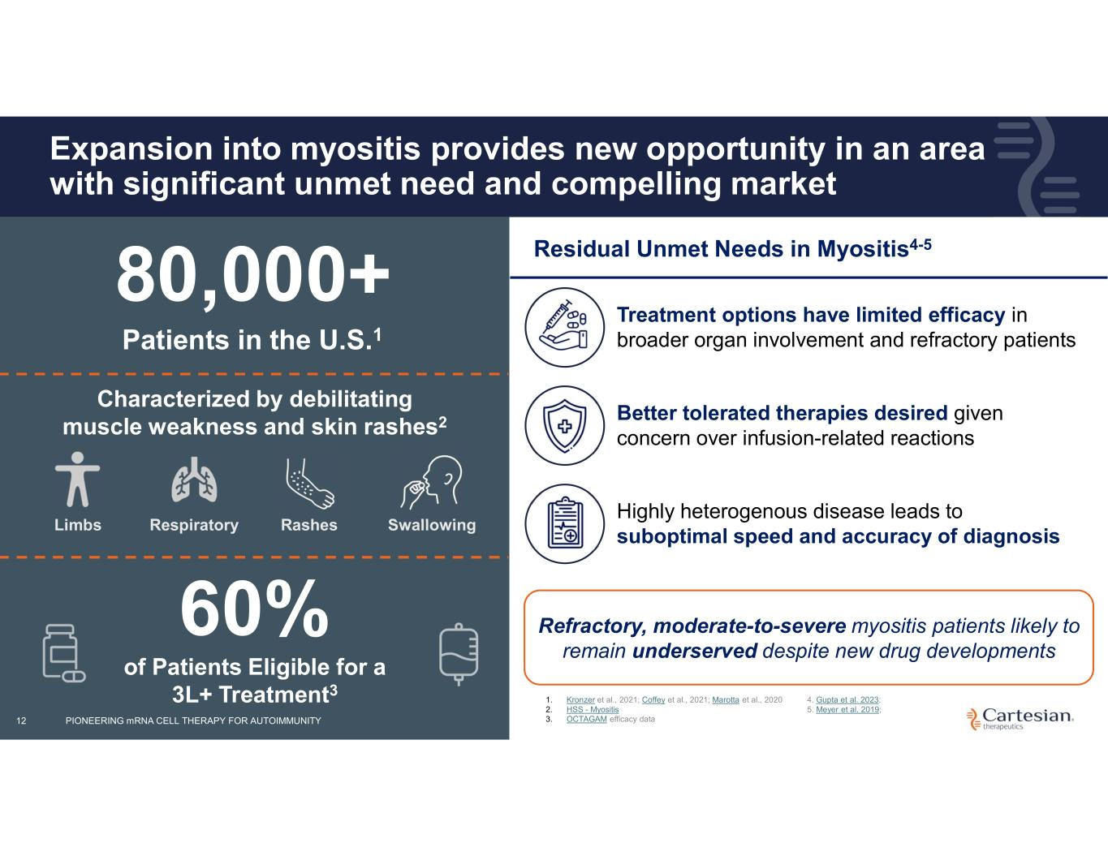
12 Expansion into myositis provides new opportunity in an area with significant unmet need and compelling market Characterized by debilitating muscle weakness and skin rashes2 Limbs Respiratory Rashes Swallowing 80,000+ Patients in the U.S.1 60% of Patients Eligible for a 3L+ Treatment3 Residual Unmet Needs in Myositis4-5 Refractory, moderate-to-severe myositis patients likely to remain underserved despite new drug developments Treatment options have limited efficacy in broader organ involvement and refractory patients Better tolerated therapies desired given concern over infusion-related reactions Highly heterogenous disease leads to suboptimal speed and accuracy of diagnosis 1. Kronzer et al., 2021; Coffey et al., 2021; Marotta et al., 2020 2. HSS - Myositis 3. OCTAGAM efficacy data 4. Gupta et al. 2023; 5. Meyer et al. 2019; PIONEERING mRNA CELL THERAPY FOR AUTOIMMUNITY

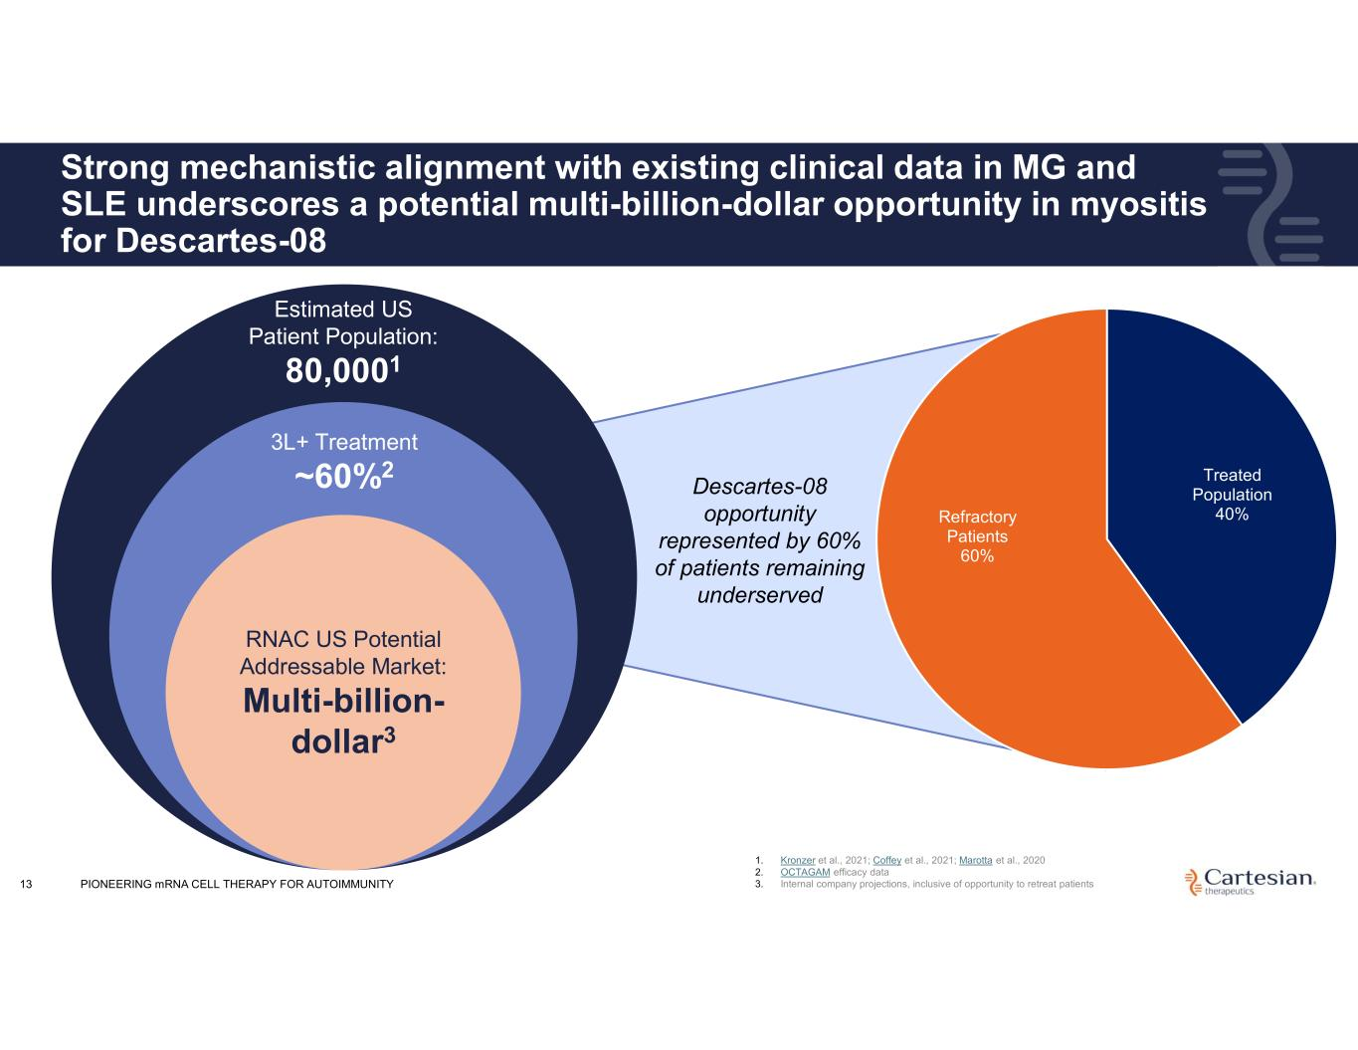
13 Strong mechanistic alignment with existing clinical data in MG and SLE underscores a potential multi-billion-dollar opportunity in myositis for Descartes-08 Estimated US Patient Population: 80,0001 3L+ Treatment ~60%2 RNAC US Potential Addressable Market: Multi-billion- dollar3 Descartes-08 opportunity represented by 60% of patients remaining underserved Treated Population 40%Refractory Patients 60% 1. Kronzer et al., 2021; Coffey et al., 2021; Marotta et al., 2020 2. OCTAGAM efficacy data 3. Internal company projections, inclusive of opportunity to retreat patientsPIONEERING mRNA CELL THERAPY FOR AUTOIMMUNITY

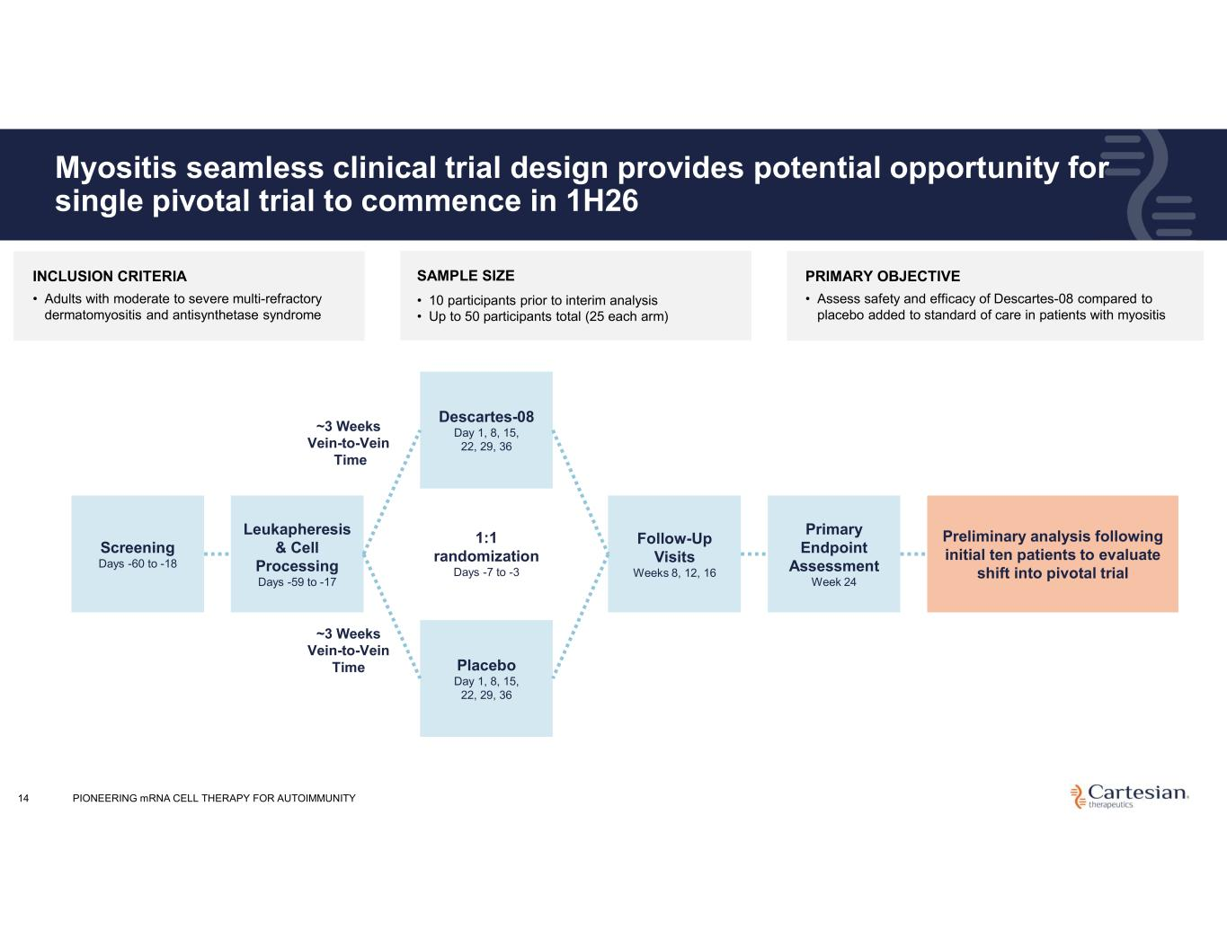
14 Myositis seamless clinical trial design provides potential opportunity for single pivotal trial to commence in 1H26 Screening Days -60 to -18 Leukapheresis & Cell Processing Days -59 to -17 ~3 Weeks Vein-to-Vein Time Descartes-08 Day 1, 8, 15, 22, 29, 36 Follow-Up Visits Weeks 8, 12, 16 Primary Endpoint Assessment Week 24 Placebo Day 1, 8, 15, 22, 29, 36 ~3 Weeks Vein-to-Vein Time 1:1 randomization Days -7 to -3 Preliminary analysis following initial ten patients to evaluate shift into pivotal trial INCLUSION CRITERIA • Adults with moderate to severe multi-refractory dermatomyositis and antisynthetase syndrome PRIMARY OBJECTIVE • Assess safety and efficacy of Descartes-08 compared to placebo added to standard of care in patients with myositis SAMPLE SIZE • 10 participants prior to interim analysis • Up to 50 participants total (25 each arm) PIONEERING mRNA CELL THERAPY FOR AUTOIMMUNITY

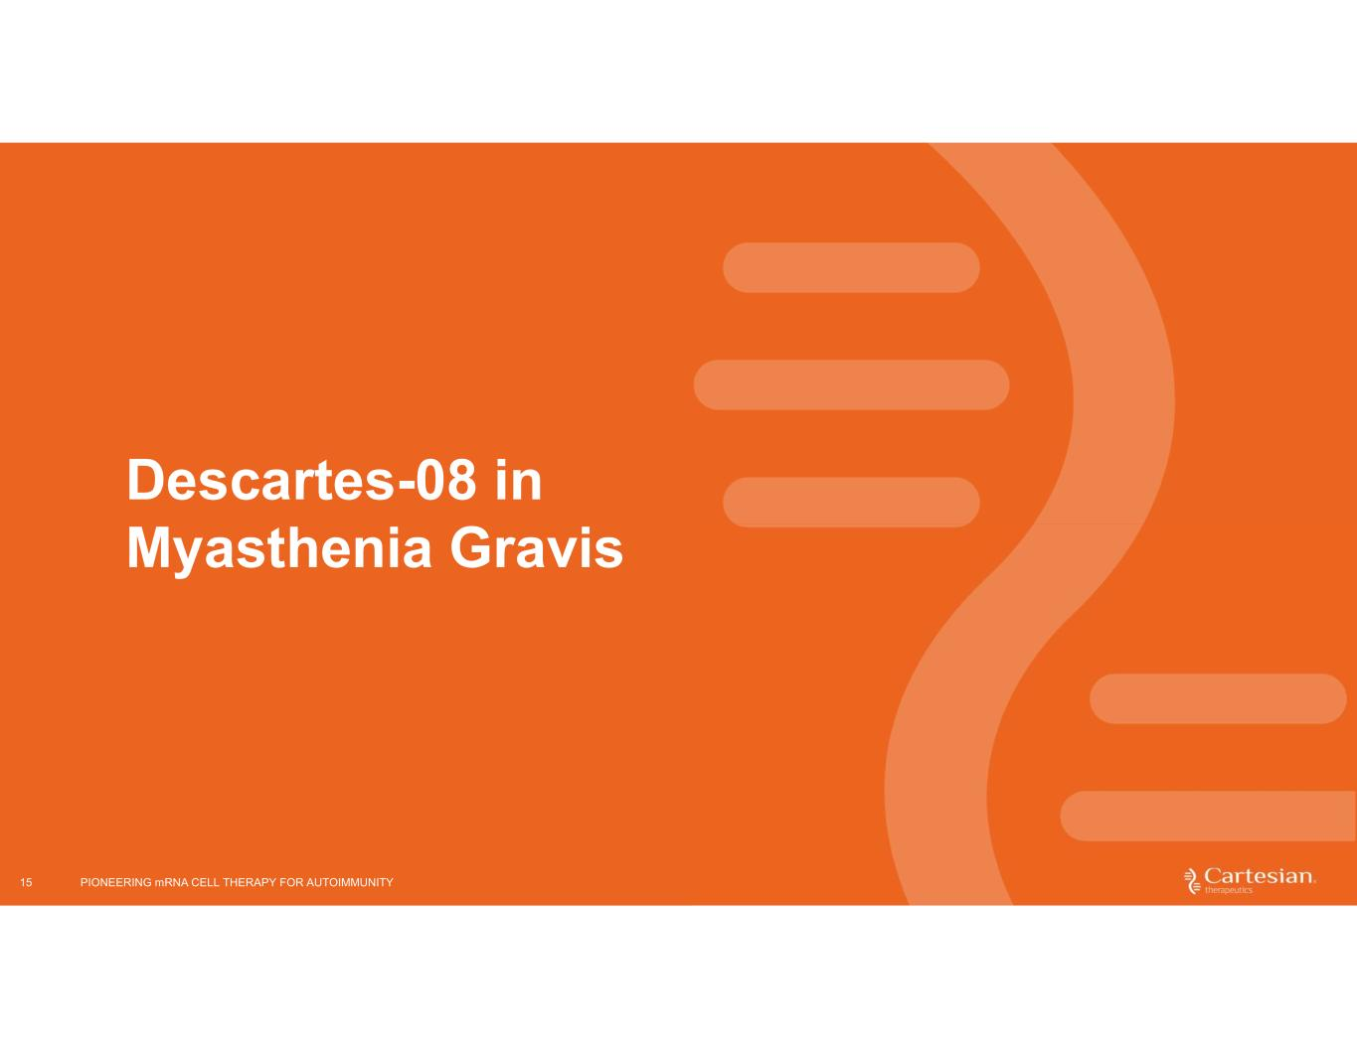
15 Descartes-08 in Myasthenia Gravis PIONEERING mRNA CELL THERAPY FOR AUTOIMMUNITY

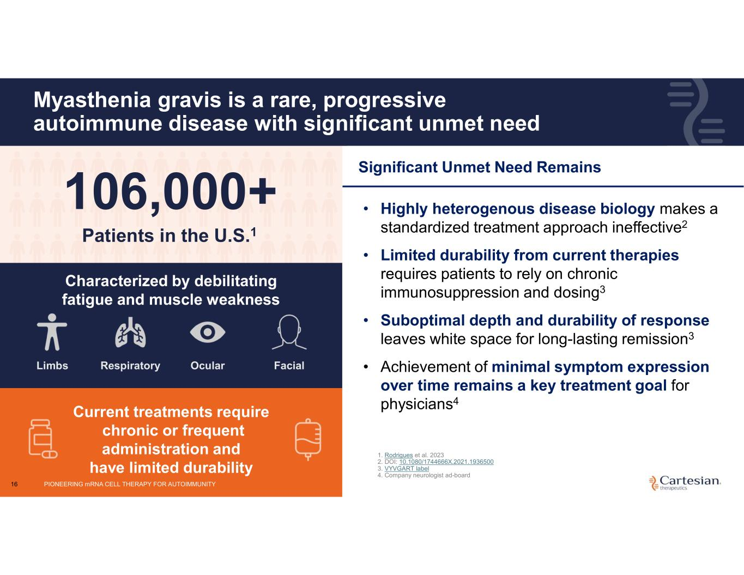
16 Myasthenia gravis is a rare, progressive autoimmune disease with significant unmet need Characterized by debilitating fatigue and muscle weakness Limbs Respiratory Ocular Facial 106,000+ Patients in the U.S.1 Current treatments require chronic or frequent administration and have limited durability Significant Unmet Need Remains • Highly heterogenous disease biology makes a standardized treatment approach ineffective2 • Limited durability from current therapies requires patients to rely on chronic immunosuppression and dosing3 • Suboptimal depth and durability of response leaves white space for long-lasting remission3 • Achievement of minimal symptom expression over time remains a key treatment goal for physicians4 1. Rodrigues et al. 2023 2. DOI: 10.1080/1744666X.2021.1936500 3. VYVGART label 4. Company neurologist ad-board PIONEERING mRNA CELL THERAPY FOR AUTOIMMUNITY

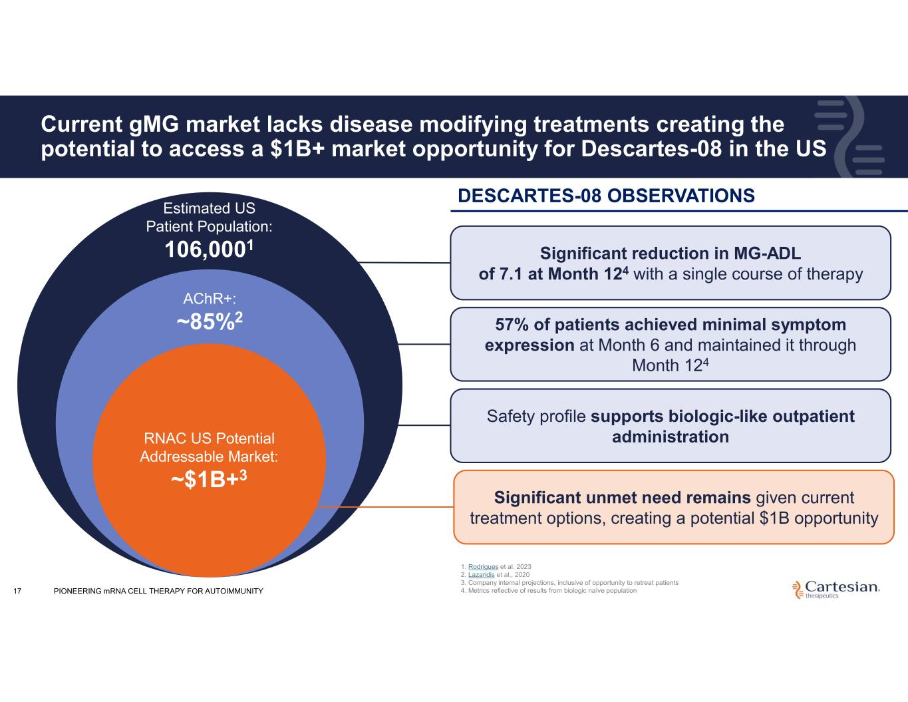
17 Current gMG market lacks disease modifying treatments creating the potential to access a $1B+ market opportunity for Descartes-08 in the US Estimated US Patient Population: 106,0001 AChR+: ~85%2 RNAC US Potential Addressable Market: ~$1B+3 Significant reduction in MG-ADL of 7.1 at Month 124 with a single course of therapy 57% of patients achieved minimal symptom expression at Month 6 and maintained it through Month 124 Safety profile supports biologic-like outpatient administration Significant unmet need remains given current treatment options, creating a potential $1B opportunity 1. Rodrigues et al. 2023 2. Lazaridis et al., 2020 3. Company internal projections, inclusive of opportunity to retreat patients 4. Metrics reflective of results from biologic naïve population DESCARTES-08 OBSERVATIONS PIONEERING mRNA CELL THERAPY FOR AUTOIMMUNITY

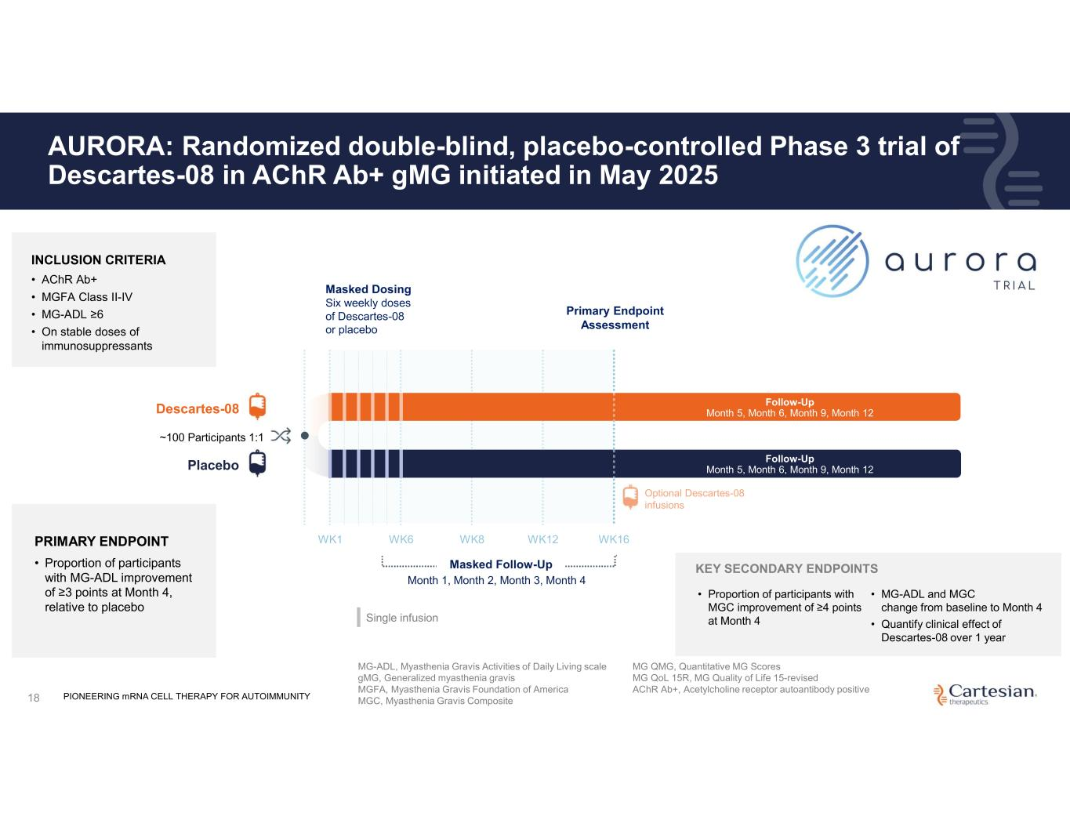
18 AURORA: Randomized double-blind, placebo-controlled Phase 3 trial of Descartes-08 in AChR Ab+ gMG initiated in May 2025 WK1 Masked Dosing Six weekly doses of Descartes-08 or placebo PRIMARY ENDPOINT • Proportion of participants with MG-ADL improvement of ≥3 points at Month 4, relative to placebo • Proportion of participants with MGC improvement of ≥4 points at Month 4 WK6 WK8 WK12 WK16 Masked Follow-Up Month 1, Month 2, Month 3, Month 4 Primary Endpoint Assessment Optional Descartes-08 infusions Follow-Up Month 5, Month 6, Month 9, Month 12 Follow-Up Month 5, Month 6, Month 9, Month 12Descartes-08 Placebo ~100 Participants 1:1 INCLUSION CRITERIA • AChR Ab+ • MGFA Class II-IV • MG-ADL ≥6 • On stable doses of immunosuppressants Single infusion MG-ADL, Myasthenia Gravis Activities of Daily Living scale gMG, Generalized myasthenia gravis MGFA, Myasthenia Gravis Foundation of America MGC, Myasthenia Gravis Composite MG QMG, Quantitative MG Scores MG QoL 15R, MG Quality of Life 15-revised AChR Ab+, Acetylcholine receptor autoantibody positive KEY SECONDARY ENDPOINTS • MG-ADL and MGC change from baseline to Month 4 • Quantify clinical effect of Descartes-08 over 1 year PIONEERING mRNA CELL THERAPY FOR AUTOIMMUNITY

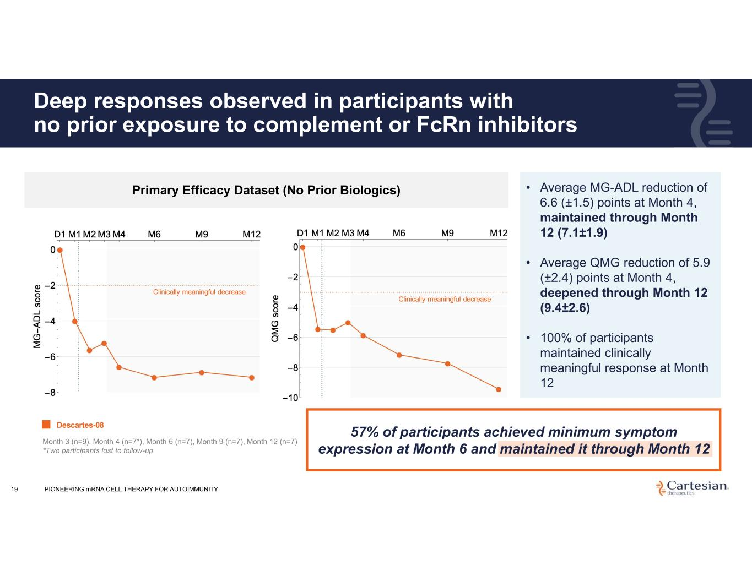
Deep responses observed in participants with no prior exposure to complement or FcRn inhibitors 19 • Average MG-ADL reduction of 6.6 (±1.5) points at Month 4, maintained through Month 12 (7.1±1.9) • Average QMG reduction of 5.9 (±2.4) points at Month 4, deepened through Month 12 (9.4±2.6) • 100% of participants maintained clinically meaningful response at Month 12 Primary Efficacy Dataset (No Prior Biologics) Month 3 (n=9), Month 4 (n=7*), Month 6 (n=7), Month 9 (n=7), Month 12 (n=7) *Two participants lost to follow-up Descartes-08 Clinically meaningful decrease Clinically meaningful decrease 57% of participants achieved minimum symptom expression at Month 6 and maintained it through Month 12 PIONEERING mRNA CELL THERAPY FOR AUTOIMMUNITY

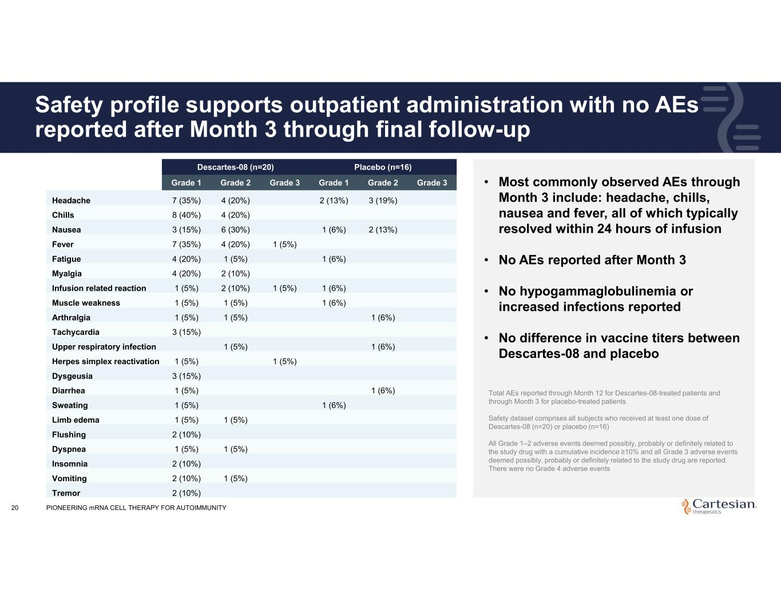
20 Safety profile supports outpatient administration with no AEs reported after Month 3 through final follow-up Placebo (n=16)Descartes-08 (n=20) Grade 3Grade 2Grade 1Grade 3Grade 2Grade 1 3 (19%)2 (13%)4 (20%)7 (35%)Headache 4 (20%)8 (40%)Chills 2 (13%)1 (6%)6 (30%)3 (15%)Nausea 1 (5%)4 (20%)7 (35%)Fever 1 (6%)1 (5%)4 (20%)Fatigue 2 (10%)4 (20%)Myalgia 1 (6%)1 (5%)2 (10%)1 (5%)Infusion related reaction 1 (6%)1 (5%)1 (5%)Muscle weakness 1 (6%)1 (5%)1 (5%)Arthralgia 3 (15%)Tachycardia 1 (6%)1 (5%)Upper respiratory infection 1 (5%)1 (5%)Herpes simplex reactivation 3 (15%)Dysgeusia 1 (6%)1 (5%)Diarrhea 1 (6%)1 (5%)Sweating 1 (5%)1 (5%)Limb edema 2 (10%)Flushing 1 (5%)1 (5%)Dyspnea 2 (10%)Insomnia 1 (5%)2 (10%)Vomiting 2 (10%)Tremor • Most commonly observed AEs through Month 3 include: headache, chills, nausea and fever, all of which typically resolved within 24 hours of infusion • No AEs reported after Month 3 • No hypogammaglobulinemia or increased infections reported • No difference in vaccine titers between Descartes-08 and placebo Total AEs reported through Month 12 for Descartes-08-treated patients and through Month 3 for placebo-treated patients Safety dataset comprises all subjects who received at least one dose of Descartes-08 (n=20) or placebo (n=16) All Grade 1–2 adverse events deemed possibly, probably or definitely related to the study drug with a cumulative incidence ≥10% and all Grade 3 adverse events deemed possibly, probably or definitely related to the study drug are reported. There were no Grade 4 adverse events PIONEERING mRNA CELL THERAPY FOR AUTOIMMUNITY

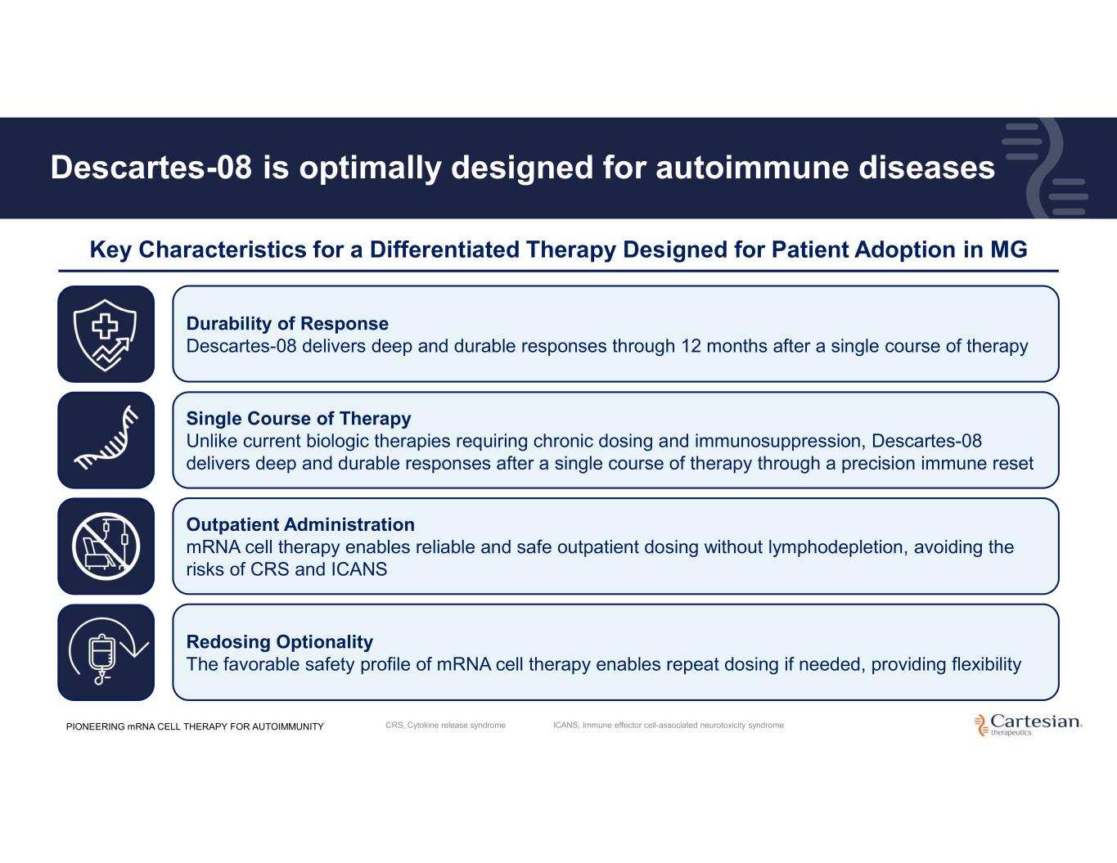
Descartes-08 is optimally designed for autoimmune diseases Key Characteristics for a Differentiated Therapy Designed for Patient Adoption in MG Durability of Response Descartes-08 delivers deep and durable responses through 12 months after a single course of therapy Single Course of Therapy Unlike current biologic therapies requiring chronic dosing and immunosuppression, Descartes-08 delivers deep and durable responses after a single course of therapy through a precision immune reset Outpatient Administration mRNA cell therapy enables reliable and safe outpatient dosing without lymphodepletion, avoiding the risks of CRS and ICANS Redosing Optionality The favorable safety profile of mRNA cell therapy enables repeat dosing if needed, providing flexibility PIONEERING mRNA CELL THERAPY FOR AUTOIMMUNITY CRS, Cytokine release syndrome ICANS, Immune effector cell-associated neurotoxicity syndrome


22 Manufacturing PIONEERING mRNA CELL THERAPY FOR AUTOIMMUNITY

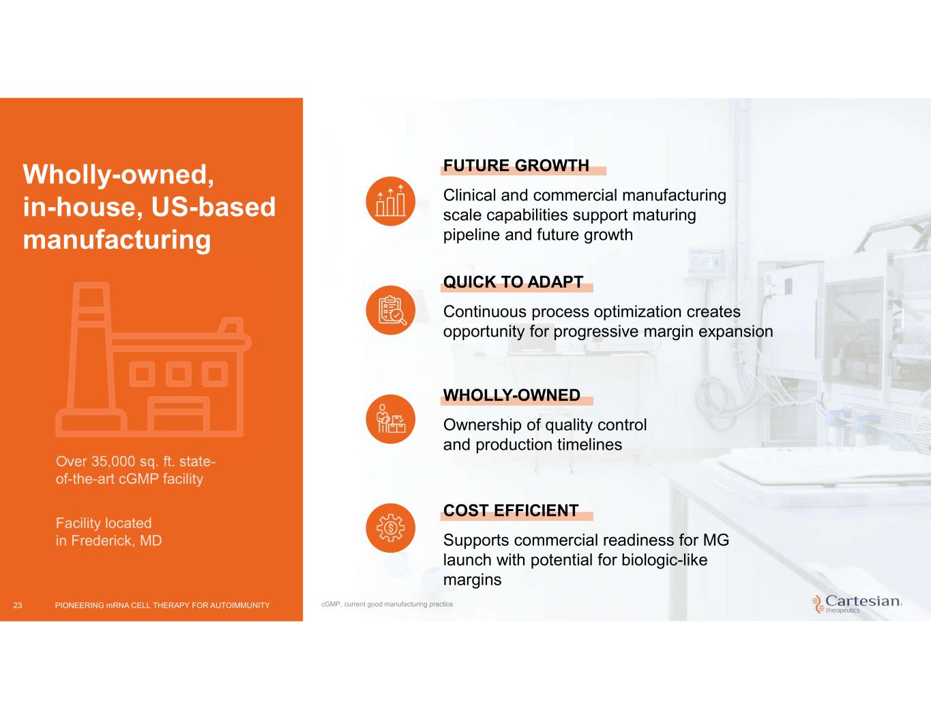
23 Wholly-owned, in-house, US-based manufacturing FUTURE GROWTH Clinical and commercial manufacturing scale capabilities support maturing pipeline and future growth QUICK TO ADAPT Continuous process optimization creates opportunity for progressive margin expansion WHOLLY-OWNED Ownership of quality control and production timelines COST EFFICIENT Supports commercial readiness for MG launch with potential for biologic-like margins Facility located in Frederick, MD Over 35,000 sq. ft. state- of-the-art cGMP facility PIONEERING mRNA CELL THERAPY FOR AUTOIMMUNITY cGMP, current good manufacturing practice

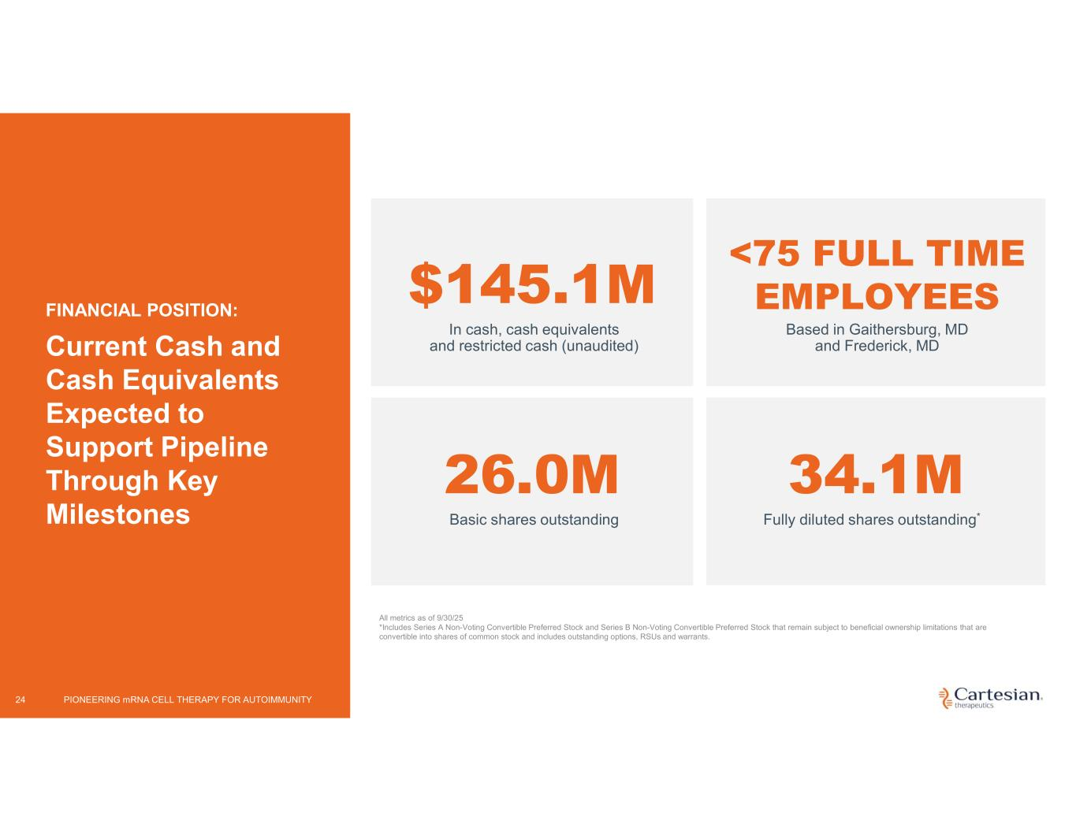
24 FINANCIAL POSITION: Current Cash and Cash Equivalents Expected to Support Pipeline Through Key Milestones All metrics as of 9/30/25 *Includes Series A Non-Voting Convertible Preferred Stock and Series B Non-Voting Convertible Preferred Stock that remain subject to beneficial ownership limitations that are convertible into shares of common stock and includes outstanding options, RSUs and warrants. $145.1M <75 FULL TIME EMPLOYEES Based in Gaithersburg, MD and Frederick, MD 26.0M Basic shares outstanding 34.1M Fully diluted shares outstanding* In cash, cash equivalents and restricted cash (unaudited) PIONEERING mRNA CELL THERAPY FOR AUTOIMMUNITY

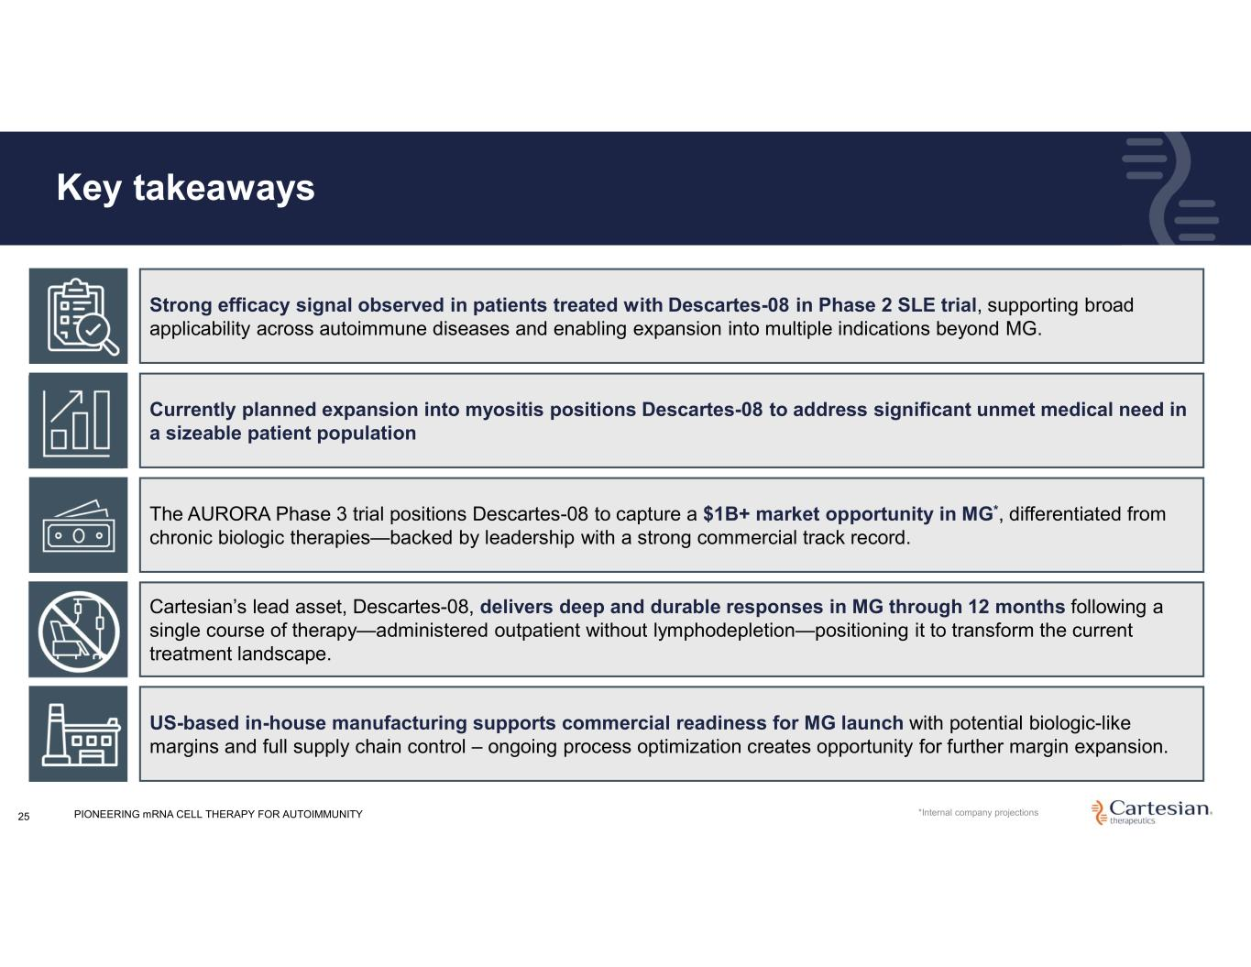
Key takeaways 25 Cartesian’s lead asset, Descartes-08, delivers deep and durable responses in MG through 12 months following a single course of therapy—administered outpatient without lymphodepletion—positioning it to transform the current treatment landscape. The AURORA Phase 3 trial positions Descartes-08 to capture a $1B+ market opportunity in MG*, differentiated from chronic biologic therapies—backed by leadership with a strong commercial track record. US-based in-house manufacturing supports commercial readiness for MG launch with potential biologic-like margins and full supply chain control – ongoing process optimization creates opportunity for further margin expansion. Currently planned expansion into myositis positions Descartes-08 to address significant unmet medical need in a sizeable patient population Strong efficacy signal observed in patients treated with Descartes-08 in Phase 2 SLE trial, supporting broad applicability across autoimmune diseases and enabling expansion into multiple indications beyond MG. PIONEERING mRNA CELL THERAPY FOR AUTOIMMUNITY *Internal company projections


26 Appendix PIONEERING mRNA CELL THERAPY FOR AUTOIMMUNITY

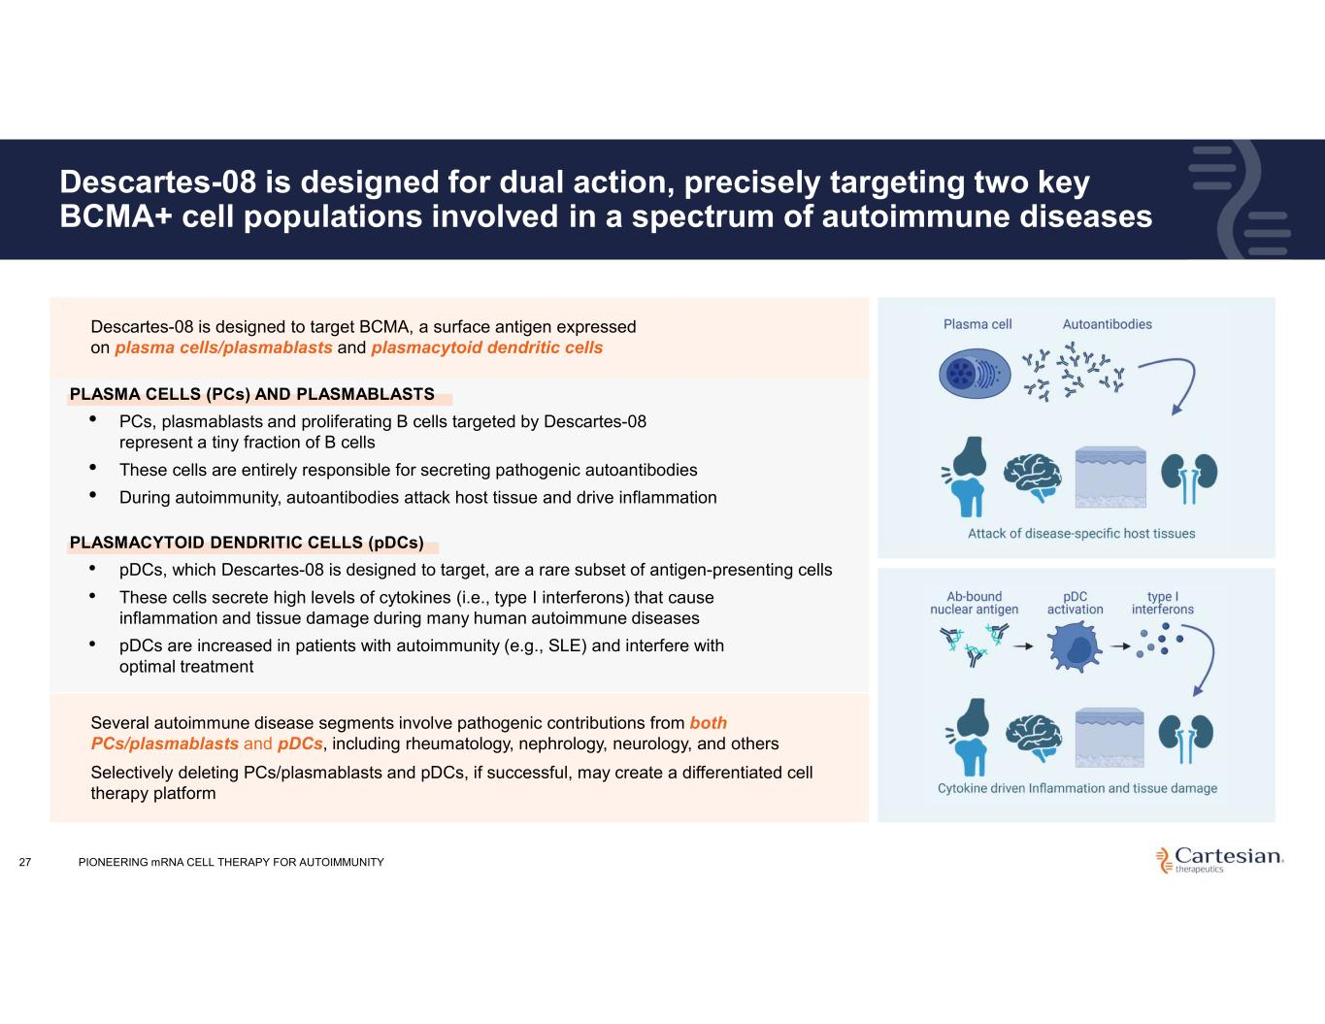
Descartes-08 is designed for dual action, precisely targeting two key BCMA+ cell populations involved in a spectrum of autoimmune diseases 27 Several autoimmune disease segments involve pathogenic contributions from both PCs/plasmablasts and pDCs, including rheumatology, nephrology, neurology, and others Selectively deleting PCs/plasmablasts and pDCs, if successful, may create a differentiated cell therapy platform • Descartes-08 is designed to target BCMA, a surface antigen expressed on plasma cells/plasmablasts and plasmacytoid dendritic cells PLASMA CELLS (PCs) AND PLASMABLASTS • PCs, plasmablasts and proliferating B cells targeted by Descartes-08 represent a tiny fraction of B cells • These cells are entirely responsible for secreting pathogenic autoantibodies • During autoimmunity, autoantibodies attack host tissue and drive inflammation PLASMACYTOID DENDRITIC CELLS (pDCs) • pDCs, which Descartes-08 is designed to target, are a rare subset of antigen-presenting cells • These cells secrete high levels of cytokines (i.e., type I interferons) that cause inflammation and tissue damage during many human autoimmune diseases • pDCs are increased in patients with autoimmunity (e.g., SLE) and interfere with optimal treatment PIONEERING mRNA CELL THERAPY FOR AUTOIMMUNITY

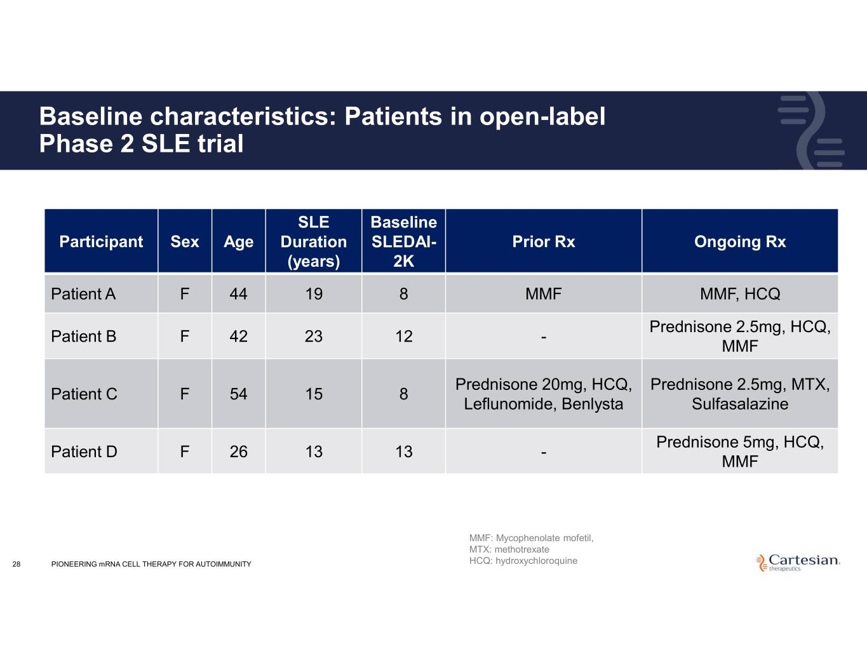
28 Baseline characteristics: Patients in open-label Phase 2 SLE trial Ongoing RxPrior Rx Baseline SLEDAI- 2K SLE Duration (years) AgeSexParticipant MMF, HCQMMF81944FPatient A Prednisone 2.5mg, HCQ, MMF -122342FPatient B Prednisone 2.5mg, MTX, Sulfasalazine Prednisone 20mg, HCQ, Leflunomide, Benlysta 81554FPatient C Prednisone 5mg, HCQ, MMF -131326FPatient D MMF: Mycophenolate mofetil, MTX: methotrexate HCQ: hydroxychloroquinePIONEERING mRNA CELL THERAPY FOR AUTOIMMUNITY

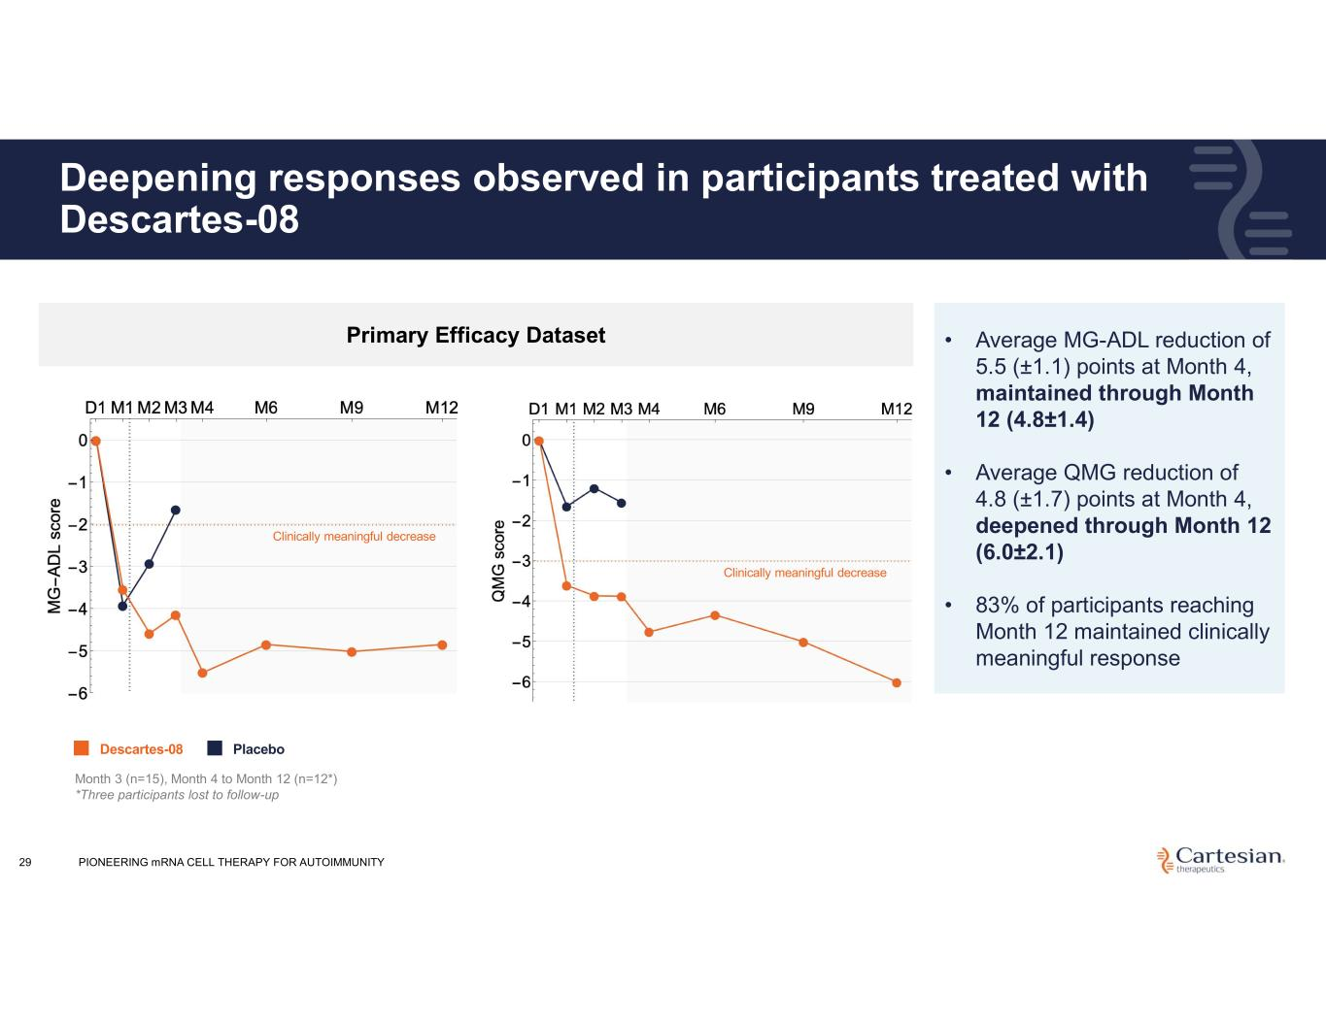
Deepening responses observed in participants treated with Descartes-08 29 • Average MG-ADL reduction of 5.5 (±1.1) points at Month 4, maintained through Month 12 (4.8±1.4) • Average QMG reduction of 4.8 (±1.7) points at Month 4, deepened through Month 12 (6.0±2.1) • 83% of participants reaching Month 12 maintained clinically meaningful response Primary Efficacy Dataset Month 3 (n=15), Month 4 to Month 12 (n=12*) *Three participants lost to follow-up Descartes-08 Placebo Clinically meaningful decrease Clinically meaningful decrease PIONEERING mRNA CELL THERAPY FOR AUTOIMMUNITY

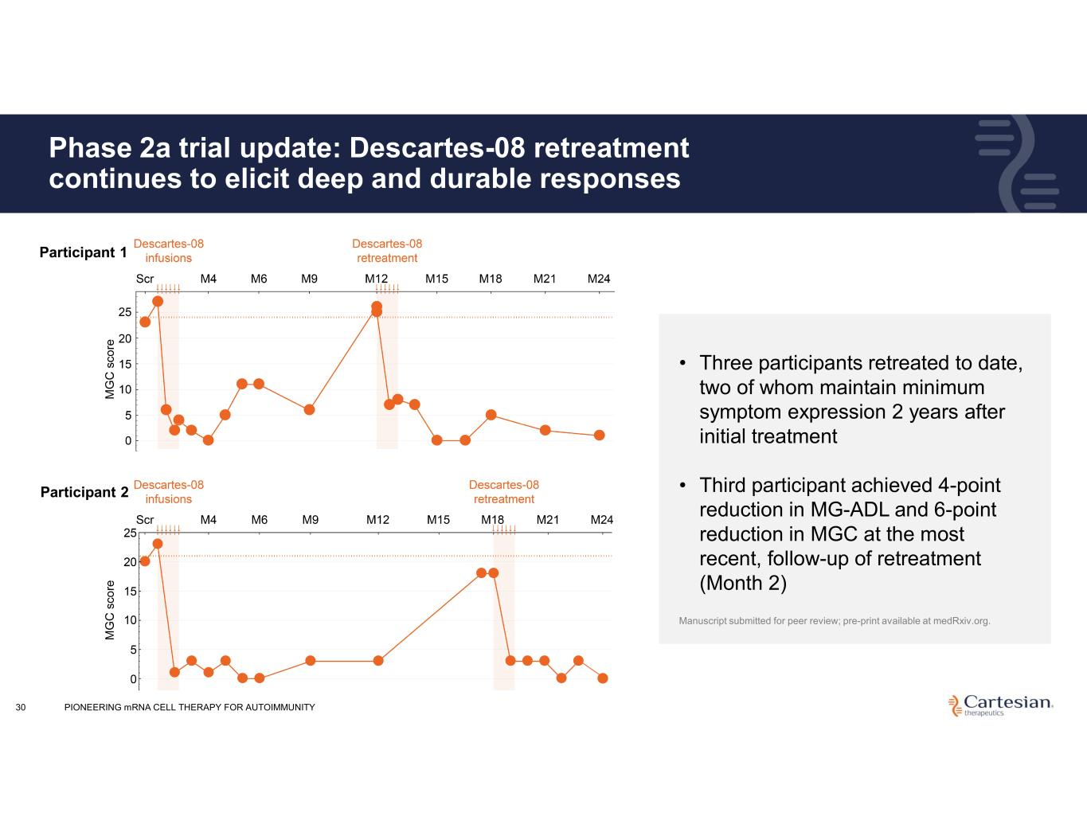
Phase 2a trial update: Descartes-08 retreatment continues to elicit deep and durable responses Manuscript submitted for peer review; pre-print available at medRxiv.org. • Three participants retreated to date, two of whom maintain minimum symptom expression 2 years after initial treatment • Third participant achieved 4-point reduction in MG-ADL and 6-point reduction in MGC at the most recent, follow-up of retreatment (Month 2) 30 Participant 1 Participant 2 PIONEERING mRNA CELL THERAPY FOR AUTOIMMUNITY

